School: ……………………………………….. | Date:……………………………………..
Class: ……………………………..................... | Period: ………………………………….

UNIT 5: HEALTHY LIVING
Lesson 3.1: Reading (Page 52)

1. Objectives
By the end of this lesson, students will be able to…
1.1. Language knowledge/ skills
- practice reading for the main idea and details for the main idea and details.
- practice listening for the main idea and specific information
- improve reading skills.
1.2. Competences
- improve Ss’ communication, collaboration, analytical, and critical thinking skills.
1.3. Attributes
- Encourage students to be observant when searching for health information sources on social networks.

2. Teaching aids and materials
- Teacher’s aids: Student’s book and Teacher’s book, class CDs, DCR– Phần mềm tương tác trực quan, DHA – Ứng dụng trò chơi tương tác, projector / interactive whiteboard /TV (if any), PowerPoint slides.
- Students’ aids: Student’s book, Workbook, Notebook.
3. Assessment Evidence
Performance Tasks | Performance Products | Assessment Tools
- Read and choose the correct answers.  - Read and summarise the main idea.  - Read and circle the correct answers.  - Listen and read.  - Talk about your summary | - Ss’ answers.  - Ss’ answers.  - Ss’ answers.  - Ss’ performance.  - Ss’ answers/presentation. | - Observation and feedback.  - Observation and feedback.  - Observation and feedback.  - Observation and feedback.  - Observation and feedback.
4. Procedures
A. Warm-up: 5 minutes
a. Objectives: to introduce the topic.
b. Content: Let’s talk.
c. Expected outcomes: Ss can talk about where they get health information
d. Organization
Teacher’s activities | Students’ activities
Let’s talk: Look at the pictures. Where do these people get information about health? Where do you usually get health information from?  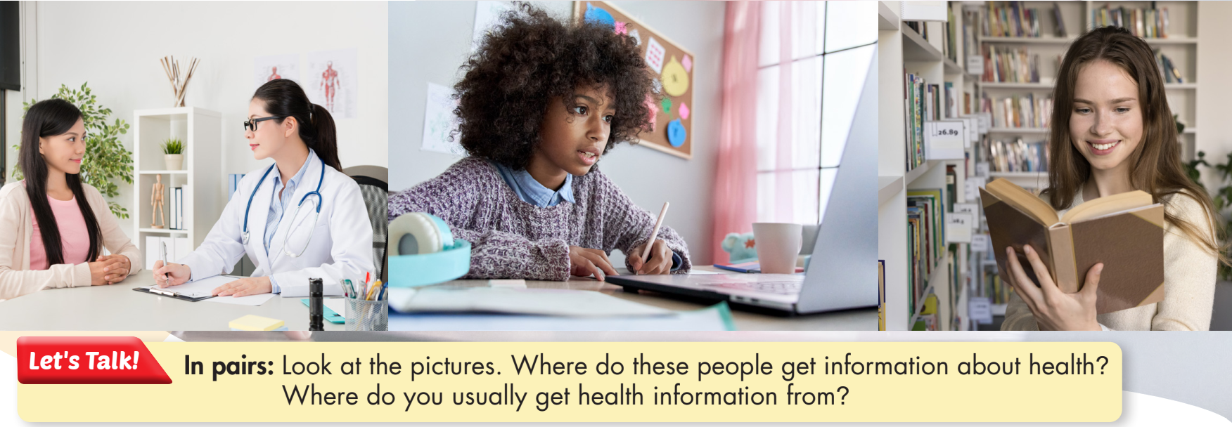  - Have Ss work in pairs, look at the pictures, and answer the questions (using the DCR/ PPTs slides).  - Invite some pairs to give their answers.  - Give feedback. | - Work in pairs, look at the pictures and answer the questions.  - Share the answers with the class.  Suggested answers:  They get information about health by  - Talking to the experts  - Searching for information on the Internet  - Reading books  I usually get health information from:  - Doctors  - Books  - Magazine / Newspaper  Ss’ answers

B. New Lesson (35’)
1. Pre-Reading (15’)
a. Objectives: To prepare vocabulary for students to understand the text.
b. Content: Tasks a
c. Expected outcomes: Ss can read and understand the text better.
d. Organization
Teacher’s activities | Students’ activities
Task a: Look at the Reading on page 45 and the Listening on page 49, then read the summary below. Why are the headings organized this way?  - Have students read the two possible answers. - Have students look at the Reading on page 45 and the Listening on page 49.  - Have students read the summary and answer the question.  - Check the answer as a whole class. | - read the possible answers  - Read the Reading & Listening and take notes.  - Check the answers with their partner.  Answer Keys: 2

2. While Reading (15’)
a. Objectives: To help Ss read for inference and details.
b. Content: Tasks b, and c.
c. Expected outcomes: Ss can read for specific information about health facts/myths.
d. Organization:
Teacher’s activities | Students’ activities
Task b: Now, read and choose the correct answers.  - Have students read the questions.  - Have students read the summary again and choose the correct answers.  - Check answers as a whole class | - Read and circle the correct answers.  Answer Keys:  1. B  2. A  3. B  4. D  5. B
Task c: Listen and read.  - Play audio.  - Have Ss listen and read. | - Listen to the audio.  - Read along.

3. Post-reading (5’)
a. Objectives: To provide students with an opportunity to reinforce comprehension and enhance their English fluency and communication skills.
b. Content: Task d
c. Expected outcomes: Ss can talk about the most interesting health information and explain.
d. Organization
Teacher’s activities | Students’ activities
Task d: In pairs: Discuss which piece of information you find most interesting and say why  - Have Ss work in pairs and discuss the questions.  - Elicit answers from some Ss. | - Work in pairs to share their ideas.  - Share their ideas with the class.  Suggested answers:  I’m interested in learning which chemicals are safe because it helps us understand the ratio of chemicals in food that we eat. Therefore, it’s easy for us to choose good food for our health.

C. Consolidation and homework assignments (5’)
- Do Listening & Reading in WB page 30
- Prepare for the next lesson (Writing & Speaking – page 53 - SB)
- Play the consolidation games on www.eduhome.com.vn
5. Reflection
a. What I liked most about this lesson today:
…………………………………………………………………………………………
b. What I learned from this lesson today:
…………………………………………………………………………………………
c. What I should improve for this lesson next time:
…………………………………………………………………………………………

