School: ……………………………………….. | Date:……………………………………..
Class: ……………………………..................... | Period: ………………………………….

UNIT 5: HEALTHY LIVING
Lesson 2.1: Vocabulary and Listening (Pages 48 & 49)

1. Objectives
By the end of this lesson, students will be able to…
1.1. Language knowledge/ skills
- use new words to describe health problems.
- listen for the main idea and specific information
1.2. Competences
- improve Ss’ communication, collaboration, analytical, and critical thinking skills.
1.3. Attributes
- foster Ss’ understanding of teens health problems.
2. Teaching aids and materials
- Teacher’s aids: Student’s book and Teacher’s book, class CDs, DCR– Phần mềm tương tác trực quan, DHA – Ứng dụng trò chơi tương tác, projector / interactive whiteboard /TV (if any), PowerPoint slides.
- Students’ aids: Student’s book, Workbook, Notebook.
3. Assessment Evidence
Performance Tasks | Performance Products | Assessment Tools
- Look at the pictures and fill in the blanks.  - Listen and circle the correct answer.  - Listen and fill in the blanks.  - Read the Conversation Skill box. Listen and repeat.  - Listen to the conversation again and circle the phrase. | - Ss’ answers.  - Ss’ answers/ presentation.  - Ss’ answers.  - Ss’ answers.  - Ss’ presentation. | - Observation and feedback.  - Observation and feedback.  - Observation and feedback.  - Observation and feedback.  - Observation and feedback.
4. Procedures
A. Warm-up: 5 minutes
a. Objectives: to introduce the topic.
b. Content: Let’s talk.
c. Expected outcomes: Ss can describe problems they see in the pictures.
d. Organization
Teacher’s activities | Students’ activities
Let’s talk: Look at the pictures. What is the problem? Do you think it’s a common problem teens have? What other health problems do teens have?  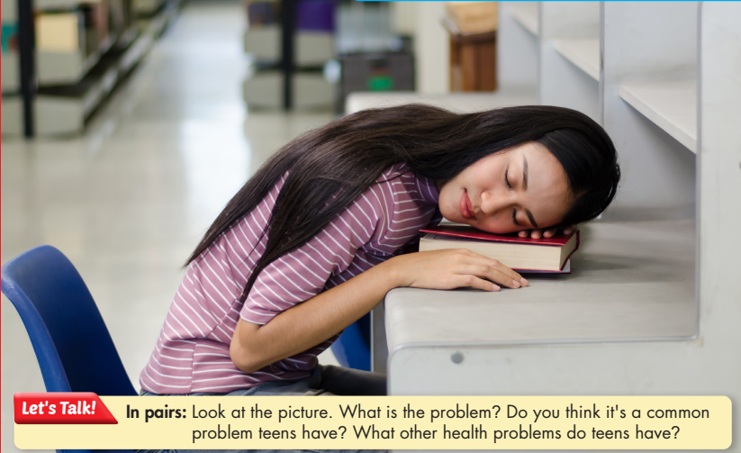  - Have Ss work in pairs, look at the pictures, and answer the questions (using the DCR/ PPTs slides).  - Invite some pairs to give their answers.  - Give feedback. | - Work in pairs, look at the pictures and answer the questions.  - Share the answers with the class.  Suggested answers:  1. She doesn’t get enough sleep and feels tired at school.  2. It’s a common problem teens have recently.  3. Other health problems that teens have:  - Eating too much fast food or junk food  - Addicting to online games  - Sleeping late  - Skipping meals  Ss’ answers

B. New Lesson (35’)
1. Vocabulary (15’)
a. Objectives: To prepare vocabulary for students to discuss health problems.
b. Content: tasks a and b.
c. Expected outcomes: Ss can use vocabulary to talk about health problems.
d. Organization
Teacher’s activities | Students’ activities
Task a: Match the underlined words to the definitions. Listen and repeat.  - Have Ss work by themselves and match the words (using the DCR/ PPTs slides) to the definitions.  - Have Ss check their answers with their partner.  - Check Ss’ answers around the class.  - Have Ss listen and check.  - Have Ss listen and repeat. | - Match the words to the definitions.  - Check the answers with their partner.  - Listen and repeat.  Answer Keys:  1. obese  2. nourishing  3. cafeteria  4. risk  5. promote  6. addicted  7. access  8. maintain
Task b: In pairs: Use the new words to talk about things that people are addicted to, what things people should have access to, and what things we should promote at school.  - Explain and model the activity.  - Have Ss work in pairs and talk about things people are addicted to, what things people should have access to, and what things we should promote at school.  - Check Ss’ answers around the class and support in need.  - Invite some Ss to share their ideas. | - Work in pairs.  - Share the ideas with the whole class.  Suggested answers:  People are often addicted to online games.  People should have access to fresh food.  We should promote sports at school.

2. Pre & While-listening (15’)
a. Objectives: To help Ss listen for the main idea and specific information.
b. Content: Tasks a, b, c and d.
c. Expected outcomes: Ss can listen for the main idea and specific information.
d. Organization:
Teacher’s activities | Students’ activities
Task a: Listen to people talking about teens' health problems. Who are the participants?  - Have Ss work in groups and read the question.  - Play audio, and have Ss listen and take notes  - Have Ss circle the correct answer.  - Check the answer as a whole class | - Work in a group and read the question  - Listen and take notes  - Check answers  Answer Key: number 1
Task b: Now, listen and fill in the blanks.  - Have Ss read the sentences.  - Have Ss listen and fill in the blanks.  - Have Ss check the answers with a partner.  - Check the answer as a whole class. | - Read the sentences.  - Listen and fill in the blanks.  - Check theỉr answers with a partner.  Answer Keys  1. six to seven  2. 11 p.m.  3. School  4. obese  5. sugar  6. nourishing lunches
Task c: Read the Conversation Skill box, then listen and repeat.  - Have Ss read the Conversation Skill box.  - Explain and clarify the use of the Conversation Skill.  - Play audio.  - Have Ss listen and repeat. | - Read the Conversation Skill box.  - Listen to the explanation  - Listen and repeat.
Task d: Now, listen to the conversation again and circle the phrase that you hear  - Have Ss listen to the audio again and circle the phrase they hear.  - Check the answer. | - Listen and circle  Answer keys:  That’s all for today. Thank you for your time.

3. Post-listening (5’)
a. Objectives: To provide students with an opportunity to practice how to ask for clarification and discuss health problems.
b. Content: Task e.
c. Expected outcomes: Ss can know how to ask for more information to understand more about the problems and they can discuss health problems and what experts suggest.
d. Organization
Teacher’s activities | Students’ activities
Task e: In pairs: Do you have any of the problems Dr. Anderson talked about? What other health problems do you have?  - Divide the class into pairs.  - Have Ss discuss the questions.  - Elicit answers from some Ss. | - Work in pairs.  - Discuss the questions.  - Share the ideas with the class.  Suggested answers  Yes, I do. I usually don’t get enough sleep, so I always feel sleepy during the daytime. I do have a busy schedule every day so I keep skipping meals. I know this habit is harmful to my body and always makes me feel under the weather.

C. Consolidation and homework assignments (5’)
- Vocabulary: obese, nourishing, cafeteria, risk, promote, addicted, access, maintain
- Do Vocabulary and Listening in WB pages 28 & 29
- Make sentences using the new words in SB
- Prepare for the next lesson (Grammar - pages 49 & 50 - SB)
- Play the consolidation games on www.eduhome.com.vn
5. Reflection
a. What I liked most about this lesson today:
…………………………………………………………………………………………
b. What I learned from this lesson today:
…………………………………………………………………………………………
c. What I should improve for this lesson next time:
…………………………………………………………………………………………

