School: ……………………………………….. | Date:……………………………………..
Class: ……………………………..................... | Period: ………………………………….

UNIT 5: HEALTHY LIVING
Lesson 1: Vocabulary and Reading (Pages 44 & 45)

1. Objectives
By the end of this lesson, students will be able to…
1.1. Language knowledge/ skills
- use new words to talk about health myths.
- practice reading for inference and details.
- improve reading skills.
1.2. Competences
- improve Ss’ communication, collaboration, analytical, and critical thinking skills.
1.3. Attributes
- understand more about the human body and healthy lifestyle.
2. Teaching aids and materials
- Teacher’s aids: Student’s book and Teacher’s book, class CDs, DCR– Phần mềm tương tác trực quan, DHA – Ứng dụng trò chơi tương tác, projector / interactive whiteboard /TV (if any), PowerPoint slides.
- Students’ aids: Student’s book, Workbook, Notebook.
3. Assessment Evidence
Performance Tasks | Performance Products | Assessment Tools
- Fill in the blanks.  - Read the text and choose the best answer.  - Read the text and circle True, False or Don’t say.  - Talk about health myths. | - Ss’ answers.  - Ss’ answers.  - Ss’ answers.  - Ss’ answers/presentation. | - Observation and feedback.  - Observation and feedback.  - Observation and feedback.  - Observation and feedback.
4. Procedures
A. Warm-up (5’)
a. Objectives: to introduce the topic.
b. Content: Let’s talk.
c. Expected outcomes: Ss can describe what they see in the picture and give opinions on what people are doing is healthy or unhealthy.
d. Organization
Teacher’s activities | Students’ activities
Let’s talk: Look at the pictures. What are these people doing? Do you think what they’re doing is healthy or unhealthy? Why?  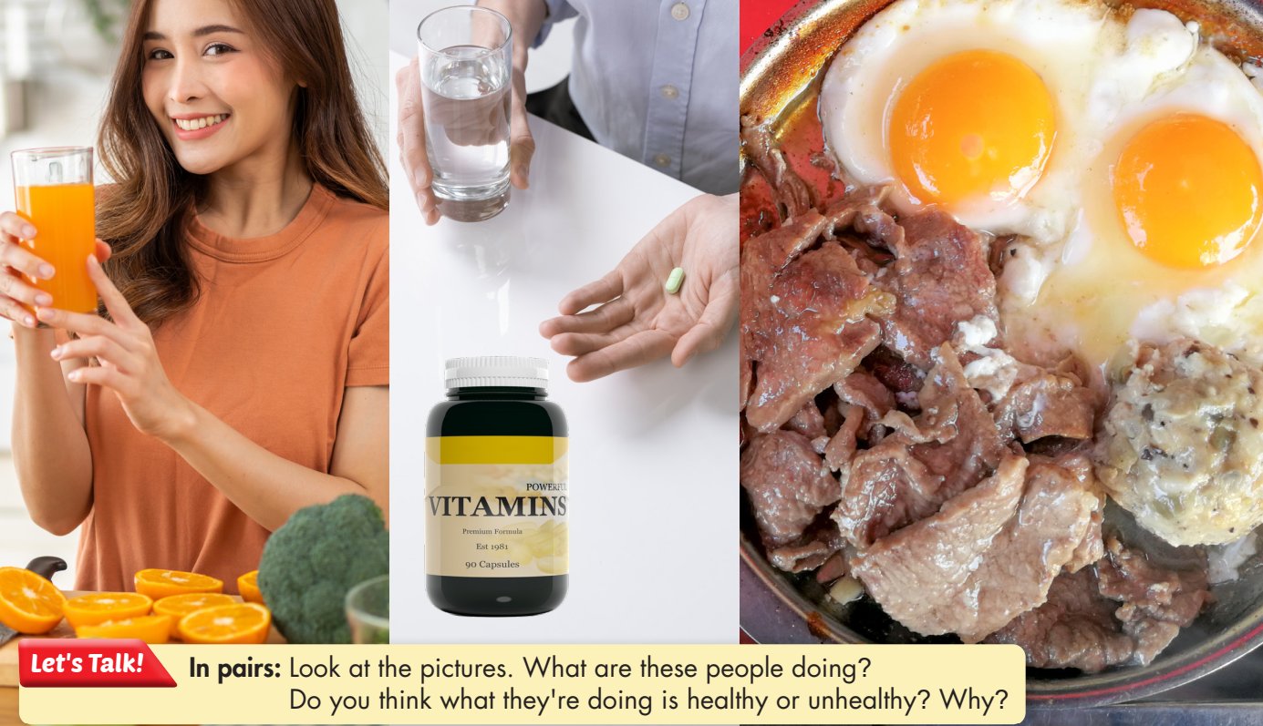  - Have Ss work in pairs, look at the pictures, and answer the questions (using the DCR/ PPTs slides).  - Invite some pairs to give their answers.  - Give feedback. | - Work in pairs, look at the pictures and answer the questions.  - Share the answers with the class.  Suggested answers  What are these people doing?  - She is drinking orange juice.  - He is taking vitamins.  - He/she is having breakfast.  Do you think what they’re doing is healthy or unhealthy? Why?  I think what they’re doing is healthy because orange juice, vitamins, and nutrient breakfast are good for our health.  Ss’ answers

B. New Lesson (35’)
1. Vocabulary – 10’
a. Objectives: To prepare vocabulary about the human body.
b. Content: tasks a and b.
c. Expected outcomes: Ss can use vocabulary to talk about problems in their hometown or talk about themselves.
d. Organization
Teacher’s activities | Students’ activities
Task a: Read the definitions, then fill in the blanks with the new words.  - Have Ss read the definitions, then fill in the  blanks with the new words (using the DCR/ PPTs slides)  - Have Ss check their answers with their partner.  - Check Ss’ answers around the class.  - Have Ss listen and repeat. | - Fill in the blanks.  - Check the answers with their partner.  - Listen and repeat.  Answer Keys:  1. detox 2. chemical 3. calorie  4. nutrient 5. virus 6. bone  7. fat 8. organ
Task b: In pairs: Use the new words to talk about what you know about the human body and healthy lifestyles.  - Explain and model the activity.  - Have Ss work in pairs, and talk about what they know about the human body and healthy lifestyles.  - Check Ss’ answers around the class and support in need.  - Invite some Ss to share their ideas. | - Listen to the instructions.  - Work in pairs  - Share the ideas with the whole class.  Suggested answers:  1. The skin is the largest organ in our body.  We shouldn't eat too many calories or avoid exercise.  2. Eating too much fat is bad.  3. We should wash our hands regularly to prevent viruses.

2. Pre & While Reading – 15’
a. Objectives: To help Ss read for inference and details.
b. Content: Tasks a, b, and c.
c. Expected outcomes: Ss can read for specific information and be aware of health myths or facts.
d. Organization:
Teacher’s activities | Students’ activities
Task a: Read the article about health. Which of the following is the best title for the passage?  - Have students read the article.  - Have students choose the correct answer.  - Check the answer as a whole class. | - Read the article, underline the evidence, and circle the correct answer.  - Check the answer with a partner and show the evidence to justify the answer.  Answer Key: number 2
Task b: Now, read and circle True, False or Don’t say.  - Have students read the questions.  - Have students read the article again and circle True, False, or Doesn't say.  - Have students check their answers with a partner.  - Check answers as a whole class. | - Read the text and circle True, False, or Doesn't say.  - Check theỉr answers with a partner.  Answer Keys  1. False 2. Doesn't say  3. False 4. Doesn't say  5. True
Task c: Listen and read.  - Play the CD and have Ss listen and read along. | - Listen and read along.

3. Post-reading – 10’
a. Objectives: To provide Ss with an opportunity to reinforce comprehension and communication skills.
b. Content: Task d
c. Expected outcomes: Ss can talk about the health myths.
d. Organization
Teacher’s activities | Students’ activities
Task d: In pairs: Do you know anyone who believes in the myths in the article? Which of the myths were surprising to you?  - Have Ss discuss and answer the question in pairs.  - Monitor the class and help them if necessary.  - Elicit answers from some students. | - Work in pairs to share their ideas.  - Share their ideas with the class.

C. Consolidation and homework assignments (5’)
- Vocabulary: nutrient, calorie, fat, organ, bone, virus, chemical, detox, harmful, harmless
- Do Vocabulary & Reading exercises in the workbook on pages 26 & 27.
- Prepare the next lesson: Lesson 1.2 – Grammar, pages 45 & 46.
5. Reflection
a. What I liked most about this lesson today:
…………………………………………………………………………………………
b. What I learned from this lesson today:
…………………………………………………………………………………………
c. What I should improve for this lesson next time:
…………………………………………………………………………………………

