Date of teaching: 22/4/2024
Period :91
UNIT 8: TRADITIONS OF ETHNIC GROUPS IN VIETNAM
Lesson 1.2 – Grammar (Pages 75 & 76)
I. OBJECTIVES
By the end of the lesson, Ss will be able to:
1.1. Language knowledge and skills
- review the vocabulary learned in lesson 1.1 related to the topic about tradition of ethinc groups in Vietnam.
- learn, practice, and use the articles correctly.
1.2. Competences
- have a general understanding about the articles.
- practice listening, reading, and speaking in communicative situations using the articles.
1.3. Attributes
- nuture national pride, culture respect for different ethinic groups.
II. TEACHING AIDS AND LEARNING MATERIALS
1. Teacher’s aids: Student book and Teacher’s book, class CDs, Digital Book (DCR phần mềm tương tác SB, DHA (từ vựng/ cấu trúc) phần mềm trò chơi tương tác), projector/interactive whiteboard / TV (if any), PowerPoint slides, handouts.
2. Students’ aids: Student’s book, Workbook, Notebook.
III. ASSESSMENT EVIDENCE
Performance Tasks | Performance Products | Assessment Tools
- Listen and repeat.  - Unscramble the sentences.  - Fill in the blanks with correct articles.  - Listen and repeat .  - Work in pair to discuss a topic. | - Ss’ performance.  - Ss’ answers.  - Ss’ answers.  - Ss’ answers/ presentation.  - Ss’ participation. | - T’s feedback.  - T’s feedback/Peers’ feedback.  - T’s feedback/Peers’ feedback.  - T’s observation, T’s feedback/Peers’ feedback.  - T’s observation, T’s feedback/Peers’ feedback.
IV. PROCEDURES
A. Warm up: (5’)
a) Objective: Review the old lesson and prepare Ss to acquire new main learning points. Help Ss identify the language materials and create the excitement for students before entering the new content of the lesson.
b) Content: Ss work individually to listen, write and repeat the words.
c) Expected outcomes: Ss can review the learned vocabulary words, listen, and write as many words as they can.
d) Organization of the activity:
TEACHER’S ACTIVITIES | STUDENTS’ ACTIVITIES
- Option 1: Listen and write the words.  - Call 2 Ss go to the board and then play the audio track CD 2 25 & 26.  - The student which write the correct words is the winner.  - Ask Ss to say the word again with correct pronunciation.  Wordlist: ethnic, embroidery, pottery, headscarf, cloth, baskewt, silver, ethnic, pattern, product.  à Lead to the new lesson.  - Option 2: Total Recall  - Show Ss a picture of diffrent ethnic groups in Vietnam. (can be online or in-house picture)  - Write the word ‘Ethnic Group’ on the board.  - Have Ss recall the vocabulary words that they have learned previously.  - Have one S at the time raise hand and say one word from the topic.  - Keep it run until all the learned vocabulary words are spoken.  Wordlist: ethnic, embroidery, pottery, headscarf, cloth, basket, silver, ethnic, pattern, product.  à Lead to the new lesson. | - Raise hands and volunteer.  - Write the word after T says.  - Say the word aloud with correct pronunciation.  - Observe and prepare for the task.  - Listen to T’s instruction.  - Say the words with correct pronunciation.

B. New lesson (35’)
- Activity 1: Presentation (10’)
a) Objective: Introduce articles and their functions.
b) Content: Ss work individually to study and practice the articles in task a on page 75.
c) Expected outcomes: Ss know how to use the correct articles “a, an, the, and zero article” well.
d) Organization of the activity:
TEACHER’S ACTIVITIES | STUDENTS’ ACTIVITIES
Grammar box  - Introduce the function of each article.  - Ask Ss to read the grammar boxes, then explain the functions of the articles.  - Walk Ss through some examples.  - Option 1:  - Have Ss look at the grammar explanation (using DCR).  - Have Ss do task a (Page 75).  - Give corrections.  - Check Ss’ understanding of the usage by asking Ss to make example sentences using the articles in the same way.  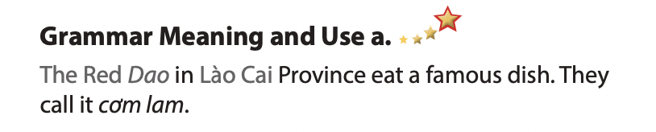  - Option 2:  - Have Ss look at the grammar box on page 75 & 76.  - Have Ss identify the parts of speech of the words a, an, and the.  - Tell Ss to study the instances of the articles in small groups and sort them out into 2 categories: definite and indefinite.  Suggested approach  Definite Indefinite  … …  - Have Ss work in group and read the grammar summary and match parts of sentences that describe the rules governing the use of definite and indefinite articles.  - Draw Ss attention that sometimes we do not use articles (zero article) before some nouns.  Suggesed approach  Match the numbers with the letters to complete the rules:  1. We can use the definite article a / an when we talk about a. things in general or when we use names of people and places.  2. We can use the definite article the when our listener/reader one thing or one member of a group of things.  3. We use zero article when we talk about knows the the particular person or, thing(s) we’re talking about, or when there is only one of that thing.  - Ask Ss to make more examples using articles.  - Give feedback and correction (if needed). | - Look and listen.  - Listen, then read.  - Listen and repeat.  - Do the task  - Make example sentences using the articles.  - Listen and do the task.  - Work in groups and do the matching.  - Look and give answers.  - Give more examples.  - Listen and take notes.

- Activity 2: Practice (19’)
a) Objective: help Ss review different question types and practice using “a, an, the, zero article”
b) Content:
- Do task a on page 76. Unscramble the sentences.
- Do task b on page 76. Fill in the blanks with the correct articles.
c) Expected outcomes: Ss can do exercises related to questions types and know deeper the function of articles.
d) Organization of the activity:

TEACHER’S ACTIVITIES | STUDENTS’ ACTIVITIES
Task a. Unscramble the sentences.  - Demonstrate the activity, using the example (using DCR).  - Have Ss read the words and unscramble to make a correct sentence.  - Have Ss work in pairs to check each other’s work.  - Have some Ss share their answers with the whole class.  - Give feedback, correct Ss’ answers (if needed).  Task b. Fill in the blanks with a, an, the, or zero article.  - Demonstrate the activity, using the example (using DCR).  - Have Ss look at all the sentences. Tell Ss to recall the function of articles and do the task.  - Have Ss check answers with their partners.  - Call Ss to write answers.  - Check Ss’ answers, give feedback. | - Look and listen.  - Work individually.  - Work in pairs.  - Raise hands to give answers.  Answer keys  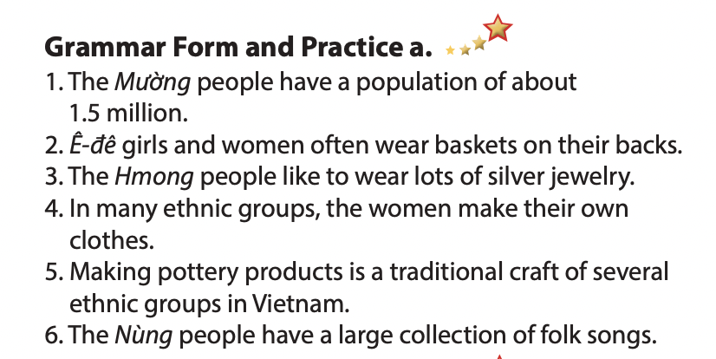  - Look and listen.  - Work individually.  - Work in pairs.  - Write answers.  Answer keys  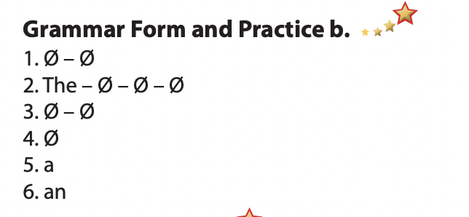

- Activity 3: Production (6’)
a) Objective: Ss can use articles in real context.
b) Content: Task c
c) Expected outcomes: Ss can use articles in real context correctly.
d) Organization of the activity:
TEACHER’S ACTIVITIES | STUDENTS’ ACTIVITIES
Task c. In pairs: Talk about traditional clothes, food, and customs of your ethnic group.  - Divide Ss into pairs.  - Have Ss read example box  - Ask Ss to check any unfamilair vocabulary words so that everyone understands the meaning of the text in the box.  - Set the time im 2 minutes for Ss’discussion.  - Have some pairs demonstrate the activity in front of the class.  - Give feedback and evaluation.    - For more practice, have Ss play a game with DHA. | - Read the text in the box.  - Check the unfamiliar words.  - Starts discussing.  - Present in front of the class.  - Listen to T’s feedback.

C. Consolidation and homework assignments (5’)
* Consolidation:
- How to use of articles, types of questions and answer.
- Use correct articles in different contexts correctly.

* Homework:
- Do the exercises in WB: Grammar (page 45).
- Complete the grammar notes and do exercise in Tiếng Anh 8 i-Learn Smart World Notebook (page 64).
- Play the consolidation games in Tiếng Anh 8 i-Learn Smart World DHA App on www.eduhome.com.vn
- Prepare: Lesson 1.3 – Pronunciation and Speaking (pages 76 & 77 – SB).

V. Reflection
a. What I liked most about this lesson today:
…………………………………………………………………………………………
- What I learned from this lesson today:
…………………………………………………………………………………………
c. What I should improve for this lesson next time:
…………………………………………………………………………………………

