Date of teaching: 2/4/2024
Period :83
UNIT 7: TEENS
Lesson 2.1 - Vocabulary and Reading (Pages 68 & 69)
I. OBJECTIVES
By the end of the lesson, Ss will be able to:
1.1. Language knowledge and skills
- learn and use vocabulary which is related to Teens
- practice reading for gist and specific information.
1.2. Competences
- improve communication, collaboration, analytical and critical thinking skills.
1.3. Attributes
- know more about celebrities’ lives which can be a part of their dream jobs.
II. TEACHING AIDS AND LEARNING MATERIALS
1. Teacher’s aids: Student book and Teacher’s book, class CDs, Digital Book (DCR phần mềm tương tác SB, DHA (từ vựng/ cấu trúc) phần mềm trò chơi tương tác), projector/interactive whiteboard / TV (if any), PowerPoint slides.
2. Students’ aids: Student’s book, workbook, notebook.
III. ASSESSMENT EVIDENCE
Performance Tasks | Performance Products | Assessment Tools
- Introduce words about celebrity’s life .  - Match the words with the pictures in a.  - Listen and repeat.  - Discuss.  - Read the article about an interview with teenage celebrity.  - Read the questions and circle the correct answers. | - Ss’ answers in notebooks.  - Ss’ answers.  - Ss’ s performance.  - Ss’ answers/ presentation.  - Ss’ answers.  - Ss’ answers. | - T’s feedback.  - T’s observation and feedback.  - T’s observation.  - T’s observation.  - T’s observation.  - T’s feedback/Peers’ feedback.
IV. PROCEDURES
A. Warm up: (5’)
a) Objective: Introduce the new lesson and set the scene for Ss to acquire new language; get students' attention at the beginning of the class by enjoyable and short activities as well as to engage them in the follow-up steps.
b) Content: Introducing some words about celebrities’ lives.
c) Expected outcomes: Ss have general ideas about the topic of the new lesson: “Teens”
d) Organization of the activity:
TEACHER’S ACTIVITIES | STUDENTS’ ACTIVITIES
Option 1: Matching  - Use the “New words” – page 68 for the warm-up activity.  - Show pictures and words (using DCR), have Ss match the words and phrases with the pictures (in pairs).  - Call Ss to give answers.  - Give feedback and show correct answers (using DCR).  - Lead to the new lesson.  - Play the audio (CD2 – Track 19), have Ss listen and repeat.  - Correct Ss’ pronunciation if necessary.  Option 2: Game: CROSSWORD  - Explain the rules of the game.  - Design the game “Crossword Puzzle” with words and pictures about “Teens”  - Have Ss play the game, encourage Ss to guess the key words.  - If any S can give the correct key word, T hasn’t confirmed yet, the game will be continued until the keyword is opened (to check whether his/her answer is correct or not and to let other Ss take part in the game eagerly).  - Give a small gift to the Ss who is the fastest to give the correct key word.  - Ask Ss an extra question: What is your dream job?  - Give feedback and lead to the new lesson.  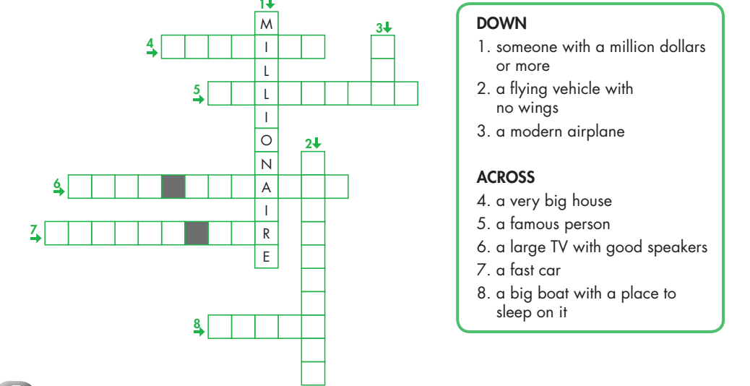 | - Work in pairs to match the words and phrases with the pictures.  - Give answers.  - Give the answer.  - Listen and take note.  - Do the task.  - Listen and repeat.  - Listen and take note.  Answer keys  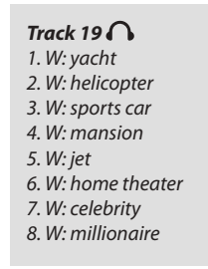  - Listen.  - Listen.  - Play the game.  - Take part in the game.  - Observe.  - Answer the question.  - Listen and take note.  Answer  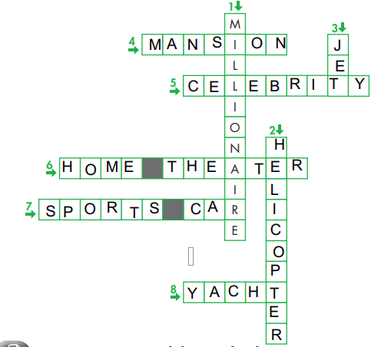

B. New lesson (35’)
- Activity 1: Pre-Reading (Vocabulary) (12’)
a) Objective: Ss know some words about celebrities’ lives.
b) Content:
- New words (celebrity, millionaire, mansion, home theaters, sport cars, helicopter).
- Speaking: Discuss some good things of in a celebrity’s life.
c) Expected outcomes: Ss know how to pronounce the new words correctly and use them in appropriate situations.
d) Organization of the activity:
TEACHER’S ACTIVITIES | STUDENTS’ ACTIVITIES
Task a. Match the words and phrases with the pictures. Listen and repeat.  Option 1 (If the teacher hasn’t used this part for the Warm-up activity)  - Demonstrate the activity, using the example (using DCR).  - Have Ss match the words and phrases with the pictures.  - Divide class into pairs and have them check their answers with their partners.  - Call Ss to give answers (read or write).  - Check answers as a whole class (using DCR).  - Play audio (CD2 – Track 19), have Ss listen and repeat.  - Correct Ss’ pronunciation.  - Option 2: Matching (If the teacher has used part a. for the Warm-up activity)  - Have Ss review the words they have known in the warm-up activity by looking at the pictures and filling in the blanks. (use different pictures from those in the textbook).  - Call Ss to give answers (read or write).  - Check answers as a whole class.  - Call some Ss to read the words again.  - Correct Ss’ pronunciation if necessary.  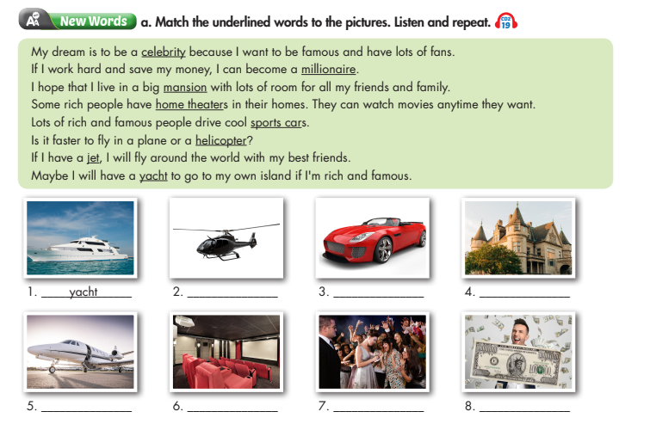  Task b. What do you think are some good things about being a celebrity?  - Have Ss discuss in pairs which are good things about being a celebrity.  - Have Ss share their ideas in front of the class.  - Give feedback and evaluation.  - Lead Ss to the Reading.  - Ask Ss read the two questions of the article.  - Instruct Ss underline the key words in each question, then compare the answer in the article to their normal lives.  - Check the meaning of the new words in the task b: sports cars, mansion, helicopter.  - Instruct Ss how to scan the information to do the True False exercises. | - Look and listen.  - Work individually.  - Work in pairs.  - Give answers.  - Listen and repeat.  - Listen and take notes.  Answer keys  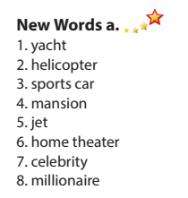  - Work in pairs.  - Give answers.  - Listen and take notes.  - Read.  - Listen and take note.  Answer keys  - Yacht  - Helicopter  - Sports cars  - Mansion  - Jet  - Home theaters  - Celebrity  - Millionaire  - Work in pairs.  - Present.  - Listen and take note  Suggested answers  Celebrities usually have a lot of money, have luxury sports cars. They also live in mansions and some of them are billionaire.  - Listen.  - Read the questions.  - Listen and take notes.  - Answer the questions.  - Listen and take notes.
- Activity 2: While - Reading (17’)
a) Objective: Students can develop their reading skills.
b) Content: Read the article about an interview with a teenage celebrity. Does he live like a normal teenager?
c) Expected outcomes: Students can read and understand general and specific information about a celebrity’s life.
d) Organization of the activity:
TEACHER’S ACTIVITIES | STUDENTS’ ACTIVITIES
Task a. Read the article about an interview with a teenage celebrity. Does he live a normal teenager?  - Have Ss read the questions.  - Have Ss read the article and answer the question.  - Call a S give the answer.  - Check the answers as a whole class and explain.  Task b. Read and circle the answer that best fits the numbered blank.  - Have Ss read the sentences.  - Have Ss read the text again and circle the correct answers – underline or highlight the supporting ideas which suggest the answers.  - Have Ss check answers with their partners.  - Call Ss to give answers as a whole class  - Give feedback and evaluation. | -Work individually.  - Circle the correct answers.  - Read answer, explain.  - Check answers.  Answer keys  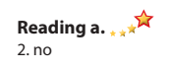  - Read and underline.  - Read the text and do as instructed.  - Check the answers.  - Present.  - Listen and take note.  Answer keys  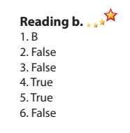
- Activity 3: Post - Reading (6’)
a) Objective: Students can use the vocabulary and ideas from the reading text to develop their speaking skill.
b) Content: Speaking: Would you like to live like TJ? Why (not)?
c) Expected outcomes: Students can state their opinion about a celebrity’s life.
d) Organization of the activity:
TEACHER’S ACTIVITIES | STUDENTS’ ACTIVITIES
Task c. In pairs: Would you like to live like TJ? Why (not)?  - Have Ss work in pairs to talk about a celebrity’s life to answer the question:  Would you like to live like JT?  - Call some Ss to share their ideas with the whole class.  - Give feedback and evaluation. | - Discuss in pairs.  - Listen.
C. Consolidation and homework assignments (5’)
* Consolidation:
- Words about celebrity’s life: celebrity, millionaire, mansion, home theaters, sports cars, helicopter, jet, yacht.
* Homework:
- Learn the new words by heart.
- Practice talking about celebrity’s life
- Do the exercises in WB: Unit 7 - Lesson 2 – Listening + Reading (page 42).
- Do the vocabulary exercise in Tiếng Anh 7 i-Learn Smart World Notebook (pages 57 & 58).
- Play the consolidation games in Tiếng Anh 7 i-Learn Smart World DHA App on www.eduhome.com.vn
- Prepare: Lesson 2.2 – Grammar (pages 69 & 70 – SB).
V. REFLECTION
a. What I liked most about this lesson today:
………….………………………………………………………………………………
- What I learned from this lesson today:
…………………………………………………………………………………………
c. What I should improve for this lesson next time:
…………………………………………………………………………………………

