Date of teaching: 27/3/2024
Period :81
UNIT 7: TEENS
Lesson 1.2 - Grammar (Pages 65 & 66)

I. OBJECTIVES
By the end of the lesson, Ss. will be able to:
1.1. Language knowledge and skills
- ask and answer about their dream jobs.
- use Possessive Pronouns in communication.
1.2. Competences
- improve communication, critical thinking, collaboration.
1.3. Attributes
- know more about the jobs around them and talk about their dream jobs and the other jobs.
II. TEACHING AIDS AND LEARNING MATERIALS
1. Teacher’s aids: Student book and Teacher’s book, class CDs, Digital Book (DCR phần mềm tương tác SB, DHA (từ vựng/ cấu trúc) phần mềm trò chơi tương tác), projector/interactive whiteboard / TV (if any), PowerPoint slides, handouts.
2. Students’ aids: Student’s book, Workbook, Notebook.
III. ASSESSMENT EVIDENCE
Performance Tasks | Performance Products | Assessment Tools
- Listen.  - Fill in the blanks.  - Answer the questions.  - Rewrite the sentences | - Ss’ performance.  - Ss’ performance.  - Ss’ answers.  - Ss’ performance. | - T’s feedback.  - T’s feedback  - T’s feedback  - T’s feedback
IV. PROCEDURES
A. Warm up: (5’)
a) Objective: to introduce the new lesson and set the scene for Ss to acquire new language; get students' attention at the beginning of the class by enjoyable and short activities as well as to engage them in the follow-up steps.
b) Content: Reviewing the /i:/ sound and possessive pronouns
c) Expected outcomes: Ss are able to use Possessive Pronouns correctly.
d) Organization of the activity:
TEACHER’S ACTIVITIES | STUDENTS’ ACTIVITIES
- Option 1: Possessive pronouns  - Have Ss listen to the audio (CD2 – track 16)  lead to the new lesson.  - Option 2: Possessive pronouns  - Write on the board.  My dream is to be a nurse.  - Ask Ss:  What’s about yours?  - Have Ss answer.  - Rewrite Ss.’s answer.  Mine is to become a teacher  - Have Ss. listen to the audio (CD2 – track 16).  lead to the new lesson. | - Listen and do the exercise.  - Look and listen.  - Look and listen.  - Answer the question.  - Look and listen.  - Listen.

B. New lesson (35’)
- Activity 1: Presentation (10’)
a) Objective: to introduce possessive pronouns.
b) Content: Grammar form and practice.
c) Expected outcomes: Ss. know about possessive pronouns and use them in some exercises that follow.
d) Organization of the activity:
TEACHER’S ACTIVITIES | STUDENTS’ ACTIVITIES
Task a. fill in the blanks  - Option 1:  - Have Ss. read the conversation.  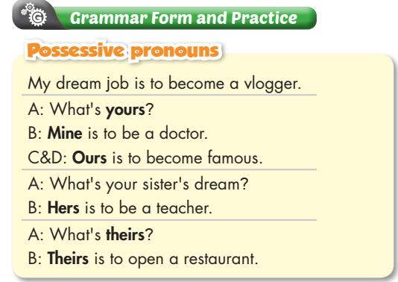  - Analyze the part of speech and lead Ss. to Possessive Pronouns, then remind Ss. of their usages and meanings.  - yours  - mine  - ours  - hers  - theirs  - Lead Ss. to the exercise a.  - Option 2:  - Ask Ss.:  Teacher: What’s yours?  Student: My dream is to become an artist  - Change the statements: “My dream is to become an artist” into “Mine is an artist” and write these statements on the board.  My dream is to become an artist.  Mine is an artist.  - Ask some more students about their dream jobs and write their jobs and their name on the board, group the similar jobs together.  Student 3’s name / a vlogger Hers  Student 1 ‘s name / have a company  Theirs  Student 2’s name/ have a small shop  - Ask Ss. about their friends’ dream jobs and have Ss. answer the questions by using the new structure.  Teacher: What’s your friend’s dream?  Student: Hers is an artist  - Point the group of jobs and ask Ss.:  Teacher: What’s theirs?  Student: Theirs is to have a company (or have a small shop)  - Analyze the part of speech and lead Ss. to Possessive pronouns; remind Ss. of the usages and meanings.  - yours  - mine  - ours  - hers  - theirs | - Read the conversation.  - Listen and take notes the knowledge.  - Read the exercise a.  - Listen and answer the question.  - Listen.  - Answer the question.  - Answer.  - Answer.  - Listen.
- Activity 2: Practice (15’)
a) Objective: Students can use Possessive Pronouns.
b) Content: Tasks a, b, page 66.
c) Expected outcomes: Students can get used to the use of the Possessive Pronouns and use them correctly.
d) Organization of the activity:
TEACHER’S ACTIVITIES | STUDENTS’ ACTIVITIES
Task a. Read the examples and fill in the blanks with the correct possessive pronouns.  - Demonstrate the activity, using the examples.  - Have Ss. do the task a.  - Call Ss. to read the conversation from task a with their answers.  - Check Ss’ answers, give feedback and evaluation.  Task b. Rewrite underlined parts using possessive pronouns.  - Demonstrate the activity, using the example.  - Have Ss. do the task b.  - Have Ss. check answers with their partners.  - Call Ss. to write answers on the board.  - Check Ss’ answers, give feedback and evaluation. | - Listen.  - Do the task a.  - Read the conversation from task a.  - Listen and correct the answers.  Answer  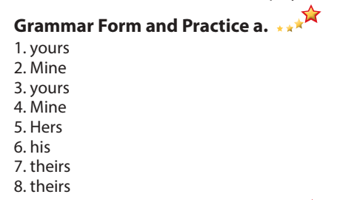  - Listen.  - Do task b.  - Read the conversation from task a.  - Write the answers on the board.  - Listen and correct the answers.  Answer  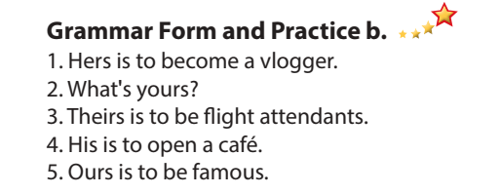
- Activity 3: Production (10’)
a) Objective: Students master the grammar point they study in the lesson.
b) Content: Tasks a & b in WB, page 39.
c) Expected outcomes: Ss. produce the new language successfully.
d) Organization of the activity:
TEACHER’S ACTIVITIES | STUDENTS’ ACTIVITIES
Task a. (Workbook) Look and write the correct pronouns.  - Demonstrate the activity, using the example.  - Have Ss. do the task a.  - Have Ss. check answers with their partners.  - Check Ss’ answers, give feedback and evaluation.  Task b. (Workbook) Look and tick the correct answer:  - Demonstrate the activity, using the example.  - Have Ss. do the task b.  - Check Ss’ answers, give feedback and evaluation. | - Listen.  - Do the task.  - Check the answers with their partners.  - Listen and correct the answers.  Answer  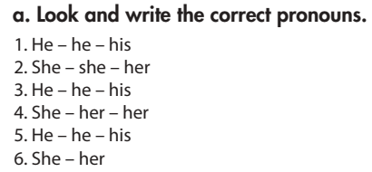  - Listen.  - Do the task.  - Listen to the correction and take note the answers.  Answer  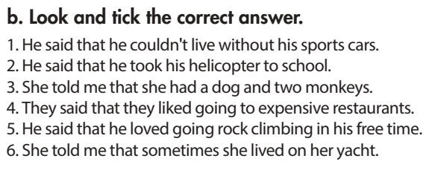
C. Consolidation. (5’)
* Consolidation: Possessive Pronouns.
* Homework:
- Make 3 sentences, using Possessive Pronouns.
- Do the exercises in Tiếng Anh 7 i-Learn Smart World Notebook (page 56)
- Play the consolidation games in Tiếng Anh 7 i-Learn Smart World DHA App on www.eduhome.com.vn
- Prepare: Pronunciation and Speaking (pages 66 & 67 – SB).
V. REFLECTION
a. What I liked most about this lesson today:
…………………………………………………………………………………………
- What I learned from this lesson today:
…………………………………………………………………………………………
c. What I should improve for this lesson next time:
…………………………………………………………………………………………

