Date of teaching: 25/3/2024
Period :80
UNIT 7: TEENS
Lesson 7.1 - Vocabulary and Listening (Pages 64 & 65)

I. OBJECTIVES
By the end of the lesson, Ss will be able to:
1.1. Language knowledge and skills
- talk about dreams and dream jobs.
- learn vocabulary related to dreams and dream jobs.
- practice listening and understanding general and specific information.
- practice responding to ideas.
1.2. Competences
- improve communication, collaboration, analytical and critical thinking skills.
1.3. Attributes
- think about their dream jobs and be well – prepared for their future.
II. TEACHING AIDS AND LEARNING MATERIALS
1. Teacher’s aids: Student’s book and Teacher’s book, class CDs, Digital Book (DCR phần mềm tương tác SB, DHA (từ vựng/ cấu trúc) phần mềm trò chơi tương tác), projector/interactive whiteboard / TV (if any), PowerPoint slides.
2. Students’ aids: Student’s book, workbook, notebook.
III. ASSESSMENT EVIDENCE
Performance Tasks | Performance Products | Assessment Tools
- listen and repeat to the new words.  - look at the pictures, fill in the blanks, then listen and repeat.  - talk about famous people with the jobs.  - listen to answer the questions, then listen again to fill in the blanks.  - learn how to respond to ideas. | - Ss’ answers.  - Ss’ answers.  - Ss’ answers.  - Ss’ answers/ presentation.  - Ss’ answers. | - T’s observation and feedback.  - T’s feedback.  - T’s feedback.  - T’s observation/ Peers’ feedback.  - T’s feedback.

IV. PROCEDURES
A. Warm up: (5’)
a) Objective: Introducing the new lesson and setting the scene for Ss to acquire new language; get students' attention at the beginning of the class by enjoyable and short activities as well as to engage them in the follow-up steps.
b) Content: Introducing some nouns about jobs.
c) Expected outcomes: Ss. can remember new vocabulary related to jobs and talk about their dream jobs by using new vocabulary.
d) Organization of the activity:
TEACHER’S ACTIVITIES | STUDENTS’ ACTIVITIES
- Option 1: Matching  - Use the “New words” part a.– page 64 for the warm-up activity.  - Show pictures and words (using DCR), have Ss match the words and phrases with the pictures (in pairs).  - Call Ss. to give answers.  - Give feedback and show correct answers (using DCR).  - Lead to the new lesson.  - Play the audio from the slides to correct pronunciation, have Ss listen and repeat.  - Correct Ss’ pronunciation if necessary.  - Option 2: Game: SLAP THE BOARD  - Explain the rules of the game.  - Design the game “SLAP THE BOARD” by writing Vietnamese meaning of the new words on the board or hanging the pictures about jobs on the board.  - Divide the class into two teams and have a student from each team come up to the board with fly swatters.  - Read loudly a new word which its picture is on the board.  - Whenever a S gives the correct answer, his/ her team will receive one point from the teacher. The team with more points will be the winner.  - Give a small gift to the winners.   | - Work in pairs to match the words and phrases with the pictures.  - Listen.  - Give answers.  - Listen to the T’s feedback.  - Listen.  - Listen and repeat.  - Listen.  - Listen.  - Take part in the game by slapping the correct word on the board.  Answer Keys  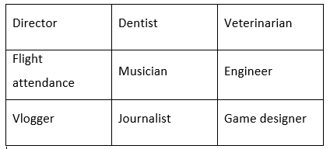

B. New lesson (30’)
- Activity 1: Pre-Listening (10’)
a) Objective: Ss remember new words related to dream jobs, know how to put these new words in the sentences with indefinite articles and practice how to analyze a statement before listening
b) Content:
- New Vocabulary (dream, director, vlogger, musician, game designer, veterinarian, dentist, engineer, journalist, flight attendant.).
- Pre – listening activity: part of speech and analyzing a statement before listening
- Speaking: talk about the dream jobs.
c) Expected outcomes: Ss know how to pronounce the new words correctly, to analyze statements before listening, use them in appropriate situations.
d) Organization of the activity:
TEACHER’S ACTIVITIES | STUDENTS’ ACTIVITIES
- Remind Ss of the indefinite article: A/ an and have Ss read the new words with a/an.  - Write the following words on the board and check their meanings and parts of speech.  - My (adj) + noun  To become (v)  To become + a(n) + name of a job  - Want (v)  Want to be a (n) + name of job  - To be + a(n) + name of a job  - good (adj) : tốt  adj + noun  7. to be + adj  8. to start a(n) + noun  - Lead Ss to task a  a. Look at the pictures and fill in the blanks. Listen and repeat  - Have Ss underline the key words before and after the blanks  - Ask Ss:  “What part of speech of the word in each blank?”  - Have Ss read the statements individually and analyze each statement.  - Play the audio (CD2 – track 13), have Ss listen and do the task.  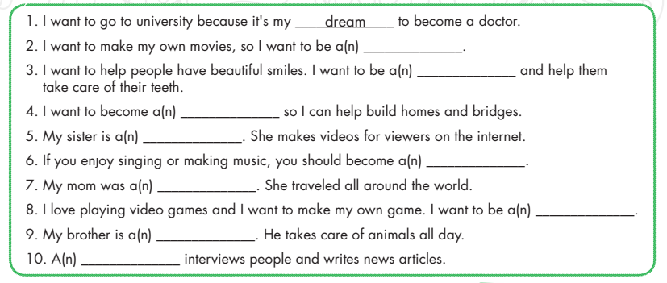  - Give the correct answers and have Ss read the statements again, then listen and give feedback.  - In pairs: Talk about famous people with these jobs.  - Show photos and their names.  - Have Ss work in pairs and make sentences about their job as the example.  Listening  Task a. Listen to Margaret talking to her mother. Did the dream of Margaret’s mother come true?  - Draw a boy on the board  “this is my son”    - Ask Ss “What is your dream job?”  - Write “My dream is to be a __” on the board, have Ss make their own sentences.  - Call Ss to give answers.  - Write “My dream was to be a teacher.” and ask Ss “Did my dream come true?” | - Look and listen.  - Look and listen.  - Listen and read.  - Listen and do the task.  - Read the statements and analyze them.  Answer keys  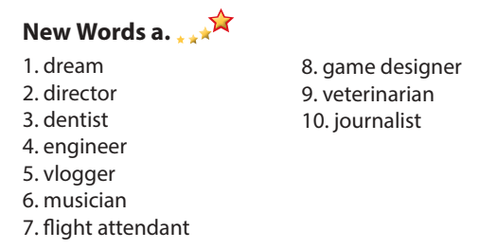  - Work in pair and give the answers  Answer keys  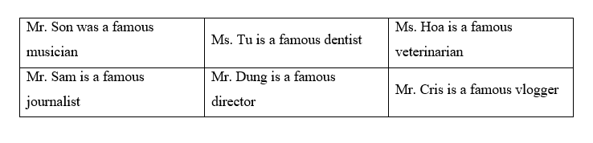  - Look and listen.  - Answer.  - Answer.

- Activity 2: While - Listening (15’)
a) Objective: Students can develop their listening skill.
b) Content: Listening to Margaret talking to her mother and filling in the blanks with the new words.
c) Expected outcomes: Students can listen and understand general, specific information from the audio and discus the dream jobs.
d) Organization of the activity:
TEACHER’S ACTIVITIES | STUDENTS’ ACTIVITIES
Task a. Listen to Margaret talking to her mother. Did the dream of Margaret’s mother come true?  - Lead Ss to task a. (CD2 – Track 14).    Task b. Listen and fill in the blanks  - Have Ss. do the exercise.  - Play audio (CD2 – Track 14) again and have Ss do task b.  - Check the answers as well as the key words with the explanation. | - Look and listen.  - Listen and give the answer  Answer keys    - Listen and do the task.  - Check the answers and take note the explanation.  Answer keys  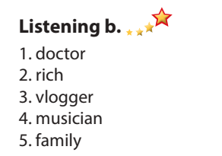

- Activity 3: Post - Listening (5’)
a) Objective: Students can use the vocabulary and phrases from the conversation to develop their speaking skill.
b) Content: Ss can ask and answer about their dream job by using phrases from the conversation.
c) Expected outcomes: Students can talk about their dream jobs in the future.
d) Organization of the activity:
TEACHER’S ACTIVITIES | STUDENTS’ ACTIVITIES
- Play the audio again (CD2 – track 14), have Ss listen and repeat the following statement.  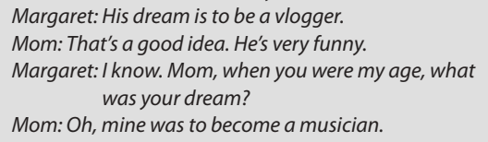  “That’s a good idea”  - Give other statement as on the Conversation Skills.  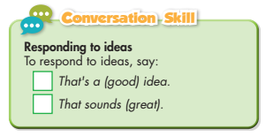  - Have Ss listen to the audio (CD2 – track 14) again and ask Ss “Who do you think had the most interesting dream? Why?”  - Write on the board:  “I think _______ had the most interesting dream. You need to_______”  - Have Ss work in pairs: one asks – one answers as the model on the board.  - Have Ss work in pairs to share their dream jobs, as the following models:  “What is your dream job?  My dream job is to be a _____  That’s a good idea / That sounds great. You need to ___” | - Listen and repeat.  - Listen.  - Listen and take notes the answer.  - Look.  - Work in pairs.  - Work in pairs.

C. Consolidation and homework assignments (5’)
* Consolidation:
- New vocabulary about dream jobs: dream, director, vlogger, musician, game designer, veterinarian, dentist, engineer, journalist, flight attendant.
* Homework:
- Learn the new words by heart.
- Practice talking about dream jobs
- Do the exercises in WB: Unit 7 - Lesson 1 - New words + Listening (page 38).
- Do the exercises in Tiếng Anh 8 i-Learn Smart World Notebook on pages 54 & 55.
- Play the consolidation games in Tiếng Anh 8 i-Learn Smart World DHA App on www.eduhome.com.vn
- Prepare: Lesson 7.2 – Grammar (pages 66 & 67– SB).

V. REFLECTION
a. What I liked most about this lesson today:
………….………………………………………………………………………………
- What I learned from this lesson today:
…………………………………………………………………………………………
c. What I should improve for this lesson next time:
…………………………………………………………………………………………

