Date of preparing:10/3/2024
Date of teaching:11/3/2024
Period :73
UNIT 6: LIFE ON OTHER PLANETS
Lesson 4 – Review (page 98)

I. OBJECTIVES
By the end of the lesson, Ss will be able to
1.1. Language knowledge and skills
- talk about possible UFO sightings in the past.
- make predictions about where humans will live in the future.
- review the target language and language skills in unit 6
Grammar: Future Simple, Past Continuous and Past Simple
Vocabulary: Words of the topic “life on other planets”: (Earth, Mars, Venus, oxygen, space station, gravity, temperature, appear, disappear, disk-shaped, flying saucer, huge, tiny, strange, terrified, UFO).
- practice test-taking skills.
1.2. Competences
- improve speaking, listening, reading and writing skills.
- improve the use of English.
1.3. Attributes
- have a good attitude toward learning English
- become more diligent.
- reread the previous lesson and be well-prepared for the second mid-term examination.
II. TEACHING AIDS AND LEARNING MATERIALS
1. Teacher’s aids: Student book and Teacher’s book, class CDs, Digital Book (DCR phần mềm tương tác SB, DHA (từ vựng/ cấu trúc) phần mềm trò chơi tương tác), projector/interactive whiteboard / TV (if any), PowerPoint slides, handouts.
2. Students’ aids: Student’s book, workbook, notebook.
III. ASSESSMENT EVIDENCE
Performance Tasks | Performance Products | Assessment Tools
- Unscramble the sentences.  - Listening: You will hear five short conversations. You will hear each conversation twice. There is one question for each conversation. For each question, choose the correct answer (A, B, or C). | - Ss’ answers.  - Ss’ answers. | - T’s feedback/Peers’ feedback.  - T’s feedback/Peers’ feedback.
- Listening: Listen to part of a presentation about UFOs and fill in the blanks. | - Ss’ answers. | - T’s feedback/Peers’ feedback.
- Reading: Read the blog post. Choose the correct answer (A, B, or C). | - Ss’ answers. | - T’s feedback/Peers’ feedback.
- Reading: Reading the blog post “A meeting with an alien” and answer the questions. | - Ss’ answers. | - T’s feedback/Peers’ feedback.

IV. PROCEDURES
A. Warm up: (5’)
a) Objective: Introduce the new lesson and set the scene for Ss to acquire new language; get students' attention at the beginning of the class by enjoyable and short activities as well as to engage them in the follow-up steps.
b) Content: Review: Life on other planets
c) Expected outcomes: Ss are ready for the new lesson.
d) Organization of the activity:
TEACHER’S ACTIVITIES | STUDENTS’ ACTIVITIES
Unscramble the sentences.  - Have Ss work in pairs to unscramble the following sentences.  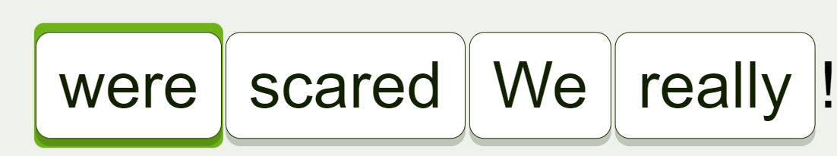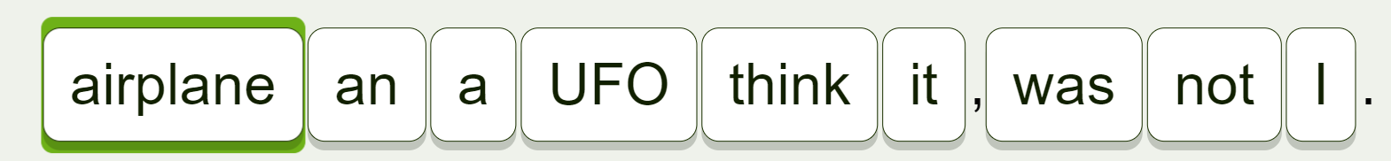  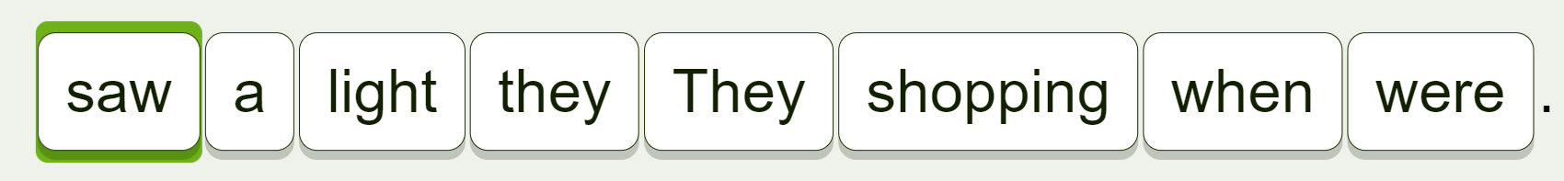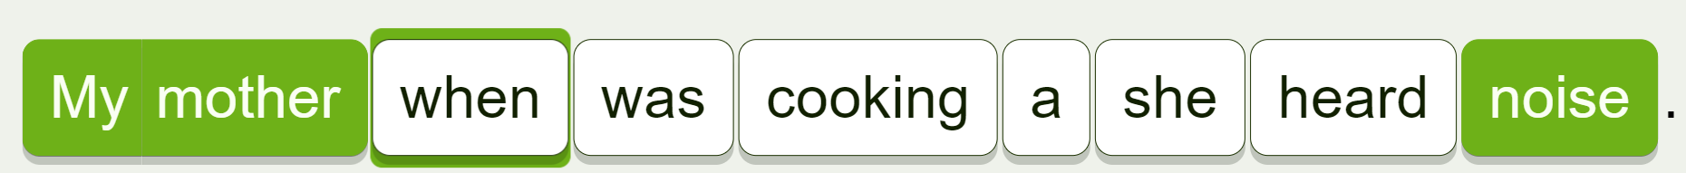  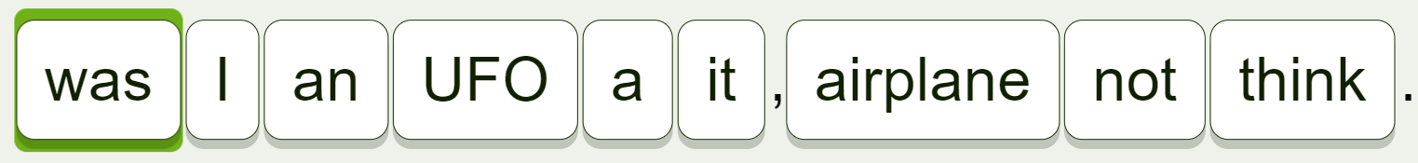  - Call Ss to give answers.  - Lead to the new lesson. | - Work in pairs.  - Give answers.  Suggested answer    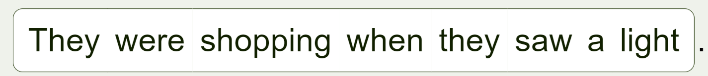

B. New lesson (35’)
- Activity 1: Listening (12’)
a) Objective: Help Ss improve their listening skill.
b) Content: Listening to five short conversations and choosing the correct answer (A, B, or C).
c) Expected outcomes: Ss listen in details and get familiar with the listening test format.
d) Organization of the activity:
TEACHER’S ACTIVITIES | STUDENTS’ ACTIVITIES
You will hear five short conversations. You will hear each conversation twice. There is one question for each conversation. For each question, choose the correct answer (A, B, or C).  - Have Ss read through the listening part, focusing on the pictures on each question.  - Demonstrate the activity, using the example.  - Play the audio (CD 2 – Track 43). Have Ss listen and choose the correct answer.  - Have Ss check answers in pairs, then read answers.  - Check answers as a whole class. | - Read the questions and look at the pictures.  - Listen and read answers.  Answer keys

- Activity 2: Reading (12’)
a) Objective: Students can improve their reading skill.
b) Content: Reading the blog post and choosing the correct answer (A, B, or C).
c) Expected outcomes: Ss read for comprehension and get familiar with the reading test format.
d) Organization of the activity:
TEACHER’S ACTIVITIES | STUDENTS’ ACTIVITIES
Read the blog post. Choose the correct answer (A, B, or C).  - Demonstrate the activity, using the example.  - Have Ss look and read, then choose the correct answer, underline the supporting ideas for their answers.  - Call Ss to give answers and explain.  - Give feedback. | - Observe and listen.  - Work individually.  - Give answers and explain.  Answer keys  

- Activity 3: Listening (11’)
a) Objective: Help Ss improve their listening skill.
b) Content: Listening to part of a presentation about UFOs and filling in the blanks.
c) Expected outcomes: Ss listen in details and get familiar with the listening test format.
d) Organization of the activity:
TEACHER’S ACTIVITIES | STUDENTS’ ACTIVITIES
Listen to part of a presentation about UFOs and fill in the blanks.  - Use the task in WB – page 36 for review.  - Give Ss handouts of the task.  - Have Ss read through the listening part, focusing on the blanks on each question.  - Demonstrate the activity, using the example.  - Play the audio (WB - CD – Track 13). Have Ss listen and fill the blanks.  - Have Ss check answers in pairs, then read answers.  - Check answers as a whole class.  *Handout:  Listen to part of a presentation about UFOs. Fill in the blanks.  1. People reported more than 90,000 UFO sightings in __________.  2. Most of the time, these UFOs were everyday things like __________ or balloons.  3. In New Jersey, people saw __________ in the sky at night.  4. In __________, someone saw another UFO at an airport in Chicago.  5. The UFO stayed above the airport for about __________. | - Read the questions.  - Check answers in pairs.  - Listen and read answers.  Answer keys  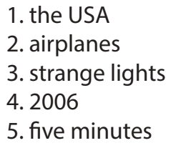

C. Consolidation and homework assignments (5’)
* Consolidation:
- Grammar of Unit 6: Future Simple, Past Continuous and Past Simple
- Vocabulary of Unit 6: Words of the topic “life on other planets”: (Earth, Mars, Venus, oxygen, space station, gravity, temperature, appear, disappear, disk-shaped, flying saucer, huge, tiny, strange, terrified, UFO).
The following reading task adapted from WB – page 36:
Reading the blog post and answer the questions.

I will never forget the day I met an alien.
I was ten years old. I was with my friend Jonathan. We were climbing trees in the forest near my home.
I was sitting near the top of a tree when I saw a large, green face next to me. It had huge, black eyes, and a tiny mouth. It was looking at me and making strange noises.
I think it was trying to tell me something, but I couldn’t understand its language. I was terrified, but I couldn’t move my body. The alien spoke for about a minute. Then, I saw a strange light and closed my eyes.
Read and answer the questions.
1. How old was Mike in this story?
2. Where were Mike and Jonathan playing?
3. How did Mike feel when the alien was speaking to him?
Answer keys:
- ten years ago
- in the forest
- terrified
* Homework:
- Review vocabulary, grammar and language skills of unit 6.
- Do the exercises in WB: Unit 6 Review - Part 1 (page 55).
- Prepare: Review – SB (page 99)
V. Reflection
a. What I liked most about this lesson today:
…………………………………………………………………………………………
- What I learned from this lesson today:
…………………………………………………………………………………………
c. What I should improve for this lesson next time:
…………………………………………………………………………………………

