School: THCS LUONG VAN CHANH | Date: 21.12.2023
 | Period: 53

REVIEW

I. PRONUNCIATION
Choose the word whose underlined part differs from the other three in pronunciation in each of the following questions.
1. A. volcanic B. fire C. disaster D. tsunami
2. A. emergency B. email C. battery D. escape
3. A. flood B. school C. moon D. tool
B. Choose the word whose primary stress is NOT placed on the second syllable.
4. A. tornado B. earthquake C. typhoon D. tsunami
C. Choose the word whose primary stress is NOT placed on the first syllable.
5. A. volcano B. forest C. wooden D. safer
II. USE OF ENGLISH
Choose the best option (A, B, C or D) to complete each of the following questions.
6. Air __________ is often seen as a major environmental result of modern living.
A. pollution B. smoke C. fume D. sewage
7. Tornadoes – very strong winds that move in a circle – can suck up anything that is in their ___.
A. road B. line C. eye D. path
8. _______, the sky became very dark, and the storm came with strong winds and heavy rain.
A. Logically B. Luckily C. Normally D. Suddenly
9. Jane’s mom: Stay inside in case of earthquakes. - Jane: __________.
A. OK. It’s empty outside.
B. I know. Earthquakes can cause trees, electricity poles, and buildings to collapse.
C. I agree. We can get under a desk or table.
D. I disagree. We cannot run away from the danger made by earthquakes.
10. During an earthquake, you should get ______ a desk because something could fall on you.
A. on B. for C. into D. under
11. You __________ open the windows when there is a storm.
A. shouldn’t B. don’t have to C. should D. must
12. Make sure your phone has enough _________ in case of a terrible storm.
A. space B. air C. battery D. electricity
13. Thousands of lives were ______________ thanks to the timely warning.
A. stored B. saved C. reserved D. limited
14. Please, pay attention to the ________ announcements from the National Weather Service.
A. main B. emergency C. frequently D. week
15. Although Tom’s grandmother doesn’t ______ weather forecasts, she likes watching them.
A. experience B. trust C. expect D. predict
16. It was the world’s __________ volcanic eruption in more than 50 years.
A. large B. larger C. the largest D. largest
17. Jack: What shouldn’t we do when there is a typhoon? Sue: We shouldn’t ________.
A. have an escape plan B. have emergency items ready to go.
C. keep enough supplies for at least five days D. stay near windows
III. WORD FORMATION
Write the correct form of the words in brackets.
18. The disastrous typhoon last year made thousands of people homeless. (DISASTER)
19. During a typhoon, be prepared to leave your home and follow your escape plan. (PREPARATION)
20. Emergency announcement from the National Weather Service are very important to local people during disasters. (ANNOUNCE)
IV. ERROR RECOGNITION
Find the underlined part that needs correction in each of the following questions.
21. People should keep a fire extinguish in a safe place.
A B C D
22. If you are in danger, calling the emergency service, they can help you.
A B C D
V. READING
Read the email from Chris to his friend, Luke. Choose the best word or phrase, A, B, C, or D, for each numbered space.
Hi Luke,
Did you watch that program about natural disasters last night? It was excellent! I was a bit bored at the beginning, because the first disaster was snow coming down a mountainside. I’m not sure that (23) ____________ are really disasters, but they are horrible for skiers.
After the first break, there was a sad story about a (24) ____________ in a part of India. It didn’t rain for nine months, and there was no water in any of the lakes or rivers. All the food plants died, and people brought things into the area by truck every day.
Next, we had a story about a kind of storm. It turns very fast over water and sometimes causes a lot of damage when it goes over land. It’s called a (25) ____________.
There’s another program next week about other natural disasters, but this program ended with some advice. The presenter said people need to be ready, but that is strange, because he also said there is often no (26) ____________ that a natural disaster will happen.
Next week, we will learn about the (27) ____________ of natural disasters, which will be very interesting. Do you want to come and watch it with me?
Best wishes,
Chris
23. | - blizzards | - avalanches | - landslides | - earthquakes
24. | - heat wave | - drought | - wildfire | - fire
25. | - typhoon | - tsunami | - wave | - wind
26. | - extinguisher | - kit | - plan | - warning
27. | - expects | - informs | - causes | - supplies

School: THCS LUONG VAN CHANH | Date: 21.12.2023
 | Period: 54
- LISTENING
Listen to five short texts. Choose the correct picture for each question.
1. | Which natural disaster was the man in?
 | 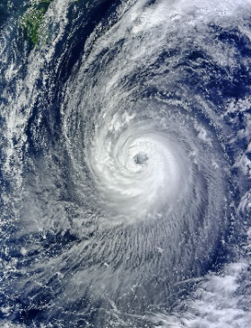 |  |  | 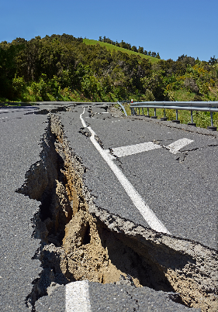 |  |  | 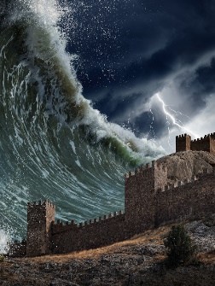
 | A |  | B |  |  | C
2. | What happened to the man?
 | 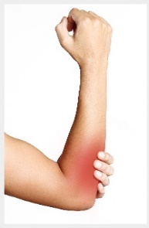 |  |  | 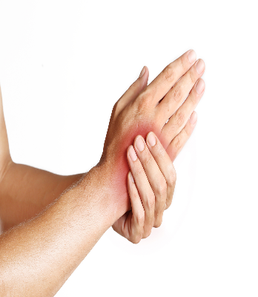 |  |  | 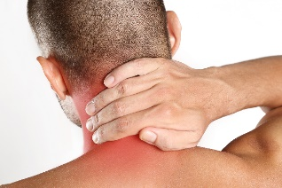
 | A |  | B |  |  | C
3. | Which natural disaster was the woman in?
 | 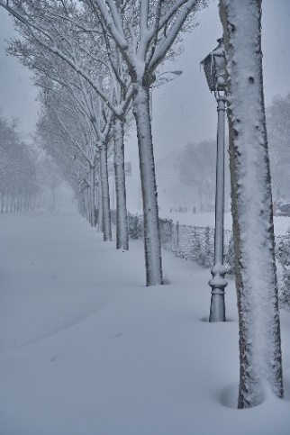 |  |  | 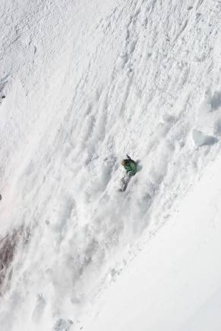 |  |  | 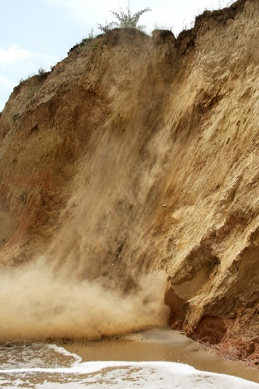
 | A |  | B |  |  | C

4 | What did the woman do?
 | 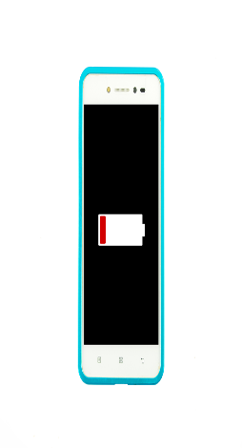 |  |  | 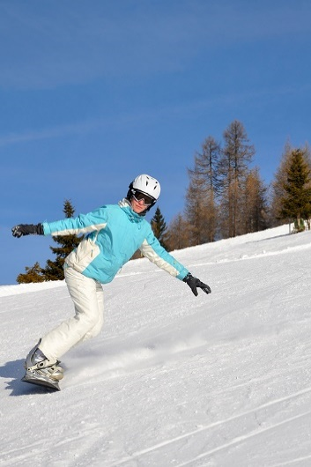 |  |  | 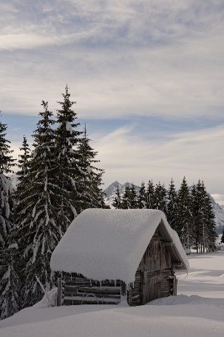
 | A |  | B |  |  | C
5. | What is the warning telling people to do?
 | 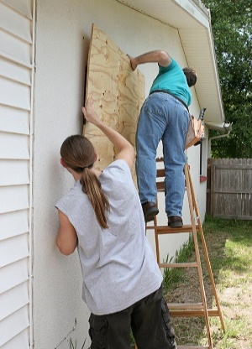 |  |  | 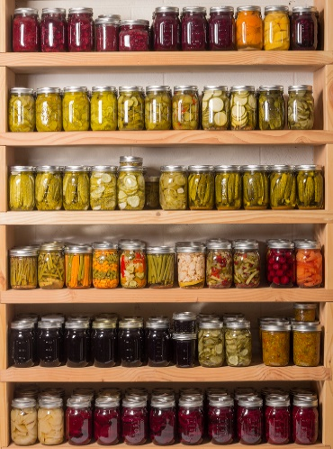 |  |  | 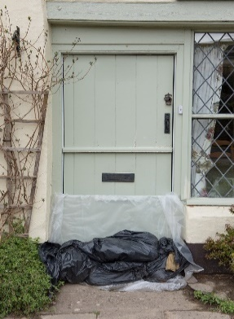
 | A |  | B |  |  | C

II. WRITING
A. Rewrite the following sentences without changing their meaning. Use the given word(s) if any.
33. You shouldn’t go outside of the house during disasters. (INSIDE)
→ You should stay inside the house during disasters.
34. Everybody in my neighborhood is well-prepared for the coming typhoon. (HAS)
→ Everybody in my neighborhood has a good preparation for the coming typhoon.
→ Everybody in my neighborhood has good preparation for the coming typhoon.
→ Everybody in my neighborhood has good preparations for the coming typhoon.
35. I suggest keeping a first aid kit in every bathroom.
→ I think we should keep a first aid kit in every bathroom.
→ I think you should keep a first aid kit in every bathroom.
36. Watching local TV or listening to the radio for more information is very useful.
→ It is very useful to watch local TV or listen to the radio for more information.
→ It is very useful to watch local TV or to listen to the radio for more information.
→ It is very useful to listen to the radio or watch local TV for more information.
→ It is very useful to listen to the radio or to watch local TV for more information.
B. Use the given words or phrases to make complete sentences.
37. We / have / escape plan / save / ourselves / disasters /.
→ We should have escape plans to save ourselves from disasters.
→ We should have an escape plan to save ourselves from disasters.
38. Disasters / can take / a lot / live / and make / people / homeless / .
→ Disasters can take a lot of lives and make people homeless.
→ Disasters can take a lot of lives and make a lot of people homeless.
→ Disasters can take a lot of lives and make many people homeless.
C. Put the words in the correct order to make correct sentences.
39. a safe place / An escape plan / you know / how to / will help / get outside / and go to / .
→ An escape plan will help you know how to get outside and go to a safe place.
40. earthquake / tsunami / undersea / A large / started a /.
→ A large undersea earthquake started a tsunami.
*Audio script*
- Man: We don’t usually have natural disasters here. But last year, a typhoon started out in the ocean and came onto the land in my town. There was a lot of damage from the high winds.
- Man: A piece of wood from a big tree came towards me and I put up my arm. It didn’t hit my head, but it hurt my hand a lot.
- Woman: I was on a skiing holiday. The weather was very cold, and there was a lot of snow. I had a great time for two days. Then, on the third day, I was on the mountainside when I heard a loud noise behind me. I turned and saw a huge amount of snow sliding down towards me.
- Woman: I didn’t try to call for help or ski away, because avalanches can move at over 300 kilometers an hour. Luckily, I saw an old wooden house, maybe for animals. I went inside, and I heard the snow move past on each side.
- This is a warning. We expect a typhoon to arrive in this town in the next 12 hours. Don’t worry about stocking up on food. It will pass on very quickly. We don’t think there will be any flooding. But you must board up your windows because of the high winds.

