Date of preparing:14/1/2024
Date of teaching: 16/1/2024
Period :56

UNIT 5: LIFE ON OTHER PLANETS
Lesson 1.2 - Grammar (pages 45 & 46)

I. OBJECTIVES
By the end of the lesson, Ss will be able to:
1.1. Language knowledge and skills
- practice and use Wh-questions and Yes/No questions correctly
- improve writing skill.
1.2. Competences
- improve Ss’ communication, collaboration and critical thinking skills.
1.3. Attributes
- to understand how electronic devices work and their impacts on daily life.
II. TEACHING AIDS AND LEARNING MATERIALS
1. Teacher’s aids: Student book and Teacher’s book, class CDs, Digital Book (DCR phần mềm tương tác SB, DHA (từ vựng/ cấu trúc) phần mềm trò chơi tương tác), projector/interactive whiteboard / TV (if any), PowerPoint slides, handouts.
2. Students’ aids: Student’s book, Workbook, Notebook.
III. ASSESSMENT EVIDENCE
Performance Tasks | Performance Products | Assessment Tools
- Do the crossword puzzle.  - Read about Wh-questions and  Yes/No questions and fill in the blanks.  - Listen and check answers.  - Fill in the blanks with the correct form of the verbs or question words.  - Ask and answer about two devices your friend has in pairs. | - Ss’ performance.  - Ss’ answers.  - Ss’ answers.  - Ss’ answers/ presentation.  - Ss’ answers/ presentation. | - T’s feedback.  - T’s feedback/Peers’ feedback.  - T’s feedback/Peers’ feedback.  - T’s observation/ feedback/Peers’ feedback.  - T’s feedback/Peers’ feedback.
IV. PROCEDURES
A. Warm up: (5’)
a) Objective: Introduce the new lesson and set the scene for Ss to acquire new language; get students' attention at the beginning of the class by enjoyable and short activities as well as to engage them in the follow-up steps.
b) Content: Practicing Wh-questions and Yes/No questions.
c) Expected outcomes: Ss review the previous grammar point that will help them in the upcoming lesson.
d) Organization of the activity:
TEACHER’S ACTIVITIES | STUDENTS’ ACTIVITIES
Do the crossword puzzle  - Use the activity “Word Search” – task b – page 26 - Workbook for the warm-up activity.  - Distribute the crossword puzzle handout to each S, and give them instructions to read through the clues carefully.  - Have S work in pairs to complete the puzzle, using their knowledge of vocabulary and spelling they have learned.  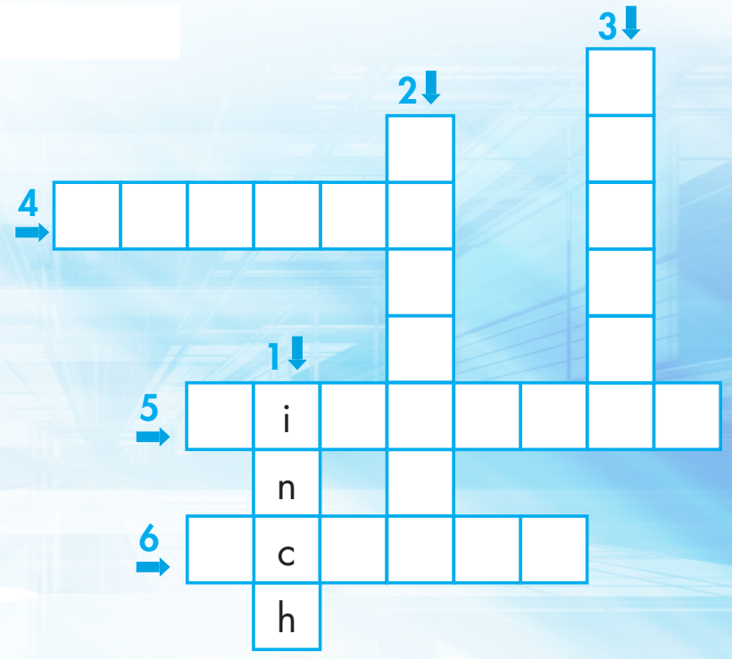  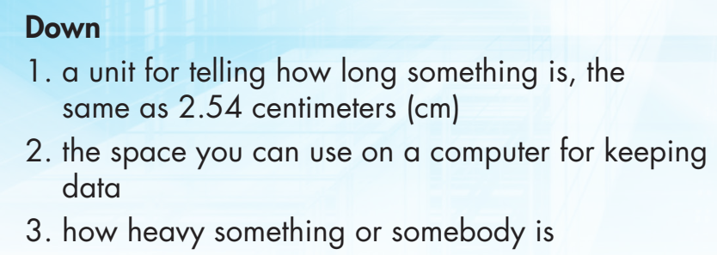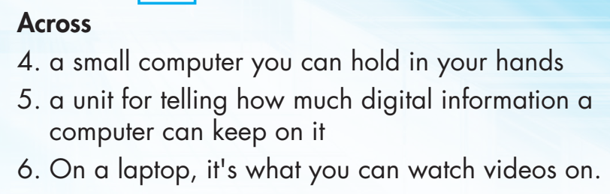  - Call Ss to give answers.  - Give feedback and show correct answers.  - Lead to the new lesson. | - Work in pairs to fill in the puzzle.  - Give answers.  Answer keys  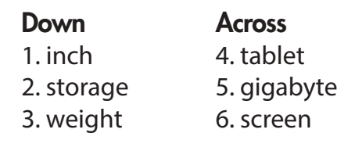

B. New lesson (35’)
- Activity 1: Presentation (10’)
a) Objective: Introduce Wh-questions and Yes/No questions
b) Content: - Going over the grammar point regarding its meaning, use and form.
c) Expected outcomes: Ss practice and use Wh-questions and Yes/No questions in the upcoming exercises.
d) Organization of the activity:
TEACHER’S ACTIVITIES | STUDENTS’ ACTIVITIES
Task a. Read about Wh-questions and Yes/No questions and fill in the blanks.  - Ask Ss to have a quick look at the picture and the grammar box on page 45.  - Have Ss predict what the man and the woman are talking about.  Who are they?  Where are they?  Are they a customer and a seller?  What are they talking about?  - Ask Ss share answers.  - Check answers.  Task b. Listen again and repeat.  - Play audio (CD1 – Track 52) and have Ss listen and read the speech bubbles.  - Play the audio again and have Ss listen and repeat. | - Look at the picture and the grammar box.  - Share the answers.  Answer keys  M: Is this laptop good for playing games?  W: Yes, it is.  M: How much is it?  W: It’s five hundred and ninety-nine dollars.  - Listen, then read.  - Listen and repeat.
GRAMMAR BOXES  - Have Ss look at the box of the grammar meaning and use.  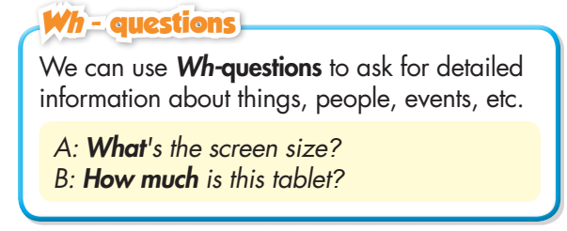 | - Look and read.
- Emphasize the use of Wh-question to ask for detailed information. (They are formed by using a wh-word (such as what, where, when, who, why, how) at the beginning of the sentence, followed by the auxiliary verb and subject.)  - Ask Ss ‘What is another question type?’  - Have Ss look at the grammar form box and read Yes/ No questions.  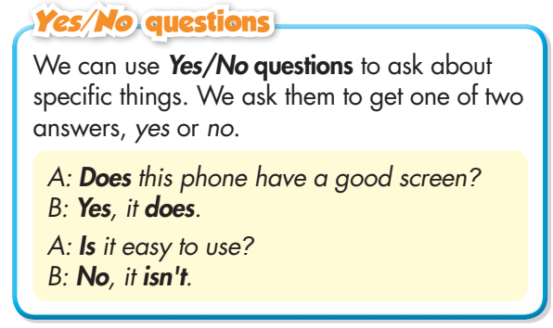  - Ask Ss to circle the bold words in the sentences, and elicit what begins the questions and what is their answers.  - Have Ss look at the boxes with the different forms.  - Have some Ss read the sentences aloud.  - Ask Ss to give more examples using the two question types.  - Give feedback. | - Read.  - Answer the question.  - Read the box.  - Circle the bold words.  - Read aloud.  - Give more examples.
- Activity 2: Practice (19’)
a) Objective: Students can use Wh-questions and Yes/ No questions to do the exercises.
b) Content: Filling in the blanks and writing questions and answers using the prompts.
c) Expected outcomes: Students can get used to the question types and use them correctly.
d) Organization of the activity:
TEACHER’S ACTIVITIES | STUDENTS’ ACTIVITIES
Task a. Read the examples above and fill in the blanks with the correct form of the verbs or question words in the box.  - Demonstrate the activity using the example.  - Have Ss fill in the blanks with the correct  form of the verbs or question words in the box.  - Have pairs check each other's work.  - Have some Ss share their answers with the class.  - Check Ss’ answers, give feedback and evaluation. | - Look and listen.  - Work individually.  - Work in pairs.  - Write the answers on the board.  Answer keys  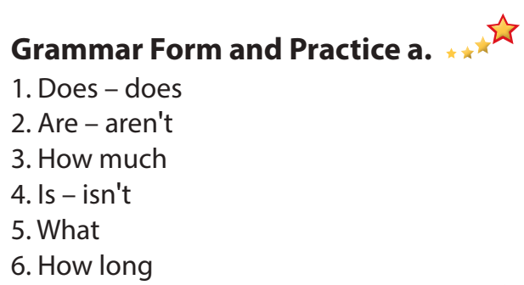
Task b. Write questions and answers using the prompts.  - Demonstrate the activity using the example.  - Have Ss write questions and answers using  the prompts.  - Have pairs check each other's work.  - Have some Ss share their answers with the class.  - Give feedback and correct Ss’ answers if necessary. | - Look and listen.  - Work individually.  - Work in pairs.  Answer keys  1. Does it have a long battery life?  Yes, it does.  2. What is its screen size? It's 11 inches.  3. Is its camera good? No, it isn't.  4. Is this laptop good for playing games?  Yes, it is.  5. How much is this laptop?It's 820 dollars.  6. What do you want to use it for?  I want to use it for drawing.
- Activity 3: Production (6’)
a) Objective: Students master the grammar point they have studied in the lesson.
b) Content: Encouraging communication in using the new language.
c) Expected outcomes: Ss produce the new language successfully, and they can the question types in daily communication.
d) Organization of the activity:
TEACHER’S ACTIVITIES | STUDENTS’ ACTIVITIES
Task c. In pairs: Ask and answer about two devices your friend has.  - Divide the class into pairs.  - Have Ss ask and answer about two devices their friend has.  - Have some pairs share their ideas with the class.  - Give feedback and evaluation.  - For more practice, have Ss play the consolidation game, using DHA. | - Have conversation in pairs.  - Present.  - Listen.

C. Consolidation and homework assignments (5’)
* Consolidation:
Survey
Give each student a handout with a list of survey questions to ask their classmates the questions as follows:
- Do you own a smartphone?
- Is the screen big?
- Do you often listen to music on your phone?
- Can you add more storage to your smart phone?
- What kind of phone do you have?
- What do you want to use your smart phone/ tablet for?
- Which app do you often use on your phone?
- How many apps do you have on your phone?
* Homework:
- Make four sentences using Wh-questions and Yes/No questions.
- Do the exercises in WB: Grammar (page 27).
- Complete the grammar notes in Tiếng Anh 8 i-Learn Smart World Notebook (page 40).
- Play consolidation games in Tiếng Anh 8 i-Learn Smart World DHA App on www.eduhome.com.vn
- Prepare: Lesson 1 – Pronunciation and Speaking (pages 45 & 46 – SB).

V. Reflection
a. What I liked most about this lesson today:
…………………………………………………………………………………………
- What I learned from this lesson today:
…………………………………………………………………………………………
c. What I should improve for this lesson next time:
…………………………………………………………………………………………

