UNIT 5: FOOD and DRINKS
Lesson 2.1 - Vocabulary and Reading (Page 39)

I. OBJECTIVES
By the end of the lesson, Ss will be able to:
1.1. Language knowledge and skills
- know some words about containers and quantities of food and drinks (a bunch of bananas, a bag of flour, a bottle of oil, a can of beans, a carton of eggs, a stick of butter, a carton of milk, a box of spaghetti).
- talk about containers and quantities of food and drinks in their kitchen.
- read a paragraph about Pete and his mom mentioning different containers and quantities of food and drinks to understand general and specific information.
1.2. Competences
- improve communication, collaboration, analytical and critical thinking skills.
1.3. Attributes
- help family with the cooking.
- eat healthily.

II. TEACHING AIDS AND LEARNING MATERIALS
1. Teacher’s aids: Student book and Teacher’s book, class CDs, Digital Book (DCR phần mềm tương tác SB, DHA (từ vựng/ cấu trúc) phần mềm trò chơi tương tác), projector/interactive whiteboard / TV (if any), PowerPoint slides.
2. Students’ aids: Student’s book, workbook, notebook.

III. ASSESSMENT EVIDENCE
Performance Tasks | Performance Products | Assessment Tools
- Fill in the blanks. | - Ss’ answers. | - T’s feedback/Peers’ feedback.
- Listen and repeat. | - Ss’ answers/ presentation. | - T’s observation / feedback.
- Say which of these you have in your kitchen. | - Ss’ answers. | - T’s feedback/Peers’ feedback.
- Read the paragraph about Pete. What did his mom want him to do? | - Ss’ answers. | - T’s feedback/Peers’ feedback.
- Read the paragraph and complete the table. | - Ss’ answers. | - T’s feedback/Peers’ feedback.
- What different containers do they mention in the reading? What other ones do you know? | - Ss’ answers. | - T’s feedback/Peers’ feedback.

IV. PROCEDURES
A. Warm up: (5’)
a) Objective: Introduce the new lesson and set the scene for Ss to acquire new language; get students' attention at the beginning of the class by enjoyable and short activities as well as to engage them in the follow-up steps.
b) Content: Introduce some words about containers and quantities of food and drinks (a bunch of bananas, a bag of flour, a bottle of oil, a can of beans, a carton of eggs, a stick of butter, a carton of milk, a box of spaghetti).
c) Expected outcomes: Ss have general ideas about the topic of the new lesson: containers and quantities of food and drinks.
d) Organization of the activity:
TEACHER’S ACTIVITIES | STUDENTS’ ACTIVITIES
- Option 1:  - Use the “New words” part a.– page 39 for the warm-up activity.  - Show pictures and words using DCR, have Ss fill in the blanks (in pairs).  - Call Ss to give answers.  - Give feedback and show correct answers using DCR.  - Lead to the new lesson.  - Play the audio (CD1 – Track 53), have Ss listen and repeat.  - Correct Ss’ pronunciation if necessary.  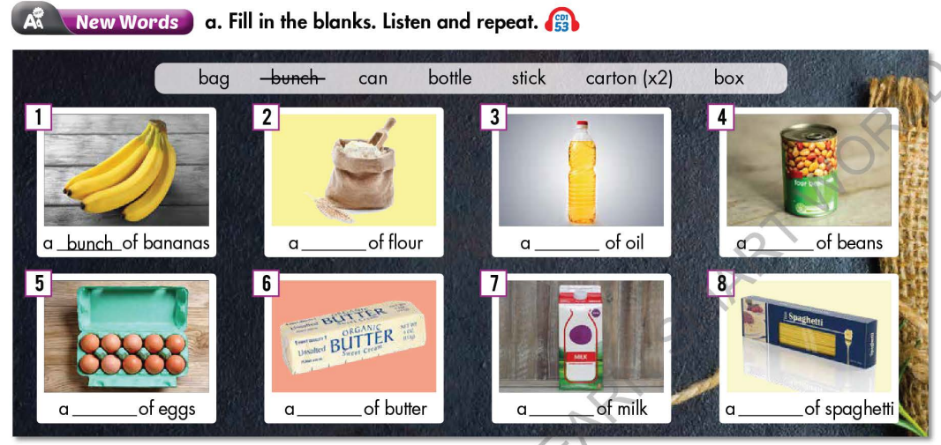  - Option 2: Containers  - Show pictures, have Ss do the matching activity in pairs.  - Call Ss to give answers.  - Give feedback.  - Introduce the new lesson: containers and quantities of food and drinks.  *Illustration:  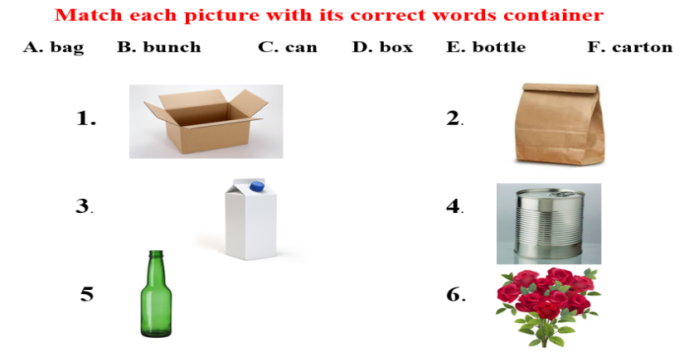 | - Work in pairs to fill in the blanks.  - Give answers.  - Listen.  Answer keys  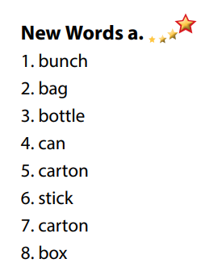  - Work in pairs.  - Give answers.  Suggested answers  1D  2A  3F  4C  5E  6B

B. New lesson (35’)
- Activity 1: Pre-Reading (Vocabulary) (12’)
a) Objective: Ss know some words about containers and quantities of food and drinks.
b) Content:
- Vocabulary study: Fill in the blanks: Words about containers and quantities of food and drinks (a bunch of bananas, a bag of flour, a bottle of oil, a can of beans, a carton of eggs, a stick of butter, a carton of milk, a box of spaghetti).
- Listen and repeat.
- Speaking: Say which of these you have in your kitchen.
c) Expected outcomes: Ss know how to pronounce the new words correctly and use them in appropriate situations.
d) Organization of the activity:
TEACHER’S ACTIVITIES | STUDENTS’ ACTIVITIES
Task a. Fill in the blanks. Listen and repeat.  - Option 1 (If the teacher hasn’t used this part for the Warm-up activity.)  - Demonstrate the activity on DCR, using the example.  - Have Ss look at the pictures and phrases, then fill in the blanks.  - Divide class into pairs and have them check their answers with their partners.  - Call Ss to give answers (read or write).  - Check answers as a whole class using DCR.  - Play audio (CD1 – Track 53). Have Ss listen and repeat.  - Correct Ss’ pronunciation.  - Option 2: Brainstorming (If the teacher has used part a. for the Warm-up activity.)  - Have Ss review the words they have known in the warm-up activity by thinking of other food and drinks that can go with words of containers and quantities.  - Call Ss to give answers (read or write).  - Check answers as a whole class.  - Call some Ss to read the words again.  - Correct Ss’ pronunciation if necessary.  *Illustration:  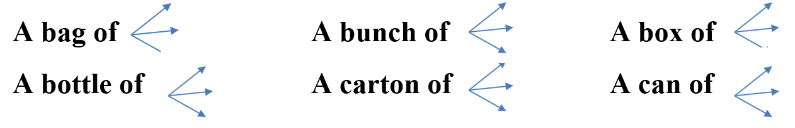  Task b. Say which of these you have in your kitchen.  - Have students say which foods they have in their kitchen.  - Have Ss share their answers in front of the class.  - Give feedback and evaluation. | - Look and listen.  - Work individually.  - Work in pairs.  - Give answers.  - Listen and repeat.  Answer keys  - Work in groups.  - Give answers.  - Read.  Expected answers  - A bag of: chocolate, candies, sugar, …  - A bunch of: banana, grapes, flowers, …  - A box of: chocolate, candies, pens, …  - A bottle of: cooking oil, water, soda, …  - A carton of: milk, yoghurt, juice, …  - A can of: fish, soda, candies, …  - Work in pairs.  - Present.  Sample answers  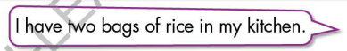
- Activity 2: While - Reading (17’)
a) Objective: Students can develop their reading skill.
b) Content:
- Read the paragraph about Pete. What did his mom want him to do?
- Read the paragraph and complete the table.
c) Expected outcomes: Students can read a paragraph and understand more about containers and quantities of food and drinks.
d) Organization of the activity:

TEACHER’S ACTIVITIES | STUDENTS’ ACTIVITIES
Task a. Read the paragraph about Pete. What did his mom want him to do?  - Have Ss read 3 options and guess the answer.  - Ask Ss to scan the paragraph, then choose the best answer.  - Remind Ss to underline or highlight the keywords or supporting ideas for their answers.  - Have some Ss share their answers with the class (read), explain for their answers.  - Give feedback.  - Give feedback and correct Ss’ answers if necessary.  Task b. Now, read the paragraph and complete the table.  - Have Ss look at the paragraph and the table.  - Have Ss work in pairs to compete the table.  - Elicit answers from different pairs.  - Give feedback and evaluation. | -Work individually.  - Read answers, explain.  - Check answers.  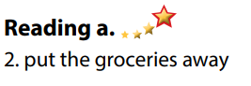  Answer keys  - Work in pairs to compete the table - Write answers.  - Read answers.  Answer keys  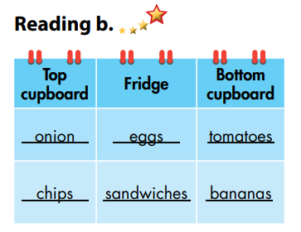

- Activity 3: Post - Reading (6’)
a) Objective: Students can use the vocabulary and ideas from the reading text to develop their speaking skill.
b) Content: Speaking: What different containers do they mention in the reading? What other ones do you know?
c) Expected outcomes: Students can talk about other containers and quantities of food and drinks.
d) Organization of the activity:
TEACHER’S ACTIVITIES | STUDENTS’ ACTIVITIES
Task c. In pairs: What different containers do they mention in the reading? What other ones do you know?  - Have Students work in pairs to answer the questions.  - Go round and give help if necessary.  - Call some Ss to share their ideas with the whole class.  - Give feedback and evaluation. | - Discuss in pairs.  - Present.  - Listen.

C. Consolidation and homework assignments (5’)

* Consolidation:
- Words about containers and quantities of food and drinks (a bunch of bananas, a bag of flour, a bottle of oil, a can of beans, a carton of eggs, a stick of butter, a carton of milk, a box of spaghetti).

* Homework:
- Learn the new words by heart.
- Practice talking about containers and quantities of food and drinks.
- Do the exercises in WB: New words + Reading (Pages 28, 29).
- Do the vocabulary exercise in Tiếng Anh 7 i-Learn Smart World Notebook (page 30).
- Play consolation games in Tiếng Anh 7 i-Learn Smart World DHA App on www.eduhome.com.vn
- Prepare: Unit 5 - Lesson 2.2 – Grammar (page 40 – SB).

D. Reflection
a. What I liked most about this lesson today:
…………………………………………………………………………………………
- What I learned from this lesson today:
…………………………………………………………………………………………
c. What I should improve for this lesson next time:
…………………………………………………………………………………………

