UNIT 5: FOOD and DRINKS
Lesson 1.3 – Pronunciation and Speaking (Page 38)

I. OBJECTIVES
By the end of the lesson, Ss will be able to:
1.1. Language knowledge and skills
- pronounce the cluster /sp/ correctly.
- ask and answer about ingredients and recipes.
- ask for repetition.
- prepare ingredients to make lemon pancake, spaghetti and beans.
1.2. Competences
- improve listening and speaking skills.
1.3. Attributes
- help family with the cooking.
- eat healthily.

II. TEACHING AIDS AND LEARNING MATERIALS
1. Teacher’s aids: Student book and Teacher’s book, class CDs, Digital Book (DCR phần mềm tương tác SB, DHA (từ vựng/ cấu trúc) phần mềm trò chơi tương tác), projector/interactive whiteboard / TV (if any), PowerPoint slides, handouts.
2. Students’ aids: Student’s book, workbook, notebook.

III. ASSESSMENT EVIDENCE
Performance Tasks | Performance Products | Assessment Tools
- Listen to the words and focus on the underlined letters. | - Ss’ performance and answers. | - T’s observation.
- Listen to the /sp/ sound. Find and note down three more words with the same sound. | - Ss’ performance and answers. | - T’s feedback/Peers’ feedback.
- Read the words in Task c with the sound notes in Task a. | - Ss’ performance. | - T’s feedback/Peers’ feedback.
- Ask and answer using the recipes. | - Ss’ performance. | - T’s feedback/Peers’ feedback.
- Speak: Ask and answer about the ingredients to make lemon pancakes, spaghetti and beans. | - Ss’ performance /  Presentation. | - T’s observation, T’s feedback/Peers’ feedback.

IV. PROCEDURES
A. Warm up: (5’)
a) Objective: Introduce the new lesson and set the scene for Ss to acquire new language; get students' attention at the beginning of the class by enjoyable and short activities as well as to engage them in the follow-up steps.
b) Content: Introduce /sp/ cluster / guess food dish from the ingredients.
c) Expected outcomes: Ss have good preparation for the new lesson.
d) Organization of the activity:
TEACHER’S ACTIVITIES | STUDENTS’ ACTIVITIES
- Option 1: /sp/ cluster  - Give class a sentence:  The special spaghetti for the sportsmen in Spanish is very spicy.  - T reads this sentence as a model, ask Ss to pay attention to the words with the letters “sp”.  - Have Ss practice reading this sentence, try to read it as fluently as possible.  - Call some Ss to read again.  - Give feedback, and give a small present for the best Ss that can read this sentence smoothly and correctly.  - Lead to the new lesson: the /sp/ sound.  - Option 2: Ingredients and dishes  - Have Ss close all books.  - Give some groups of ingredients.  - Have Ss look at the ingredients and guess the name of the dish.  - Call Ss to read answers.  - Give feedback.  - Lead to the new lesson.  *Illustration:  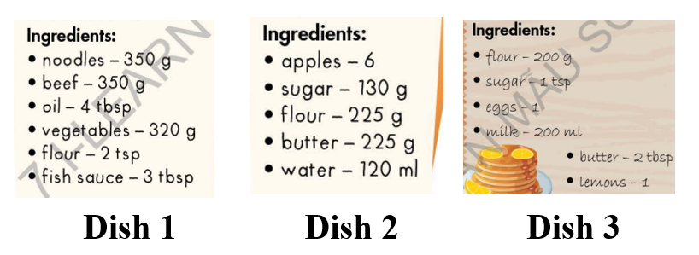  - Option 3: Introduce /sp/ sound  - Play the video clip.  - Have Ss watch, listen and repeat, then listen again and sing together.  *Link: https://www.youtube.com/watch?v=tHFNNAh4FII  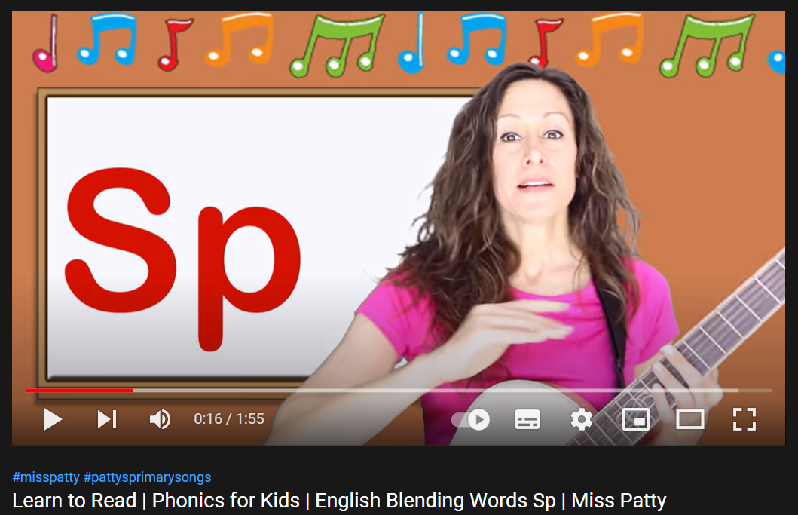  - Lead to the new lesson: the /sp/ sound. | - Listen.  - Read.  - Listen.  - Close books.  - Work in pairs, then give answers.  Answer keys  Dish 1:Beef Noodles  Dish 2:Apple Pie  Dish 3: Lemon Pancake  - Watch the video clip, listen and repeat, then sing together.

B. New lesson (35’)
- Activity 1: Pre-Speaking: Pronunciation (10’)
a) Objective: Introduce: /sp/ sound.
b) Content:
- recognize /sp/ sound and know how to pronounce it.
- listen and check, find more words with the same sound.
- practice.
c) Expected outcomes: Ss distinguish /sp/ sound and know how to pronounce it correctly in their speaking.
d) Organization of the activity:
TEACHER’S ACTIVITIES | STUDENTS’ ACTIVITIES
Task a + b. Listen to the words and focus on the underlined letters.  - Briefly explain cluster /sp/ using DCR.  - Play the recording (CD1, track 51).  - Ask Ss to listen and focus on the underlined letters.  - Play the recording again, have Ss listen and repeat with a focus on the pronunciation feature.  Task c + d. Listen to the /sp sound. Find and note down three more words with the same sound.  - Play the recording (CD 1 – Track 52), have Ss listen to the /sp sound, then find and note down three more words with the same sound.  - Call Ss to give answers.  - Give feedback and evaluation.  - Then have Ss practice saying the words they have just added.  - Call some Ss to read the words in front of the class.  - Ask some Ss to make sentences with the words containing /sp / sound.  - Give feedback and evaluation. | - Listen, take notes.  - Listen again and repeat.  - Listen to the /sp sound, then find and note down three more words with the same sound.  - Give answers.  - Practice.  - Read.  - Make sentences.  Suggested answers  Some more words with /sp/ sound: space, sport, speak, Spanish, spam, spell, spin, spoil, splash, split, spider, special, …
- Activity 2: While-speaking (20’)
a) Objective: Students can talk about ingredients of many different dishes.
b) Content:
- Ask and answer, using the recipes.
- Student B, turn to page 119, File 3. Student A, you’re helping your friend cook lemon pancakes. Look at the recipe for lemon pancakes and answer Student B's questions. Then, swap roles and talk about the ingredients and recipe of the dish: spaghetti and beans.
c) Expected outcomes: Ss produce the new language successfully.
d) Organization of the activity:

TEACHER’S ACTIVITIES | STUDENTS’ ACTIVITIES
*PRACTICE  Ask and answer using the recipes.  - Demonstrate the activity by asking and answering with a student.  - Have pairs take turns to ask and answer using the recipes.  - Remind Ss to pronounce words with /sp/ sound correctly.  - Have some pairs demonstrate the activity in front of the class.  - Give feedback and evaluation.  *SPEAKING: What Do We Need?  Task a. In pairs: Student B, turn to page 119, File 3. Student A, you’re helping your friend cook lemon pancakes. Look at the recipe for lemon pancakes and answer Student B's questions.  - Demonstrate the activity by practicing the role-play with a student.  - Divide the class into pairs.  - Have Student A stay on the page and Student B turn to page 119, File 3 and do the task.  - Remind Ss to use languages to ask for repetition.  - Observe, give help if necessary.  - Have students do the role-play.  - Give feedback and evaluation.  Task b. Swap roles. Student A, ask Student B what you need to make spaghetti and beans, then write the recipe in your notebook.  - Have pairs swap roles.  - Have pairs ask and answer about what they need to make spaghetti and beans, then write the recipe in their notebook.  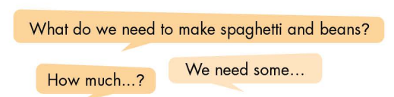  - Observe, give support.  - Have pairs do the role-play in front of the class.  - Make comment and evaluation. | - Observe, listen.  - Work in pairs.  - Present.  - Observe, listen.  - Work in pairs.  - Role play.  - Swap roles.  - Work in pairs.  - Role play.

- Activity 3: Production (5’)
a) Objective: Check Ss’ writings.
b) Content: Share their recipes with the class.
c) Expected outcomes: Ss produce the new language successfully in everyday speaking and writing.
d) Organization of the activity:
TEACHER’S ACTIVITIES | STUDENTS’ ACTIVITIES
SPEAKING: What do we need?  Extra Task: Share the recipes with the class.  - Have some Ss write their recipes on the board.  (If time is not enough, T may capture the recipes Ss have written and show them on the screen.)  - Check Ss’ answers.  - Have other Ss in class make comment and vote for the best recipe.  - Give feedback and evaluation.  - Announce the winner. | - Write / present answers.  - Make comment and vote for the best recipe.

C. Consolidation and homework assignments (5’)
* Consolidation:
- How to make /sp/ sound: This cluster is a combination of the /s/ and /p/ sounds. Begin with the /s/ sound — it should be a voiceless stream of air from your mouth. Be careful not to include an “e” sound before the /s/ begins. As you produce /s/, the tip of your tongue should be close to, but not completely touching, the top of your mouth. To make the /p/, press your upper and lower lips together, briefly stopping the air. Then, release the air.
- Words with /sp / sound: space, sport, speak, Spanish, spam, spell, spin, spoil, splash, split, spider, special …

* Homework:
- Make 2 sentences with words containing the /sp/ sound.
- Complete the recipe for those who haven’t finished it in class.
- Prepare: Unit 5 - Lesson 2 – New words and Reading (page 39 – SB).
- Review the vocabulary and grammar notes in Tiếng Anh 7 i-Learn Smart World Notebook
(pages 28 & 29).
- Play consolation games in Tiếng Anh 7 i-Learn Smart World DHA App on www.eduhome.com.vn

D. Reflection
a. What I liked most about this lesson today:
…………………………………………………………………………………………
- What I learned from this lesson today:
…………………………………………………………………………………………
c. What I should improve for this lesson next time:
…………………………………………………………………………………………

