UNIT 4: COMMUNITY SERVICES
Lesson 4 – Review (Pages 92, 93)

I. OBJECTIVES
By the end of the lesson, Ss will be able to:
1.1. Language knowledge and skills
- review words about charity and fund raising activities (donate clothes, bake sale, car wash, clean up parks, craft fair, raise money, plant trees, etc.) and talk about them.
- review grammar: Past simple form of regular verbs, making suggestions.
- review how to plan charity events.
- pronoun some sounds correctly: “ed” endings, /ʌ/, /ei/, /ɔ/, / ʊ /.
- put stress on words with two and three syllables.
1.2. Competences
- improve speaking, listening, reading and writing skills.
- improve the use of English.
1.3. Attributes
- have positive attitude in English language learning so that they actively participate in all classroom activities.
- review the old lesson and have good preparation for any assessment.

II. TEACHING AIDS AND LEARNING MATERIALS
1. Teacher’s aids: Student book and Teacher’s book, class CDs, Digital Book (DCR phần mềm tương tác SB, DHA (từ vựng/ cấu trúc) phần mềm trò chơi tương tác), projector/interactive whiteboard / TV (if any), PowerPoint slides, handouts
2. Students’ aids: Student’s book, workbook, notebook.

III. ASSESSMENT EVIDENCE
Performance Tasks | Performance Products | Assessment Tools
- Listening: You will hear a boy talking to his friend about different kinds of community service. Listen and complete questions 1– 5. You will hear the conversation twice. | - Ss’ answers. | - T’s feedback/Peers’ feedback.
- Reading: Look and read. Choose the correct answer (A, B, or C). | - Ss’ answers. | - T’s feedback/Peers’ feedback.
- Vocabulary: Fill in the blanks with the words from the box. | - Ss’ answers. | - T’s feedback/Peers’ feedback.
- Grammar: Fill in the blanks with the Past Simple form of the verbs in brackets.  + Underline the mistake in each sentence. Write the correct word on the line. | - Ss’ answers | - T’s feedback/Peers’ feedback.
-Pronunciation: Circle the word that has the underlined part pronounced differently from the others.  + Circle the word that differs from the other three in the position of primary stress in each of the following questions. | - Ss’ answers/ presentation. | - T’s observation, T’s feedback/Peers’ feedback.

IV. PROCEDURES
A. Warm up: (5’)
a) Objective: Introduce the new lesson and set the scene for Ss to acquire new language; get students' attention at the beginning of the class by enjoyable and short activities as well as to engage them in the follow-up steps.
b) Content: Slogan competition / Poster designing competition.
c) Expected outcomes: Ss are ready for the new lesson.
d) Organization of the activity:
TEACHER’S ACTIVITIES | STUDENTS’ ACTIVITIES
- Option 1: Slogan competition  - Divide class into groups of 4 or 5.  - Have Ss close their books.  - Choose a charity activity (It can be: craft fair, tree planting day, car wash, soup kitchen, …).  - Have Ss work in groups to think and write a slogan for the activity.  - Have Ss in groups their share their answers with the whole class.  - Have Ss in the class vote for the best slogan.  - Give feedback and announce the winner.  - Give an applause or a present to the winner.  - Lead to the new lesson.  - Option 2: Poster designing competition  - Divide class into groups of 4 or 5.  - Have Ss close their books.  - Choose a charity activity (It can be: craft fair, tree planting day, car wash, soup kitchen, …).  - Have Ss work in groups to design a poster for the activity.  - Have Ss in groups their share their products with the whole class.  - Have Ss in the class vote for the best poster.  - Give feedback and announce the winner.  - Give applause or a present to the winner.  - Lead to the new lesson.  *Note: In order for this activity to be carried out smoothly, T can have Ss prepare at home, then show their products in front of the class. | - Work in groups to write slogan.  - Give answers.  - Vote for the best slogan.  - Listen.  - Work in groups to design posters.  - Hang the poster on the board.  - Vote for the best posters.  - Listen.

B. New lesson (35’)
- Activity 1: Listening (7’)
a) Objective: Help Ss improve their listening skill.
b) Content:
- You will hear a boy talking to his friend about different kinds of community service. Listen and complete questions 1– 5. You will hear the conversation twice.
c) Expected outcomes: Ss listen in details and get familiar with the listening test format.
d) Organization of the activity:
TEACHER’S ACTIVITIES | STUDENTS’ ACTIVITIES
You will hear a boy talking to his friend about different kinds of community service. Listen and complete questions 1– 5. You will hear the conversation twice.  - Have Ss read through the listening part.  - Demonstrate the activity on DCR by using the example.  - Play the audio (CD 2 – Track 37).  - Have Ss check answers with pairs and then give answers.  - Check answers as a whole class. | - Read in silence.  - Listen and then give answers.  Answer keys  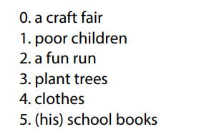
- Activity 2: Reading (7’)
a) Objective: Students can improve their reading skill.
b) Content:
- Look and read. Choose the correct answer (A, B, or C).
c) Expected outcomes: Ss read for comprehension and get familiar with the reading test format.
d) Organization of the activity:

TEACHER’S ACTIVITIES | STUDENTS’ ACTIVITIES
Look and read. Choose the correct answer (A, B, or C).  - Demonstrate the activity using DCR by using the example.  - Have Ss look and read, then choose the correct answer, underline the supporting ideas for their answers.  - Call Ss to give answers, explain.  - Give feedback and evaluation. | - Observe and listen.  - Work individually.  - Give answers, explain.  Answer keys  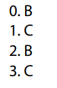

- Activity 3: Vocabulary (7’)
a) Objective: Ss can review vocabulary about community services.
b) Content: Fill in the blanks with the words from the box.
c) Expected outcomes: Ss produce the new language successfully, and they can use these words in speaking and writing.
d) Organization of the activity:
TEACHER’S ACTIVITIES | STUDENTS’ ACTIVITIES
Fill in the blanks with the words from the box  - Have Ss read the phrases and observe the pictures.  - Ask Ss to work in pairs to fill in the blanks with the words from the box.  - Have Ss give answers, tell the meaning of the words /phrase again.  - Check answers as a whole class using DCR. | - Read the phrases and observe the pictures.  - Work in pairs.  - Give answers.  Answer keys  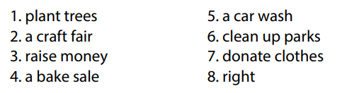
- Activity 4: Grammar (10’)
a) Objective: Ss can review the use of English: Past simple form of regular verbs + making suggestions.
b) Content:
- Fill in the blanks with the Past Simple form of the verbs in brackets.
- Underline the mistake in each sentence. Write the correct word on the line.
c) Expected outcomes: Ss produce the new language successfully, and they can use the grammar points in speaking and writing.
d) Organization of the activity:
TEACHER’S ACTIVITIES | STUDENTS’ ACTIVITIES
Task a. Fill in the blanks with the Past Simple form of the verbs in brackets.  - Have Ss retell the way to use past simple form of regular verbs.  - Ask Ss to work individually to fill in the blanks with the Past Simple form of the verbs in brackets.  - Have Ss work in pairs to check each other’s work.  - Call Ss to give answers, explain for their choice.  - Check answers as a whole class using DCR.  Task b. Underline the mistake in each sentence. Write the correct word on the line.  - Have Ss read the sentences, underline the mistake in each sentence.  - Encourage Ss to correct the mistakes.  - Ask Ss to work in pairs to check each other’s work.  - Have Ss write answers on the board.  - Check Ss’ answers, give feedback. | - Review old knowledge.  - Work individually.  - Work in pairs.  - Give answers.  Answer keys  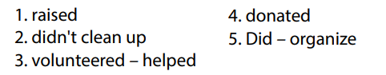  - Do the task.  - Exchange answers.  - Write answers on the board.  Answer keys  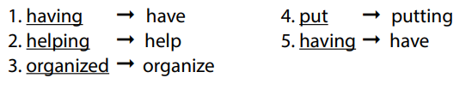
- Activity 5: Pronunciation (4’)
a) Objective: Ss can review the word stress and vowels, last consonant of “ed” endings.
b) Content:
- Circle the word that has the underlined part pronounces differently from the others.
- Circle the word that differs from the other three in the position of primary stress in each of the following questions.
c) Expected outcomes: Ss produce the new language successfully.
d) Organization of the activity:
TEACHER’S ACTIVITIES | STUDENTS’ ACTIVITIES
Task a. Circle the word that has the underlined part pronounced differently from the others.  - Have Ss distinguish the sound: /“ed” endings, /ʌ/, /ei/, /ɔ/, / ʊ /.  - Ask Ss to work individually to circle the answer.  - Have Ss work in pairs to check each other’s work.  - Call Ss to give answers, pronounce the words again.  - Give feedback, correct Ss’ pronunciation if necessary.  Task b. Circle the word that differs from the other three in the position of primary stress in each of the following questions.  - Remind Ss some basic rules of putting stress on words with 2 or 3 syllables.  - Ask Ss to work individually.  - Have Ss work in pairs to check each other’s work.  - Call Ss to give answers, pronounce the words again.  - Give feedback, correct Ss’ pronunciation if necessary. | - Listen.  - Work individually.  - Work in pairs.  - Give answers.  Answer keys  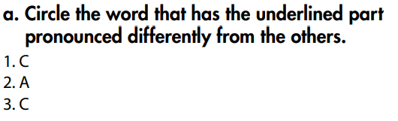  - Listen.  - Work individually.  - Work in pairs.  - Give answers.  Answer keys  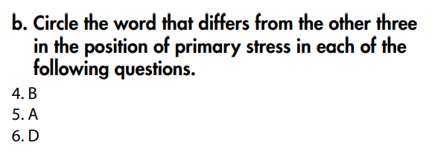

C. Consolidation and homework assignments (5’)
* Consolidation:
* Grammar of Unit 4: Past simple form of regular verbs, making suggestions.
* Vocabulary of Unit 4: Words about charity and fund raising activities (donate clothes, bake sale, car wash, clean up parks, craft fair, raise money, plant trees, …).

* Homework:
- Review vocabulary, grammar of unit 4.
- Do the exercises in WB: Review of Unit 4 (page 65).
- Prepare: Unit 5 – New words and Listening (page 36 – SB).

D. Reflection
a. What I liked most about this lesson today:
…………………………………………………………………………………………
- What I learned from this lesson today:
…………………………………………………………………………………………
c. What I should improve for this lesson next time:
…………………………………………………………………………………………

