**UNIT 4: COMMUNITY SERVICES**

**Lesson 2.2 - Grammar (Page 32)**

**I. OBJECTIVES**

By the end of the lesson, Ss will be able to:

**1.1. Language knowledge and skills**

- listen to 2 people asking and answering about activity to help community.

- use Past Simple with regular verbs correctly.

**1.2. Competences**

- improve speaking, listening and writing skills.

- improve the use of English.

**1.3. Attributes**

- be active to take part in social activities.

- help other people.

**II. TEACHING AIDS AND LEARNING MATERIALS**

**1. Teacher’s aids:** Student book and Teacher’s book, class CDs, Digital Book (DCR phần mềm tương tác SB, DHA (từ vựng/ cấu trúc) phần mềm trò chơi tương tác), projector/interactive whiteboard / TV (if any), PowerPoint slides, handouts.

**2. Students’ aids:** Student’s book, workbook, notebook.

**III. ASSESSMENT EVIDENCE**

|  |  |  |
| --- | --- | --- |
| **Performance Tasks** | **Performance Products** | **Assessment Tools** |
| - Listen and repeat. | **-** Ss’ performance. | - T’s feedback. |
| **-** Study the grammar box. | - Ss’ task. | - T’s observation. |
| - Fill in the blanks with the Past Simple form of verbs in brackets. | - Ss’ answers. | - T’s feedback/Peers’ feedback. |
| - Look at the table and write the answers. | - Ss’ answers. | - T’s feedback/Peers’ feedback. |
| - Ask and answer using the information in Task c (in pairs). | - Ss’ performance/ presentation. | - T’s observation, T’s feedback/Peers’ feedback. |

**IV. PROCEDURES**

**A. Warm up: (5’)**

**a) Objective:** Introduce the new lesson and set the scene for Ss to acquire new language; get students' attention at the beginning of the class by enjoyable and short activities as well as to engage them in the follow-up steps.

**b) Content:** Review phrases about helping community / introduce Past Simple with regular verbs.

**c) Expected outcomes:** Ss review old knowledge and have general ideas about the grammar point they are going to study in the new lesson.

**d) Organization of the activity:**

|  |  |
| --- | --- |
| **TEACHER’S ACTIVITIES** | **STUDENTS’ ACTIVITIES** |
| * **Option 1:**   - Give some sets of pictures.  - Have Ss find a word that can goes with the things in each set of pictures.  - Call Ss to give answers.  - Check Ss’ answers, give feedback.  - Have Ss make sentences, using the vocabularies above.  - Lead to the new lesson.     * **Option 2:**   - Give Ss a list of many verbs.  - Divide class into 4 groups.  - Have Ss in each group give the past form of verbs and divide them into 2 groups: regular past form and irregular past form.  - Call Ss to give answers.  - Check Ss’ answers, give feedback and evaluation.  - Lead to the new lesson: Past Simple with regular verbs.  **\*Suggested verb list:** *go, recycle, become, raise, have, donate, plant, give, eat, clean, do.* | - Work in pairs.  - Give answers.  - Make sentences and read them.  **Answers keys**    - Do the task.  - Give answers.    **Expected answers**  ***-*** regular past form: *recycle, raise, donate, plant, clean.*  - irregular past form: *go, become, have, give, eat, do.* |

**B. New lesson (35’)**

* **Activity 1: Presentation (10’)**

**a) Objective:** Introduce Past Simple with regular verbs.

**b) Content:**

**-** Listen and repeat.

**-** Introduce the grammar point: Past Simple with regular verbs.

**c) Expected outcomes:** Ss know how to use Past Simple with regular verbs to do some following exercises.

**d) Organization of the activity:**

|  |  |
| --- | --- |
| **TEACHER’S ACTIVITIES** | **STUDENTS’ ACTIVITIES** |
| **Task a. Listen and repeat.**  - Have Ss look at the picture using DCR.  - Play audio (CD1 – Track 43) and have Ss listen and read the speech bubbles.  - Play the audio again and have Ss listen and repeat.  **Grammar box**   * **Option 1:**   - Have Ss look at the grammar explanation and read: Past Simple with regular verbs.    - Have Ss look at the “Past Simple-spelling rules for -ed” and read.    - Briefly explain the grammar point.  - Ask Ss to give more past Simple with regular verbs and make sentences with them.   * **Option 2:**   - Have Ss close books.  - Show sample sentences, have Ss read them and make comment on the bold verbs and the underlined time expressions in these sentences.  **\*Suggested sentences**:  *1.Last month, we* ***raised*** *money to help the poor family.*  *2.He* ***donated*** *some books 2 weeks ago.*  *3. I* ***volunteered*** *to work for a local charity organization last year.*  *4. Yesterday my father* ***planted*** *some tress in the garden.*  - Have Ss give answers.  - Give feedback and evaluation.  →Lead to the grammar box and explain more: Past Simple with regular verbs.    - Next, have Ss look at the spelling rules of verbs ending with “ed” and read aloud.    - Get Ss to give more past Simple with regular verbs and make sentences with them.  - Give feedback and evaluation. | - Look.  - Listen, then read.  - Listen and repeat.  - Look and read.  - Look and read.  - Listen and take notes.  **-** Give more verbs and make sentences.  - Close all books.  - Look and answer.  **Suggested answers**  *- The bold verbs are in simple past.*  *- The underlined time expressions can be put at the beginning or at the end of the sentence.*  **-** Open the books and read the grammar box.  - Look and read.  - Give more verbs with regular past simple form and make sentences with them. |

* **Activity 2: Practice (19’)**

**a) Objective:** Students can use Past Simple with regular verbs correctly.

**b) Content:**

- Fill in the blanks with the Past Simple form of the verbs in brackets.

- Look at the table and write the answers.

**c) Expected outcomes:** Students can use Past Simple with regular verbs in their speaking.

**d) Organization of the activity:**

|  |  |
| --- | --- |
| **TEACHER’S ACTIVITIES** | **STUDENTS’ ACTIVITIES** |
| **Task b. Fill in the blanks with the Past Simple form of the verbs in brackets.**  - Demonstrate the activity on DCR, using the example.  - Have Ss fill in the blanks with the Past Simple form of the verbs in brackets.  - Have Ss work in pairs to check each other’s work.  - Have some Ss share their answers with the whole class.  - Give feedback, correct Ss’ answers if necessary.  **Task c. Look at the table and write the answers.**  - Demonstrate the activity on DCR, using the example.  - Have Ss look at the table and write the answers.  - Have Ss check answers with their partners.  - Call Ss to read or write answers.  - Check Ss’ answers, give feedback. | - Look and listen.  - Work individually.  - Work in pairs.  - Write answers on the board.  **Answer keys**    - Look and listen.  - Work individually.  - Work in pairs.  - Read or write answers.  **Answer keys** |

* **Activity 3: Production (6’)**

**a) Objective:** Students master the grammar point they study in the lesson.

**b) Content:**  Speaking: Ask and answer using the information in Task c.

**c) Expected outcomes:** Ss produce the new language successfully, and they can apply the grammar point they have learnt in speaking and writing.

**d) Organization of the activity:**

|  |  |
| --- | --- |
| **TEACHER’S ACTIVITIES** | **STUDENTS’ ACTIVITIES** |
| **Task d. In pairs: Ask and answer using the information in Task c.**  - Divide class into pairs.  - Have Ss ask and answer using the information in Task c.    - Then, encourage Ss to add their own ideas to practice.  - Have some pairs demonstrate the activity in front of the class.  - Give feedback and evaluation. | - Work in pairs.  - Have conversation in pairs.  - Present.  - Listen. |

**C. Consolidation and homework assignments (5’)**

**\*Consolidation**

**- Past Simple with regular verbs**

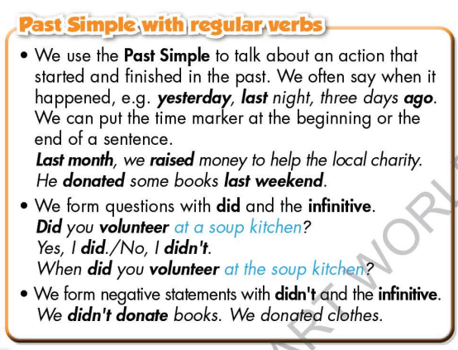

**- Spelling rules for “ed” endings**

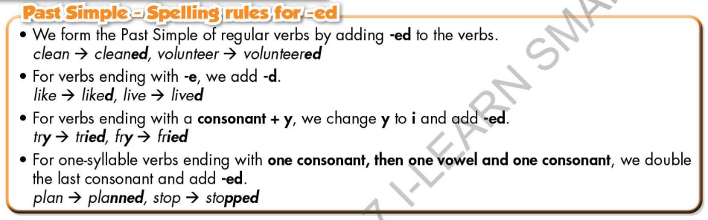

*.*

**\* Homework:**

- Make 2 sentences using Past Simple with regular verbs.

- Do the exercises in WB: Grammar (page 23).

- Complete the grammar notes in Tiếng Anh 7 i-Learn Smart World Notebook (page 25).

- Play consolation games in Tiếng Anh 7 i-Learn Smart World DHA App on [www.eduhome.com.vn](http://www.eduhome.com.vn)

- Prepare: Lesson 2.3 – Pronunciation and Speaking (page 33 – SB).

**D. Reflection**

a. What I liked most about this lesson today:

…………………………………………………………………………………………

1. What I learned from this lesson today:

…………………………………………………………………………………………

c. What I should improve for this lesson next time:

…………………………………………………………………………………………