UNIT 4: COMMUNITY SERVICES
Lesson 2.1 – New words and Listening (Page 31)

I. OBJECTIVES
By the end of the lesson, Ss will be able to:
1.1. Language knowledge and skills
- know more words about activities to help community.
- talk about things to do to help community.
- practice listening to an interview about how students help community (for general and specific details).
- introduce a topic.
1.2. Competences
- improve communication, collaboration, and critical thinking skills.
1.3. Attributes
- be active to take part in social activities.
- help other people.

II. TEACHING AIDS AND LEARNING MATERIALS
1. Teacher’s aids: Student book and Teacher’s book, class CDs, Digital Book (DCR phần mềm tương tác SB, DHA (từ vựng/ cấu trúc) phần mềm trò chơi tương tác), projector/interactive whiteboard / TV (if any), PowerPoint slides.
2. Students’ aids: Student’s book, workbook, notebook.

III. ASSESSMENT EVIDENCE
Performance Tasks | Performance Products | Assessment Tools
- Fill in the table. | - Ss’ answers. | - T’s feedback/Peers’ feedback.
- Listen and repeat. | - Ss’ presentation. | - T’s feedback/Peers’ feedback.
- Add more words to the table. Share your ideas with the class. | - Ss’ answers. | - T’s feedback/Peers’ feedback.
- Listen to two people talking. What is the purpose of the interview? | - Ss’ answers. | - T’s feedback/Peers’ feedback.
- Listen and circle the correct answers. | - Ss’ answers. | - T’s feedback/Peers’ feedback.
- Speak: What kinds of things could you do to help your local community? | - Ss’ answers/ presentation. | - T’s observation and feedback / DCR.

IV. PROCEDURES
A. Warm up: (5’)
a) Objective: Introduce the new lesson and set the scene for Ss to acquire new language; get students' attention at the beginning of the class by enjoyable and short activities as well as to engage them in the follow-up steps.
b) Content: Introduce words about activities to help community.
c) Expected outcomes: Ss get to know some new words they are going to study in the lesson.
d) Organization of the activity:
TEACHER’S ACTIVITIES | STUDENTS’ ACTIVITIES
- Option 1: Fill in the table. Listen and repeat.  - Use the “New words” part a.– page 31 for the warm-up activity.  - Show words and tables using DCR, have Ss fill in the table (in pairs).  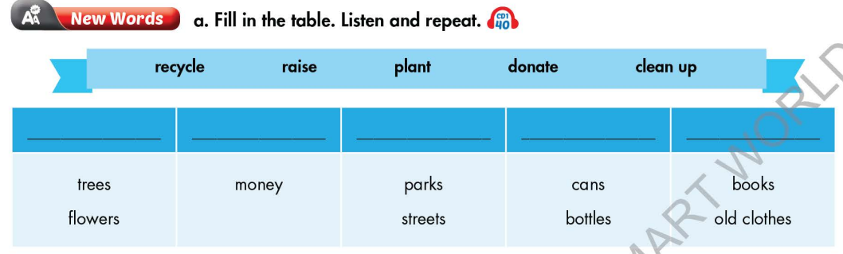  - Call Ss to give answers.  - Give feedback and show correct answers.  - Lead to the new lesson.  - Play the audio (CD1 – Track 40), have Ss listen and repeat.  - Correct Ss’ pronunciation if necessary.  - Option 2: Matching  - Have Ss work in pairs and do the matching exercise.  - Call Ss to give answers.  - Read the words, have Ss listen and repeat.  - Give feedback and evaluation.  - Lead to the new lesson.  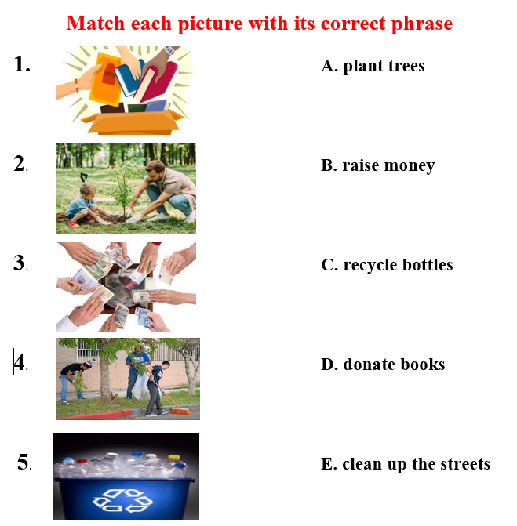 | - Work in pairs.  - Give answers.  - Listen.  - Listen and repeat.  Answer keys  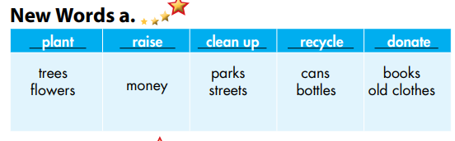  - Work in pairs and match.  - Give answers.  - Listen and repeat.  Answer keys  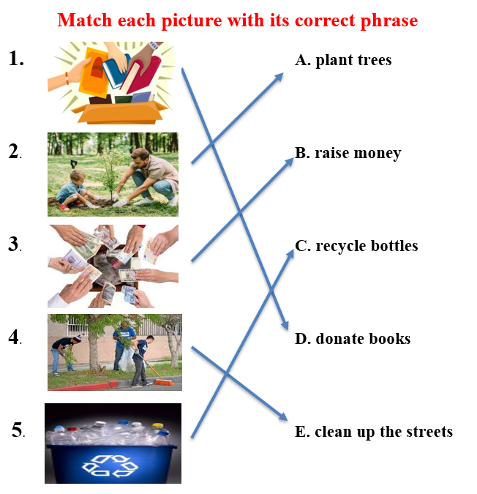

B. New lesson (35’)
- Activity 1: Pre-Listening (Vocabulary) (12’)
a) Objective: Ss get to know words about activities to help community.
b) Content:
- Vocabulary study (recycle, raise, plant, donate, clean up).
- Speaking: Ask and answer about activities to help community.
c) Expected outcomes: Ss know how to pronounce the new words correctly and use them when talking about activities to help community.
d) Organization of the activity:
TEACHER’S ACTIVITIES | STUDENTS’ ACTIVITIES
Task a. Fill in the table. Listen and repeat.  - Option 1 (If the teacher hasn’t used this part for the Warm-up activity)  - Demonstrate the activity on DCR, using the example.  - Have Ss fill in the table.  - Divide class into pairs and have them check their answers with their partners.  - Call Ss to give answers (read or write).  - Check answers as a whole class.  - Play audio (CD1 – Track 40). Have Ss listen and repeat.  - Correct Ss’ pronunciation.  - Option 2: Odd one out (If the teacher has used part a. for the Warm-up activity)  - Give 5 sets of words.  - Have Ss work in pairs to odd one out (Find a word which doesn’t belong to the group).  - Have Ss give answers and explain for their answers.  - Check answers as a whole class.  - Call some Ss to read the words again.  - Correct Ss’ pronunciation if necessary.  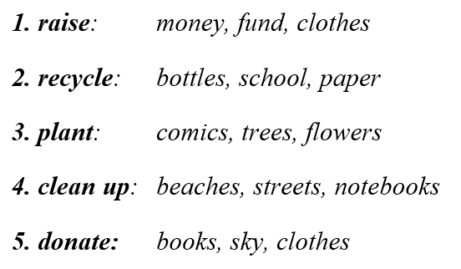  Task b. In pairs: Add more words to the table. Share your idea with the class.  - Have Ss work in pairs to add more words to the table.  - Go round and give help if necessary.  - Have some pairs share their ideas with the class.  - Give feedback and evaluation. | - Look and listen.  - Work individually.  - Work in pairs.  - Give answers.  - Listen and repeat.  Answer keys  - Work in pairs.  - Give answers, explain.  - Read.  Answer keys  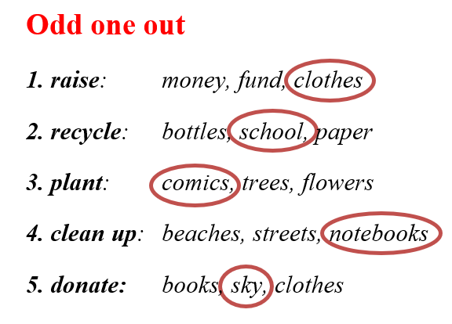  - Work in pairs.  - Present.  Suggested answers  1. raise: fund, awareness, …  2. recycle: paper, plastic products, food waste, …  3. plant: vegetables, herbs, …  4. clean up: beaches, rooms, schools, …  5. donate: blood, money, clothes, …
- Activity 2: While - Listening (17’)
a) Objective: Students can develop their listening skill.
b) Content: Listen to two people talking. What is the purpose of the interview? + Circle the answers.
c) Expected outcomes: Students can listen and understand general and specific information about activities to help community.
d) Organization of the activity:
TEACHER’S ACTIVITIES | STUDENTS’ ACTIVITIES
Task a. Listen to two people talking. What is the purpose of the interview?  - Have Ss read the phrases, guess the answer.  - Play audio (CD1 - Track 41).  - Have Ss listen and circle the correct answer.  - Check answer as a whole class.  Task b. Now, listen and circle.  - Have Ss read the through the content of task b, underline the key words.  - Play the audio again (CD1 - Track 41)  - Have Ss listen and circle the correct answers.  - Have Ss check answers with their partners.  - Call Ss to give answers.  - Give feedback and show correct answers using DCR. | -Work individually.  - Listen.  - Circle the correct answers.  Answer keys  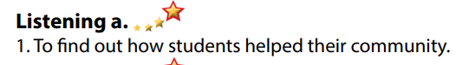  - Read and underline the key words.  - Do the task.  - Check answers.  Answer keys  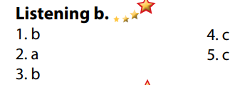

- Activity 3: Post - Listening (6’)
a) Objective: Students can use the vocabulary and the content in listening part to develop their speaking skill.
b) Content: Speaking: What kinds of things could you do to help your local community?
c) Expected outcomes: Students can have a free-talk about things to do to help their local community
d) Organization of the activity:
TEACHER’S ACTIVITIES | STUDENTS’ ACTIVITIES
Conversation skill  - Have Ss look at the Conversation skill box and read.  - Play audio (CD 1 - Track 42), have Ss listen and repeat.  - Ask Ss to find more ways to introduce a topic.  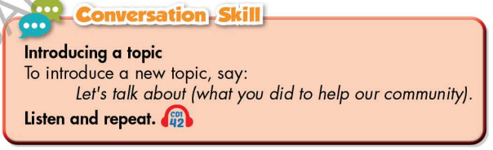  Task c. In pairs: What kinds of things could you do to help your local community?  - Have Ss work in pairs to discuss.  - Observe and give help if necessary.  - Call some pairs to share their ideas with the class.  - Give feedback and evaluation. | - Look and read.  - Listen and repeat.  - Give answers.  - Work in pairs.  - Present.

C. Consolidation and homework assignments (5’)
* Consolidation:
- Words about activities to help community:
1. raise: fund, awareness, money…
2. recycle: paper, plastic products, food waste, bottle, cans…
3. plant: vegetables, herbs, trees, flowers…
4. clean up: beaches, rooms, schools, streets, …
5. donate: blood, money, clothes, books, …
- Language to introduce a topic: Let’s talk about … / Let’s begin with …

* Homework
- Learn the new words by heart.
- Practice talking about how to help the community.
- Do the exercises in WB: New words and Listening (page 22 – WB).
- Do the vocabulary exercise in Tiếng Anh 7 i-Learn Smart World Notebook (page 24).
- Play consolation games in Tiếng Anh 7 i-Learn Smart World DHA App on www.eduhome.com.vn
- Prepare: Lesson 2.2 – Grammar (page 32 – SB).

D. Reflection
a. What I liked most about this lesson today:
…………………………………………………………………………………………
- What I learned from this lesson today:
…………………………………………………………………………………………
c. What I should improve for this lesson next time:
…………………………………………………………………………………………

