**UNIT 3: MUSIC AND ARTS**

**Lesson 3.2 – Speaking and Writing (Page 27)**

**I. OBJECTIVES**

By the end of the lesson, Ss will be able to:

**1.1. Language knowledge and skills**

- study format of writing a movie description.

- talk about their favorite movies.

- write a short description of a movie they like.

**1.2. Competences**

- improve communication, collaboration, writing and critical thinking skills.

**1.3. Attributes**

- love movies.

**II. TEACHING AIDS AND LEARNING MATERIALS**

**1. Teacher’s aids:** Student book and Teacher’s book, class CDs, Digital Book (DCR phần mềm tương tác SB, DHA (từ vựng/ cấu trúc) phần mềm trò chơi tương tác), projector/interactive whiteboard / TV (if any), PowerPoint slides.

**2. Students’ aids:** Student’s book, workbook, notebook.

**III. ASSESSMENT EVIDENCE**

|  |  |  |
| --- | --- | --- |
| **Performance Tasks** | **Performance Products** | **Assessment Tools** |
| - Speaking: You're talking about your favorite movies. In pairs: Ask your partner the following questions. | **-** Ss’ answers / presentation. | - T’s feedback. |
| **-** Make notes about your favorite movie using the questions. | - Ss’ answers. | - T’s feedback/Peers’ feedback. |
| - Writing: Read about writing a movie description. Then, read the description of The Dark Knight again and underline the plot summary. | - Ss’ answers. | - T’s feedback/Peers’ feedback. |
| - Reorder the movie description. Use the skill box to help you. | - Ss’ answers. | - T’s feedback/Peers’ feedback. |
| - Write a short description of a movie you like. | - Ss’ answers. | - T’s observation and feedback. |

**IV. PROCEDURES**

**A. Warm up: (5’)**

**a) Objective:** Introduce the new lesson and set the scene for Ss to acquire new language; get students' attention at the beginning of the class by enjoyable and short activities as well as to engage them in the follow-up steps.

**b) Content:** Types of films.

**c) Expected outcomes:** Ss know some film types that they are going to talk and write about in new the lesson.

**d) Organization of the activity:**

|  |  |
| --- | --- |
| **TEACHER’S ACTIVITIES** | **STUDENTS’ ACTIVITIES** |
| **Option 1: Types of films**  - Give a list of film types and their equivalent movie names.  - Have Ss look and guess the meaning of these film types.  - Have Ss give answers.  - Give feedback and show correct answers.  - Lead to the new lesson.     * **Option 2: Chatting**   - Ask Ss some questions:  *1. What is your favorite movie?*  *2. What kind of movie is it?*  *3. Who does it start?*  *4. What is it about?*  *5. What do many people / critics say about it?*  - Have some Ss share their answers with the whole class.  - Give feedback and evaluation.  - Lead to the new lesson. | - Work in pairs: Look and guess.  - Give answers.  - Listen.  **Answer keys**    - Answer teacher’s questions.  - Listen. |

**B. New lesson (35’)**

* **Activity 1: Pre-Writing (Speaking) (10’)**

**a) Objective:** Ss prepare for what they are going to write about.

**b) Content:**

**-** Speaking: You're talking about your favorite movies. In pairs: Ask your partner the following questions.

**-** Make notes about your favorite movie using the questions.

**c) Expected outcomes:** Ss know more vocabularies about kinds of films and apply the language from speaking to their writing.

**d) Organization of the activity:**

|  |  |
| --- | --- |
| **TEACHER’S ACTIVITIES** | **STUDENTS’ ACTIVITIES** |
| **Task a. You're talking about your favorite movies. In pairs: Ask your partner the following questions.**  **-** Divide the class into pairs.  - Have students ask and answer using the questions.    - Have some students share their ideas with the class.  - Give feedback and evaluation.  **Task b. Make notes about your favorite movie using the questions**  - Have students make notes about their favorite movie using the questions.  - Go round and give help if necessary.  - Have some pairs read their answers.  - Give feedback and evaluation. | - Work in pairs.  - Give answers.  - Make notes.  - Present. |

* **Activity 2: While - Writing (20’)**

**a) Objective:** Students can develop their writing skill.

**b) Content:**  - Read about writing a movie description. Then, read the description of The Dark Knight again and underline the plot summary.

- Reorder the movie description. Use the skill box to help you.

- Write a short description of a movie you like.

**c) Expected outcomes:** Students can write a film description, using right format and rich vocabularies.

**d) Organization of the activity:**

|  |  |
| --- | --- |
| **TEACHER’S ACTIVITIES** | **STUDENTS’ ACTIVITIES** |
| **Task a. Read about writing a movie description. Then, read the description of The Dark Knight again (page 26) and underline the plot summary**  -Briefly explain the Writing skill box.  - Have Ss read the description of The Dark Knight again (page 26), then underline the plot summary.  - Have Ss check their answers with a partner.  - Call Ss to give answers.  - Check answer as a whole class using DCR.  **Task b. Reorder the movie description. Use the skill box to help you.**  - Have Ss read the sentences, then reorder the movie description.  - Have Ss check their answers with a partner.  - Call Ss to give answers.  - Check answer as a whole class using DCR.  **\*Let’s Write: Now, write a short description of a movie you like. Use the feedback form to help you**  - Draw Ss’ attention to the feedback form.  - Have Ss use their notes in speaking part and the instruction in the Writing box to write a short description of a movie they like.  - Go round, observe and give help if necessary.  - Have some Ss write their letter on the board. | - Listen.  -Work in pairs.  - Exchange their answers with a partner.  - Give answers.  **Answer keys**    - Read and reorder the movie description.  - Exchange answers.  - Give answers.  **Answer keys**    - Look and listen.  - Do the writing part.  -Write.  **Suggested writing** |

* **Activity 3: Post - Writing (5’)**

**a) Objective:** Help Ss realize their mistakes in writing and correct them.

**b) Content:**  Correcting Ss’ writings.

**c) Expected outcomes:** Students know whether their writings follow the model and use the correct structures and language, whether their writings are interesting and understandable or not.

**d) Organization of the activity:**

|  |  |
| --- | --- |
| **TEACHER’S ACTIVITIES** | **STUDENTS’ ACTIVITIES** |
| - Give feedback, correct Ss’ mistakes.  - Use the feedback form to give evaluation. Focus on:  + the format, the structures.  + the understandability.  + the coherence and cohesion. | - Look, listen and correct mistakes. |

**C. Consolidation and homework assignments (5’)**

**\* Consolidation:**

**- Writing Skill**:

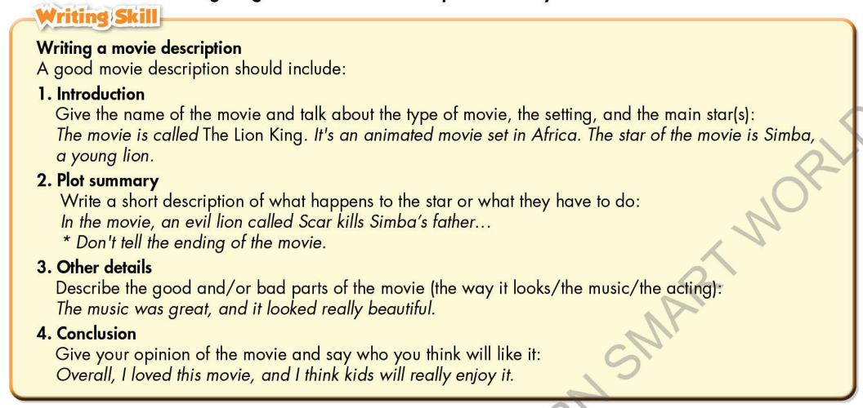

**\* Homework**

- Remember how to write a movie description.

- Finish the writing part.

- Do the exercises in WB: Lesson 3 – Writing (page 19).

- Complete the grammar notes in Tiếng Anh 7 i-Learn Smart World Notebook (page 21).

- Play consolation games in Tiếng Anh 7 i-Learn Smart World DHA App on [www.eduhome.com.vn](http://www.eduhome.com.vn)

- Prepare: Unit 3 – Review (pages 88, 89 – SB).

**D. Reflection**

a. What I liked most about this lesson today:

…………………………………………………………………………………………

1. What I learned from this lesson today:

…………………………………………………………………………………………

c. What I should improve for this lesson next time:

…………………………………………………………………………………………