LUONG VAN CHANH SECODARY SCHOOL
UNIT 3: MUSIC AND ARTS
Lesson 2.1 – New words and Listening (Page 23)

I. OBJECTIVES
By the end of the lesson, Ss will be able to:
1.1. Language knowledge and skills
- know more words about other different types of music (which are unfamiliar with teenagers): blues, reggae, electronic, RnB, folk (music), heavy metal.
- make plans to go to a music event.
- practice listening to a conversation between three friends about a music event (for general and specific details).
- invite someone to speak.
1.2. Competences
- improve communication, collaboration, and critical thinking skills.
1.3. Attributes
- love other music types in the world.
- be well-organized for planning to do some activities with friends.

II. TEACHING AIDS AND LEARNING MATERIALS
1. Teacher’s aids: Student book and Teacher’s book, class CDs, Digital Book (DCR phần mềm tương tác SB, DHA (từ vựng/ cấu trúc) phần mềm trò chơi tương tác), projector/interactive whiteboard / TV (if any), PowerPoint slides.
2. Students’ aids: Student’s book, workbook, notebook.

III. ASSESSMENT EVIDENCE
Performance Tasks | Performance Products | Assessment Tools
- Activate some new words about music types.  - Match the words with the description.  - Listen and repeat.  - Ask and answer about each type of music. Do you like any of them?  - Listen to three friends talking about a music event. Where are they?  - Listen and answer the questions.  - Speak: What kind of music concert would you like to go to? Which band or singer would you like to see? | - Ss’ answers.  - Ss’ answers.  - Ss’ performance.  - Ss’ answers/ presentation.  - Ss’ answers.  - Ss’ answers.  - Ss’ answers/ presentation. | - T’s feedback.  - T’s observation/ DCR.  - T’s feedback/Peers’ feedback.  - T’s feedback/Peers’ feedback.  - T’s feedback/Peers’ feedback.  - T’s feedback/Peers’ feedback.  - T’s observation and feedback / DCR.

IV. PROCEDURES
A. Warm up: (5’)
a) Objective: Introduce the new lesson and set the scene for Ss to acquire new language; get students' attention at the beginning of the class by enjoyable and short activities as well as to engage them in the follow-up steps.
b) Content: Introduce words about some more music types: electronic, heavy metal, reggae, blues, folk music, RnB.
c) Expected outcomes: Ss get to know some new words they are going to study in the lesson.
d) Organization of the activity:
TEACHER’S ACTIVITIES | STUDENTS’ ACTIVITIES
- Option 1: Match the words with the descriptions. Listen and repeat.  - Use the “New words” part a.– page 23 for the warm-up activity.  - Show pictures with description (using DCR), have Ss look at the pictures and read the description, then match them with the words in the box (in pairs).  - Call Ss to give answers.  - Give feedback and show correct answers.  - Lead to the new lesson.  - Play the audio (CD1 – Track 28), have Ss listen and repeat.  - Correct Ss’ pronunciation if necessary.  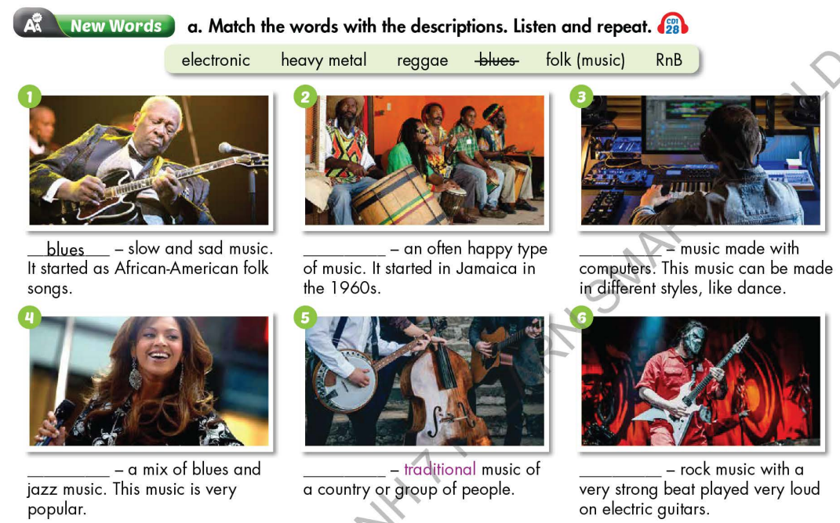  - Option 2: Listen and identify music types  - Find some pieces of music of different music types on the internet (mp3 files – each file lasts about 15-20 seconds). There are 6 sound files of 6 types: electronic, heavy metal, reggae, blues, folk music, RnB.  - Play the mp3 sound files, have Ss listen and give names of music types.  - Call Ss to give answers.  - Give feedback and evaluation.  →Lead to the new lesson. | - Work in pairs.  - Give answers.  - Listen.  - Listen and repeat.  Answer keys  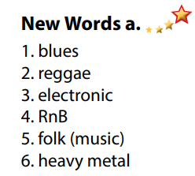  - Listen and guess the names of music types.

B. New lesson (35’)
- Activity 1: Pre-Listening (Vocabulary) (12’)
a) Objective: Ss get to know words about music types and state whether they like them or not.
b) Content:
- Vocabulary study (electronic, heavy metal, reggae, blues, folk music, RnB).
- Speaking: Ask and answer about each type of music. Do you like any of them?
c) Expected outcomes: Ss know how to pronounce the new words correctly and use them when talking about music types.
d) Organization of the activity:
TEACHER’S ACTIVITIES | STUDENTS’ ACTIVITIES
Task a. Match the words with the descriptions. Listen and repeat.  - Option 1 (If the teacher hasn’t used this part for the Warm-up activity)  - Demonstrate the activity on DCR, using the example.  - Have Ss match the words with the descriptions.  - Divide class into pairs and have them check their answers with their partners.  - Call Ss to give answers (read or write).  - Check answers as a whole class.  - Play audio (CD1 – Track 28). Have Ss listen and repeat.  - Correct Ss’ pronunciation.  - Option 2: Matching (If the teacher has used part a. for the Warm-up activity)  - Have Ss review the words they have known in the warm-up activity by matching music types with its short description.  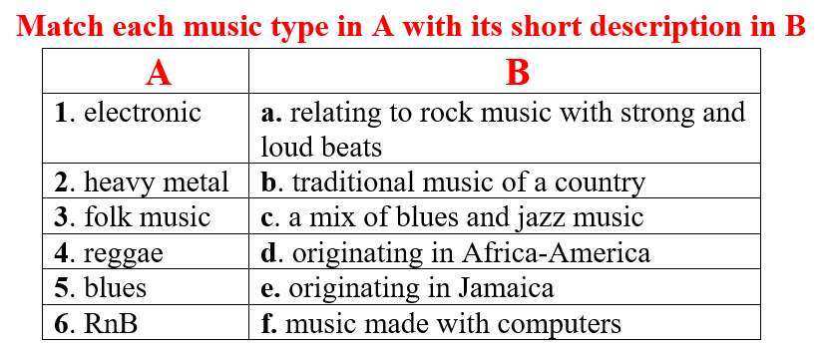  - Call Ss to read answers.  - Check answers as a whole class.  - Call some Ss to read the words again.  - Correct Ss’ pronunciation if necessary.  Task b. In pairs: Ask and answer about each type of music. Do you like any of them?  - Have Ss work in pairs to ask and answer about each type of music.  - Have pairs discuss whether they like any of the types of music in Task a.  - Have some pairs share their ideas with the class.  - Give feedback and evaluation. | - Look and listen.  - Work individually.  - Work in pairs.  - Give answers.  - Listen and repeat.  Answer keys  - Work in pairs.  - Give answers.  - Read.  Answer keys  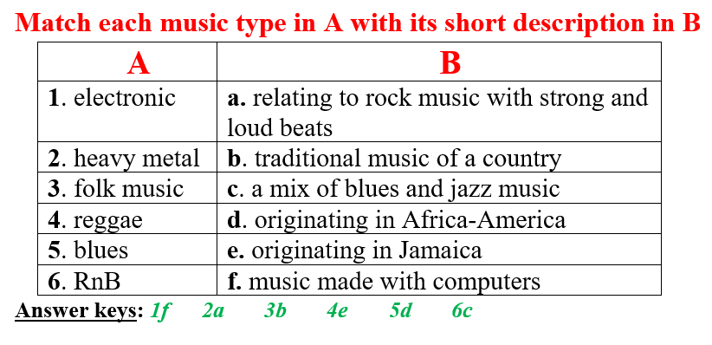  - Work in pairs.  - Present.
- Activity 2: While - Listening (17’)
a) Objective: Students can develop their listening skill.
b) Content: Listen to three friends talking about a music event. Where are they?
c) Expected outcomes: Students can listen and understand general and specific information about a music event.
d) Organization of the activity:
TEACHER’S ACTIVITIES | STUDENTS’ ACTIVITIES
Task a. Listen to three friends talking about a music event. Where are they?  - Have Ss read the phrases, guess the answer.  - Play audio (CD1 - Track 29) using DCR.  - Have Ss listen and circle the correct answer.  - Check answer as a whole class.  Task b. Now, listen and answer the questions  - Have Ss read the through the questions in task b, underline the key words.  - Play the audio again (CD1 - Track 29) using DCR.  - Have Ss listen and answer the questions.  - Remind Ss to give short answers, not a full sentence to answer for each question.  - Have Ss check answers with their partners.  - Call Ss to give answers.  - Give feedback and show correct answers. | -Work individually.  - Listen.  - Circle the correct answers.  Answer keys  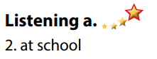  - Read and underline the key words.  - Do the task.  - Check answers.  Answer keys  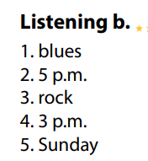

- Activity 3: Post - Listening (6’)
a) Objective: Students can use the vocabulary and the content in listening part to develop their speaking skill.
b) Content: Speaking: What kind of music concert would you like to go to? Which band or singer would you like to see?
c) Expected outcomes: Students can have a free-talk about how to overcome sickness.
d) Organization of the activity:
TEACHER’S ACTIVITIES | STUDENTS’ ACTIVITIES
Conversation skill  - Have Ss look at the Conversation skill box and read.  - Play audio (CD 1 - Track 30) using DCR, have Ss listen and repeat.  - Ask Ss to find more ways to invite someone to speak.  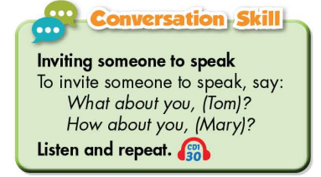  Task c. In pairs: What kind of music concert would you like to go to? Which band or singer would you like to see?  - Have Ss work in pairs to discuss.  - Observe and give help if necessary.  - Call some pairs to share their ideas with the class  - Give feedback and evaluation. | - Look and read.  - Listen and repeat.  - Give answers.  - Work in pairs.  - Present.

C. Consolidation and homework assignments (4’)
* Consolidation:
- Words about music types: electronic, heavy metal, reggae, blues, folk music, RnB.
- Language to invite someone to speak: What about you? / How about you? …

* Homework
- Learn the new words by heart.
- Practice making plans to go to a music event.
- Do the exercises in WB: New words and Listening (page 16).
- Do the vocabulary exercise in Tiếng Anh 7 i-Learn Smart World Notebook (page 18).
- Play consolation games in Tiếng Anh 7 i-Learn Smart World DHA App on www.eduhome.com.vn
- Prepare: Lesson 2.2 – Grammar (page 24 – SB).

D. Reflection
a. What I liked most about this lesson today:
…………………………………………………………………………………………
- What I learned from this lesson today:
…………………………………………………………………………………………
c. What I should improve for this lesson next time:
…………………………………………………………………………………………

