UNIT 1: FREE TIME
Lesson 4 – Review (Page 84)

I. OBJECTIVES
By the end of the lesson, Ss will be able to:
1.1. Language knowledge and skills
- review words about free time activities (play badminton, bake cakes, make vlogs, play online games, play volleyball, take photos, build models).
- review words about places of entertainment (sports center, ice rink, market, fair, water park).
- review grammar: prepositions of place, the Present Continuous.
- pronoun some sounds correctly: /ɒ/, /ɪ/, /aɪ/, / eɪ/.
1.2. Competences
- improve speaking, listening, reading and writing skills.
- improve the use of English.
1.3. Attributes
- have positive attitude in English language learning so that they actively participate in all classroom activities.
- review the old lesson and have good preparation for any assessment.

II. TEACHING AIDS AND LEARNING MATERIALS
1. Teacher’s aids: Student book and Teacher’s book, class CDs, Digital Book (DCR phần mềm tương tác SB, DHA (từ vựng/ cấu trúc) phần mềm trò chơi tương tác), projector/interactive whiteboard / TV (if any), PowerPoint slides, handouts.
2. Students’ aids: Student’s book, workbook, notebook.

III. ASSESSMENT EVIDENCE
Performance Tasks | Performance Products | Assessment Tools
- Listening: Listen to John talking to his mom about his friend’s free time activities. Which activity does each person do? For each question, write letter A-H next to each person.  - Reading: Read about 3 people and choose the correct answer.  - Vocabulary: Fill in the blanks with the words from the box.  - Grammar: Unscramble the sentences + Circle the correct words.  -Pronunciation: sound and stress. | - Ss’ answers.  - Ss’ answers.  - Ss’ answers.  - Ss’ answers.  - Ss’ answers/ presentation. | - T’s feedback/Peers’ feedback.  - T’s feedback/Peers’ feedback.  - T’s feedback/Peers’ feedback.  - T’s feedback/Peers’ feedback.  - T’s observation, T’s feedback/Peers’ feedback.

IV. PROCEDURES
A. Warm up: (5’)
a) Objective: Introduce the new lesson and set the scene for Ss to acquire new language; get students' attention at the beginning of the class by enjoyable and short activities as well as to engage them in the steps that followed.
b) Content: Reviewing vocabulary.
c) Expected outcomes: Ss are ready for the new lesson.
d) Organization of the activity:
TEACHER’S ACTIVITIES | STUDENTS’ ACTIVITIES
- Option 1: Word Dictation  - Choose 7 words from Vocabulary tasks (pages 4 to 11), find mp3 sound.  - Play the mp3 sound of each word (or T reads the words out loud), have Ss listen and write the word down on the board.  - Check and correct Ss’ answers.  - Give feedback.  → Lead to the new lesson.  - Option 2: Game: LEAVE ME OUT  - Give Ss some words with wrong spelling (There is 1 extra letter in each word).  - Have Ss find the extra letter to leave it out to make a right English word.  - Have Ss read their answers.  - Give feedback.  →Lead to the new lesson.  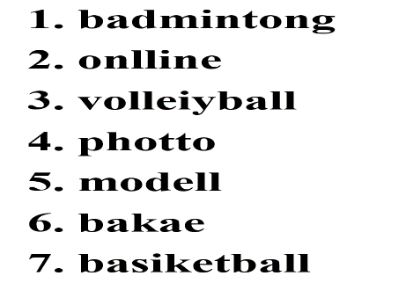 | - Listen and write the words you can hear.  Answer Keys  1. badminton  2. online  3. volleyball  4. photo  5. model  6. bake  7. basketball  - Take part in the class activity.  - Give answers.  Answers keys  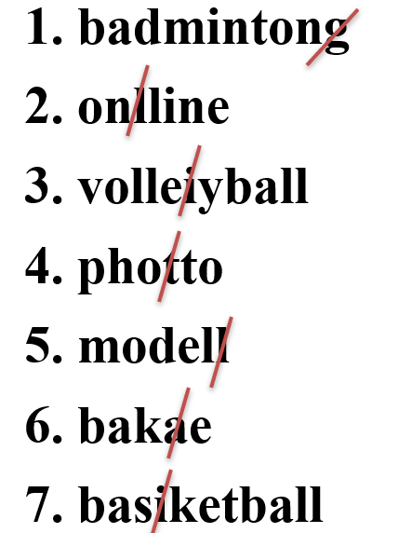

B. New lesson (35’)
- Activity 1: Listening (7’)
a) Objective: Help Ss improve their listening skill.
b) Content:
- Listening and writing letter A-H next to each person.
c) Expected outcomes: Ss listen in details and get familiar with the listening test format.
d) Organization of the activity:
TEACHER’S ACTIVITIES | STUDENTS’ ACTIVITIES
You will hear John talking to his mom about his friends’ free time activities. Which activity does each person do? For each question, write a letter (A-H) next to each person.  - Use DCR to show the task.  - Have Ss read through the listening part.  - Demonstrate the activity by using the example.  - Play the audio (CD 2 – Track 34).  - Have Ss check answers with pairs and then give answers.  - Check answers as a whole class. | - Read in silence.  - Listen and then give answers.  Answer keys  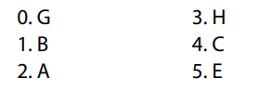
- Activity 2: Reading (7’)
a) Objective: Students can improve their reading skill.
b) Content:
- Reading a text and choose the correct answer.
c) Expected outcomes: Ss read for comprehension and get familiar with the reading test format.
d) Organization of the activity:

TEACHER’S ACTIVITIES | STUDENTS’ ACTIVITIES
Read about three people. Choose the correct answer (A, B or C).  - Use DCR to show the task.  - Demonstrate the activity by using the example.  - Have Ss read the text about three people and choose the correct answer.  - Call Ss to give answers, explain.  - Give feedback and evaluation. | - Observe and listen.  - Work individually.  - Give answers, explain.  Answer keys  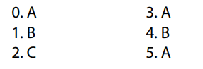

- Activity 3: Vocabulary (7’)
a) Objective: Ss can review vocabulary about places of entertainment.
b) Content: Filling in the blanks with the correct words from the box.
c) Expected outcomes: Ss produce the new language successfully, and they can use these words in speaking and writing.
d) Organization of the activity:
TEACHER’S ACTIVITIES | STUDENTS’ ACTIVITIES
Fill in the blanks with the words from the box  - Use DCR to show the task.  - Have Ss read the sentences.  - Ask Ss to work in pairs to fill in the blanks with the words from the box.  - Have Ss give answers, tell the meaning of the words again.  - Check answers as a whole class. | - Read the sentences.  - Work in pairs.  - Give answers.  Answer keys  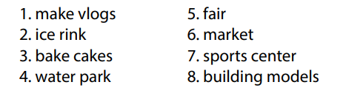
- Activity 4: Grammar (10’)
a) Objective: Ss can review the use of English: The Present Continuous and prepositions of place.
b) Content:
- Unscrambling the sentences.
- Circling the correct words (using the map).
c) Expected outcomes: Ss produce the new language successfully, and they can use the grammar points in speaking and writing.
d) Organization of the activity:
TEACHER’S ACTIVITIES | STUDENTS’ ACTIVITIES
Task a. Unscramble the sentences.  - Use DCR to show the task.  - Have Ss read the sentences and unscramble the words to make a meaningful sentence.  - Ask Ss to work in pairs to check each other’s work.  - Have Ss write answers on the board.  - Check Ss’ answers, give feedback.  Task b. Look at the map and circle the correct words.  - Use DCR to show the task.  - Ask Ss to work individually to circle the correct answer.  - Have Ss work in pairs to check each other’s work.  - Call Ss to give answers, explain for their choice.  - Check answers as a whole class. | - Do the task.  - Exchange answers.  - Write answers on the board.  Answer keys  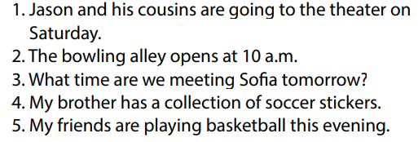  - Work individually.  - Work in pairs.  - Give answers.  Answer keys  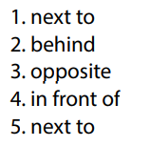
- Activity 5: Pronunciation (4’)
a) Objective: Ss can review the word stress and vowels.
b) Content:
- Circling the word that has the underlined part pronounces differently from the others.
- Circling the word that has different stress from the rest.
c) Expected outcomes: Ss produce the new language successfully.
d) Organization of the activity:
TEACHER’S ACTIVITIES | STUDENTS’ ACTIVITIES
Task a. Circle the word that has the underlined part pronounced differently from the others.  - Use DCR to show the task.  - Have Ss distinguish the sound /i/ and / ai/, /ɒ/ and /eɪ/.  - Ask Ss to work individually to circle the answer.  - Have Ss work in pairs to check each other’s work.  - Call Ss to give answers, pronounce the words again.  - Give feedback, correct Ss’ pronunciation if necessary.  Task b. Circle the word that differs from the other three in the position of primary stress in each of the following questions.  - Use DCR to show the task.  - Remind Ss some basic rules of putting stress on words with 2 or 3 syllables.  - Ask Ss to work individually.  - Have Ss work in pairs to check each other’s work.  - Call Ss to give answers, pronounce the words again.  - Give feedback, correct Ss’ pronunciation if necessary. | - Listen.  - Work individually.  - Work in pairs.  - Give answers.  Answer keys  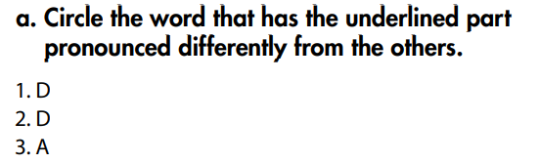  - Listen.  - Work individually.  - Work in pairs.  - Give answers.  Answer keys  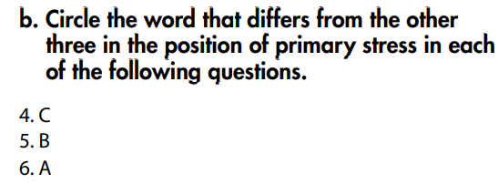

C. Consolidation and homework assignments (5’)
* Consolidation:
* Grammar of Unit 1: The Present Continuous and prepositions of place.
* Vocabulary of Unit 1: Vocabulary about free time activities and places of entertainment.

* Homework:
- Review vocabulary, grammar of unit 1.
- Do the exercises in WB: Review of Unit 1 (page 62).
- Prepare: Unit 2 – New words and Reading (page 12 – SB).

D. Reflection
a. What I liked most about this lesson today:
…………………………………………………………………………………………
- What I learned from this lesson today:
…………………………………………………………………………………………
c. What I should improve for this lesson next time:
…………………………………………………………………………………………

