UNIT 1: FREE TIME
Lesson 1.3 – Pronunciation and Speaking (Page 6)

I. OBJECTIVES
By the end of the lesson, Ss will be able to:
1.1. Language knowledge and skills
- pronounce the sound /eɪ/ correctly.
- ask and answer about free time activities, using time expressions of the Simple Present.
- conduct a survey about hobbies.
1.2. Competences
- improve listening and speaking skills.
1.3. Attributes
- take up a useful hobby and spend a suitable amount of time on this hobby.
- build good habits for themselves and ditch bad ones.

II. TEACHING AIDS AND LEARNING MATERIALS
1. Teacher’s aids: Student book and Teacher’s book, class CDs, Digital Book (DCR phần mềm tương tác SB, DHA (từ vựng/ cấu trúc) phần mềm trò chơi tương tác), projector/interactive whiteboard / TV (if any), PowerPoint slides, handouts.
2. Students’ aids: Student’s book, Workbook, Notebook.

III. ASSESSMENT EVIDENCE
Performance Tasks | Performance Products | Assessment Tools
- Listen to the words with the sound /eɪ/.  - Listen and cross out the word that doesn’t contain the sound /eɪ/.  - Read the words with the sound /eɪ/.  - Ask and answer about free time activities, using time expressions of the Simple Present.  - Complete the survey for themselves, then ask 3 more friends to have more information about hobbies, then fill in the table. | - Ss’ performance.  - Ss’ answers.  - Ss’ performance.  - Ss’ performance.  - Ss’ performance /  Presentation. | - T’s observation.  - T’s feedback/Peers’ feedback.  - T’s feedback/Peers’ feedback.  - T’s feedback/Peers’ feedback.  - T’s observation, T’s feedback/Peers’ feedback.

IV. PROCEDURES
A. Warm up: (5’)
a) Objective: Introduce the new lesson and set the scene for Ss to acquire new language; get students' attention at the beginning of the class by enjoyable and short activities as well as to engage them in the follow-up steps.
b) Content: Review vocabulary about hobbies.
c) Expected outcomes: Ss remember old words and use them in other speaking activities.
d) Organization of the activity:
TEACHER’S ACTIVITIES | STUDENTS’ ACTIVITIES
- Give greetings.  - Check attendance.  - Option 1: MATCHING  - Have Ss work in pairs, do the matching exercises.  - Call Ss to read answers.  - Give feedback and lead to the new lesson.  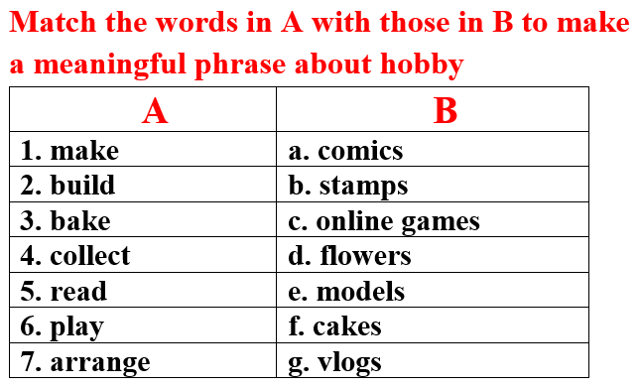  →Lead to the new lesson.  - Option 2:  - Give a sample sentence:  David makes eight cakes for his classmates on Sunday.  - Have Ss practice reading this sentence fluently.  - Ask Ss to find as many as possible words that contain the same sound in this sentence.  →Introduce the sound /eɪ/ and lead to the new lesson. | - Greet T.  - Work in pairs, then give answers.  Answer keys  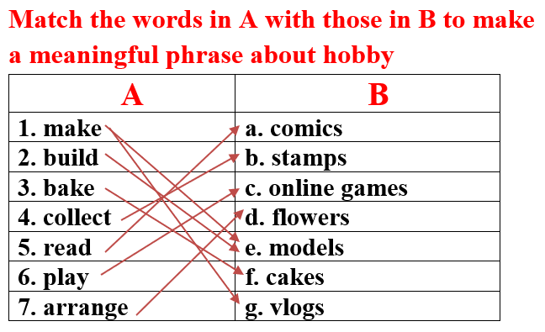  -Read.  - Practice reading out loud.  - Give answers.  Answer keys: David, makes, eight, cakes, classmates, Sunday

B. New lesson (35’)
- Activity 1: Pre-Speaking: Pronunciation (10’)
a) Objective: Introduce the sound /eɪ/ and how to pronounce it.
b) Content:
- recognize the sound /eɪ/.
- listen and check, find mistakes.
- practice.
c) Expected outcomes: Ss distinguish and pronounce the sound /eɪ/ correctly in their speaking.
d) Organization of the activity:
TEACHER’S ACTIVITIES | STUDENTS’ ACTIVITIES
Task a + b. Listen to the sentences and focus on the /eɪ/ sound.  - Play the recording (CD1, track 04) using DCR.  - Ask Ss to listen and pay attention to the /eɪ/ sound.  - Have Ss make comments on the sound of the underlined words.  - Play the recording again, have Ss listen and repeat with a focus on the pronunciation feature.  Task c + d. Listen and cross out the word that doesn’t have /eɪ/ sound, then read the words with the sound noted: /eɪ/  - Play the recording (CD 1 – Track 05) using DCR, have Ss listen and cross out the option that doesn’t use the noted sound.  - Call Ss to give answers.  - Play the recording again and check answers as a whole class.  - Then have Ss practice reading the words with a partner, using the noted sound.  - Call some Ss to read in front of the class.  - Ask Ss to find more words containing the /eɪ/ sound. | - Listen.  - Comment.  - Listen again and repeat.  - Listen and cross out.  - Give answers.  - Listen again and check.  - Work in pairs.  - Present.  - Give answers.
- Activity 2: While-speaking (20’)
a) Objective: Students can talk about their hobbies and their friends’ hobbies.
b) Content:
- asking and answer about free time activities, using time expressions of the Simple Present.
- conducting a survey about hobbies, filling in the table.
c) Expected outcomes: Ss produce the new language successfully.
d) Organization of the activity:

TEACHER’S ACTIVITIES | STUDENTS’ ACTIVITIES
PRACTICE  Task a. Ask and answer.  - Use DCR to show the task.  - Demonstrate the activity by asking and answering with a student.  - Have pairs ask and answer, using the pictures.  - Remind Ss to use the time expressions of the Present Simple.  - Have some pairs demonstrate the activity in front of the class.  b. Practice with your own ideas.  - Have pairs practice the conversation with their own ideas, then swap roles.  - Call some pairs to demonstrate the activity in front of the class.  - Give feedback and evaluation.  SPEAKING: Top Teen Hobbies.  Task a. You’re asking your classmates about their hobbies. In groups of 4, complete the survey for yourself, then ask 3 more friends. Fill in the table.  - Use DCR to show the task. Demonstrate the activity by practicing role-play with a student.  - Have Ss work in groups, ask and answer, then complete the table with information about their hobbies  - Observe, give help if necessary. | - Observe, listen.  - Work in pairs.  - Present.  - Work in pairs.  - Present.  Suggested conversation  - What do you do in your free time?  - I arrange flowers  - How often do you arrange flowers?  - I arrange flowers on the weekends or on some special occasions such as my family members’ birthday, Tet holiday or Christmas.  - Observe and listen.  - Work in groups.

- Activity 3: Production (5’)
a) Objective: Students report to the class about the survey results of their group.
b) Content: Answering: What is the most popular hobby in your group?
c) Expected outcomes: Ss produce the new language successfully in everyday speaking and writing.
d) Organization of the activity:
TEACHER’S ACTIVITIES | STUDENTS’ ACTIVITIES
SPEAKING: Top Teen Hobbies.  Task b. Answer the question: What is the most popular hobby in your group?  - Have some Ss share their findings with the class.  - Give feedback and evaluation.  -Ask Ss some more questions:  1.What is the most popular hobby in your class?  2.Can you list top 3 most popular hobbies in your group / class?  3. In your group, is there any easy or difficult hobby? | - Present.  - Listen.  - Give answers.

C. Consolidation and homework assignments (5’)
* Consolidation:
- Words with the sound /eɪ/: make, play, place, bake, game, say, day, …
- Time expressions in the Simple Present: once a week, every day, a few times a month, on the weekends, …
* Homework:
- Make 2 sentences containing some words with the sound /eɪ/, then practice reading them.
- Complete the survey for those who haven’t finished it in class.
- Prepare: Lesson 2 – New words and Listening (page 7 – SB).
- Review the vocabulary and grammar notes in Tiếng Anh 7 i-Learn Smart World Notebook
(pages 4 & 5).
- Play consolation games in Tiếng Anh 7 i-Learn Smart World DHA App on www.eduhome.com.vn

D. Reflection
a. What I liked most about this lesson today:
…………………………………………………………………………………………
- What I learned from this lesson today:
…………………………………………………………………………………………
c. What I should improve for this lesson next time:
…………………………………………………………………………………………

