Date of planning: 19/01/2024
Date of teaching: 22/01/2024
Unit 7 (cont.)
Period 58: Lesson 4: COMMUNICATION

I. OBJECTIVES
By the end of this lesson, Ss will be able to:
1. Knowledge
- Asking for clarification
2. Competences
- Develop communication skills and creativity
- Be collaborative and supportive in pair work and teamwork
- Actively join in class activities
3. Personal qualities
- Be ready and confident in real life conversations
II. MATERIALS
- Grade 8 textbook, Unit 7, Communication
- Computer connected to the Internet
- Projector / TV
- hoclieu.vn
III. PROCEDURES
1. WARM-UP (5 mins)
a. Objectives:
- To create an active atmosphere in the class before the lesson;
- To lead into the new lesson.
b. Content:
- Jumbled conversation
c. Expected outcomes:
- Students can arrange the sentence in the correct order to form a conversation.
d. Organisation
TEACHER’S AND STUDENTS’ ACTIVITIES | CONTENTS
Jumbled conversation:  - Teacher gives out a jumbled conversation  - Teacher asks students to rearrange it to make a meaningful conversation.  - Teacher gives some follow-up questions to lead in the introduction of the target grammar point.  - Teacher corrects for students (if needed) | Suggested answers:  Mi: Hey, Linda. What does ‛endangered species̓ mean?  Linda: Endangered species are animals in the wild that face a high risk of extinction.  Mi: And what do you mean by ‘in the wild’?  Linda: That means animals that live in their natural habitats, not in zoos.  Mi: Oh, I get it now. Thanks, Linda.
2. ACTIVITY 1: PRESENTATION (12 mins)
a. Objectives:
- To provide Ss with the two ways of asking for clarification;
- To help Ss practise asking for clarification.
b. Content:
- Task 1: Listen and read the dialogue. Pay attention to the highlighted sentences.
c. Expected outcomes:
- Students know how to use the structures to respond to compliments.
d. Organisation
TEACHER’S AND STUDENTS’ ACTIVITIES | CONTENTS
Task 1: Listen and read the dialogue. Pay attention to the highlighted sentences. (6 mins)
- Play the recording and have Ss listen and read the conversation at the same time. Tell them to pay attention to the highlighted questions. Elicit the two ways of asking for clarification.  - Ask them to act out the conversation in pairs. Go around and offer help if necessary. Check their  pronunciation. | 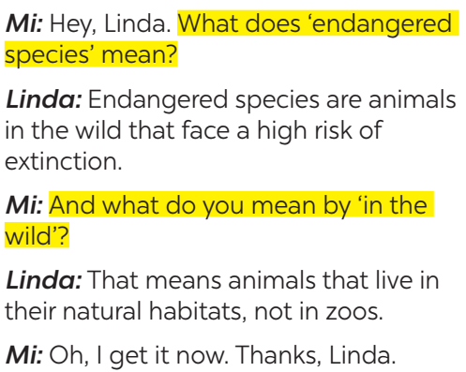
Task 2: Work in pairs. Make similar conversations to ask for and give clarification for the following. (6 mins)
- Ask Ss to work in pairs to make similar dialogues with the given cues.  - Move around to observe and provide help. Call on some pairs to practise in front of the class. Comment on their performance.  - Teacher checks students’ understanding by asking some checking-questions. | Suggested answers:  A: What do you mean by ‘single-use products’?  B: ‘Single-use products’ are products made to be used once only.  A: And what does it mean by ‘global warming’?  B: It is the increase in the atmosphere’s temperatures caused by the rise of gases, especially carbon dioxide.  A: Oh, thank you.
3. ACTIVITY 2: PRACTICE (20 mins)
a. Objectives:
- To help Ss learn about Earth Day around the world;
- To give Ss more practice talking about what they do on Earth Day.
b. Content:
- Task 3: Read the passage and tick the correct answers.
- Task 4: Work in groups. Match the activities people do on Earth Day with their results.
c. Expected outcomes:
- Students know about Earth Day, when and how it began, and how it is celebrated around the world.
d. Organisation
TEACHER’S AND STUDENTS’ ACTIVITIES | CONTENTS
Task 3: Read the passage and tick the correct answers. (8 mins)
- Ss read the passage for a few minutes. Make sure they understand the main ideas and offer explanations if needed.  - T may ask some comprehension questions:  • When is Earth Day?  • How many countries celebrate Earth Day?  • What for?  - Then Ss work in pairs and do the task. Explain if necessary.  - Check their answers as a class. | Answer key: 1,3,4
Task 4: Work in groups. Match the activities people do on Earth Day with their results. (6 mins)
- Ss work in groups and do the matching.  - T goes round the class to monitor.  - Correct Ss’ mistakes. | Answer key:  1. b 2. d 3. a 4. c
4. ACTIVITY 3: PRODUCTION (16 mins)
a. Objectives:
- To help Ss learn about Earth Day around the world;
- To give Ss more practice talking about what they do on Earth Day.
b. Content:
- Task 5: Work in pairs. Ask and answer about the things you and your friends do on Earth Day.
c. Expected outcomes:
- Students can talk to each other about the activities on Earth Day.
d. Organisation
TEACHER’S AND STUDENTS’ ACTIVITIES | CONTENTS
Task 5: Work in pairs. Ask and answer about the things you and your friends do on Earth Day. (10 mins)
- Give Ss a few minutes to study the example first.  - Then Ss work in pairs, taking turns to ask and answer.  - T goes round giving help when and where necessary.  - Encourage them to say what they do (and like to do).  - Teacher corrects students by going around while they’re practising.  - Teacher gives corrections and feedback | Suggested outcome:  A: What do you do on Earth Day?  B: We pick up litter and clean the streets. And you?  …
5. CONSOLIDATION (2 mins)
a. Wrap-up
- Have Ss say what they have learnt in the lesson.
- Ask Ss to say what they do on Earth Day?
b. Homework
- Name a list of the activities people do on Earth Day to protect our environment.
- Do exercises ……… in the workbook.
- Prepare Lesson 5: Skills 1
===================================

