Date of planning: 12/01/2024
Date of teaching: 15/01/2024
Unit 7 (cont.)
Period 56: Lesson 2: A closer look 1

I. OBJECTIVES
By the end of this lesson, Ss will be able to:
1. Knowledge
- Vocabulary: The lexical items related to Environmental Protection
- Pronunciation: Correctly pronounce words that contain the sounds: /bl/ and /kl/
2. Competences
- Develop communication skills and creativity
- Be collaborative and supportive in pair work and teamwork
- Actively join in class activities
3. Personal qualities
- Raise the students’ awareness about environmental protection.
II. MATERIALS
- Grade 8 textbook
- Computer connected to the Internet, TV
III. PROCEDURES
1. WARM-UP (6 mins)
a. Objectives:
- To create an active atmosphere in the class before the lesson.
- To lead into the new lesson.
b. Content:
- Jumbled words game
c. Expected outcomes:
- Students get some vocabulary from the lesson and be ready for the lesson.
d. Organization
TEACHER’S AND STUDENTS’ ACTIVITIES | CONTENTS
Jumbled words:  - T divides the class into 4 groups and explains the rules  - Ss look at the screen to see the jumbled words. They have to send 1 person to the board as quickly as possible to write the correct word.  - Teacher shows students the answer on the screen and announces the winning group.  - T sets the context for the lesson  - Teacher shows students the answer on the screen and announces the winning group. | Suggested answers:  AHTTABI -> HABITAT  PLTINOOLU -> POLLUTION  XEOGYN -> OXYGEN  EEERLAS -> RELEASE  BBSOAR ->ABSORB  MECYSSOET ->ECOSYSTEM
2. ACTIVITY 1: PRESENTATION (26 mins)
a. Objectives:
- To prepare vocabulary for students to do the tasks.
- To give Ss practice on how to use words / phrases related to the topic in context.
b. Content:
- Vocabulary pre-teaching.
- Task 1: Label each picture with a phrase from the list.
- Task 2: Match each word or phrase in column A with its meaning in column B.
- Task 3: Complete each sentence with a word or phrase from the box.
c. Expected outcomes:
- Students can use the target vocabulary.
d. Organization
TEACHER’S AND STUDENTS’ ACTIVITIES | CONTENTS
Vocabulary pre-teaching (5 mins)
- Teacher asks students to guess the meaning of the words by giving definitions/photos.  - Teacher checks the students' understanding by the Rub out and Remember technique.  - Teacher asks St to repeat and read the words.  - Teacher corrects the students as a whole class. | New words:  1. ecosystem (n): hệ sinh thái  2. marine life (n): sinh vật biển  3. absorb (v): thẩm thấu  4. harmful substances (n): tác nhân gây hại  5. extinction (n): sự tuyệt chủng
Task 1: Label each picture with a phrase from the list. (6 mins)
- Teacher Ss to look at the pictures.  - Let Ss work in pairs. Teacher tells them to name the activities, then label the pictures using the phrases given, then check their answers as a class.  - Have Ss read the phrases aloud. Correct their pronunciation if necessary.  - Tell Ss to tick the activities that help protect the environment.  - Teacher gives feedback. | Answer key:  1. picking up rubbish  2. protecting endangered species  3. cutting down trees  4. saving water  5. building a campfire  Tick: 1, 2, 4
Task 2: Match each word or phrase in column A with its meaning in column B. (6 mins)
- Teacher tells Ss to read the words / phrases in column A and their meaning in column B carefully.  - Tell them to work in pairs or small groups and match each word or phrase with its meaning.  - T goes around and gives assistance if necessary and checks their answers.  - Confirm the correct answers  - Teacher gives feedback.  - Teacher corrects the students as a whole class. | Answer key:  1. c  2. a  3. e  4. b  5. d
Task 3: Complete each sentence with a word or phrase from the box. (6 mins)
- Ss read the sentences carefully and look for clues so that they can choose the correct words /phrases to complete the sentences.  - Teacher asks one student to write the answers on the board. Confirm the correct answers.  - Call on some Ss to read the sentences.  - Teacher corrects the students as a whole class. | Answer key:  1. endangered species  2. habitat  3. carbon dioxide  4. cutting down trees  5. ecosystem
3. ACTIVITY 2: PRACTICE (6 mins)
a. Objectives:
- To help Ss pronounce the sounds /bl/ and /kl/ correctly.
b. Content:
- Task 4: Listen and repeat the words. Pay attention to the sounds /bl/ and /kl/.
c. Expected outcomes:
- Students know how to pronounce the two sounds in words and sentences.
d. Organization
TEACHER’S AND STUDENTS’ ACTIVITIES | CONTENTS
Task 4: Listen and repeat the words. Pay attention to the sounds /bl/ and /kl/. (4 mins)
- Teacher asks some Ss to read out the words first. Then play the recording for them to listen and repeat the words they hear. Ask them to pay close attention to the two sounds.  - Play the recording as many times as necessary.  - Explain to Ss the difference between the two sounds if needed  - Invite some Ss to say some words they know that include the two sounds.  - Teacher gives corrections and feedback to students’ pronunciation | 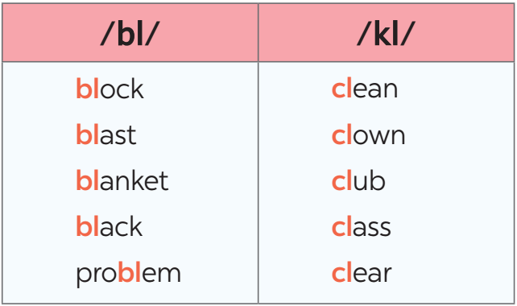
4. ACTIVITY 3: PRODUCTION (6 mins)
a. Objectives:
- To help Ss differentiate the sounds /bl/ and /kl/.
b. Content:
- Task 5: Listen and practise the sentences. Underline the words with /bl/ and circle the words with /kl/.
c. Expected outcomes:
- Students know how to pronounce the two sounds in words and sentences.
d. Organization
TEACHER’S AND STUDENTS’ ACTIVITIES | CONTENTS
Task 5: Listen and practise the sentences. Underline the words with /bl/ and circle the words with /kl/. (6 mins)
- Play the recording. Let Ss listen and repeat sentence by sentence.  - Have Ss read the sentences again and underline the words having the sound /bl/ and circle the words having  the sound /kl/.  - Then play the recording for Ss to listen and check what they have done.  - Have them work in pairs to compare their answers. Check Ss’ answers.  - Teacher gives corrections and feedback to students’ pronunciation | Answer key:  1. Look! There are black clouds all over!  2. A truck blocked the way to the club.  3. The students painted the classroom blue.  4. The wind blew the clock down.  5. We cleaned up the environment after the blast.
5. CONSOLIDATION (2 mins)
a. Wrap-up
- Ask one or two Ss to tell the class what they have learnt.
- Ask Ss to say make some sentences with words and phrases they remember from the lesson
b. Homework
- Practice Pronunciation
- Do exercises A12 in Students’ workbook
- Prepare Project (cont’)
- Prepare Unit 7 - A closer look 2
===================================

