Date of planning: 13/11 / 2023
Date of teaching: 16/11 / 2023
UNIT 4: ETHNIC GROUPS OF VIETNAM
Period 31: Lesson 5: Skills 1

I. OBJECTIVES: By the end of the lesson, ss will be able to:
- Scan for specific information about an essay (about 150 words) of customs and traditions.
- Skim for general information about an essay (about 150 words) of customs and traditions.
- Talk about the customs and traditions in their own family.
1. Knowledge
- Vocabulary: recognize some lexical items related to the topic “customs” and “tradition”
- Grammar: Use present simple to can talk about the customs and traditions in their own family.
2. Competences
- Linguistic competence, cooperative learning and communicative competence.
3. Personal qualities
- Be aware of protecting “custom and traditions”.
II. MATERIALS
- Grade 8 textbook, Unit 4, Skills 2
- Computer connected to the Internet
- Projector / TV
III. PROCEDURES
1. WARM-UP (5 mins)
a. Objectives:
- To provide Ss’ some background knowledge about the topic of the reading text.
b. Content:
- Ss work in pairs to answer the questions.
c. Expected outcomes:
- Ss can identify the topic of the reading text.
d. Organisation

TEACHER’S AND STUDENTS’ ACTIVITIES | CONTENTS
- T asks ss to look at the pictures in and answer the questions in pairs.  - Ss work in pairs to answer the questions.  - T elicits answers from Ss.  - T leads in new lesson. | 1. Look at the pictures and answer the questions  => Suggested answers:  + Picture 1: A family is celebrating a birthday.  + Picture 2: People are making Chung cake.  + Picture 3: A family is at an amusement park.

2. ACTIVITY 1: PRESENTATION (7 mins)
a. Objectives:
- To prepare vocabulary for students to understand the conversation.
b. Content:
- Pre-teach vocabulary related to the content of the dialogue.
c. Expected outcomes:
- Students know how to use the target vocabulary.
d. Organisation

TEACHER’S AND STUDENTS’ ACTIVITIES | CONTENTS
Vocabulary pre-teaching  - Teacher explains the meaning of the new vocabulary by pictures.  - Teacher reveals that the words according to the pictures will appear in the reading text and asks students to open their textbook to find these words.  - Teacher introduces the vocabulary.  - Teacher checks students’ pronunciation and gives feedback. | New words:  1. stilt house (n)  2. ethnic group (n)  3. open fire (n)  4. posts (n)  5. staircase (n)

3. ACTIVITY 2: PRACTICE (20 mins)
a. Objectives:
- To help Ss skim for general information about reading text.
b. Content:
- Task 1: Write the words and phrases from the box under the correct pictures
- Task 2 : Read the passage and tick (✓) T (True) or F (False).
- Task 3: Read the passage again and fill in each blank with ONE word.
- Task 4 :Work in pairs. Discuss and tick (✓) the features of a stilt house from the list below. Share your opinions with the class.
c. Expected outcomes:
- Ss can identify the general information of the reading text.
- Ss can identify the specific information of the reading text and ask and answer about the customs and traditions in their family well.
d. Organisation
TEACHER’S AND STUDENTS’ ACTIVITIES | CONTENTS
Task 1. Write the words and phrase from the box under the correct pictures. (5 mins)
- T asks ss to look at the picture and describe what can they see, guess what is the topic of the passage. | I. Reading  1. Look at the picture and guess  1. staircase: bậc cầu thang  2. open fire: bếp lửa  3. post: cột nhà
Task 2. Read the passage and tick T_F. (5 mins)
- T asks Ss to read the statements and underline the keywords. Then read through the passage quickly and locate the keywords.  - T asks Ss to stop to read the part that includes the keywords more carefully to make sure the information is True or False.  - T may model with the first statement.  - Asks Ss to work individually then compare their answers with a classmate before giving the answers to T. Ss do it.  - T corrects and gives feedback.  . | 2. Read the passage and tick (✓) T (True) or F (False).  Suggested answers:  1. F  2. F  3. T  4. T
Task 3. Read the passage again and fill in each blank with ONE word. (6 mins)
- T asks Ss work in pair to do this task  - T asks Ss to read the passage again and fill in the blanks. Ss do it.  - T asks some pairs to read the answers. Some Ss read.  - T asks some other pair to give recommend  - T checks and corrects. | 3. Read the passage again and fill in each blank with ONE word.  Suggested answers:  1. traditional  2. fields  3. forest - mountain  4. Rong
Task 4. Work in pairs and discuss and tick (✓) the features. (5 mins)
- Teacher has Ss work in pairs to discuss and tick (✓) the features of a stilt house from the list below and explain their choices.  - Teacher asks for Ss’ answers and confirms the correct ones.  - For a more able class, Teacher has Ss work in groups. Each group writes down their keys. Then they stand up and discuss together.  - Teacher corrects for students as a whole class. | II. Speaking  4. Work in pairs. Discuss and tick (✓) the features of a stilt house from the list below. Share your opinions with the class.  => Example:  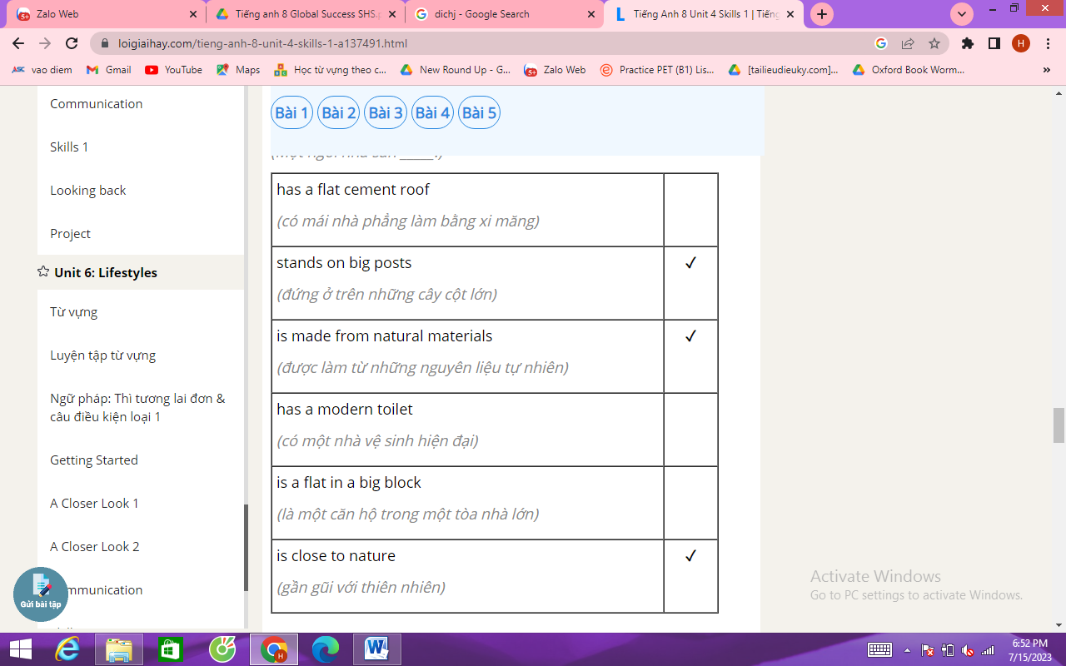
4. ACTIVITY 3: PRODUCTION (10 mins)
a. Objectives:
- To help Ss present about the type of home each of you lives in.
b. Content:
- Ss work in pairs to answer the questions. Then work individually to present in front of the class.
c. Expected outcomes:
- Ss can talk about the type of home each of you lives in.
d. Organisation
TEACHER’S AND STUDENTS’ ACTIVITIES | CONTENTS
Task 5: Work in pairs. Ask and answer about the type of home each of you lives in. Take notes of your partner’s answers and report what you find to the class.
(10 mins)
- Now T tells ss that two pairs of Ss join together. One pair interviews the other.  ? Spend a few minutes preparing the findings to the whole class.  ? Interview each other in pairs  ? Report the findings to the whole class.  - Ss work in pairs to interview.  - Some groups present in front of the class.  - Some others take notes of their partner’s answers and report it.  - Teacher monitors and gets feedback. | 5. Work in pairs. Ask and answer about the type of home each of you lives in. Take notes of your partner’s answers and report what you find to the class.  - What type of home do you live in? (a flat, a house, a detached house, a stilt house, a farmhouse, a cottage, a tree house. ...)  - What materials is it made from?  - What is the most important part of your home? What do you do there?  Example:  Names of interviewees: Hoa  Question 1:  - cottage house  - the house is a wooden structure.  - She likes the living room best.  => Presentation:  E.g: Hoa lives in a cottage house. It's an old-fashioned house, built by the lake. The house is built by wooden. She likes the living room best, it's where the whole family gathers and has warm gatherings.

5. CONSOLIDATION (5 mins)
a. Wrap-up
- Asks ss to recall the main contents of the lesson.
- Consolidates ss more for ss to remember.
b. Homework
+ complete the exercises in their notebooks.
+ translate the text into Vietnamese.
+ prepare Skills 2 + do Part B in WB.

