Date of planning: 21/10/2023
Date of teaching: 23/10/2023
Unit 3 (cont.)
Period 22: Lesson 7: LOOKING BACK, PROJECT

I. OBJECTIVES
By the end of this lesson, Ss will be able to:
1. Knowledge
- Repeat and distinguish the structures of simple sentences and compound sentences
- Memorise the uses of some conjunctions
- Memorise some words related to teen school clubs, teens’ use of social media, and teen stress and pressure.
2. Competences
- Develop communication skills and creativity
- Develop presentation skill
- Develop critical thinking skill
- Be collaborative and supportive in pair work and teamwork
- Actively join in class activities
3. Personal qualities
- Consolidate ss’ awareness of teen school clubs, teens’ use of social media, and teen stress
- Have a positive attitude toward pressures and know how to deal with them.
II. MATERIALS
- Grade 8 textbook, Unit 3, Looking back and project
- Computer connected to the Internet
- Projector / TV
- hoclieu.vn
III. PROCEDURES
1. WARM-UP (5 mins)
a. Objectives:
- To create an active atmosphere in the class before the lesson;
- Recall types of pressure that teen may face
b. Content:
- Have ss play the game “Kim’s game”
c. Expected outcomes:
- Ss are able to recall the words and phrases about types of pressure through the given pictures
d. Organisation

TEACHER’S AND STUDENTS’ ACTIVITIES |  |  | CONTENTS
Kim’s game:  - T asks students to work in groups of three or four students  - Get them look at the pictures about some kinds of pressure on the screen.  - Tell ss that the pictures will disappear after 2 seconds, so they should try to remember all the pictures without writing them down.  - After all the pictures disappear, ss have 1 minute to write down the kinds of pressure in each picture on their poster. (2 points for each correct answer)  - T gets ss to swap the posters among groups and give corrections after T shows the answers.  - Ss give marks to their friends’ answers.  - T leads in the lesson. |  |  | 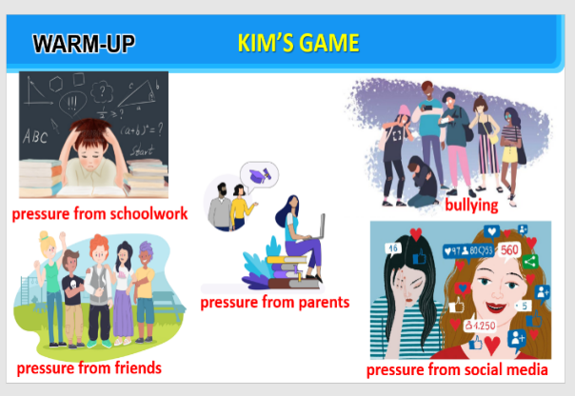
2. ACTIVITY 1: PRESENTATION
a. Objectives:
- To help Ss review the vocabulary learnt. .
b. Content:
- Task 1: Complete the webs with suitable words and phrases.
- Task 2: Fill each blank with the correct form of the words in the box.
c. Expected outcomes:
- Recall the vocabulary learnt
d. Organisation
TEACHER’S AND STUDENTS’ ACTIVITIES |  | CONTENTS
Task 1: Complete the webs with suitable words and phrases. (4 mins)
- Have Ss work individually to complete the webs with words / phrases.  - Check answers as a class.  - Have Ss read out their words/phrases from their webs.  - Correct Ss’ pronunciation if necessary. |  | Suggested answers:  - activities on social media: browsing websites, uploading pictures, checking notifications, connecting with friends, discussing problems, sharing opinions, commenting on posts, sharing posts  - causes of teen stress: pressure from parents, pressure from schoolwork, bullying, spending too much time on social media
Task 2: Fill each blank with the correct form of the words in the box. (5 mins)
- Have Ss work individually to fill in each blank with the correct form of the words from the box.  - Check answers as a class.  - Ask some Ss to read the passage aloud. |  |  |  | Answer key:  1. participates  2. clubs  3. connects  4. skills  5. upload  6. bullies / bullying
3. ACTIVITY 2: PRACTICE
a. Objectives:
- To help Ss review compound sentences.
- To help Ss create compound sentences by writing a simple sentence to complete the given sentences.
b. Content:
- Task 3: Use the conjunctions provided to connect the sentences.
- Task 4: Complete the sentences below. Then compare your sentences with your partners’.
c. Expected outcomes:
- Recall the uses of conjunctions and structures of compound sentences and practise through grammar exercises
d. Organisation
TEACHER’S AND STUDENTS’ ACTIVITIES |  |  |  | CONTENTS
Task 3: Use the conjunctions provided to connect the sentences. (6 mins)
- Have Ss work individually to connect the two simple sentences to create a compound sentence using the words in bold. Remind them of the meanings and use of the connectors.  - Then ask Ss to work in pairs to swap and check their answers.  - Check answers as a class.  - Ask one student to read out the sentences. Correct his / her pronunciation if necessary. | Answer key:  1. Mai is the head of the club, so she knows the members very well.  2. Lan wanted to go to the party, but she couldn’t choose a suitable dress.  3. Tom felt stressed; however, he tried to finish his homework.  4. He isn’t a member of the chess club; therefore, he won't join the chess competition.  5. We will have a short holiday; otherwise, we will feel very stressed.
Task 4: Complete the sentences below. Then compare your sentences with your partners’.
(5 mins)
- Ask Ss to work individually to complete the sentences as requested.  - Ask one or two Ss to go to the board and write their full sentences.  - Then ask the class to work in pairs. Tell them to swap their sentences and check their partner’s answers.  - Check the sentences on the board.  - Have all Ss correct their partner’s answers.  - Ask some Ss to read out their sentences. | Suggested answer:  1. Teens need to have good health, so they should do some sport(s).  2. His parents have high expectations of him, but they don’t care about his abilities.  3. Teenagers should develop social skills; otherwise, they may not be able to communicate with peers and other people.  4. We sometimes feel lonely and sad; therefore, we need our families and friends.  5. He does very well at school; however, he doesn’t have teamwork or communication skills.
4. ACTIVITY 3: PRODUCTION (15 mins)
a. Objectives:
- To raise Ss’ awareness of the need to participate in a school club;
- To improve Ss’ teamwork and public speaking skills.
b. Content:
- Present the poster to the class.
c. Expected outcomes:
- Present the poster of a club ss would like to have at their school.
d. Organisation

TEACHER’S AND STUDENTS’ ACTIVITIES |  | CONTENTS
Our school club  - Ask Ss to read the instructions again (T has already been assigned the project since the first lesson of the Unit and checked their progress after each lesson). Let students have some time to check their posters for the final time and make any adjustments if necessary.  - T has groups show their posters and present them to the class. |  | Students’ posters & presentations
5. CONSOLIDATION (2 mins)
a. Wrap-up
- Ask Ss to complete the self-assessment table.
- Identify any difficulties and provide further practice.
b. Homework
- Do exercises in the Workbook.
- Prepare the new lesson. Unit 4.Getting Started.

