Date of planning : 05/10/ 2023
Date of teaching : 08/10/ 2023
Unit 3 (cont.)
Period 17: Lesson 2 : A CLOSER LOOK 1

I. OBJECTIVES: By the end of this lesson, Ss will be able to gain the following:
1. Knowledge:
- The lexical items related to social media.
- Pronunciation: Correctly pronounce words that contain the sounds /ʊə/ and /ɔɪ
+ Vocabulary:- :- Use The lexical items related to social media.
+ Correctly pronounce words that contain the sounds /ʊə/ and /ɔɪ
+ Grammar:-Simple sentences and compound sentences
2. Competence:
- Students will be able to know more new words about social media.
- Develop competencies of communication, cooperation, and self-management.
- Be collaborative and supportive in pair work and teamwork
- Be actively join in class activities.
3. Personal qualities:
- Raise ss’ awareness of social media
- Have good attitude to school pressure
- Develop self-study skills.
II. MATERIALS:
- Teacher: Grade 8 text book, laptop, projector / TV.....
- Students : Text books, workbook…
- Computer connected to the Internet
- Sach mem.vn ; Or hoclieu.vn .
III. PROCEDURES:
1. WARM UP ( 5mins )
a. Objectives:
a. Objectives:
- To create an active atmosphere in the class before the lesson;
b. Content:
- To have some warm-up activities to create a friendly and relaxed atmosphere to inspire Ss to warm up to the new class.
c. Expected outcomes:
- Having a chance to speak English and focus on the topic of the lesson. Students get some vocabulary from the lesson and be ready for the lesson.
d. Organisation: Teacher’s instructions …
TEACHER AND STUDENTS’ ACTIVITIES | CONTENTS
+ Greeting  Game: Word puzzles  - Give Ss a few minutes to play a game. Have Ss play in two groups.  - Ask ss to find 6 meaningful words in the puzzles  - The team with the more correct answers wins.  - T leads in the new lesson. which focuses on  words and phrases social media and the sounds /ʊə/ and /ɔɪ  - Share with Ss the lesson objectives. Write the objectives in a corner of the board and leave them there till the end of the lesson, or put them on a slide to show Ss. | + Greeting ; - T_Ss.  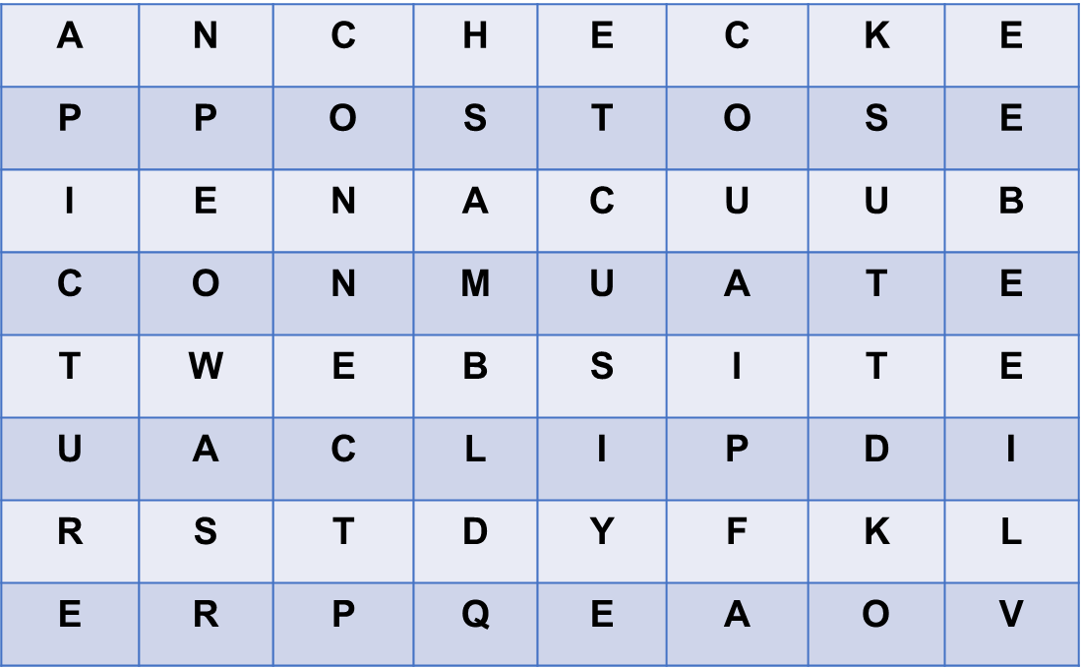  Answer key: CHECK; POST; WEBSITE; CLIP; PICTURE; CONNECT
2. ACTIVITY 1: PRESENTATION (10mins)
a.Objectives:
- To introduce some verbs and verb phrases that are often used when teens talk about using social media.
- To allow Ss to use the learnt words in contexts.
b. Content:
- Circle the correct options to complete the phrases.
c. Expected outcomes:
- Know more new verbs and verb phrases that are often used when teens talk about using social media.
- Know how to use learned words/ phrases in context.
d. Organization : Teacher’s instructions.
TEACHER AND STUDENTS’ ACTIVITIES | CONTENTS
Task 1: Write a word or phrase from the box under each picture.
* Teach vocabulary:  + Teacher uses different techniques to teach vocab (situation, realia, translation.)  + Teacher introduces the vocabulary by:  - providing the pictures  - eliciting the definition of the words  - Have Ss read aloud the verbs and the word / phrases given.  - Explain the meaning of the new verb phrases by using pictures or synonyms or even their mother tongue  - Invite Ss to take turns to read out their answers. Correct their pronunciation if needed.  - Ask Ss to work in pairs to circle the correct options to complete the phrases.  - Check the answers as a class.  - T can also ask Ss to add more words / phrases to the verbs to make other phrases. This way, T can broaden Ss’ vocabulary if they are ready. | - T_Ss  * New words:  - upload (v) = to copy or move :tải lên  browse (v) = to look at things  = đọc lướt, tìm (trên mạng)  / check over sth  3. notifications (n): thông báo  4. log on (to) (v): đăng nhập  5. check (v): kiểm tra  6. account (n):tài khoản  Answer key:  1. A  2. A  3. B  4. B  5. B
3. ACTIVITY 2: PRACTICE ( 10mins)
a. Objectives:
1. To help Ss understand more clearly the meaning of some words and phrases.
2. To help Ss use the words in specific contexts.
b. Content:
-Use the correct form of the verbs in 1 to complete the sentences.
- Choose the correct answer A, B, or C.
c. Expected outcomes: Know more new words and phrases. Know how to use the words/ phrases in context.
d. Organisation :
TEACHER AND STUDENTS’ ACTIVITIES | CONTENTS
Task 2: Use the correct form of the verbs in 1 to complete the sentences.
- Ask Ss to work individually to complete each of the sentences with a suitable verb from 1.  - Check the answers as a class.  - Have some Ss read aloud the complete sentences.  - Correct Ss’ pronunciation if necessary  - Teacher checks the answers as a class. | - T_Ss  * Key:  1. browsed  2. uploaded  3. connects  4. checked  5. logs on
Task 3: Choose the correct answer A, B, or C.
- - T asks Ss to work individually to choose the correct answer for each sentence.  - Ss swap their answers with their partners.  - T check the answers as a class.  - T can also ask some Ss to read out their answers. Then have Ss read the sentences aloud as a class. Correct Ss’ pronunciation if necessary.  - Teacher checks the answers as a class and gives feedback. | - T_ Ss  * Answer key:  1. B  2. C  3. A  4. A  5. B
4. ACTIVITY 3: PRODUCTION: ( 15mins)
PRONUNCIATION /ʊə/ and /ɔɪ
a. Objectives:
- To help students identify how to pronounce the sounds /ʊə/ and /ɔɪ
- To help students practise pronouncing these sounds/ʊə/ and /ɔɪ
correctly in words and in sentences.
b. Content:
Listen and repeat the words. Pay attention to the sounds Listen and repeat the sentences. Pay attention to the underlined words.
c. Expected outcomes: Students repeats the words correctly. Learn how to pronounce the words correctly. Ss distinguish and pronounce the sound /ʊə/ and /ɔɪ
correctly in their speaking.

d. Organisation:
TEACHER AND STUDENTS’ ACTIVITIES | CONTENTS
Task 4: Listen and repeat the words. Pay attention to the sounds /ʊə/ and /ɔɪ

+ Have Ss read the sentences, paying attention to the underlined words /ʊə/ and /ɔɪ  - Play the recording and ask them repeat each sentence  - Teacher asks Ss to listen and pay attention to the sounds /ʊə/ and /ɔɪ  - Ss repeat the words as a class, in groups and individually.  - Call on some Ss to read the sentence individually.  - Play the recording as many times as necessary.  * Teacher gives corrections and feedbacks to students’ pronunciation . | - T_ Ss. Ss- Ss  Answer key:  /ʊə/: tourist, ensure, sure, tournament  /ɔɪ/: boy, toy, avoid, choice
Task 5: Listen and repeat the sentences. Pay attention to the underlined words.
- Have some Ss read the sentences first.  - Play the recording for Ss to listen to, then repeat each sentence after the recording.  - Play the recording as many times as necessary.  - Ask them to underline the words with the sound /ʊə/ and circle the words with the sound /ɔɪ/.  - Check the answers as a class.  - Call some Ss to read the sentences individually.  * Teacher’s observation and feedback. | * Answer:  Answer key:  1. She is a noisy and curious girl.  2. They joined a full-day city tour.  3. I found it enjoyable to watch the tournament.  4. She’ll record our voices during the interview.  5. He is not acting very mature and is starting to annoy me.
5. CONSOLIDATION ( 5mins )
a. Wrap-up
- Teacher asks Ss to summarize what they have learnt in the lesson.
b. Homework
- Learn by heart all the words that they have just learnt.
- Do more exercises in workbook.
- Prepare project.
- Prepare new lesson: Lesson 2: A CLOSER LOOK 2 .

