Date of preparing:
Date of teaching:
UNIT 10: ENERGY SOURCES
Period 93: Lesson 6: SKILLS 2
I. OBJECTIVES:
By the end of this lesson, students will be able to:
1. Knowledge
+ Listening
use the lexical items related to the topic Energy sources
listen for main ideas and specific information about the topic how to save energy at home.
+ Writing: Write a paragraph of about 70 words about how you save energy at home.
2. Competence
- Develop communication skills
- Be collaborative and supportive in pair work and team work
- Actively join in class activities
3. Educational aim:
Ss will be more aware of saving energy and be more responsiple for protecting the environment.
II. TEACHING AIDS:
- Grade 7 textbook, Unit 10, Skills 2
- Computer connected to the internet
- Pictures
- Sachmem.vn
III. PROCEDURES:
Activity 1: Warm –up (5’)
* Aim: To help students revise the vocabulary items they have learnt in the unit and lead in the next part of the lesson.
* Content: Listen a song and answer the question.
* Products: Ss play in groups and choose the the pair of number correctly.
* Organization of implementation:
Teacher’s and Ss’activities |  | Content
* Teacher has Ss watch video clip about how to save energy at home.  ** Ss watch and then discuss in groups  *** Teacher calls some students to give their answers.  **** Teacher listens and give comments.  -Teacher introduces students the content of the lesson: “In the lesson today, we are going to listen to a person talking about how to save energy at home.” |  | * Warm up : listen a song and answer the question:  What is the song about?  How to save energy at home  Write some ways to save energy in the video clip
Activity 2: Listening ( 15’)
* Pre-Listening
Task 1
* Aim: To help Ss brainstorm the topic and prepare for the listening text.
* Content: Look at the pictures and answer some questions.
* Products: Ss can get some information the content of the conversation.Choose the correct picture.
* Organization of implementation:
Teacher’s and Ss’activities | Content
* Teacher asks Ss to work in pairs to answer the questions in the picture.  ** Ss work with their partner to do the task.  *** Teacher calls on some Ss to answer.  **** Teacher gives comments and leads Ss to task | Task 1: What can you see in this picture? What is special about it?  * Suggested answers:  1- solar energy  2- turn off the tap while brushing your teeth, use paper fan, use low energy light bulbs, turn off the lights when going out,…
* While -listening
Task 2
* Aims: To help Ss listen for specific information about how to save energy at home.
To help students develop their skill of listening for details.
* Content: Listen conversation and tick the column
* Products: Ss give the answers correctly and correct mistakes where necessary
* Organization of implementation:
Teacher’s and Ss’activities | Content
Task 2  * Ask Ss to read the instructions.** Have Ss read the phrases provided and say which one(s) is / are new or difficult. Help them understand the phrases by giving explanations or the Vietnamese equivalents.  ***Play the recording once or twice, if necessary, for Ss to listen and circle the phrases they hear.  ****Have Ss compare their answers in pairs or groups. Then call on some Ss to read aloud the phrases. T checks their answers.  Task 3  * Teacher asks Ss to read and underline the key words.  ** Ss work independently listen to the recording and tick T or F  *** Teacher calls on some students to give the answers the have listened.  **** Teacher corrects and give feedback. | Task 2: Listen and circle the phrases you hear  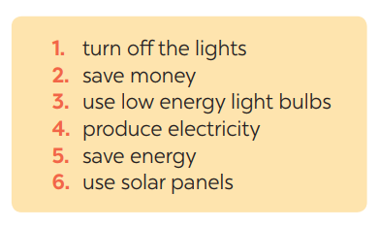  Task 3: Listen again and tick T (True) or F (False) for each sentence  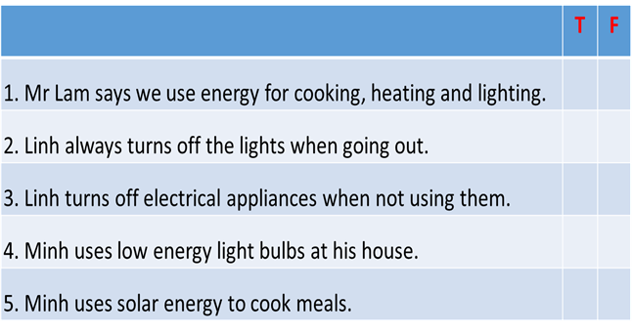  * Answer key:  Key: 1. T 2.F 3.T 4.T 5. F
Post-Listening
Activity 3 : Pre -writing (15’)
* Aims: To help Ss indentify some ways to save energy at home. To help Ss prepare ideas to write a passage.
* Content: Read some ways to save energy at home. Choose three ways and write them in your notebook.
* Products: Ss answer the Qs correctly.
* Organization of implementation:
Teacher’s and Ss’activities | Content
Task 4  * Teacher asks Ss to write the methods they use to save energy at home then asks them to give out more if they can.  ** Ss think of it and can discuss with their partners.  *** Teacher calls on some Ss to raise their ideas.  **** Teacher listens and confirms. | Task 4: Work in pairs. Read some ways to save energy at home. Choose three ways and write them in your notebook.  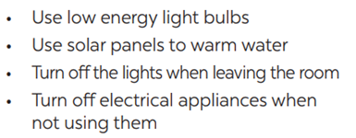
While - Writing
* Aims: To help Ss practise writing a passage about 70 words about how you save energy at home
* Content: write a passage about 70 words about how you save energy at home
* Products: Students write a passage in their notebooks.
* Organization of implementation:
Teacher’s and Ss’activities | Content
Task 5  * Teacher tells Ss that they are going to write a passage about how you save energy at home.  ** Teacher reminds Ss of the structure of a passage and steps to make an outline for the passage.  ** * Ss work independently to do the task and try to use the notes from the previous tasks.  Teacher goes around and help if necessary. | Task 5: Write a paragraph of about 70 words about how you save energy at home.  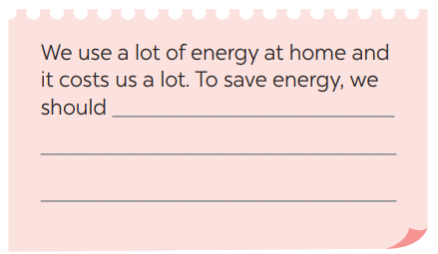
Activity 4 : Post-Writing(5’)
* Aim: To peer check, cross check and final check students’ writing.
* Content: Students’ writing and cross check.
* Products: Students’ writing.
* Organization of implementation:
Teacher’s and Ss’activities | Content
*** Teacher asks Ss to share their writing with their partners. Then, call on some Ss to show their writing in front of the class.  **** Teacher checks ideas, grammar, vocabulary and gives comments. | Task 5: Students’ writing and cross check.  We use a lot of energy at home and it costs us a lot. To save energy, we should use low energy light bulbs in all rooms. We need to turn off electrical appliances such as lights, TVs, fans when we do not use them. We should also put solar panels on the roof of our houses to heat water.
Activity 5 : Consolidation (3’)
* Aim: To consolidate what students have learnt in the lesson.
* Content: Summarize the content of the lesson.
* Products: A student says what she/ he has learnt in the lesson.
* Organization of implementation:
Teacher’s and Ss’ activities | Content
- Teacher asks students to talk about what they have learnt in the lesson. | - Listen a passage about dream house.  - Write a paragraph of about your dream house.
Homework (2’)
* Aim: To revise the knowledge that students have gained in this lesson.
* Content: Review the lesson and prepare for the next lesson and do exersie in the workbbook
* Products: Students’ textbook and workbook.
* Organization of implementation
Teacher asks students to rewrite their writing in their books.  - Teacher asks students to prepare the new lesson. | Rewrite the writing in the notebook.  - Prepare “ Looking back and project”
*- Complement: …………………………………………………………………………………………………………………………………………………………………………………………………….

