Date of preparing:
Date of teaching:
UNIT 10: ENERGY SOURCES
Period 92: Lesson 5: SKILLS 1
I. OBJECTIVES:
By the end of this lesson, students will be able to gain:
1. Knowledge
+ Reading:
- read for specific information about renewable and non-renewable sources of energy.
+ Speaking:
talk about advantages and disadvantages of different sources of energy
2. Competence
- Develop communication skills
- Be collaborative and supportive in pair work and team work
- Actively join in class activities
3. Educational aim:
- Develop awareness of saving the energy sources
II. TEACHING AIDS:
Grade 7 textbook, Unit 10, Skills 1
Computer connected to the internet
TV/ Pictures, cards
Sachmem.vn
III. PROCEDURES:
* Activity 1: Warm-up (5’)
* Aim: To activate students’ prior knowledge and vocabulary related to the topic of reading and To lead in the lesson about Skills 1.
* Content: Think of the word which has 9 letters in it related the topic “ENERGY SOURCES”.
* Products: Ss give the correct answers.
* Organization of implementation:
Teacher’s and Ss’activities | Content
Warm up  * Teacher divides class into 2 teams and asks them to think of the word which has 9 letters in it related the topic “ENERGY SOURCES”.  ** Ss have 1 min to think of the words related to the topic or they can discuss with their partners.  *** Each member from each team turn by turn guesses the letter in the secret word.  **** Teacher corrects their answers.  The team which can find or guess the secret first will be the winner.  → Teacher leads students into the lesson by telling what they are going to learn: “We are going to read a passage about renewable and non-renewable source of energy.” | * Warm up: Game: Hangman  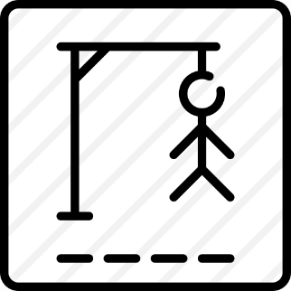  R E N E W A B L E
* Activity 2: Reading (5’)

Presentation vocab.
* Aim:. To provide students with some lexical items before reading the text.
* Content: Learn some vocab related the topic.
* Products: Read and understand the meaning of words.
* Organization of implementation:
Teacher’s and Ss’activities | Content
- Pre teach vocabulary  * Teacher use different techniques to teach vocab (pictures, situation, explaination…..)  ** Repeat in chorus and individually  *** Copy all the words  **** Checking vocab: Checking: Call words in EL | * Vocabulary  - produce (v)/prəˈdjuːs/: Sản xuất  = to make things, mostly in large quantity  Examples: Companies produce many toys for children before Christmas.  - limited (a)/ˈlɪmɪtɪd/: bị hạn chế  = not very great in amount or extent  Examples: coal, oil, …  - available (a) /əˈveɪləbl/: có sẵn  Hydro energy is available, clean and safe to use.  - Electrical appliances /ɪˈlɛktrɪkəl əˈplaɪənsɪz/ (n.phr) Thiết bị điện  *Checking: Call words in EL
* Pre -reading (5’)
Task 1:
* Aims: To introduce words related to skin conditions to Ss and help Ss have a general idea of what they are going to read.
* Content: Discuss the following questions.
* Products: Ss give the answers exactly.
* Organization of implementation:
Teacher’s and Ss’activities | Content
Task 1  * Teacher asks Ss to work in pairs to look at the Picture in Ex1 and discuss to answer the questions.  ** Ss work in pairs.  *** Teacher calls some Ss to check what they have discussed.  **** Teacher corrects | Task 1: Work in pair. Discuss the following questions.  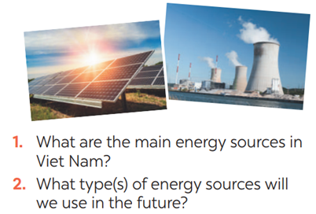  → They are hydro energy and energy from coal.  →We will use solar energy and wind energy.
* While -reading(5’)

Task 2 + 3
* Aims: To help Ss develop their reading skill for details and specific information.
* Content: Read the text and choose the best option (A, B, or C) to complete the sentences.
* Products: Ss say aloud the correct answer .
* Organization of implementation :
Teacher’s and Ss’activities | Content
Task 2.  * Teacher gives Ss time to: read each question, locate where the information appears in the text, read that part carefully and circle the correct answer.  ** Ss do the task independently  *** Teacher tells Ss to compare their answers in pairs before calling some of them to check.  **** Teacher confirms the correct answer and explains if needed.  Task 3.  * Teacher asks Ss to do the exercise carefully and individually.  ** Ss do the task independently.  *** Teachers has Ss compare their answers in pairs and call some Ss to give their ideas.  **** Teacher checks and confirms the correct answers. | Task 2. Read the text and choose the best option (A, B, or C) to complete the sentences.  * Suggested answers:  1. B 2. A 3. C 3. A  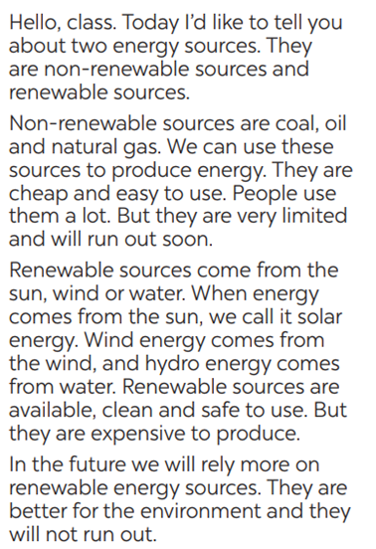  Task 3. Read the text again and answer the questio Answer key:  1. There are two energy sources. They  are non-renewable sources and renewable sources.  2. Non-renewable sources are coal, oil  and natural gas.  3. Renewable sources are available, clean and safe to use.  4. In the future, we will rely more on  renewable energy sources.ns.
* Activity 3 : SPEAKING

Pre-Speaking(5’)

Task 4:
* Aims: To help students identify the advantages and disadvantages of different energy sources.
* Content: Discuss and put the following words or phrases in the appropriate columns.
* Products: Students’ correct answers on the posters.
* Organization of implementation:
Teacher’s and Ss’activities | Content
Task 4  - Have Ss read the instructions to identify how the task is done.  - Have Ss work in groups. Ask them to read the words or phrases provided and discuss which ones are advantages and which are disadvantages.  - Have Ss put the words and phrases in the appropriate columns. T goes around and corrects mistakes or gives help when necessary.  - Call on some Ss to perform the task in front of the class. T and other Ss listen and comment. | Task 4. Work in groups. Discuss and put the following words or phrases in the appropriate columns.  * Key:  + Advantages: easy to use, cheap, available, safe to use, good for the environment  + Disadvantages: run out, limited, expensive
*While-Speaking(10’)

Task 5
* Aims: To help Ss talk about different houses in the future.
* Content: Tell your partners about your future house.
* Products: Some Ss go to the board and tell the class about different houses in the future.
* Organization of implementation:
Teacher’s and Ss’activities | Content
Task 5  * Teacher has Ss work in pairs and asks them to take turns to ask and answer  ** Ss work in pairs to do the task. Teacher goes around, listens and gives help if needed.  *** Teacher calls on some pairs to share their answers with the class.  **** Teacher comments and correct. | Task 5 : Work in pairs. Ask and answer questions about the advantages and disadvantages of different energy sources  A: What are the advantages of hydro energy?  B: It's available, clean and safe to use.  A: What are its disadvantages?  B: It's expensive to produce.  A: What are the advantages of energy from coal?  B: It's cheap and easy to use.  A: What are its disadvantages?  B: It's limited and not good for the environment.
* Activity 4: PRODUCTION(5’)
* Aims: To help students practice presenting the advantages and disadvantages of different types of energy source
* Content: Presentation: Advantages and disadvantages of a source of energy
* Products: Some groups share their answers with the class.
* Organization of implementation:
Teacher’s and Ss’activities | Content
* Teacher has students work in groups to prepare a presentation (poster/pictures/notes…)  *** Teacher calls on some groups to share their answers with the class.  **** Teacher comments and corrects if needed. | Presentation: Advantages and disadvantages of a source of energy
* Activity 5: Consolidation (3’)
* Aims: To consolidate what students have learnt in the lesson.
* Content: Ss summarise what they have learnt with the two skills.
* Products: Students say what they have learnt with the two skills in front of the class.
* Organization of implementation:
- Teacher asks students to talk about what they have learnt in the lesson. | - 2 skills ( talk about advantages and disadvantages of different sources of energy )
* Homework (2’)
* Aim: To revise the knowledge that students have gained in this lesson.
* Content: Review the lesson and prepare for the next lesson .
* Products: Students’ textbook and workbook
* Organization of implementation:
- Teacher asks students to prepare the new lesson | - Do Ex inWB  - Prepare: Skills 2
*- Complement: ………………………………………………………………………………………………………………………………………………………………………………………………………..

