Date of preparing:
Date of teaching:
UNIT 11: TRAVELLING IN THE FUTURE
Period 90: Lesson 3: A CLOSER LOOK 2

I. OBJECTIVES:
By the end of this lesson, students will be able to:
1. Knowledge
know how to recognize “The future simple: Will”
a. We use will + V:
+ to talk about future activities
Eg: We will buy an electric scooter soon.
+ to make predictions
Eg: We will probably use electric cars because normal cars cause too much pollution.
b. Possessive pronouns
+ to demonstrate ownership
Eg: This is our house. It’s ours.
2. Competence
- Develop communication skills
- Be collaborative and supportive in pair work and team work
- Actively join in class activities
3. Educational aims:
Be responsible and hard working
II. TEACHING AIDS:
Grade 7 textbook, Unit 11, A closer look 2
Computer connected to the internet
TV/ Projector/Pictures, sets of word cards
Sachmem.vn
III. PROCEDURES:
Activity 1: Warm-up (5’)
* Aim: To activate students’ prior knowledge and vocabulary related to articles in lesson.
* Content: * Game: pelmanism
* Products: Ss answer questions and find the correct key.
* Organization of implementation:
Teacher’s and Ss’activities |  | Content
Warm up:  * Teacher divides the class into 2 teams.  ** The game starts with all the cards face down and players take turns to turn over two cards. If team A choose 2 cards with the picture and the correct word . Team A will get 2 points.  *** The team with more points is the winner.  **** Teacher checks and gives feedback. |  | * Game: Pelmanism: Future means of transport  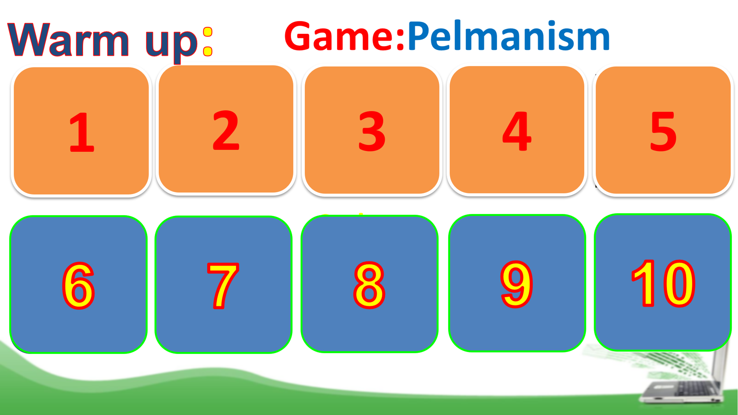
Activity 2: Presentation (5’)
GRAMMAR 1: THE FUTURE SIMPLE
* Aim: To introduce students the form and the usage of the future simple.
* Content: Grammar: The Future Simple
* Products: Understand and know how to use the Future Simple
* Organization of implementation:
Teacher’s and Ss’activities | Content
* GRAMMAR 1: THE FUTURE SIMPLE  * Teacher has Ss read “Remember box” in some minutes.  ** Ss work independently to read.  *** Teacher calls on some Ss to answer teacher’s questions to make sure they can understand how to use and form The Future Simple well.  + Teacher writes on the board:  In this situation, what do we use the future tense for?  + “To make a negative form, do we say will not or not will?” (Just add NOT behind Will)  + “For questions, where we can put Will?” (Before subjects)  **** Teacher confirms, and corrects grammar if needed, then write on the board: | * GRAMMAR 1: THE FUTURE SIMPLE  “Do we use The Future Simple to talk about past, present or future activities?”  EX: People will go to school by solowheel in 2030”  + Usage: to talk about future activities and to make predictions.  + Form: (+) S + will + V  (-) S + will + not (won’t)+ V  (?) Will + S + V ?
Activity 3: Practice (15’)
Task 1 + Task 2
* Aims: To help Ss use the right verb form to talk about future activities.
To help Ss practise making full sentences about future activities using prompts.
* Content: Fill each blank with a suitable article.
* Products: Students to read their answers aloud.
* Organization of implementation:
Teacher’s and Ss’activities | Content
Task 1  * Teacher asks students to do the exercise individually and then compare their answers with a classmate.  ** Ss do the task individually.  *** Some Ss explain their choices.  ****Teacher confirms the correct answers.  Task 2:  * Teacher has students work individually to rearrange the words to make sentences.  ** Ss do the task individually.  *** Some Ss write their answer on the board.  ****Teacher confirms the correct answers.  Task 3:  * Teacher asks Ss to work in pairs to complete the conversation.  ** Ss work in pairs to do the task.  *** Teacher calls on Ss to read aloud the complete conversation.  **** Teacher confirms the correct answers helps them to correct mistakes if needed. | Task 1 : Complete the sentences with will or won’t.  * Answer key:  1. won’t  2. will  3. will  4. won’t  5. Will  Task 2: Rearrange the words and phrases to make sentences.  * Answer key:  1. We will have driverless cars in 2030.  2. Cities won’t allow cars in 2050.  3. Will electric cars be popular?  4. We will use solar-powered buses soon.  5. Will we have enough parking places in ten years?  Task 3: Use the correct form of the verbs in brackets to complete the conversation. (Ex 3, p. 117)  * Suggested answers:  1. will take  2. won’t have  3. Will ... have  4. won’t drive  5. won’t be
Activity 4: GRAMMAR (5’)
* Aims: To review possessive pronouns.
* Content: Complete this table about possessive pronouns.
* Products: Complete this table; Ss read aloud their answers on the board
* Organization of implementation:
Teacher’s and Ss’activities | Content
* GRAMMAR 2: REVIEW  POSSESSIVE PRONOUNS  * Teacher writes on the board an example then asks Ss some questions to remind them.  + Do we use a possessive pronoun instead of a phrase?  + Does a possessive pronoun come before a noun?  + Let’s complete this table  ** Ss work individually to answer teacher’s questions  *** Teacher calls on some Ss to give their ideas.  **** Teacher confirms and corrects.  Task 4:  * Teacher asks Ss to do the task individually to replace the underlined phrases with the correct possessive pronouns.  ** Ss do the task individually and compare with their partners.  *** Some Ss read aloud their answers on the board  **** Teacher confirms the correct answers. | * GRAMMAR 2: REVIEW  POSSESSIVE PRONOUNS  Ex: THIS IS YOUR BICYCLE.  THAT BICYCLE IS HER BICYCLE. → HERS  (hers = her bicycle)  Task 4: Replace the underlined phrases with possessive pronouns. (Ex 5, p. 118)  * Suggested answers:  1. theirs  2. mine  3. His  4. Yours  5. Ours
  Personal pronouns | Possessive adjectives | Possessive pronouns
  I | my | mine
  You | your | yours
  We | our | ours
  They | their | theirs
  He | his | his
  She | her | hers
  It | its | its
Activity 5: Production (10’)
Task 5
* Aims: To help Ss practise talking about some future means of transport
To help Ss learn reasoning skills by giving reasons for their choice.
* Content:
* Products: Some pairs talk about their choices and reasons why they will / won’t use those means of travelling.
* Organization of implementation:
Teacher’s and Ss’activities | Content
Task 5  * Teacher asks Ss to work in pairs to describe the picture.  ** SS work with their partners to do the task.  ***Some pairs talk about their choices and reasons why they will / won’t use those means of  travelling.  **** Teacher listens to Ss to correct common errors after Ss finish speaking. | Task 5: Look at the pictures and tell your partner if you will / won’t travel by these means of transport. Give reason(s). (Ex 4, p. 118)  * Suggested answers:  - In picture 1, I can see a / an (electric) bus / coach. I can see many people on this bus / coach. I think I will go to school by electric coach because it has no fumes, and it can carry many people at the same time.  - In picture 2, I can see a flying car. It is flying over a city. I think I will travel by flying car. It will be fun to fly in one. I will be able to see the city below (or I can fly it when the roads are congested).  - In picture 3, I can see a ship. It has solar panels. I will travel on a solar-powered ship to visit some islands.  It will be comfortable / fun to travel by solar-powered ship.  - In picture 4, I can see a bamboo-copter. I will fly a bamboo-copter to work. It will be fun / fast. (or I won’t use a bamboo-copter to travel from one place to another. It will be dangerous. You might get hurt when it  is windy …).  - In picture 5, I can see a car with a lot of smoke behind it. I won’t go by car in the future. It pollutes the environment.
* Consolidation (3’)
* Aim: To consolidate what students have learnt in the lesson.
* Content: summarize the main content in the lesson.
* Products: Ss say what they have learnt in the lesson.
* Organization of implementation:
Teacher’s and Ss’activities | Content
Teacher asks students to talk about what they have learnt in the lesson. | + Grammar: 1. The future simple  2. The possessive pronouns.
* Homework (2’)
* Aim: To revise the knowledge that students have gained in this lesson and prepare the new lesson
* Content: Review the lesson and prepare for the next lesson and do exersie in the workbook
* Products: Students’ textbook and workbook
* Organization of implementation:
Teacher’s and Ss’ activities | Content
- T reminds Ss to do homework and prepare the new lesson. | - Do EX in the Textbook.  - Prepare lesson 4 ( communication)
*- Complement: ……………………………………………………………………………………………………………………………………………………………………………………………………………..

……………………………………………………………………………………….

