Date of preparing:
Date of teaching:
UNIT 11: TRAVELLING IN THE FUTURE.

Period 88: Lesson 1: GETTING STARTED

I hope we will have a hyperloop soon!
I. OBJECTIVES:
By the end of this lesson, students will be able to gain:
1. Knowledge
- An overview about the topic TRAVELLING IN THE FUTURE.
- Vocabulary to talk about future means of transport.
2. Competence
- Develop communication skills and creativity
- Be collaborative and supportive in pair work and team work
- Actively join in class activities
3. Educational aim:
- Develop self-study skills,
- Ss are more aware of means of transport in the future.
II. TEACHING AIDS:
Grade 7 textbook, Unit 11, Getting started
Pictures, maps and CD player
Sachmem.vn
III. PROCEDURES:

Activity 1: Warm-up (5’)
* Aim: To set the context for the listening and reading text.
To introduce the topic of the unit.
* Content: Look at the picture and answer the Qs
* Products: Ss’ answers in front of the class.
* Organization of implementation:
Teacher’s and Ss’activities |  | Content
* Warm up:  * Teacher has Ss to look at the picture and talk about it by answering these questions.  ** Ss work in pairs to do the task.  *** Teacher calls on some Ss to give their ideas about it.  **** Teacher listens, comments, then leads Ss to the new lesson.  Teacher says: “In the lesson today we are going to learn a new unit about “Travelling in the future”. Let’s start to see and find out more information related to our new topic”. |  | * Chitchatting:  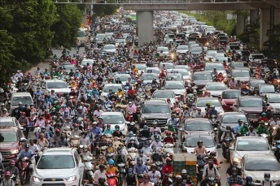  + How do you people travel every day?  + What do you think about the traffic in the picture?  + How about traffic in the future?  → People travel by different means of transport such as cars, motorbikes, bicycles, buses or on foot  → There's too much traffic on the road. This can easily cause traffic congestion ( traffic jam)  → I think there will be many modern means of transport that will save energy and protect the environment.
Activity 2: Presentation (10’)
Pre-teach Vocab
* Aim: To introduce new vocabulary, To set the context for the introductory conversation;
* Content: learn some vocabularies related to the topic.
* Products: Students read and understand the meaning of vocab.
* Organization of implementation:
Teacher’s and Ss’activities | Content
Pre teach vocabulary  * Teacher use different techniques to teach vocab (pictures, situation, realia)  ** Follow the seven steps of teaching vacab.  *** Repeat in chorus and individually  **** Copy all the words  * Checking vocab: < Rub out and remmember>  SET THE SCENE: PRE- QUESTIONS  * Teacher draws students’ attention to the pictures in the textbook and asks them some questions about the pictures. Teacher don’t confirm whether theirs are right or wrong.  ** Ss work out and answer questions in pairs.  *** Ss share their answers as a whole class.  **** T asks them to read and listen to the conversation to check their answers. | * Vocabulary  1. eco – friendly (a) /ˈiː.kəʊˌfrend.li/:thân thiện với môi trường  2. fume (n) /fjuːm/: khói  3. hyperloop (n) /ˈhaɪ.pərluːp/: hệ thống giao thông tốc độ cao  4. teleporter (n) /ˈtel.ɪ.pɔː.tər/: phương tiện di chuyển tức thời  5. campsite (n) /ˈkæmp.saɪt/: địa điểm cắm trại  * PRE- QUESTIONS  + Who are they?  + Where are they?  + Where are they going?  + What can you see outside the coach?  + What can you see in the bubble?  + What could they be talking about?  * Suggested answers:  + They are Minh and Ann.  + They are on a coach.  + They are going to the campsite.  + Outside the coach, we can see the crowded street. There is a traffic jam.  + In the bubble, there is a system of tubes. Minh is thinking about means of transport.
Activity 3: Practice: (20’)
Task 1 +Task 2
* Aims: To practice the targeted language and the background knowledge
* Content: Listen and read the conversation
* Products: Students read and understand the meaning of the conversation
Students know how to role play
* Organization of implementation:
Teacher’s and Ss’activities | Content
Task 1 + 2  * Teacher plays the recording, asks students to underline the words related to the topic. (Teacher may check the meaning of some words if necessary.)  Teacher can play the recording more than once.  Students listen and read.  ** Teacher can invite some pairs of students to read aloud.  *** Teacher refers to the questions previously asked.  **** Then, teacher confirms the correct answer: “Ann and Minh are talking about future modes of travel. | Task 1: Listen and read.  ? What are Ann and Minh talking about?  (Ex 1, 2, p. 114, 115)  A. Travelling by teleporter  B. Future modes of travel  C. Being in a traffic jam  *Answer key: 2B
Task 3
* Aims: To help Ss read for specific information about Ann and Minh’s conversation.
* Content: Read the conversation again and tick T (True) or F (False).
* Products: Students give the corect answers
* Organization of implementation:
Teacher’s and Ss’activities | Content
Task 3  * Teacher asks Ss to work in pairs to read the conversation again and underline the key words in each sentence.  ** Ss work in pairs to do the task.  *** Ss answer and point out where in the conversation they find the information for their answers.  **** Teacher checks the answers as a class. | Task 2: Read the conversation again and tick T (True) or F (False). (Ex 3, p. 115)  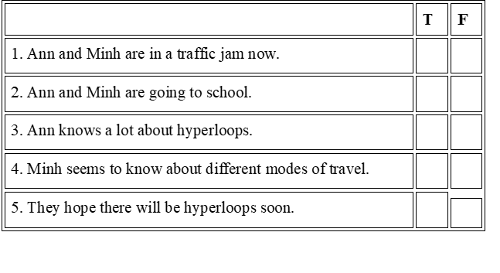  * Answer keys: 1. T 2. F 3. F 4. T 5. T
Task 4
* Aims: To help Ss recognise the words / phrases used to describe means of transport; – To help Ss further understand the text.
* Content: Find the words and phrases that describe the means of transport
* Products: Ss write them in the correct columns.
* Organization of implementation:
Teacher’s and Ss’activities | Content
Task 4  * Teacher asks Ss to work in pairs to read the conversation again and to underline the words / phrases that describe means of transport: hyperloop and teleporter.  ** Ss work in pairs to pick out words / phrases they have found to write down in the correct column.  *** Teacher asks some Ss to read out words / phrases they have found in the conversation to put into each column.  **** Teacher checks the answers as a class | Task 4 : Find the words and phrases that describe the means of transport in the conversation and write them in the correct columns. (Ex 4, p. 115)  * Answer keys:  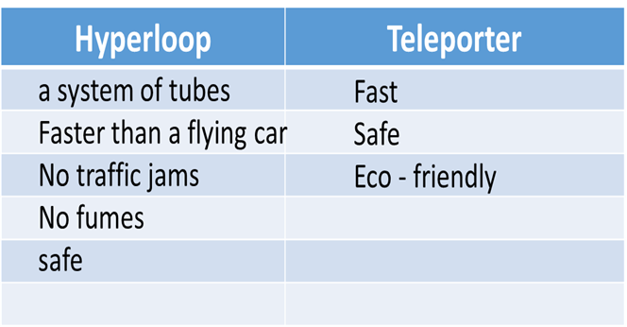
Activity 4: Production:(5’)
Task 5
* Aims: – To help Ss review vocabulary related to different means of transport;
– To give Ss a chance to develop creative thinking;
* Content: Quiz - What vehicle is this?
* Products: Practise in pairs and give correct answers.
* Organization of implementation:
Teacher’s and Ss’activities | Content
Task 5  * Teacher asks Ss to work in pairs to discuss to find out the vehicles in these sentences.  ** Ss work in pairs to do the task  *** Teacher reads out loud each question and the pairs answer. The pair who correctly completes its first wins  **** Teacher confirms the answers.  * Then, teacher has Ss work in pairs again to discuss how the vehicles they have thought of will be like in 50 years.  ** Ss work in pairs to do the task.  *** Teacher calls SS give any description about future means of transport they can imagine.  **** Teacher corrects grammar or pronunciation mistakes if needed. | Task 5: Quiz (Ex 5, p. 115)  What vehicle is this?  * Answer keys:  1. bicycle / bike  2. car  3. train  4. sailing boat  5. rocket / spaceship  --:>What do you think these vehicles will be like in 50 years?  I think people will use some of these vehicles in 50 years. They will be innovated to save more energy and save the environment.
Activity 5: Consolidation (3’)
* Aim: To consolidate what students have learnt in the lesson.
* Content:. Summarize the main content what students have learnt in the lesson.
* Products: Some Ss say aloud in front of the class.
* Organization of implementation:
Teacher’s and Ss’ activities | Content
- Teacher asks students to talk about what they have learnt in the lesson.  - Ss work indepently | - Some new words  - Read and understand content of the conversation
* Homework (2’)
* Aim: To revise the lesson and prepare for the next lesson.
* Content: Review the lesson and prepare for the next lesson ( A closer look 1)
* Products: Students’ textbook and workbook.
* Organization of implementation
Teacher’s and Ss’ activities | Content
- T reminds Ss to do homework and prepare the new lesson. | - Learn by heart all the new words.  - Read  the dialogue again.  - Prepare lesson 2 ( A closer look 1).

*- Complement:
………………………………………………………………………………………………………………………………………………………………………………………………………………………….

