Date of preparing:
Date of teaching:
UNIT 10: ENERGY SOURCES
Period 85: Lesson 5: SKILLS 1
I. OBJECTIVES:
By the end of this lesson, students will be able to gain:
1. Knowledge
+ Reading:
- read for specific information about renewable and non-renewable sources of energy.
+ Speaking:
talk about advantages and disadvantages of different sources of energy
2. Competence
- Develop communication skills
- Be collaborative and supportive in pair work and team work
- Actively join in class activities
3. Educational aim:
- Develop awareness of saving the energy sources
II. TEACHING AIDS:
Grade 7 textbook, Unit 10, Skills 1
Computer connected to the internet
TV/ Pictures, cards
Sachmem.vn
III. PROCEDURES:
* Activity 1: Warm-up (5’)
* Aim: To activate students’ prior knowledge and vocabulary related to the topic of reading and To lead in the lesson about Skills 1.
* Content: Think of the word which has 9 letters in it related the topic “ENERGY SOURCES”.
* Products: Ss give the correct answers.
* Organization of implementation:
Teacher’s and Ss’activities | Content
Warm up  * Teacher divides class into 2 teams and asks them to think of the word which has 9 letters in it related the topic “ENERGY SOURCES”.  ** Ss have 1 min to think of the words related to the topic or they can discuss with their partners.  *** Each member from each team turn by turn guesses the letter in the secret word.  **** Teacher corrects their answers.  The team which can find or guess the secret first will be the winner.  → Teacher leads students into the lesson by telling what they are going to learn: “We are going to read a passage about renewable and non-renewable source of energy.” | * Warm up: Game: Hangman  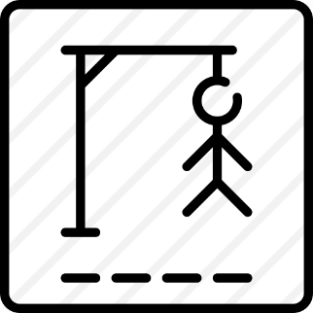  R E N E W A B L E
* Activity 2: Reading (5’)

Presentation vocab.
* Aim:. To provide students with some lexical items before reading the text.
* Content: Learn some vocab related the topic.
* Products: Read and understand the meaning of words.
* Organization of implementation:
Teacher’s and Ss’activities | Content
- Pre teach vocabulary  * Teacher use different techniques to teach vocab (pictures, situation, explaination…..)  ** Repeat in chorus and individually  *** Copy all the words  **** Checking vocab: Checking: Call words in EL | * Vocabulary  - produce (v)/prəˈdjuːs/: Sản xuất  = to make things, mostly in large quantity  Examples: Companies produce many toys for children before Christmas.  - limited (a)/ˈlɪmɪtɪd/: bị hạn chế  = not very great in amount or extent  Examples: coal, oil, …  - available (a) /əˈveɪləbl/: có sẵn  Hydro energy is available, clean and safe to use.  - Electrical appliances /ɪˈlɛktrɪkəl əˈplaɪənsɪz/ (n.phr) Thiết bị điện  *Checking: Call words in EL
* Pre -reading (5’)
Task 1:
* Aims: To introduce words related to skin conditions to Ss and help Ss have a general idea of what they are going to read.
* Content: Discuss the following questions.
* Products: Ss give the answers exactly.
* Organization of implementation:
Teacher’s and Ss’activities | Content
Task 1  * Teacher asks Ss to work in pairs to look at the Picture in Ex1 and discuss to answer the questions.  ** Ss work in pairs.  *** Teacher calls some Ss to check what they have discussed.  **** Teacher corrects | Task 1: Work in pair. Discuss the following questions.  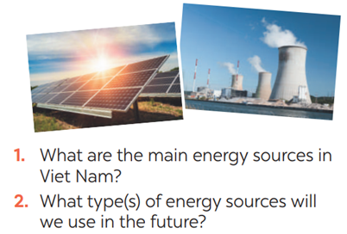  → They are hydro energy and energy from coal.  →We will use solar energy and wind energy.
* While -reading(5’)

Task 2 + 3
* Aims: To help Ss develop their reading skill for details and specific information.
* Content: Read the text and choose the best option (A, B, or C) to complete the sentences.
* Products: Ss say aloud the correct answer .
* Organization of implementation :
Teacher’s and Ss’activities | Content
Task 2.  * Teacher gives Ss time to: read each question, locate where the information appears in the text, read that part carefully and circle the correct answer.  ** Ss do the task independently  *** Teacher tells Ss to compare their answers in pairs before calling some of them to check.  **** Teacher confirms the correct answer and explains if needed.  Task 3.  * Teacher asks Ss to do the exercise carefully and individually.  ** Ss do the task independently.  *** Teachers has Ss compare their answers in pairs and call some Ss to give their ideas.  **** Teacher checks and confirms the correct answers. | Task 2. Read the text and choose the best option (A, B, or C) to complete the sentences.  * Suggested answers:  1. B 2. A 3. C 3. A  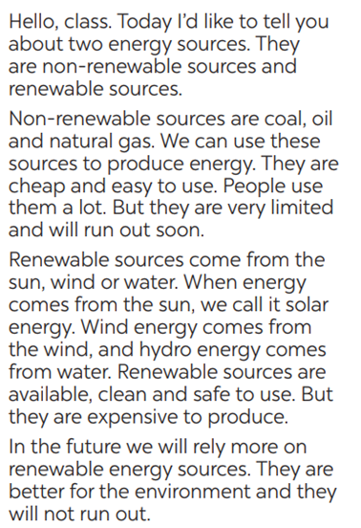  Task 3. Read the text again and answer the questio Answer key:  1. There are two energy sources. They  are non-renewable sources and renewable sources.  2. Non-renewable sources are coal, oil  and natural gas.  3. Renewable sources are available, clean and safe to use.  4. In the future, we will rely more on  renewable energy sources.ns.
* Activity 3 : SPEAKING

Pre-Speaking(5’)

Task 4:
* Aims: To help students identify the advantages and disadvantages of different energy sources.
* Content: Discuss and put the following words or phrases in the appropriate columns.
* Products: Students’ correct answers on the posters.
* Organization of implementation:
Teacher’s and Ss’activities | Content
Task 4  - Have Ss read the instructions to identify how the task is done.  - Have Ss work in groups. Ask them to read the words or phrases provided and discuss which ones are advantages and which are disadvantages.  - Have Ss put the words and phrases in the appropriate columns. T goes around and corrects mistakes or gives help when necessary.  - Call on some Ss to perform the task in front of the class. T and other Ss listen and comment. | Task 4. Work in groups. Discuss and put the following words or phrases in the appropriate columns.  * Key:  + Advantages: easy to use, cheap, available, safe to use, good for the environment  + Disadvantages: run out, limited, expensive
*While-Speaking(10’)

Task 5
* Aims: To help Ss talk about different houses in the future.
* Content: Tell your partners about your future house.
* Products: Some Ss go to the board and tell the class about different houses in the future.
* Organization of implementation:
Teacher’s and Ss’activities | Content
Task 5  * Teacher has Ss work in pairs and asks them to take turns to ask and answer  ** Ss work in pairs to do the task. Teacher goes around, listens and gives help if needed.  *** Teacher calls on some pairs to share their answers with the class.  **** Teacher comments and correct. | Task 5 : Work in pairs. Ask and answer questions about the advantages and disadvantages of different energy sources  A: What are the advantages of hydro energy?  B: It's available, clean and safe to use.  A: What are its disadvantages?  B: It's expensive to produce.  A: What are the advantages of energy from coal?  B: It's cheap and easy to use.  A: What are its disadvantages?  B: It's limited and not good for the environment.
* Activity 4: PRODUCTION(5’)
* Aims: To help students practice presenting the advantages and disadvantages of different types of energy source
* Content: Presentation: Advantages and disadvantages of a source of energy
* Products: Some groups share their answers with the class.
* Organization of implementation:
Teacher’s and Ss’activities | Content
* Teacher has students work in groups to prepare a presentation (poster/pictures/notes…)  *** Teacher calls on some groups to share their answers with the class.  **** Teacher comments and corrects if needed. | Presentation: Advantages and disadvantages of a source of energy
* Activity 5: Consolidation (3’)
* Aims: To consolidate what students have learnt in the lesson.
* Content: Ss summarise what they have learnt with the two skills.
* Products: Students say what they have learnt with the two skills in front of the class.
* Organization of implementation:
- Teacher asks students to talk about what they have learnt in the lesson. | - 2 skills ( talk about advantages and disadvantages of different sources of energy )
* Homework (2’)
* Aim: To revise the knowledge that students have gained in this lesson.
* Content: Review the lesson and prepare for the next lesson .
* Products: Students’ textbook and workbook
* Organization of implementation:
- Teacher asks students to prepare the new lesson | - Do Ex inWB  - Prepare: Skills 2
*- Complement: ………………………………………………………………………………………………………………………………………………………………………………………………………..

Date of preparing:
Date of teaching:
UNIT 10: ENERGY SOURCES
Period 86: Lesson 6: SKILLS 2
I. OBJECTIVES:
By the end of this lesson, students will be able to:
1. Knowledge
+ Listening
use the lexical items related to the topic Energy sources
listen for main ideas and specific information about the topic how to save energy at home.
+ Writing: Write a paragraph of about 70 words about how you save energy at home.
2. Competence
- Develop communication skills
- Be collaborative and supportive in pair work and team work
- Actively join in class activities
3. Educational aim:
Ss will be more aware of saving energy and be more responsiple for protecting the environment.
II. TEACHING AIDS:
- Grade 7 textbook, Unit 10, Skills 2
- Computer connected to the internet
- Pictures
- Sachmem.vn
III. PROCEDURES:
Activity 1: Warm –up (5’)
* Aim: To help students revise the vocabulary items they have learnt in the unit and lead in the next part of the lesson.
* Content: Listen a song and answer the question.
* Products: Ss play in groups and choose the the pair of number correctly.
* Organization of implementation:
Teacher’s and Ss’activities |  | Content
* Teacher has Ss watch video clip about how to save energy at home.  ** Ss watch and then discuss in groups  *** Teacher calls some students to give their answers.  **** Teacher listens and give comments.  -Teacher introduces students the content of the lesson: “In the lesson today, we are going to listen to a person talking about how to save energy at home.” |  | * Warm up : listen a song and answer the question:  What is the song about?  How to save energy at home  Write some ways to save energy in the video clip
Activity 2: Listening ( 15’)
* Pre-Listening
Task 1
* Aim: To help Ss brainstorm the topic and prepare for the listening text.
* Content: Look at the pictures and answer some questions.
* Products: Ss can get some information the content of the conversation.Choose the correct picture.
* Organization of implementation:
Teacher’s and Ss’activities | Content
* Teacher asks Ss to work in pairs to answer the questions in the picture.  ** Ss work with their partner to do the task.  *** Teacher calls on some Ss to answer.  **** Teacher gives comments and leads Ss to task | Task 1: What can you see in this picture? What is special about it?  * Suggested answers:  1- solar energy  2- turn off the tap while brushing your teeth, use paper fan, use low energy light bulbs, turn off the lights when going out,…
* While -listening
Task 2
* Aims: To help Ss listen for specific information about how to save energy at home.
To help students develop their skill of listening for details.
* Content: Listen conversation and tick the column
* Products: Ss give the answers correctly and correct mistakes where necessary
* Organization of implementation:
Teacher’s and Ss’activities | Content
Task 2  * Ask Ss to read the instructions.** Have Ss read the phrases provided and say which one(s) is / are new or difficult. Help them understand the phrases by giving explanations or the Vietnamese equivalents.  ***Play the recording once or twice, if necessary, for Ss to listen and circle the phrases they hear.  ****Have Ss compare their answers in pairs or groups. Then call on some Ss to read aloud the phrases. T checks their answers.  Task 3  * Teacher asks Ss to read and underline the key words.  ** Ss work independently listen to the recording and tick T or F  *** Teacher calls on some students to give the answers the have listened.  **** Teacher corrects and give feedback. | Task 2: Listen and circle the phrases you hear  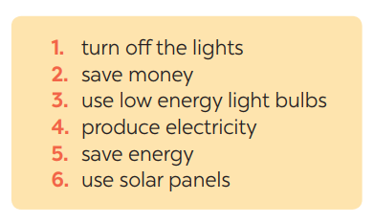  Task 3: Listen again and tick T (True) or F (False) for each sentence  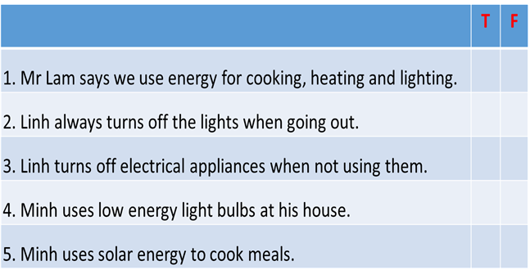  * Answer key:  Key: 1. T 2.F 3.T 4.T 5. F
Post-Listening
Activity 3 : Pre -writing (15’)
* Aims: To help Ss indentify some ways to save energy at home. To help Ss prepare ideas to write a passage.
* Content: Read some ways to save energy at home. Choose three ways and write them in your notebook.
* Products: Ss answer the Qs correctly.
* Organization of implementation:
Teacher’s and Ss’activities | Content
Task 4  * Teacher asks Ss to write the methods they use to save energy at home then asks them to give out more if they can.  ** Ss think of it and can discuss with their partners.  *** Teacher calls on some Ss to raise their ideas.  **** Teacher listens and confirms. | Task 4: Work in pairs. Read some ways to save energy at home. Choose three ways and write them in your notebook.  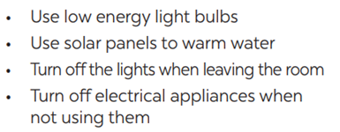
While - Writing
* Aims: To help Ss practice writing a passage about 70 words about how you save energy at home
* Content: write a passage about 70 words about how you save energy at home
* Products: Students write a passage in their notebooks.
* Organization of implementation:
Teacher’s and Ss’activities | Content
Task 5  * Teacher tells Ss that they are going to write a passage about how you save energy at home.  ** Teacher reminds Ss of the structure of a passage and steps to make an outline for the passage.  ** * Ss work independently to do the task and try to use the notes from the previous tasks.  Teacher goes around and help if necessary. | Task 5: Write a paragraph of about 70 words about how you save energy at home.  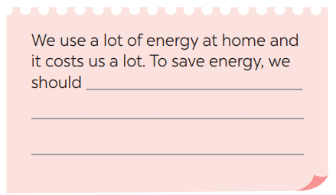
Activity 4 : Post-Writing(5’)
* Aim: To peer check, cross check and final check students’ writing.
* Content: Students’ writing and cross check.
* Products: Students’ writing.
* Organization of implementation:
Teacher’s and Ss’activities | Content
*** Teacher asks Ss to share their writing with their partners. Then, call on some Ss to show their writing in front of the class.  **** Teacher checks ideas, grammar, vocabulary and gives comments. | Task 5: Students’ writing and cross check.  We use a lot of energy at home and it costs us a lot. To save energy, we should use low energy light bulbs in all rooms. We need to turn off electrical appliances such as lights, TVs, fans when we do not use them. We should also put solar panels on the roof of our houses to heat water.
Activity 5 : Consolidation (3’)
* Aim: To consolidate what students have learnt in the lesson.
* Content: Summarize the content of the lesson.
* Products: A student says what she/ he has learnt in the lesson.
* Organization of implementation:
Teacher’s and Ss’ activities | Content
- Teacher asks students to talk about what they have learnt in the lesson. | - Listen a passage about dream house.  - Write a paragraph of about your dream house.
Homework (2’)
* Aim: To revise the knowledge that students have gained in this lesson.
* Content: Review the lesson and prepare for the next lesson and do exersie in the workbbook
* Products: Students’ textbook and workbook.
* Organization of implementation
Teacher asks students to rewrite their writing in their books.  - Teacher asks students to prepare the new lesson. | Rewrite the writing in the notebook.  - Prepare “ Looking back and project”
*- Complement: …………………………………………………………………………………………………………………………………………………………………………………………………….

Date of preparing:
Date of teaching:
UNIT 10: ENERGY SOURCES
Period 87: Lesson 7: LOOKING BACK and PROJECT
I. OBJECTIVES:
I. Objectives
By the end of this lesson, students will be able to:
1. Knowledge
review the vocabulary and grammar of Unit 10
apply what they have learnt (vocabulary and grammar) into practice through a project.
2. Core competence
- Develop communication skills and creativity
- Be collaborative and supportive in pair work and team work
- Actively join in class activities
3. Personal qualities
- Be benevolent and responsible
- Develop self-study skills
II. MATERIALS:
Grade 7 textbook, Unit 10, Looking back & Project
Computer connected to the internet
TV/ Pictures, A0 cards and colours
sachmem.vn
III. PROCEDURES : (STAGES)
Activity1: Warm up: (5’)
* Aim: To revise the vocabulary related to the topic .
To enhance students’ skills of cooperating with team mates
* Content: * Brainstorming – Write about household appliances.
* Products: The group having the most suitable answers is the winner.
* Organization of implementation:
Teacher’s and Ss’activities |  | Content
* Warm up (Team work)  - Teacher divides the board, and divides the class into 2 big groups.  - Teacher asks students to write some ways to save energy at home.  - Members from 2 teams take turns writing ways to save energy on the board.  - The group having the most suitable answers is the winner. |  | * Warm up: * Brainstorming  How to save energy  at home.  -turn off the lights.  - save money.  - use low energy light bulbs .  - produce electricity .  - save energy.  - use solar panels
Activity 2: VOCABULARY (15’)
* Task 1
* Aim: To help Ss revise the vocabulary items (verbs) they have learnt in the unit.
* Content: Match the adjectives in A with the nouns in B to make phrases
* Products: Some students read the words aloud.
* Organization of implementation:
Teacher’s and Ss’activities | Content
Task 1:  * Teacher has Ss work individually.  ** Ss do this activity individually, then compare their answers with their partners.  *** Teacher asks for Ss’ answers.  **** Teacher confirms the correct ones and asks students to make sentences using the phrases. | Task 1: Match the adjectives in A with the nouns in B to make phrases  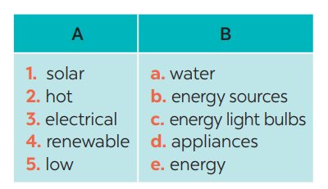  * Answer keys:  1. e 2. a 3. d 4. b 5. c
Task 2
* Aims: To help Ss revise the vocabulary items (adjectives) they have learnt in the unit.
* Content: Complete the sentences, using the phrases in 1
* Products: Complete the sentences by writing the correct phrases on the boaard.
* Organization of implementation:
Teacher’s and Ss’activities |  |  | Content
Task 2  * Teacher has Ss work individually.  ** Ss do this activity then compare their answers with their partners.  *** Teacher asks for Ss’ answers.  **** Teacher confirms the correct ones |  |  | Task 2: Complete the sentences, using the phrases in 1  * Answer keys:  1. low energy light bulbs  2. electrical applicances  3. renewable energy sources  4. solar energy  5. hot water
Activity 3: GRAMMAR (15’)
Task 3,4
* Aims: To help Ss revise grammar points.
* Content: Complete the sentences with will , won’t, might, might not.
* Products: Ss read the complete sentences in front of the class.
* Organization of implementation:
Teacher’s and Ss’activities |  |  | Content
Task 3.  * Teacher asks Ss to recall the structures of “The present continuous”, and tell them to do Ex 3 in the book.  ** Ss do the exercise individually and swap with their partners.  *** Teacher calls some Ss to check their answer.  **** Teacher confirms the correct answer.  Task 4  * Teacher asks Ss to do the task.  ** Ss work individually to do the task.  *** Teacher calls Ss to give out their answers.  **** Teacher checks and confirms their answer. |  |  | Task 3: Complete the sentences by using the correct form of the present continuous or present simple of the verbs in brackets.  * Answer keys:  1- is raining  2- start  3- is walking  4- does  5- am writing  Task 4: Find ONE mistake in each sentence and correct it.  * Answer keys:  1. do -> are doing  2. explain -> explaining  3. is -> are  4. use -> using  5. look -> are looking
Activity 4: Project
* Production (5’):
* Aims: To allow students to apply what they have learnt (vocabulary and grammar) into practice through a project.
* Content: * PROJECT: How to save energy in your school
* Products: Students’ project on the posters.
* Organization of implementation:
Teacher’s and Ss’activities |  |  | Content
Task 5  * Have students read the instruction of how to do the project.  ** Teacher asks Ss to discuss in groups of 4-6  Teacher also has Ss spend some time to make their brainstorm, narrow down the ideas, make a poster out of these ideas and practice presenting within their groups.  *** Some students raise their ideas and explain their answers among groups  **** Teacher listens, correct (if needed) and confirms.  Task 6  Poster presentation  * Teacher asks Ss to work in groups of 4 – 6 to stick their posters onto the classroom’s wall and present about them.  ** Ss work in group to do the task.  *** Teacher calls some groups to present their poster to the class  **** Teacher confirms and corrects. |  |  |   Task 5:* PROJECT: Discussion: Which tips can be applied in your schol.  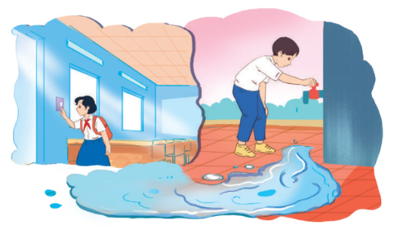  Task 6  * Poster presentation: How to save energy in your school  Hello everyone, today our group will talk about some tips to save energy in our school. First, we should turn the lights off when you leave the classroom because this saves electricity. Second, we should turn off electrical appliances when they are not in use. A variety of different electronic devices and appliances can consume electricity even when they're turned off, so it’s important to switch them off after using. Finally, we should check that none of your taps around the school are dripping. This helps saving a large amount of water every day
Activity 5: Consolidation (3’)
* Aim: To consolidate what students have learnt in the lesson.
* Content: Summarize the content of the lesson.
* Products: A student says the lesson’s content aloud.
* Organization of implementation:
Teacher’s and Ss’activities |  |  | Content
- Teacher asks students to talk about what they have learnt in the lesson. |  |  | - revise vocabulary and grammar in unit 10  - make Project: “How to save energy in your school ”
* Homework (2’)
* Aim: To revise the knowledge that students have gained in Unit 10 and To prepare for the next lesson
* Content: Review the lesson and prepare for the next lesson and do exersie in the workbbook
* Products: Students’ textbook and workbook.
* Organization of implementation:
Teacher’s and Ss’ activities |  |  | Content
- Teacher asks students to revise old lesson and to do exercise in workbook.  - Teacher asks students to complete the project and prepare the new lesson. |  |  | - Complete the project  - Prepare for the next lesson: Unit 11 ( Getting started)
*- Complement: ………………………………………………………………………………………………………………………………………………………………………………………………………………

