Date of preparing:
Date of teaching:
UNIT 10: ENERGY SOURCE
Period 84: Lesson 4: COMMUNICATION
I. OBJECTIVES:
By the end of this lesson, students will be able to:
1. Knowledge
- Everyday English: Asking for explanations
- Speaking skill: how well your partner saves energy.
2. Competence
- Develop communication skills
- Be collaborative and supportive in pair work and team work
- Actively join in class activities
3. Educational aim:
- Ss have the responsibility for themselves, for community and for the country about advantages and disadvantages of different sources of energy.
- Develop awareness of saving the energy sources
II. TEACHING AIDS:
- Grade 7 textbook, Unit 10, Communication
- Computer connected to the internet
- TV/ Pictures/ Projector
- Sachmem.vn
III. PROCEDURES:

Activity 1: Warm-up (5’)
* Aim: To introduce the topic; To lead in the lesson.
* Content: * Game: Pass the secret
* Products: Ss play in groups by writing the correct words on the board.
* Organization of implementation:
Teacher’s and Ss’activities |  |  | Content
* Warm up  * Teacher divides class into 2 teams and asks them to play a game “Pass the secret”  ** Ss have 1 min to pass the words related to the topic  *** Teacher shows the group leader words related to the lesson topic.  Then the leader passes it on to the next member of the team.  **** Teacher corrects their answers.  The team which has more correct words will be the winner  → Lead in  Teacher leads students into the lesson by telling what they are going to learn: “We are going to learn how to ask and answer for explanations and find out how well we save energy”. |  |  | * Game: Pass the secret  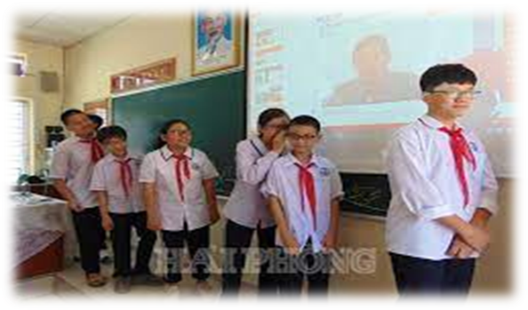  * Suggested answers:  Solar, hydro, coal, natural gas, oil, wind,…
Activity 2: Presetation ( 15’)
* EVERYDAY ENGLISH
Asking for explanation
Task 1 + 2
* Aim: To let students know the structure to ask and answer for explanation
To help students practice on how to ask and answer for explanations.
* Content: Listen and read the conversation. Pay attention to the highlighted questions.
Make similar conversations to ask for explanations.
* Products: Ss know the way to ask and answer for explanation .
* Organization of implementation:
Teacher’s and Ss’activities |  | Content
Task 1  * Teacher plays the record for SS to listen and read the conversation.  ** Ss listen and practice saying with their partners.  *** Teacher calls some pairs to read aloud.  **** Teacher corrects pronunciation if needed.  * Teacher asks Ss to pay attention to the highlighted parts and asks them some questions to elicit the new structure:  - Which tense do we use to ask and answer?  - Which question word and verb do we use?  - …..  ** Ss answer teacher’s questions to find out new structure to ask and answer for explanations.  *** Some students give the new structure to the teacher.  **** Teacher corrects and writes on the board  Task 2  * Teacher has SS look at the phrases in Ex 2 to make similar dialogue.  ** Ss work in pairs to make similar dialogue.  *** Teacher calls some pairs to present it in front of the class.  **** Teacher gives feedback and some comments |  | Task 1: Listen and read the conversation. Pay attention to the highlighted questions.  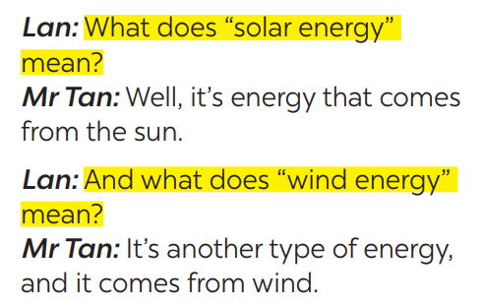  - Structure:  to ask:  - What do/does + S + mean?  to answer:  - S + mean(s)/be …  Task 2: Work in pairs. Make similar conversations to ask for explanations.  .Suggested answers:  A: What does hydro energy mean?  B: It’s energy that comes from the sun. What does nuclear energy mean?  A: It’s energy that comes from the nuclear power.
Activity 3: SAVING ENERGY (10’)
Task 3
* Aims: To provide students with more awareness of ways to save energy and help them practice the skill of speaking.
* Content: Work in groups. Speech: how well your partner saves energy.
* Products: Some pairs ask and answer the questions in front of the class.
A few group representatives to perform the task in front of the class.
* Organization of implementation:
Teacher’s and Ss’activities | Content
* Have Ss read the instructions to understand what they are going to do.  ** Teach new words (e.g. public transport, low energy light bulbs, .„). Check comprehension.  ***Have Ss work in pairs, one student in each pair asks the questions and ticks the other's answers in the boxes.  ****Select one or two pairs to ask and answer the questions in front of the class. Praise them when they give the answers.  * Have Ss read the instructions. Then let them read the example to understand how to do the task.  ** Teacher gives students time to prepare. Meanwhile, teacher walks around the classroom to help students if they have difficulties find proper words/phrases/structures  *** Teacher calls some Ss to read aloud their work  **** Teacher let Ss listen and correct mistakes (if needed). | Task 3: Work in pairs. Ask your partner the following questions and tick his or her answers in the boxes.  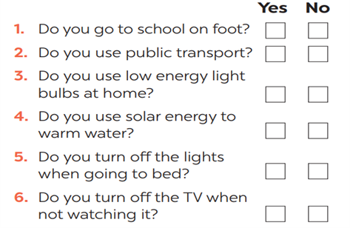  Task 4: Work in groups. Speech: how well your partner saves energy.  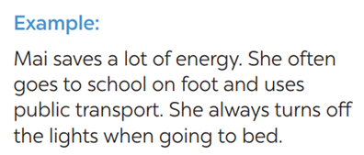
Activity 4: Production (10’)
* Aims: To help students practicing speaking about saving energy
* Content: Speech: how well you save energy
* Products: Some students perform the task in front of the class.
* Organization of implementation:
Teacher’s and Ss’activities | Content
Task 5  * Teacher allows students time to answer the questions onto their notebooks and prepare.  ** Ss work individually.  *** Ss can practicing sharing to their partners  **** Teacher calls some students to read aloud their work. Teacher let Ss listen and correct mistakes (if needed). | Task 5: Answer the questions in 3 on your own. Speech: how well you save energy  I save lots of energy. I walk to school every day. I always turn off the TV when not watching it . and my family is using low energy light bulbs at home.
Activity 5: Consolidation (3’)
* Aims: To consolidate what students have learnt in the lesson.
* Content: Summarize the content of the lesson.
* Products: Say aloud what they have learnt in front of the class.
* Organization of implementation:
Teacher’s and Ss’activities | Content
Teacher asks students to talk about what they have learnt in the lesson. | - how to ask and answer for explanations  - how well you save energy
* Homework (2’)
* Aim: To revise the knowledge that students have gained in this lesson. And prepare for the next lesson: Skills 1.
* Content: Review the lesson and prepare for the next lesson and do exercise in the workbook
* Products: Students’ textbook and workbook
* Organization of implementation:
Teacher’s and Ss’ activities | Content
- T reminds Ss to do homework and prepare the new lesson. | - Do exercise in WB  - To prepare for the next lesson: Unit 10- Skills 1.
*- Complement: ………………………………………………………………………………………………………………………………………………………………………………………………………….

