Date of preparing:
Date of teaching:
UNIT 10: ENERGY SOURCE
Period 83: Lesson 3: A CLOSER LOOK 2

I. OBJECTIVES:
By the end of this lesson, Ss will be able to gain:
1. Knowledge
Know how to use: THE PRESENT CONTINUOUS
Structure | Examples
1. Affirmative sentences: S + be + Ving | She is playing basketball in the school yard.
2. Negative sentences: S + be not + Ving | They are not using solar energy.
3. Y/N questions: Be + S + Ving? | Are you working on your Project?
4. W questions: W + S + be + Ving? | Where is your brother studying?
2. Competence
- Develop communication skills and cultural awareness
- Be collaborative and supportive in pair work and teamwork
- Actively join in class activities
3. Educational aim:
- Develop awareness of conserving the energy sources
II. TEACHING AIDS:
- Grade 7 textbook, Unit 10, A closer look 2.
- Computer connected to the internet
- Projector/ TV/ pictures.
- Sachmem.vn
III. PROCEDURES:
Activity 1: Warm-up (5’)
* Aim: -To activate students’ knowledge on the topic of the unit
-To enhance students’ skills of cooperating with team mates
* Content: Game: Sentence puzzling.
* Products: Ss have to work in groups to create as many correct sentences from the word cards.
* Organization of implementation:
Teacher’s and Ss’activities |  | Content
Warm up (group work)  * Teacher gives instructions  ** Teacher divides the class into 4 groups. Teacher delivers a set of word cards which are jumble sentences in present continuous to each group.  ** Students will have to work in groups to create as many correct sentences from the word cards as possible. The group with more correct sentences will be the winner.  **** Teacher checks and corrects if Ss make the sentences incorrectly.  →Lead in  Teacher says: “This lesson today we are going to revise how to use the present continuous ” |  | * Warm-up: JUMBLE SENTENCES  * Suggested answers:  1. She is learning English now.  2. They are not using solar energy.  3. Are you working on your Project?  4. Where is your brother studying?  5. She is playing basketball in the school yard.
Activity 2: Presentation (10’)
* Aim: To help Ss revise the use of the present continuous.
* Content: Revise the use of the present continuous.
* Products: understand and know how to use of the present continuous.
* Organization of implementation:
Teacher’s and Ss’activities | Content
* Pre – grammar  * T ask Ss look at the Remember on the screen.  ** Ss read the usage and study the example.  *** Ss may discuss within groups/pairs before answering.  **** Teacher shows and says the sentences aloud and asks Ss to make similar sentences. | * Grammar 1:  the present continuous  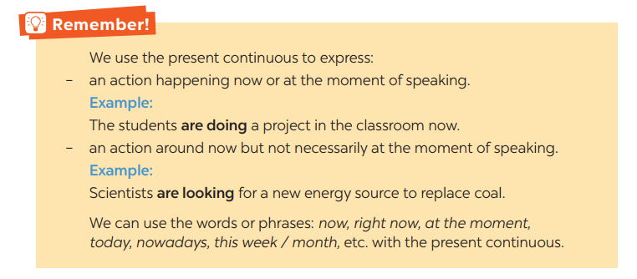
Activity 3: Practice (20’)
Task 1+ Task 2
* Aims: - To help Ss revise the use of the present continuous.
- To practice using the present continuous.
* Content: Work in pairs. Tell your partner what the people in the pictures are doing
* Products: Ss write the answers on the board correctly.
* Organization of implementation:
Teacher’s and Ss’activities | Content
Task 1  * Teacher asks Ss to look at the pictures and work in pairs. Teacher asks them how would they ask and answer (using Present continuous)  ** Ss work out and answer questions with a partner.  *** Ss share their answers in pairs.  **** T asks them to check their answers.  -Then tell share them to share their sentences as a whole in class and correct for them.  Task 2  * Have Ss read the sentences individually. Draw their attention to the words or phrases in each sentence that can be used with the present continuous such as now, today, nowadays, keep quiet, etc. Check comprehension.  ** Before doing the task,T may ask Ss how to use the appropriate present continuous form of the verbs in brackets to complete the sentences.  *** Get them to swap their answers in pairs or groups. Go around and offer help, if necessary.  **** Call on some Ss write the answers on the board. T and other Ss comment. | Task 1. Work in pairs. Tell your partner what the people in the pictures are doing  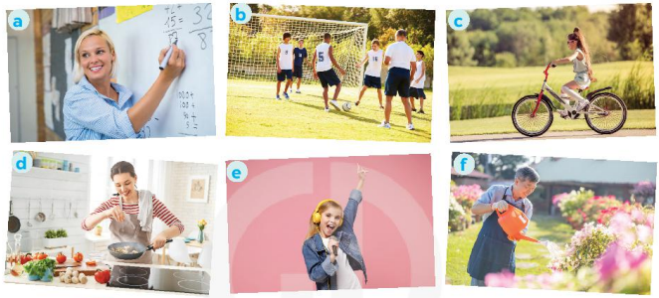  * Answers:  a- She is teaching maths/ is writing on the board.  b- They are play football/soccer.  c- She is riding her bike/bicycle.  d- She is cooking.  c- She is singing.  f- He is watering the flowers/plans/is doing gardening.  Task 2: Complete the sentences, using the present continuous form of the verbs in brackets.  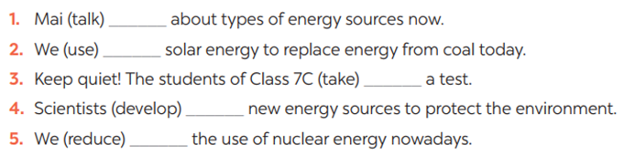  * Answers:  - is talking  - are using  - are taking  - are developing  5. are reducing
Task 3
* Aims: To help Ss distinguish the use of the present continuous from the present simple.
* Content: Circle the correct form of the verb in each sentence
* Products: Students say aloud their answers in front of the class.
* Organization of implementation:
Teacher’s and Ss’activities | Content
Task 3  * Have Ss read the instruction.  ** Give Ss time to do the task individually. Draw their attention to the words or phrases that can be used with the present continuous (e.g. now, this year, at the moment, right now) and with the present simple (e.g. three times a week). Check comprehension.  *** Get them to swap their answers in pairs or groups. Go around and offer help, if necessary.  **** If there is time, have some Ss write the answers on the board. T and other Ss comment. | Task 3: Circle the correct form of the verb in each sentence  1. Are you still work / working on your project now?  2. Nam and Lan do / are doing quite well at school this year.  3. Does she study / Is she studying at the school library at the moment?  4. Hoa studies / is studying for her exam, so she can't come to the party right now.  5. We have / are having English three times a week.  * Key: 1. working 2. are doing 3. Is she studying  4. is studying 5. have
Task 4
* Aims: To help Ss write the present continuous sentences with the suggestions given.
* Content: Write sentences about what the people are doing or not doing, using the suggestions.
* Products: Students to say out loud their answers in front of the class.
* Organization of implementation:
Teacher’s and Ss’activities | Content
Task 4  * Teacher gives Ss time to do the exercise individually and peer check with their partner.  *** Teacher nominates Ss to read aloud the sentences. Then asks them to underline the words/phrases that can be found in Present continuous sentences  **** Teacher checks and gives the corrections if they have mistakes. | Task 4: Write sentences about what the people are doing or not doing, using the suggestions.  * Answers:  1- The students are doing the project now.  2- Mrs. Lien is teaching us about solar energy at the moment.  3- They are learning about energy this month.  4- She isn’t swimming in the swimming pool right now.  5- Nowadays, people in Iceland aren’t using energy from coal.
* Production (5’)
Task 5
* Aim: - To practice speaking using the present continuous
* Content: Work in pairs. Ask and answer the following questions.
* Products: Some pairs ask and answer the questions in front of the class.
* Organization of implementation:
Teacher’s and Ss’ activities | Content
Task 5  * Have Ss read the questions and think about what they are doing now, these days, this term, etc.  ** Let Ss ask and answer the questions in pairs.  *** Select one or two pairs to ask and answer the questions in front of the class. Praise their performance.  **** Teacher gives feedback and gives the corrections if they have mistakes. | Task 5: Work in pairs. Ask and answer the following questions.  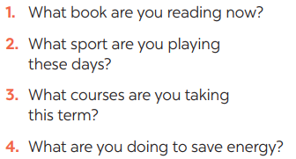
Consolidation (3’)
* Aim: To consolidate what students have learnt in the lesson.
* Content: summarize the main content in the lesson.
* Products: Ss say what students have learnt in the lesson.
* Organization of implementation:
Teacher’s and Ss’ activities | Content
Teacher asks students to talk about what they have learnt in the lesson. | - Grammar: the present continuous tense.  - form and usage.
* Homework (2’)
* Aim: To revise the knowledge that students have gained in this lesson and prepare the new lesson
* Content: Review the lesson and prepare for the next lesson and do exercise in the workbook
* Products: Students’ textbook and workbook
* Organization of implementation:
Teacher’s and Ss’ activities | Content
- T reminds Ss to do homework and prepare the new lesson. | - Do exercises in the workbook.  - Prepare lesson 4 ( communication)
*Complement: ……………………………………………………………………………………………………………………………………………………………………………………………………………..

