Date of preparing:
Date of teaching:
UNIT 10: ENERGY SOURCE
Period 82: Lesson 2: A CLOSER LOOK 1
I. OBJECTIVES:
By the end of this lesson, Ss will be able to gain:
1. Knowledge
- Vocabulary about sources of energy.
- Pronunciation: Stress in three-syllable words
2. Competence
- Develop communication skills and cultural awareness
- Be collaborative and supportive in pair work and teamwork
- Actively join in class activities
3. Educational aim:
- Develop awareness of energy sources and energy saving.
II. TEACHING AIDS:
- Grade 7 textbook, Unit 10, A closer look 1.
- Computer connected to the internet
- Projector/ TV/ small boards, markers.
- Sachmem.vn
III. PROCEDURES:
* Activity 1: Warm-up (5’)
* Aim: To create an active atmosphere in the class before the lesson and To lead in the topic.
* Content: Game - Do the crosswords
* Products: Students choose the number and answer the questions exactly.
* Organization of implementation:
Teacher’s and Ss’activities | Content
Warm -up  * Teacher gives instructions  ** Ss are divided into 2 groups  - Teacher show the crosswords onto the screen with hints/clues and students choose each line and take turn to answer.  - take turns to write until finish all the words or find out the key word.  **** Teacher checks and corrects if Ss pronounce the words incorrectly. | Warm –up : Game - CROSSWORDS  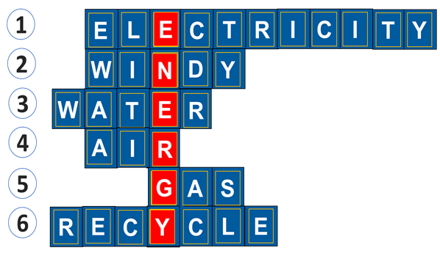
* Activity 2: Presentation (10’)
(Vocab- pre-teach)
* Aim: To introduce the new words.
* Content: Some vocab related to the lesson.
* Products: read and understand the meaning of vocab.
* Organization of implementation:
Teacher’s and Ss’activities | Content
Pre teach vocabulary  * Teacher introduces the vocabulary by:  + Providing the synonym or antonym of the words.  + Providing the pictures of the words.  + Providing the definition of the words.  ** Ss say the words.  *** Teacher shows and says the words aloud and asks Ss to repeat them.  **** Teacher asks Ss to translate the word into Vietnamese | * Vocabulary  1. solar energy (n.phr.) /ˈsōlər ˈenədʒi/: năng lượng mặt trời  2. hydro energy (n.phr.) /ˈhīdrō ˈenədʒi/: năng lượng nước  3. nuclear (n) /njuː.klɪər/: hạt nhân  * Checking vocab: < Rub out and remmember>
* Activity 3: Practice (15’)
Task 1
* Aims: To help Ss identify sources of energy by matching the phrases in A with the words in B.
* Content: Match the types of energy in A with the energy sources in B
* Products: Ss give the correct answers.
* Organization of implementation:
Teacher’s and Ss’activities | Content
Task 1  * Teacher asks Ss to look at the table and match the energy with its source.  ** Ss work out and answer questions in pairs.  *** Ss share their answers as a whole class.  - T asks them to to check their answers.  **** Teacher asks students to make full sentences to tell about the sources of different energy. Then tell share them to share their sentences with a partner and correct for them. | Task 1: Match the types of energy in A with the energy sources in B.  * Answers:  1- D 2 – C 3 – A 4 – B
Task 2
* Aims: To help Ss write the phrases to label the pictures.
* Content: Write the phrases to label the pictures
* Products: Students write correct words on the board.
* Organization of implementation:
Teacher’s and Ss’activities | Content
Task 2  * Teacher asks Ss to look at the pictures and use the knowledge from Task 1 to guess the pictures.  Then work and share their answers with their partners who sit next to them. (peer check)  ** Ss do exercise 3 in pairs.  *** Ss share and discuss with their partners to write all words/ phrases down on the notebooks.  **** Teacher corrects their answers as a class. | Task 2: Write the phrases to label the pictures:  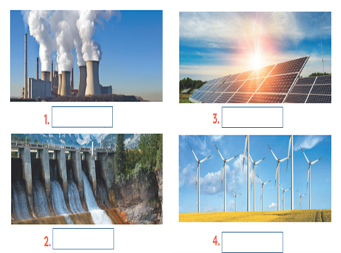  * Answer key:  1. Nuclear energy 2. Hydro energy  3. Solar energy 4. Wind energy
Task 3
* Aims: To help Ss complete the sentences about types of energy and energy sources.
* Content: Complete the sentences with the words and phrases from 1 or 2.
* Products: Some Ss call out their answers in front of the class.
* Organization of implementation:
Teacher’s and Ss’activities | Content
Task 3  * Ask Ss to read the sentences. Draw their attention to the gaps they have to fill in and the key words or phrases in the sentences (e.g. sea breezes, solar panels, hydro energy, not safe to produce,...). Ensure that they know what to do.  ** Give Ss time to do the task individually. Ask them to use the key words or phrases they have learnt in 1 and 2. Go around and offer help, if necessary.  ***Ask Ss to exchange their answers in pairs or groups. Then call on some Ss to call out their answers in front of the class.  **** Check their answers. T explains if necessary. | Task 3: Complete the sentences with the words and phrases from 1 or 2.  * Answer key:  1. A good place to change ________ to energy is near the sea because of the sea breezes.  2. They are putting solar panels on the roof of our building to produce ______.  3. When energy comes from __________, we call it hydro energy.  4. They are reducing the use of__________ because it is not safe to produce.
* Activity 4: PRONUNCIATION (10’)
STRESS IN THREE-SYLLABLE WORDS
Task 4
* Aims: To help Ss practice pronouncing three-syllable words with the correct stress.
* Content: Ss understand and know how to pronounce three-syllable words with the correct stress.
* Products: Listen and repeat the words exactly.
* Organization of implementation:
Teacher’s and Ss’activities | Content
Task 4  * Give Ss a few minutes to look at the words individually. Explain that these words have three syllables.  ** Guide Ss how to stress the nouns and the adjectives with three syllables  *** Play the recording & repeat the words paying attention to the correct stress in three-syllable words. Pause the recording to drill difficult words.  + Have Ss practice saying the words in pairs or groups until they feel confident.  **** Call on some Ss to say the words in front of the class. Correct their pronunciation if necessary. | PRONUNCIATION  Stress in three-syllable words  I. Nhấn trọng âm vào âm tiết thứ nhất  1. Khi thêm các hậu tố sau thì trọng âm từ chính không thay đổi: -ous, -ful, -ed, -ly, -ment, -ness, ... Eg: ‘dangerous; ‘plentiful  2. Những từ có 3 âm tiết mà là danh từ, tính từ, trạng từ thì trọng âm thường ở vần đầu.  Lưu ý: những từ này không chứa tiền tố và hậu tố  Eg: Energy  II. Nhấn trọng âm vào âm tiết thứ hai:  1. Các từ có tận cùng là: -tion, -sion, -ity, -ety, -ic, -ical, -ous, -ive, -ian, -al thì trọng âm rơi vào âm tiết trước đó.  Eg: e’normous , ex'pensive  2. Trọng âm thường rơi vào âm tiết thứ hai nếu:  âm tiết cuối cùng chứa một nguyên âm ngắn và âm tiết thứ hai chứa một nguyên âm dài hoặc một nguyên âm đôi hoặc tận cùng bằng hai phụ âm trở lên.  Ex: a’bundant con’venient  Task 4: Listen and repeat. Pay attention to the stressed syllables in the words.
  'energy  'dangerous  'easily  'government | re'cycle  ex'pensive  po'lluting  re'sources
Task 5
* Aims: To help Ss practice pronouncing three-syllable words with the correct stress in sentences.
* Content: Listen and repeat the sentences. Pay attention to the stress of the underlined words
* Products: Some Ss to read aloud the sentences in front of the class
* Organization of implementation:
Teacher’s and Ss’activities | Content
Task 5  -Give Ss a few minutes to read the sentences. Draw their attention to the underlined words with stress on the first or second syllable. Check comprehension.  -Play the recording, sentence by sentence, for Ss to listen and repeat. Draw their attention to the stress of three-syllable words.  -Have Ss practice saying the sentences in pairs or groups. Go around to offer help or correct pronunciation, if necessary.  -Call on some Ss to read aloud the sentences in front of the class. Correct their pronunciation if necessary. | Task 5: Listen and repeat, paying attention to the stressed syllables in the underlined words.  1.Nuclear 'energy is 'dangerous and ex'pensive.  2. We should ride a bike when 'travelling  short 'distances.  3. The word "re'cycle" has three 'syllables.  4. Burning coal is po'lluting our environment.  5. Our 'government is looking for new sources of 'energy to replace gas.
* Activity 5: Consolidation (3’)
* Aim: To consolidate what students have learnt in the lesson.
* Content: Vocab and how to pronounce the three-syllable words.
* Products: Say aloud some words they remember from the lesson.
* Organization of implementation:
Teacher’s and Ss’ activities | Content
- Teacher asks students to talk about what they have learnt in the lesson | - Vocabulary and how to pronounce the three-syllable words.
* Homework (2’)
* Aim: To revise the lesson and prepare for the next lesson.
* Content: Review the lesson and prepare for the next lesson and do exercise in the workbook
* Products: Students’ textbook and workbook
* Organization of implementation:
Teacher’s and Ss’ activities | Content
- T reminds Ss to do homework and prepare the new lesson. | - Learn by heart all the new words.  - Prepare lesson 3 ( A closer look 2)..
*- Complement
…………………………………………………………………………………………………………………………………………………………….

