Date of preparing:
Date of teaching:
Period 76: REVIEW 3
Lesson 1: LANGUAGE
I. OBJECTIVES:
By the end of this review, students will be able to revise the language they have learnt and the skills they have practiced in Units 7,8,9
1. Knowledge:
* Vocabulary: - revise words related to Units 7,8,9
* Pronunciation: - revise pronouncing the sounds: /aɪ/ and /eɪ/ ; /ɪə/ and /eə/;
pronounce two-syllable words correctly;
* Grammar: To review the grammatical points taught in Units 7-9: connectors (though/however), should/ shouldn't, and Yes/No questions.
2. Competence: Ss revise the language they have learnt and some skills they have practiced in Units 7 – 9; Doing exercises on pronunciation, vocabulary, grammar and everyday English
3. Educational aim:
Know the importance of revision and need to study harder ; Having the serious attitude toward studying and the good relationship with friends.
II. TEACHING AIDS:
1. Teacher: - Grade 7 textbook, Planning ( Review 3)
- Smart TV/Pictures, sets of word cards
- Sachmem.vn
2. Students: Text books, notebooks, posters, ….
III. PROCEDURES:
Activity1: WARM -UP (5’)
* Aim: To to review the words related the unit 7-9
* Content: Game: Write the name of the means of transport; types of films, names of festivals
* Products: Students write words related the topic exactly.
* Organization of implementation:
Teacher’s and Ss’activities |  | Content
* Warm up (Team work)  * Teacher divides the board, and divides the class into 3 teams.  ** Members of each team take turns and write the name of the means of transport; types of films, names of festivals in 2 minutes.  *** Students cross check their answers first.  **** Teacher confirms the answers and gives feedback. The group having more correct answers is the winner. |  | * Warm – up : Write the name of the means of transport; types of films, names of festivals  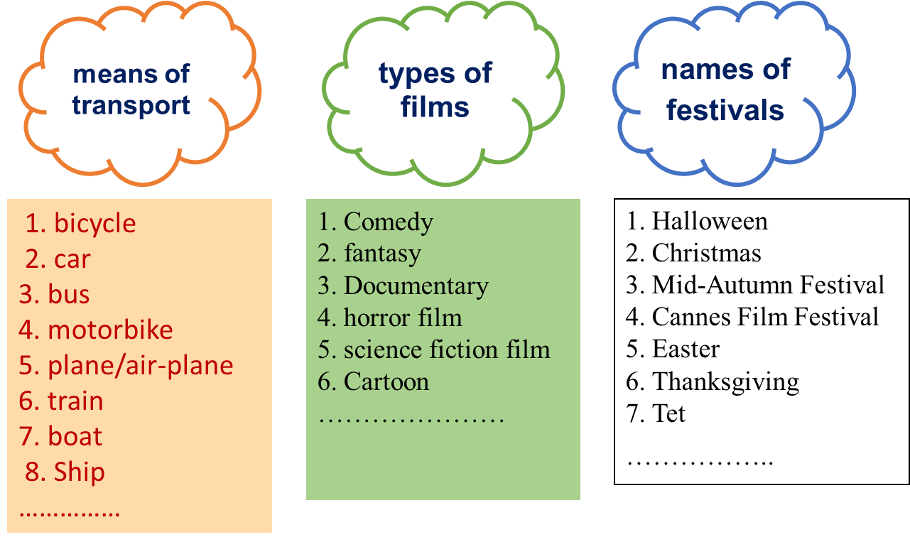
Activity 2: Practice (5’)
PRONUNCIATION
Task 1
* Aim:To help Ss review the pronunciation of the sounds learnt in Unit 7 (/ai/ and /ei/) and Unit 8 (/ ia/ and /ea/), and the pronunciation of two-syllable words learnt in Unit 9.
* Content: Choose the word whose underlined part is pronounced diﬀerently
* Products: Students say the correct answer key.
* Organization of implementation:
Teacher’s and Ss’activities | Content
Task 1  * Ss do this exercise individually,  ** Then share their answers with a partner before giving T the answers.  *** Confirm the correct answers.  **** Have some Ss read out the words.  * Elicit the rules of putting stress in two-syllable words.  ** Ss do this exercise individually then share their answers with their partners before giving T the answers.  ***Confirm the correct answers.  **** Invite some Ss to say the words with correct stress. | Task 1: Choose the word in which the underlined part is pronounced differently.  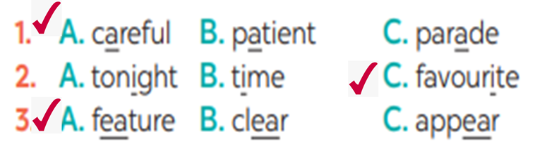  1. b Choose the word which has a different stress pattern from that of the others.  4C 5B
Activity 3: VOCABULARY (15’)
Task 2.
* Aims: To review the meanings of road signs; To review the words related t o films and festivals.
* Content: Write the phrases from the box under the road signs.
* Products: Students say the sentences aloud and pronounce the words and phrases correctly
* Organization of implementation:
Teacher’s and Ss’activities |  | Content
Task 2  * Have Ss do this exercise individually  ** Ss share their answers with their partners.  *** T checks and confirms the correct answers.  **** SS copy down  Task 3:  * Teacher asks students to work individually to choose the correct words and complete the sentences.  ** Students work individually to complete the task.  *** Teacher allows students to share answers before discussing as a class.  **** Teacher asks students to say the sentences aloud and makes sure they pronounce the words and phrases correctly. Teacher can ask for translation to check their understanding |  | Task 2: Write the phrases from the box under the road signs.  1. No left turn  2. Walking only  3. Turn right ahead  4. Road work  5. School ahead  Task 3: Fill in each blank with a suitable word from the box.  * Keys:  1. feast  2. shocking  3. Easter  4. fantasy  5. violent
Activity 4 :GRAMMAR (15’)
Task 4 + 5
* Aims: -To review the grammatical points taught inUnits 7-9: connectors (though/however), should/ shouldn't, and Yes/No questions.
- To review the grammatical points taught in Units 7-9: connectors (although/though), should/ shouldn't, and It indicating distance.
* Content:
* Products: Students say the correct answer key.
* Organization of implementation:
Teacher’s and Ss’activities |  | Content
Task 4  * Ss has Ss do this exercise on their own first. ** Ss compare their answers with a classmate. *** T invites Ss to share their answers. Ask them to explain their answers and correct the mistakes.  **** Confirm the correct answers.  Task 5  * Ss do this individually and compare their answers with a partner.  ** Call some Ss to go to the board to write their sentences.  *** Other Ss comment.  **** Confirm the correct sentences. Revise the structures if needed. |  | Task 4: Which of the underlined parts in each question is incorrect? Find and correct it.  * Answer keys:  1. C 2. B 3. B 4. B 5. C  Task 5: Rewrite the sentences so that they have the same meanings as the original ones. Use the words given in brackets.  * Answer keys:  1.It's / It is about five kilometres from my house to my school.  2.How far is it from Ha Noi to Hai Phong?  3.Although he was tired, he still performed the lion dance. / He still performed the lion dance although he was tired.  4.We/You/They shouldn't walk here because this lane is for cycling only.  5.Though my sister lives far away, she comes back home every Tet. / My sister comes back home every Tet though she lives far away.
Activity 5: Consolidation (3’)
* Aim: To consolidate what students have learnt in the lesson.
* Content: summarize the content of the lesson.
* Products: A student says the lesson’s content aloud.
* Organization of implementation:
Teacher’s and Ss’activities |  | Content
Teacher asks students to talk about what they have learnt in the lesson. |  | - vocabulary and grammar in the lesson
* Homework (2’)
* Aim: To revise the knowledge that students have gained in the lesson and to prepare for the next lesson
* Content: Review the lesson and prepare for the next lesson and do exersie in the workbbook
* Products: Students’ textbook and workbook.
* Organization of implementation:
Teacher’s and Ss’activities |  | Content
- Teacher asks students to revise old lesson and to do exercise in workbook.  - Teacher asks students to complete the project and prepare the new lesson. |  | - Do exercise in workbook.  - Prepare for the next lesson: Review (SKILLS).
*- Complement: ………………………………………………………………………………………………………………………………………………………………………………………………………………….

