Date of preparing:
Date of teaching:
UNIT 9: FESTIVALS AROUND THE WORLD
Period 73: Lesson 5: SKILLS 1

I. OBJECTIVES: By the end of the lesson, students will be able to:
By the end of this lesson, Ss will be able to gain:
1. Knowledge:
- Develop reading skill about an unusual festival
- Develop speaking skill: talking about a festival they enjoy
2. Competence:
- Develop communication skills and creativity
- Be collaborative and supportive in pair work and teamwork
- Develop presentation skill
- Actively join in class activities
3. Educational aims:
- Develop self-study skills
II. TEACHING AIDS:
- Grade 7 textbook, Unit 9, Skills 1
- Computer connected to the internet
- Projector/ TV/ pictures and cards
- Sachmem.vn
III. PROCEDURES:
Activity 1: Warm-up (5’)
* Aim: To introduce the topic of reading; To enhance students’ skills of cooperating with team mates.
* Content: Look at the symbols and then write the names of the festivals
* Products: The team with more correct answers will be the winner.
* Organization of implementation:
Teacher’s and Ss’activities | Content
* Teacher divides the class into 2 teams.  -Each team has to run in a relay to the board to write the correct types of festivals and their symbols and meaning under the posters.  -The team with more correct answers will be the winner.  ** Students play the game in team mode.  *** Teacher and students discuss the answers.  **** Teacher confirms the answers and gives feedback. | Game: Who is faster?  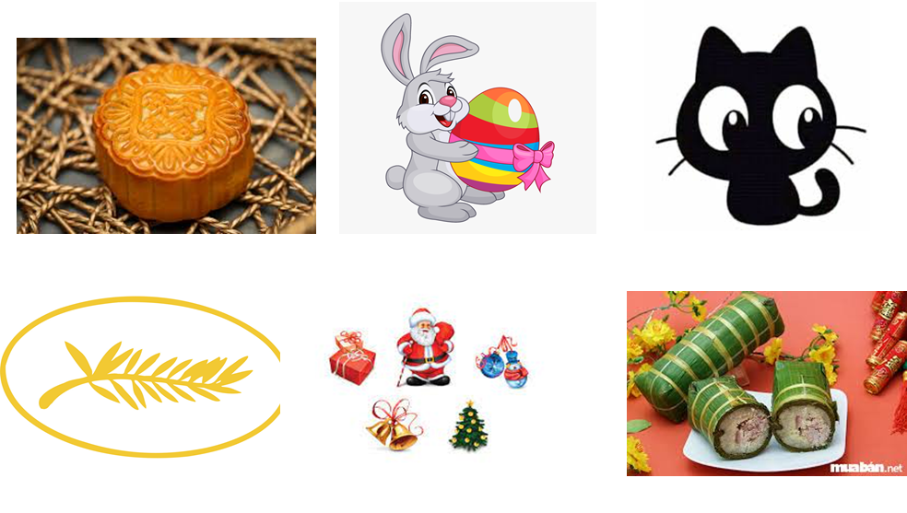
Activity 2: READING (15’)
* Pre -reading
Task 1
* Aim: To activate Ss' knowledge of the topic of the reading text.
* Content: Ss discuss what/who they see in the pictures and answer the questions.
* Products: Students give the answers correctly.
* Organization of implementation:
Teacher’s and Ss’activities | Content
Task 1  * Teacher has students work in pairs, look at the pictures in the book. Ask Ss to discuss what/who they see in the pictures and answer the questions.  ** Students works in pairs.  *** Teacher and students discuss the questions and answers.  **** Teacher accepts all students’ questions. | Task 1: Work in pairs. Look at the pictures. Which events do you think happen at the Twins Day Festival? (p.97)  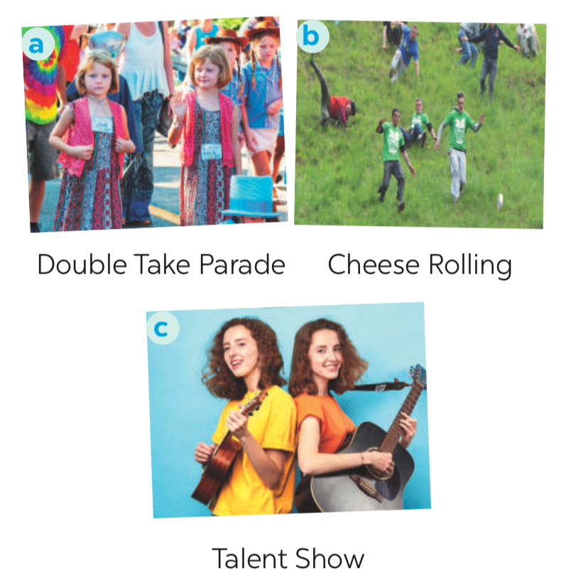
* While -reading
Task 2
* Aims: To provide students with some lexical items before reading the text.
To develop the skill of guessing the meanings of new words in context.
* Content: Learn some vocab related the topic.
* Products: Read and understand the meaning of words.
* Organization of implementation:
Teacher’s and Ss’activities | Content
Checking the meaning of words  * Teacher introduces the vocabulary.  ** Teacher asks students to get the meaning in context and try to make up sentences with of the following words:  *** Teacher and students discuss the answers.  **** Teacher confirms student’s answers and checks their pronunciation and gives feedback.  Task 2:  * Teacher tells Ss what they are going to do. Ask Ss how to do the exercise and elicits answers from Ss.  If needed, tell them that to do the exercise they can follow these steps:  + Read the words in the left column  + Locate each word in the text  + Read around the word to get the general meaning  + Read the definitions in the right column, find the suitable meaning to match each word.  Ask Ss to repeat the steps (they can speak in Vietnamese).  ** Students read the text and do the task in individuals.  *** Teacher allows students to share their answers before discussing as a class and encourages them to give evidence.  **** Teacher calls some students to give the answer, explain which sentence give them the information. | Vocabulary  1. join (v)  2. feature (v)  3. performance (n)  Now quickly read the email below and check your answers.  Answer key:  Pictures 1 + 3: Twins Day Festival  Task 2: Match each word from the email in 1 with its meaning (p.98)  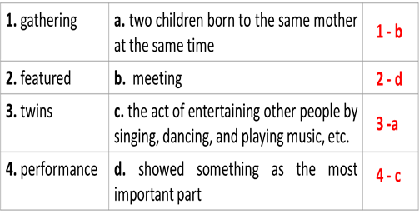
Task 3
* Aims: To develop reading skill for general and specific information.
* Content: Read the email again. Complete each sentence with no more than TWO words.
* Products: Ss play in groups actively and complete each sentence exactly.
* Organization of implementation:
Teacher’s and Ss’activities | Content
Task 3  * Teacher can set a longer time limit for students to read the text again and complete the sentences.  Briefly tell them the steps: read the sentences – underline key words – locate the key words in the text – find the words to complete the sentences.  ** Teacher asks students to work in individuals and find the answer.  *** Teacher allows students to share their answers before discussing as a class and encourages them to give evidence.  **** Teacher calls a student to write his/her answer on the board, then check sentence by sentence with class. | Task 3: Read the email again. Complete each sentence with no more than TWO words (p.98).  Game: Lucky number  * Answer key:  1. first weekend  2. countries  3. walked together  4. performance  5. Fun Run  6. exciting
Activity 3: SPEAKING (15’)
* Pre-Speaking
Task 4
* Aims: To help students identify how to ask and answer about a festival they attended.
* Content: Match the questions and answer about a festival someone joined.
* Products: Students’ correct answers.
* Organization of implementation:
Teacher’s and Ss’activities | Content
Task 4  * Teacher tells Ss they are going to ask and answer about a festival they attended and that this activity can serve as a model for them to follow in the writing task.  ** Teacher asks students to work individually and then check in pairs.  *** Teacher can go around to help weaker students.  **** Teacher call on some pairs to give the answers and check as the whole class. | Task 4: Match the questions and answer about a festival someone joined (p.98).  Answer key:  1. d  2. b  3. e  4. c  5. a
* While-Speaking
Task 5
* Aims: To help students form the ideas for their speaking
* Content: To give Ss practice in asking and answering about a festival Ss attended.
* Products: Students discuss in groups positively
* Organization of implementation:
Teacher’s and Ss’activities | Content
Task 5  * Teacher has students to work in pairs, ask and answer about a festival they attended.  ** Students work in pairs to do the task.  *** Teacher goes around to help students.  **** After finishing, teacher can call some pairs to give presentations in front of the class. | Task 5: Work in pairs. Ask and answer about a festival you and your friend joined, using the questions in 4 as cues. Tell the class about the festival your partner joined.  * Example:  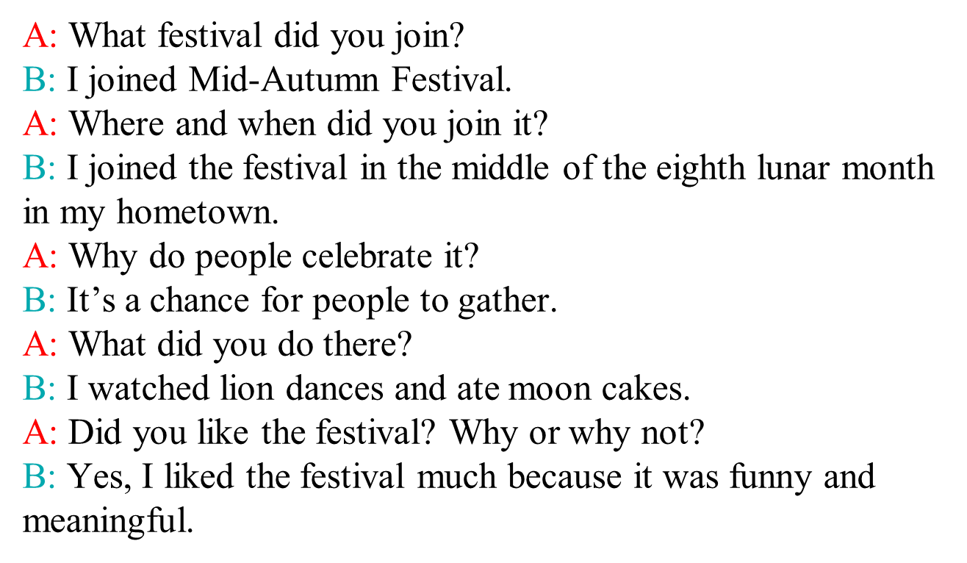
Activity 4: Post – Reading and Speaking (5’)
* Aims: To help students improve next time; To help some students enhance presentation skill
* Content: Share the information with the whole class.
* Products: Students present in front of the class fluently.
* Organization of implementation:
Teacher’s and Ss’activities | Content
* Teacher allows students to give comments for their friends and vote for the most interesting dialogue.  ** Students give comments for their friends and vote for the most interesting dialogue.  *** Teacher and students discuss.  **** Teacher gives feed-back and comments. | * Example:  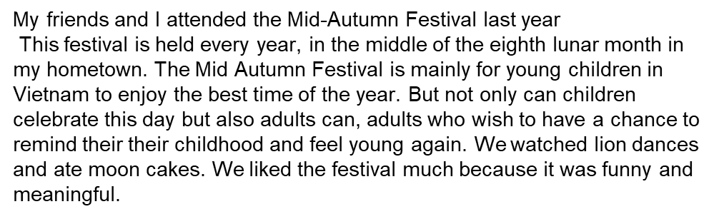
Activity 5: Consolidation(3’)

* Aims: To consolidate what students have learnt in the lesson.
* Content: Ss summarize what they have learnt with the two skills.
* Products: Students say what they have learnt with the two skills in front of the class.
* Organization of implementation:
Teacher’s and Ss’activities | Content
- Teacher asks students to talk about what they have learnt in the lesson. | - some vocab  - Talk about a a festival you and your friend joined.
* Homework (2’)
* Aim: To revise the knowledge that students have gained in this lesson.
* Content: Review the lesson and prepare for the next lesson .
* Products: Students’ textbook and workbook
* Organization of implementation:
- Teacher asks students to prepare the new lesson | - learn by heart vocab.  - Prepare for the next lesson: Unit 9-Skills 2.
*- Complement: ……………………………………………………………………………………………………………………………………………………………………………………………………………..

