Date of preparing:
Date of teaching:
UNIT 8: FILMS
Period 66: Lesson 5: Skills 1
I. OBJECTIVES
By the end of this lesson, students will be able to:
1. Knowledge
- Develop reading skill about one’s favourite film
- Develop speaking skill: Talking about a film
2. Core competence
- Develop communication skills and creativity
- Be collaborative and supportive in pair work and teamwork
- Develop presentation skill
- Actively join in class activities
3. Educational aims:
- Develop self-study skills
II. TEACHING AIDS:
- Grade 7 textbook, Unit 8, Skills 1
- Computer connected to the Internet
- Projector/ TV/ pictures and cards
- sachmem.vn
III. PROCEDURES:
Activity 1: Warm-up (5’)
* Aim: To introduce the topic of reading and also revise the previous lesson.
* Content: play a game: PELMANISM
* Products: Ss work in groups and join the game actively.
* Organization of implementation:
Teacher’s and Ss’activities |  | Content
Warm-up  * Teacher divides the class into 2 teams.  - Each team will have to choose the pair of number ( the correct types of films under the posters)  -The team with more correct answers will be the winner.  ** Students play the game in team mode.  *** Teacher and students discuss the answers.  **** Teacher confirms the answers and gives feedback. |  | Warm-up: PELMANISM  
Activity 2: Reading (20’)
Pre-reading
Task 1:
* Aim: To activate students’ knowledge of the topic of the reading text.
* Content: Look at the picture and answer the questions.
* Products: Students answers the questions in front of the class.
* Organization of implementation:
Teacher’s and Ss’activities |  | Content
Task 1  * Teacher has students work in pairs, ask and answer the following questions:  Do you like fantasies?  Why or why not?  ** Students work in pairs.  *** Teacher and students discuss the questions and answers.  **** Teacher accepts all students’ questions. |  | I/ Reading skill:  Task 1: Work in pair, discuss the questions.  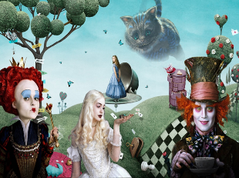  - Do you like fantasies?  - Why or why not?
(Vocab – pre-teach)
* Aim: To provide students with some lexical items before reading the text.
* Content: Learn some vocab related in the lesson.
* Products: Read and understand the meaning of vocab.
* Organization of implementation:
Teacher’s and Ss’activities |  | Content
Pre teach vocabulary  * Teacher introduces the vocabulary.  ** Teacher asks students to get the meaning in context and try to make up sentences with of the following words:  *** Teacher and students discuss the answers.  **** Teacher confirms students’ answers and checks their pronunciation and gives feedback. |  | * vocabulary:  1. series (n): chuỗi, loạt (phim, chương trình)  2. wizard (n): phù thủy, người có tài phi thường  3. must-see (n): đáng xem  4. gripping (a): lôi cuốn, hấp dẫn  * Checking vocab: < Rub out and remmember>
* While reading
Task 2
* Aims: To develop reading skill for general information (skimming).
* Content: Match the words or phrases with their meanings
* Products: Some students give the answer and explains which sentences give them the information..
* Organization of implementation:
Teacher’s and Ss’activities | Content
Task 2  * Teacher asks students to open the book, read through the text and do the task.  ** Students read the text and do the task.  *** Teacher allows students to share their answers before discussing it as a class and encourages them to give evidence.  **** Teacher calls some students to give the answer and explains which sentences give them the information. | Task 2: Read the film review of Harry Potter and the Sorcerer's Stone on Mark's blog. Match the words or phrases with their meanings  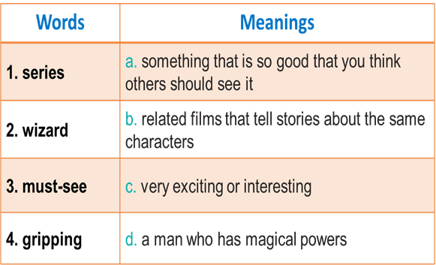  * Answer key:  1. b 2. d 3. A 4. c
Task 3
* Aims: To help students develop their reading skill for specific information (scanning);
To help students broaden and deepen their knowledge of the famous football star Pelé.
* Content: Read the text again and answer the questions.
* Products: Ss answer the questions correctly .
* Organization of implementation :
Teacher’s and Ss’activities | Content
Task 3  * Teacher can set a longer time limit for students to read the text again and answer the questions.  Teacher asks students to read the questions and underline key words, then reminds them to focus on the types of information they have to find.  Teacher asks students to note where they found the information that helped them to answer the questions.  ** Teacher asks students to work in pairs and find the answer. Students can compare answers before discussing them as a class.  *** Teacher allows students to share their answers before discussing it as a class and encourages them to give evidence.  **** Teacher calls a student to write his/ her answer on the board, then checks sentence by sentence with the class. | Task 3: Read Mark’s blog again and answer the questions.  Game: Spin the big wheel  * Answer key:  1. Harry Potter and the Sorcerer’s Stone is a fantasy.  2. Daniel Radcliffe is one of the stars in the film.  3. The film tells the story of Harry Potter. He’s a powerful wizard. He is a student at a school for wizards and learns about himself, his family, and the bad things happening around him.  4. People say it’s a must-see for teens.
Activity 3: Speaking(10’)
* Pre - speaking
Task 4:
* Aims: To help students form the ideas for their speaking.
* Content: Ask and answer questions about the film Kungfu Boy.
* Products: Some pairs practice in front of the class.
* Organization of implementation:
Teacher’s and Ss’activities | Content
Task 4  * Teacher models this activity with a good student first.  ** Teacher asks students to work in pairs.  *** Teacher can go around to help weaker students.  **** Teacher calls on some pairs to practice in front of the class. | II. SPEAKING SKILL  Task 4: Look at the table. Work in pairs. Ask and answer questions about the film Kungfu Boy.  * Example:  A: Let’s see a film this evening?  B: That’s a great idea. What film shall we see?  A: Kungfu Boy.  B: What kind of film is it?  A: __________________
* While- speaking
* Aims: To help students use what they practice to give a long talk about the film Kungfu Boy
* Content: Work in groups. Take turns to talk about the film Kungfu Boy.
* Products: Some groups give presentations in front of the class.
* Organization of implementation:
Teacher’s and Ss’activities | Content
Task 5  * Teacher has students work in groups, talk about the film Kungfu Boy based on the information from Task 4.  ** Students work in groups to do the task.  *** Teacher goes around to help students.  **** After finishing, teacher can call some groups to give presentations in front of the class. | Task 5: Work in groups. Take turns to talk about the film Kungfu Boy.  Example:  Kungfu Boy is on at … at … p.m. It’s a(n) … about …  Kungfu Boy is on at Ngoc Khanh Cinema at 4.30 p.m. It's a comedy about a very big boy who saves his town and becomes a hero. It stars Bruce Wane and was directed by John Stevenson. People say that it is very funny and interesting.
Activity 4: Post-Reading and Speaking (5’)
* Aims: -To help students improve next time; To help some students enhance their presentation skill.
* Content: Students give comments for their friends and vote for the most interesting and informative
* Products: Students give comments in front of the class.
* Organization of implementation:
Teacher’s and Ss’activities | Content
* Teacher allows students to give comments for their friends and vote for the most interesting and informative presentation.  ** Students give comments for their friends and vote for the most interesting and informative presentation.  *** Teacher and students discuss the presentations.  **** Teacher gives feedback and comments. | Students’ comments
* Consolidation (3’)
* Aims: To consolidate what students have learnt in the lesson.
* Content: Summarize the lesson’s content briefly.
* Products: Some students say aloud what they have learnt in the lesson.
* Organization of implementation:
Teacher’s and Ss’ activities | Content
T - Ss,  - Teacher asks students to talk about what they have learnt in the lesson. | - Read the text about Pele’  - Talk about the famous sportsperson .
* Homework (2’)
* Aim: To revise the knowledge that students have gained in this lesson.
* Content: Review the lesson and prepare for the next lesson .
* Products: Students’ textbook and workbook.
* Organization of implementation:
Teacher’s and Ss’ activities | Content
- Teacher asks students to write down their opinion about a famous sportsperson. | - Learn by heart vocab.  - Do EX in the workbook.  - prepair Project
Complement.
…………………………………………………………………………………………………………………………………………………………………………………………………………………

