Date of preparing:
Date of teaching:
UNIT 8: FILMS
Period 65: Lesson 4: Communication
I. OBJECTIVES
By the end of this lesson, students will be able to:
- accept and decline suggestions;
- do a survey about group members’ favorite film;
- report the survey’s result to class.
1. Knowledge:
- Vocabulary: revise vocabulary on types of films, adjectives to describe films
- Grammar: structures to accept and decline suggestions
2. Competence:
- Develop communication skills and creativity
- Be collaborative and supportive in pair work and teamwork
- Actively join in class activities
3. Educational aims:
- Develop self-study skills
II. TEACHING AIDS:
- Grade 7 textbook, Unit 8, Communication
- Computer connected to the Internet
- Projector, loudspeaker
- sachmem.vn
III. PROCEDURES :
Activity 1: Warm-up (5’)
* Aim: To activate students’ prior knowledge and to increase students’ interest.
* Content: Game: Conversation rearranging
* Products: Ss arrange the sentences to make a meaningful conversation. (Work in groups)
* Organization of implementation:
Teacher’s and Ss’activities | Content
Warm up:  * Teacher divides the class into 4 groups. Teacher delivers a set of sentences in a conversation to each group.  ** Students will have to work in groups to arrange the sentences to make a meaningful conversation. The group with the fastest correct conversation will be the winner.  *** Teacher allows students to cross check first.  **** Teacher plays the recording to check and ask students to identify the content of the conversation. | Game: Conversation rearranging  * Keys:  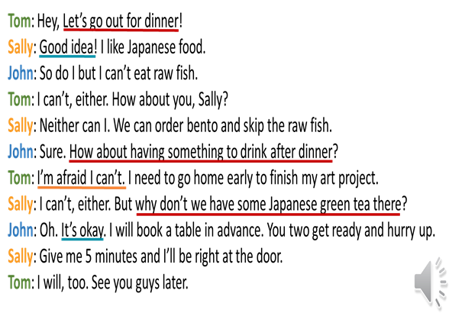
Activity 2: Presentation (7’)
* EVERYDAY ENGLISH
* Aim: To introduce ways to accept/decline suggestions.
* Content: Listen and read the short conversation below, paying attention to the highlighted parts.
* Products: Ss understand the structure of ways to accept/decline suggestions; Role play and practice in front of the class fluently.
* Organization of implementation:
Teacher’s and Ss’activities |  |  | Content
Task 1  * Teacher lets students listen to the examples in Ex. 1 in the book.  ** Teacher draws their attention to the form of ways to accept/ decline suggestions.  *** Teacher and students discuss the form of ways to accept/ decline suggestions.  **** Teacher confirms the answers and gives feedback.  - T asks Ss list of ways to accept and decline suggestions |  |  | Task 1: Listen and read the short conversation below, paying attention to the highlighted parts  .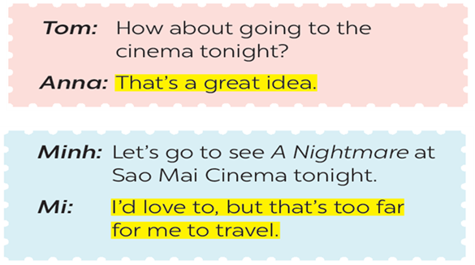  * How about + V-ing?  * Let’s + V-infinitive!   It sounds good/ interesting/ great to me/…   No, thanks./ Thanks but I can’t…
*Practice (13’)
Task 2
* Aims: To give students opportunities to use ways to accept and decline suggestions correctly in context
* Content: Make a similar conversation and work in pairs ( Role play)
* Products: Role play and practice in front of the class fluently.
* Organization of implementation:
Teacher’s and Ss’activities |  | Content
Task 2  * Teacher has students work on the conversations in pairs.  ** Students work on the conversations in pairs.  *** Teacher asks some pairs to act out in front of the class.  **** Teacher gives feedback and correction (if needed). |  | Task 2: Work in pairs. Make similar conversations with the following situations  Example:  A: Hey, let’s go to the cinema this weekend!  B: Good idea! I like action movie.  A: So do I. I’ll see you at 6 p.m. this Sunday.  B: Great. See you.
Activity 3: (10’)
A SURVEY ABOUT FILMS
Task 3
* Aims: -To teach Ss the questions they can ask their classmates to do a survey about their favourite films;
-To help Ss revise vocabulary related to the topic.
* Content: Listen to the conversation and fill in the blanks with the words you hear.
* Products: Students answer the questions exactly.
* Organization of implementation:
Teacher’s and Ss’activities |  | Content
Task 3  * Teacher asks several questions to set the scene. Then ask students to look at Ex. 3, quickly predict the answers and exchange the ideas with a partner.  ** Play the recording and ask students to fill in the blanks, focusing on the structures to ask for information in the survey.  Then let students read through the conversation and answer 2 questions:  What kinds of information do you need to ask in the survey?  Which structures do you need to ask for the information?  *** Teacher allows students to peer check first.  **** Teacher confirms the answers and gives feedback. |  | Task 3: Listen to the conversation and fill in the blanks with the words you hear.  * Answers:  (1) best  (2) comedies  (3) favourite  (4) stars  (5) funny
Task 4
* Aims: To let students have some time to brainstorm the ideas and do the survey
* Content: Do a survey about your group members’ favourite films.
* Products: Ask and answer the questions in front of the class fluently and exactly.
* Organization of implementation:
Teacher’s and Ss’activities |  | Content
Task 4  * Teacher lets students group up and spend 2 minutes on making the table onto their notebook.  ** Students work in groups.  *** Then ask them to ask an answer as well as note down among their groups.  **** Teacher goes around and listen, make suggestions and corrections if needed |  | Task 4. Work in groups. Do a survey about your group members’ favourite films.  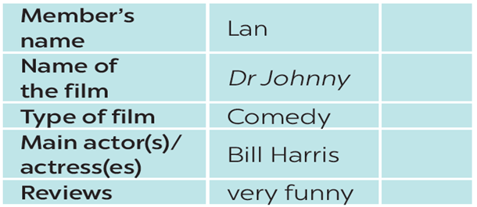
* Production (5’)
* Aims: To let students practice talking about others’ favorite films
* Content: Report your results to the class
* Products: Ss report the results of their surveys in front of the whole class
* Organization of implementation:
Teacher’s and Ss’activities |  | Content
* Teacher invites some students to show their survey notes and talk about their group member’s favorite film.  ** Students show their survey notes and talk about their group member’s favorite film.  *** Teacher allows students to cross check first.  **** Teacher listens, gives comments or corrections if needed. |  | Task 5: Report your results to the class.  My friend's name is Nam. His favourite film is Tom and Jerry because he likes cartoon. The main character are "Tom and Jerry" ,…. this film is funny.
* Consolidation (3’)
* Aims: To consolidate what students have learnt in the lesson.
* Content: Summarize the main content in the lesson.
* Products: Students say what they have learnt in the lesson.
* Organization of implementation:
Teacher’s and Ss’activities |  | Content
Teacher asks students to talk about what they have learnt in the lesson. |  | - Practice the form of to accept and decline suggestions;  - do a survey about group members’ favorite film;  - report the survey’s result to class.
* Homework (2’)
* Aim: To revise what they have learnt and prepare for the next lesson Skills 1.
* Content: Review the lesson and prepare for the next lesson and do exersie in the workbook.
* Products: Students’ textbook and workbook.
* Organization of implementation:
Teacher’s and Ss’ activities |  | Content
- T reminds Ss to do homework and prepare the new lesson. |  | - Do EX in the workbook.  - Prepare lesson 5 ( Skills 1)
Complement.
………………………………………………………………………………………………………………………………………………………………………………………………………………

