Date of preparing:
Date of teaching:
UNIT 7: TRAFFIC
Period 58: Lesson 4: COMMUNICATION
I. OBJECTIVES
By the end of this lesson, students will be able to:
1. Knowledge
- learn how to ask and answer about means of transport and some strange traffic rules.
- practice using some grammar points and vocabulary related to the topic.
2. Competence
- Asking and answering about means of transport.
- Develop communication skills
- Be collaborative and supportive in pair work and team work
- Actively join in class activities
3. Educational aims:
- Be benevolent and responsible
- Establish good habits in obeying traffic rules
II. TEACHING AIDS:
- Grade 7 textbook, Unit 7, Communication
- Computer connected to the internet
- TV/ Pictures/ Projector
- sachmem.vn
III. PROCEDURES:
Activity 1: Warm-up (5’)
* Aim: To introduce the lesson.
* Content: Game: BRAINSTORMING
* Products: Students play a game by writing the names of means of transport
* Organization of implementation:
Teacher’s and Ss’ activities |  |  | Content
* Warm up Team work  * Teacher divides class into 2 teams and asks them to think of “MEANS OF TRANSPORTS” (even the strangest ones).  ** Ss have 1 min to think of the words related to the topic or they can discuss with their partners.  *** Each member from each team turn by turn run to the board and write one word.  **** Teacher corrects their answers.  -The team which has more correct words will be the winner  + Lead in  To lead in the lesson about communication. |  |  | * Game: BRAINSTORMING  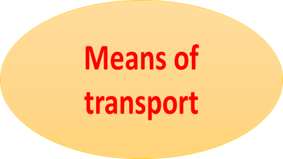  * Suggested answers:  Motorbike, bicycle, train, bus, plane, helicopter,
Activity 2: Presentation (10’)
* EVERYDAY ENGLISH
Asking and answering about means of transport
* Aim: To let students know the structure to ask and answer about means of transport.
* Content: Listen and read the conversation, paying attention to the highlighted parts
* Products: Ss understand and know to how to ask and answer about means of transport
* Organization of implementation:
Teacher’s and Ss’ activities |  | Content
Task 1  * Teacher plays the record for SS to listen and read the conversation about means of transport.  ** Ss listen and practice saying with their partners.  *** Teacher calls some pairs to read aloud.  **** Teacher corrects pronunciation if needed.  * Teacher asks Ss to pay attention to the highlighted parts and asks them some questions to elicit the new structure:  - Which tense do we use to ask and answer?  - Which question word do we use?  - …..  ** Ss answer teacher’s questions to find out new structure to ask and answer about means of transport to travel to places  *** Some students give the new structure to the teacher.  **** Teacher corrects and writes on the board: |  | Task 1: Listen and read the conversation, paying attention to the highlighted parts.  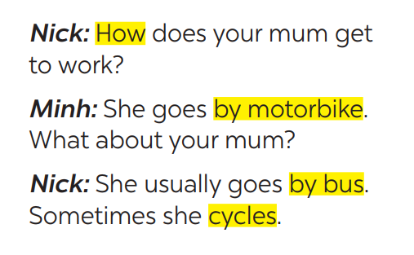  - Structure:  * to ask:  How do/does + S + go to …?  * to answer:  - S + go/goes by …  - S + V
* Practice (5’)
Task 2
* Aims: To help students practice on how to ask and answer about means of transport
* Content: Ask and answer about the means of transport your family members use every day.
* Products: Role play and practice in front of the class fluently.
* Organization of implementation:
Teacher’s and Ss’ activities | Content
Task 2:  * Teacher has SS look at the situation in Ex 2 to make similar dialogue:  ** Ss work in pairs to make similar dialogue.  *** Teacher calls some pairs to present it in front of the class.  **** Teacher gives feedback and some comments. | Task 2: Work in pairs. Take turns to ask and answer about the means of transport your family members use every day.  * Suggested answers:  A: How does your father go to work?  B: He usually drives his car but sometimes he goes by bus. How about your father?  A: He walks because we live near his office.
Activity 3: (10’)
* STRANGE TRAFFIC RULES
* Aims: To provide Ss with some countries where the traffic rule is to keep to the left.
* Content: Tick the names of the countries where the traffic rule is to keep to the left side of the road.
* Products: Ss give their answers correctly.
* Organization of implementation:
Teacher’s and Ss’ activities | Content
Task 3  * Explain to Ss that in many countries in the world, the traffic rule is to keep to the left side of the road instead of to the right.  **Ss work in groups and give the names of the countries where the traffic rule is to keep to the left side of the road.  *** Ask Ss to give their answers and correct them.  **** Teacher gives feedback and may give some more countries (Japan, Singapore, India, New Zealand, Malaysia, Indonesia, Bangladesh ...). | Task 3: Which countries below keep to the left? Tick the correct answers.
  1. The United Kingdom | ✓
  2. The United States of America
  3. Australia | ✓
  4. Thailand | ✓
  5. China
Task 4
* Aims: -To give Ss some listening practice;
-To provide Ss with some understanding of the traffic rule of keeping to the left.
* Content: listen again and complete the sentence with no more than THREE words.
* Products: Students complete the sentences exactly.
* Organization of implementation:
Teacher’s and Ss’ activities | Content
Task 4  * Play the recording again.  ** Let Ss complete the sentence by themselves, then share their answers with a partner.  ***T goes round the class to give support if necessary.  ****Correct Ss' answers as a class. | Task 4: Listen and check your answers in 3. Then listen again and complete the sentence with no more than THREE words.  *Key:  One explanation is that some countries use the same system as the UK.  Audio script - Track 51:  The right side is the wrong side!  Do you know that there are many countries in the world where the traffic rule is to keep to the left? Some of these are the United Kingdom, Australia, Thailand, and so on. There are different explanations  for this. One explanation is that some countries use the same system as the UK.
Activity 4: Production (5’)
* Aims: -To provide Ss with some strange driving rules in the world;
-To give Ss some practice in talking about traffic rules.
* Content: Read, discuss which one do is the strangest rule?
* Products: Each group shares their answers with the class.
* Organization of implementation:
Teacher’s and Ss’ activities | Content
Task  * Teacher has students work in groups to discuss which one they find strangest.  ** Ss work in groups.  *** 2-3 groups share their ides  **** Teacher encourages students to add more if they know. | Task 5: Read, discuss which one do is the strangest rule?  Which one do you think is the strangest?
Activity 5: Consolidation (3’)
* Aims: To consolidate what students have learnt in the lesson.
* Content: Summarize the main content in the lesson.
* Products: Students say what they have learnt in the lesson.
* Organization of implementation:
Teacher’s and Ss’ activities | Content
Teacher asks students to talk about what they have learnt in the lesson. | - how to ask and answer about means of transport  - recall some strange rules.
* Homework (2’)
* Aim: To revise what they have learnt and prepare for the next lesson Skills 1.
* Content: Review the lesson and prepare for the next lesson and do exercise in the workbook.
* Products: Students’ textbook and workbook.
* Organization of implementation:
Teacher’s and Ss’ activities | Content
- T reminds Ss to do homework and prepare the new lesson. | - Do EX in the workbook.  - Prepare lesson 5 (skills 1)
Complement.
………………………………………………………………………………………………………………………………………………………………………………………………………………….

