Date of preparing:
Date of teaching:
UNIT 7: TRAFFIC
Period 57: Lesson 3: A CLOSER LOOK 2
I. OBJECTIVES
By the end of this lesson, Ss will be able to gain:
1. Knowledge
Know how to use:
- It to indicate distance
- should and shouldn’t
2. Competence
- Ask and answer questions about distances;
- Know to use “should/shouldn't to give advice;
- Develop communication skills and cultural awareness
- Be collaborative and supportive in pair work and teamwork
- Actively join in class activities
3. Educational aims:
- Develop awareness of understanding the road signs and obeying the traffic rules.
II. TEACHING AIDS:
- Grade 7 textbook, Unit 7, A closer look 2.
- Computer connected to the internet
- Projector/ TV/ pictures.
- sachmem.vn
III. PROCEDURES:
Activity 1: Warm-up (5’)
* Aim: -To activate students’ knowledge on the topic of the unit
-To enhance students’ skills of cooperating with team mates
* Content: * Game: Pelmanism
* Products: Students plays in groups and choose two cards exactly.
* Organization of implementation:
Teacher’s and Ss’ activities |  |  | Content
Warm up (group work)  * Teacher divides the class into two teams and gives instructions the game  *T asks each group to choose two cards in turn.  Flip the two selected student cards, if they match exactly, they will get 1 mark. If there is no match, turn it over and continue the game until all the cards are flipped.  The group with more points wins.  Lead in: - Teacher says: “This lesson today is going to tell you about “it indicating distance” |  |  | * Game: Pelmanism  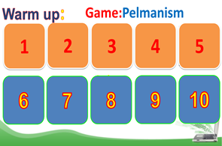  * Answers:  1- Cycle lane  2- School ahead  3- No cycling  4- No right turn  5- Hospital ahead
Activity 2: Presentation (25’)
Task 1
* Aim: To introduce students the form of the key grammar and how to use them appropriately
* Content: How to use “It” to indicate distance
* Products: know how to use “It” to indicate distance
* Organization of implementation:
Teacher’s and Ss’ activities | Content
T-Ss  * Teacher draws students’ attention to the grammar point and the example  - Teacher asks Ss:  ** Ss read the grammar explicit and study the example.  *** Ss may discuss within groups/pairs before answering.  **** Teacher shows and says the sentences aloud and asks Ss to make similar sentences. | * IT INDICATING DISTANCE  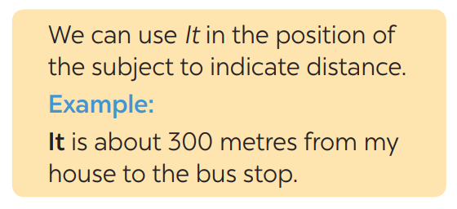  - What does the sentences tell us about?  → Distance from his/her house to the bus stop  - What is the structure using in the sentence?  → It be (about) + distance from A to B.
* Practice/ Controlled practice
Task 1
* Aim: To help Ss use “It” to write correct sentences
* Content: Write sentences with It. Use these cues.
* Products: Ss write the correct sentences on the board.
* Organization of implementation:
Teacher’s and Ss’ activities | Content
Task 1.  * Teacher asks Ss to look at the example and the task.  ** Ss work out and answer questions individually.  *** Ss share their answers in pairs.  **** T asks them to check their answers.  Then tell share them to share their sentences as a whole in class and correct for them. | Task 1. Write sentences with It. Use these cues.  EX: 500 metres / my house / nearest shop.  → It is about 500 metres from my house to the nearest shop.  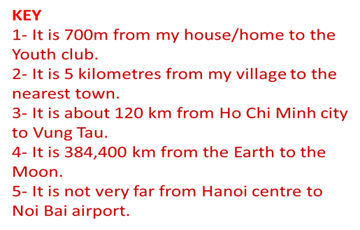
Task 2
* Aims: -To help Ss revise the question How far
-To help Ss use It to ask and answer questions about distance in their neighborhood.
* Content: Work in pairs. Ask and answer questions about distances in your neighborhood
* Products: Ss asks and answer in front of the class.
* Organization of implementation:
Teacher’s and Ss’ activities |  | Content
Task 2:  * Teacher asks Ss to look at the example and identify the structure of the question: How far is it from … to …?  Then work with their partners who sit next to them to make similar conversations.  ** Ss do exercise 2 in pairs.  *** Ss write all conversations down on the notebooks.  **** Teacher corrects their answers as a class. |  | Task 2: Work in pairs. Ask and answer questions about distances in your neighborhood  Eg:  A: How far is it from your home to your school?  B: It's about 3 kilometers from my home to my school.  * How far is it from + place 1 + to + place 2?  → It is (+ about) + from + place 1 + to + place 2.  A: How far is it from your school to the market?  B: It's about 1 kilometer from my school to the market.
Activity 3: Should / shouldn't
Task 3
* Aims: To help Ss review the first use of the modal verb should/shouldn't
* Content: Choose the correct option in brackets (should/ shouldn’t)
* Products: Ss read aloud the sentences.
* Organization of implementation:
Teacher’s and Ss’ activities |  | Content
Task 3  T : we have already learnt should/shouldn't to give advice, so you repeat the usage of “should/shouldn't”  * Teacher draws students’ attention to the remember box. Teacher asks them to study the examples and identify the structure:  * Teacher gives suggestions and asks students to make some similar sentences using the structures.  *** Teacher nominates Ss to read aloud the sentences.  **** Teacher checks and gives the corrections if they have mistakes |  | Task 3: Choose the correct option in brackets.  *Form: S + should/shouldn’t + Vinf  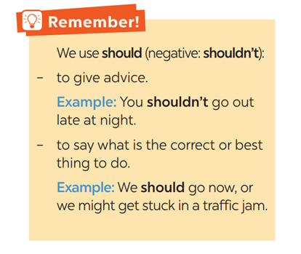  *Key:  1.should 2. should 3. shouldn't  4. should 5. shouldn't
Task 4
* Aims: To help Ss practice the uses of the modal verb should/shouldn't.
* Content: Complete each sentence, using should / shouldn’t.
* Products: Complete each sentence exactly
* Organization of implementation:
Teacher’s and Ss’ activities |  | Content
Task 4  * Teacher gives Ss time to do the exercise individually and peer check with their partner.  **Call on some Ss to read the sentences aloud  *** Other Ss comment’  **** Teacher checks and gives the corrections if they have mistakes. |  | Task 4: Complete each sentence, using should / shouldn’t.  * Answers:  1- shouldn’t 2- should 3- shouldn’t  4- should 5- should 6- shouldn’t
Activity 4: Production (10’)
Task 5
* Aims: To help Ss apply the uses of should / shouldn't in real context by making sentences using pictures and the cues.
* Content: Look at the pictures. Make sentences, using should / shouldn’t and the cues.
* Products: Ss write their answers on the board.
* Organization of implementation:
Teacher’s and Ss’ activities |  | Content
Task 5  *Have Ss look at the pictures carefully. Provide the answer for the first item since it has a when phrase and Ss may not realize this.  ** Give them some time to work independently and write down the answers.  -Then let them work in groups to check and say out the sentences.  - T goes round giving help when and where necessary.  *** Some Ss may write their answers on the board.  **** Other Ss comment and T makes corrections. |  | Task 5: Look at the pictures. Make sentences, using should / shouldn’t and the cues  * Answers:  1- He shouldn’t waste water.  2- They should wear their helmets.  3- She should be more careful.  4- They shouldn’t play football on the pavement.  5- They shouldn’t ride their bikes dangerously.
Activity 5: Consolidation (3’)
* Aim: To consolidate what students have learnt in the lesson.
* Content: Summarize the main grammar points of the lesson.
* Products: Students say what they have learnt in the lesson
* Organization of implementation:
Teacher’s and Ss’ activities |  | Content
- Teacher asks students to talk about what they have learnt in the lesson. |  | Summarize the main grammar points of the lesson.  - It indicating distance  - Should/shouldn’t
* Homework (2’)
* Aim: To revise the knowledge that students have gained in this lesson.
* Content: Review the lesson and prepare for the next lesson and do exercise in the workbook
* Products: Students’ textbook and workbook
* Organization of implementation:
Teacher’s and Ss’ activities |  | Content
- T reminds Ss to do homework and prepare the new lesson. |  | - Do exercise in the workbook.  - Prepare lesson 4 (communication)
Complement.
……………………………………………………………………………………………………………………………………………………………………………………………………………………………..

