Date of preparing:
Date of teaching:
UNIT 7: TRAFFIC
Period 56: Lesson 2: A CLOSER LOOK 1
I. OBJECTIVES
By the end of this lesson, Ss will be able to gain:
1. Knowledge
- Vocabulary about the verbs to use means of transport
- Vocabulary to read the road signs.
- Pronunciation: /aɪ/ and /eɪ/
2. Competence
-Describe / name all the road signs and know some kinds of signs: informative, prohibitive, and warning
- Pronounce the sounds /aɪ/ and /eɪ/ correctly;
- Develop communication skills and cultural awareness
- Be collaborative and supportive in pair work and teamwork
- Actively join in class activities
3. Educational aims:
- Develop awareness of understanding the road signs and obeying the traffic rules.
II. TEACHING AIDS:
- Grade 7 textbook, Unit 7, A closer look 1.
- Computer connected to the internet
- Projector/ TV/ small boards, markers.
- sachmem.vn
III. PROCEDURES:
Activity 1: Warm-up (5’)
* Aim: To activate students’ prior knowledge and vocabulary related to the topic.
To lead in the lesson about vocabulary and pronunciation.
* Content: Game: JUMBLED WORDS
* Products: Ss make the correct words and write down onto the small boards.
* Organization of implementation:
Teacher’s and Ss’ activities |  |  | Content
Warm-up: T - Ss  * Teacher gives instructions  ** In groups of 5, Ss will be given a small white board and marker.  - Teacher show the jumbled words onto the screen one by one  *** Students work in groups to make the correct words and write down onto the small boards. When they finish, they hold it up to show their answers to teacher.  - take turns to write until finish all the words.  **** Teacher checks and corrects if Ss write the words incorrectly. |  |  | Game: JUMBLED WORDS  *Answers:  1- otba -> boat  2- itanr -> train  3- npeilapra -> airplane  4- rsotrpca -> sport car  5- otmiroekb -> motorbike
Activity 2: Presentation (5’)
* Aim: To help students use key language more appropriately
* Content: Learn some vocabularies related to the topic.
* Products: Read and pronounce correctly and understand the meaning of words.
* Organization of implementation:
Teacher’s and Ss’ activities |  | Content
Pre teach vocabulary  * Teacher uses different techniques to teach vocab (pictures, situation, realia)  **Follow the seven steps of teaching vocab.  *** Repeat in chorus and individually  **** Copy all the words  * Checking vocab: < Rub out and remember> |  | * Vocabulary  - road sign (n.phr.) /ˈrəʊd saɪn/: biển báo giao thông  - cycle lane (n.phr.) /ˈsaɪkl leɪn/: đường đi riêng cho xe đạp  - traffic light (n.phr.) /ˈtræfɪk laɪt/: đèn giao thông  - crossroads /ˈkrɒsrəʊdz/: (n) ngã tư  - pavement /ˈpeɪvmənt/ = (n) Footpath: vỉa hè
Activity 3: Practice (20’)
Task 1
* Aims: To revise / teach some collocations of a verb and a phrase related to the different means of transport.
* Content: Match the words in A with the phrases in B.
* Products: Students give their answers exactly.
* Organization of implementation:
Teacher’s and Ss’ activities | Content
T - Ss  * Teacher asks Ss to look at the table (p.74), identify the form (verbs and nouns – means of transport):  ** Ss work out and answer questions in pairs.  *** Ss share their answers as a whole class.  **** T asks them to check their answers.  _ Teacher asks students to make your own sentences with these phrases. Then tell share them to share their sentences with a partner and correct for them. | Task 1: Match the words in A with the phrases in B.  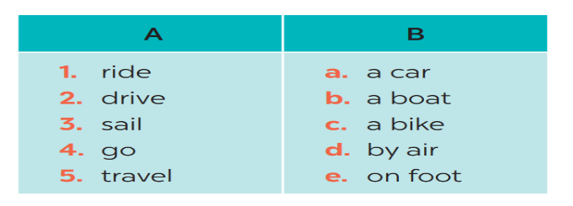*Answers:  1- C 2 – A 3 – B 4 – E 5 – D  - My father taught me how to ride a bike.  - My father usually drives a car to work.  - I sometimes go on foot to school.
Task 2
* Aims: - To practice identifying the meanings of road signs.
- To develop Ss' knowledge of vocabulary
* Content: Write the correct phrases under the signs
* Products: Ss write the correct phrases under the signs correctly.
* Organization of implementation:
Teacher’s and Ss’ activities | Content
T - Ss, Ss - Ss  * Teacher asks Ss to look at the road signs and guess their meanings. Then work and share their answers with their partners who sit next to them. (peer check)  ** Ss do exercise 3 in pairs.  *** Ss share and discuss with their partners to write all words/ phrases down on the books.  **** Teacher corrects their answers as a class. | Task 2: Look at these road signs. Then write the correct phrases under the signs.  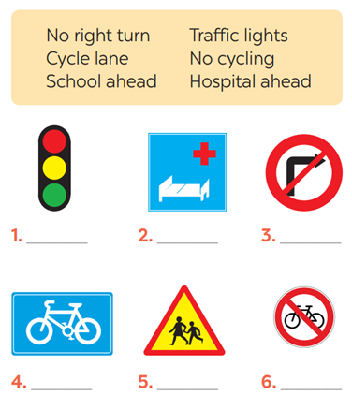  *Answers  1. traffic lights 2. Hospital ahead  3. No right turn 4. cycle lane  5. School ahead 6. No cycling
Task 3
* Aims: To give Ss practice in how to talk about road signs in real life.
* Content: Take turns to say which of the signs in 2 you see on the way to school.
* Products: Students say correct answers in front of the class.
* Organization of implementation:
Teacher’s and Ss’ activities | Content
T-Ss, Ss-Ss  * Teacher gives suggestions and asks students to share their sentences.  ** Teacher nominates Ss to say the sentences aloud  *** Ss say the sentences aloud.  **** Teacher checks and gives the corrections if they have mistakes. | Task 3: Work in pairs. Take turns to say which of the signs in 2 you see on the way to school.  A: On the way to school, there are crossroads, so I see several traffic lights.  B: On my way to school, there is a school, so I see a “school ahead sign”.  ….
Activity 4: * PRONUNCIATION (10’)
Task 4
* Aims: To teach Ss how to pronounce the sounds /aɪ/ and /eɪ/ and practice pronouncing these sounds in words correctly.
* Content: Listen and repeat. Pay attention to the sounds /aɪ/ and /eɪ/.
* Products: Students pronounce words exactly.
* Organization of implementation:
Teacher’s and Ss’ activities | Content
* Presentation: T - Ss  * First, T gives examples of the sounds /ai/ and /ei/. Ask Ss to observe the T's mouth when pronouncing the two sounds.  ** Then let Ss practice the sounds /aɪ/ and /eɪ/ together.  ***Play the recording and ask Ss to listen to these words and repeat.  ****Correct their pronunciation. Play the  recording as many times as necessary. | * PRONUNCIATION  Task 4: Listen and repeat. Pay attention to the sounds /aɪ/ and /eɪ/.  * Suggested answers:
  /aɪ/ | /eɪ/
  cycle /ˈsaɪ.kəl/  fly /flaɪ/  fine /faɪn/  sign /saɪn/  motorbike /ˈməʊ.tə.baɪk | sail /seɪl/  train /treɪn/  plane /pleɪn/  station /ˈsteɪ.ʃən /  pavement /ˈpeɪv.mənt /
Task 5
* Aims: -To help Ss pronounce the sounds /aɪ/ and /eɪ/ correctly in context;
-To help Ss differentiate the sounds /aɪ/ and /eɪ/.
* Content: Underline the words with the sound /aɪ/ and circle the words with the sound /eɪ/. Then listen, check and repeat.
* Products: Students underline the words and read the words exactly.
* Organization of implementation:
Teacher’s and Ss’ activities | Content
T - Ss, Ss-Ss  * Have Ss quickly read the sentences and underline the words with the sound /ai/ and circle the words with the sound /ei/.  **Then play the recording for Ss to listen and check what they have done.  ***Have them work in pairs to compare their answers. Check Ss' answers as a class.  - Play the recording again. Let Ss listen and repeat sentence by sentence. Tell them to pay attention to the words with the sounds /ai/ and /ei/.  **** Teacher gives Ss feedback.  - choose some typical errors and correct as a whole class | Task 5: Underline the words with the sound /aɪ/ and circle the words with the sound /eɪ/. Then listen, check and repeat  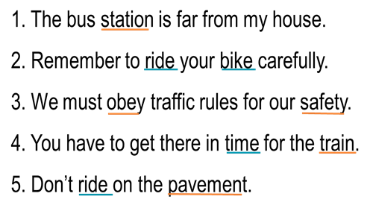
Activity 5: Consolidation (3’)
* Aim: To help Ss memorise the target language and skills that they have learned.
* Content: Vocab and how to pronounce the sounds /aɪ/ and /eɪ/
* Products: Say aloud what they remember from the lesson
* Organization of implementation:
Teacher’s and Ss’ activities | Content
T - Ss  Teacher asks students to talk about what they have learnt in the lesson | - Vocabulary of verbs and road signs  - Pronunciation: /aɪ/ and /eɪ/
* Homework (2’)
* Aim: To revise the lesson and prepare for the next lesson.
* Content: Revise Vocabulary and find 5 more words with /aɪ/ and 5 more words with /eɪ/.
* Products: Students’ textbook and workbook
* Organization of implementation
Teacher’s and Ss’ activities | Content
- T reminds Ss to do homework and prepare the new lesson. | - Learn all the new words by heart.  - Do exercises in the workbook.  - Find 5 more words with /aɪ/ and 5 more words with /eɪ/.  - Prepare lesson 3 (A closer look 2)
Complement.
……………………………………………………………………………………………………………………………………………………………………………………………………

