Date of preparing:
Date of teaching:
UNIT 7: TRAFFIC
Period 55: Lesson 1: GETTING STARTED – Meeting in the school yard
I. OBJECTIVES
By the end of this lesson, Ss will be able to gain:
1. Knowledge
- An overview about the topic Traffic
- Vocabulary to talk about means of transport
2. Competence
- Use some words related to the topic Traffic; ask and answer about some means of transport.
- Develop communication skills and cultural awareness
- Be collaborative and supportive in pair work and teamwork
- Actively join in class activities
3. Educational aims:
- Develop awareness of travelling in town/city
- Be concerned to the local traffic
- Establish good habits in obeying traffic rules
II. TEACHING AIDS:
- Grade 7 textbook, Unit 7, Getting started
- Computer connected to the internet
- Projector/ TV/ pictures and cards
- sachmem.vn
III. PROCEDURES:
Activity 1: Warm-up (5’)
* Aim: To activate students’ knowledge on the topic of the unit.
To enhance students’ skills of cooperating with team mates.
* Content: Miming game
* Products: Students guess words correctly.
* Organization of implementation:
Teacher’s and Ss’ activities | Content
*Warm up: T –Ss (Team work)  * Teacher gives instructions  ** In groups, Ss  - One of the students in the group go to the board.  *** Teacher secretly show 1 picture of a mean of transport to that student. He/ She has to mime the picture and the other has to guess. Of course the other groups will also be allowed to guess.  - take turns go to the board until finish all the pictures.  **** Teacher checks and corrects if Ss pronounce the words incorrectly.  * Lead in: Teacher uses the picture and asks Ss questions to lead in the new lesson. | * Warm up: Miming game  Ex: cycle (ride a bike)    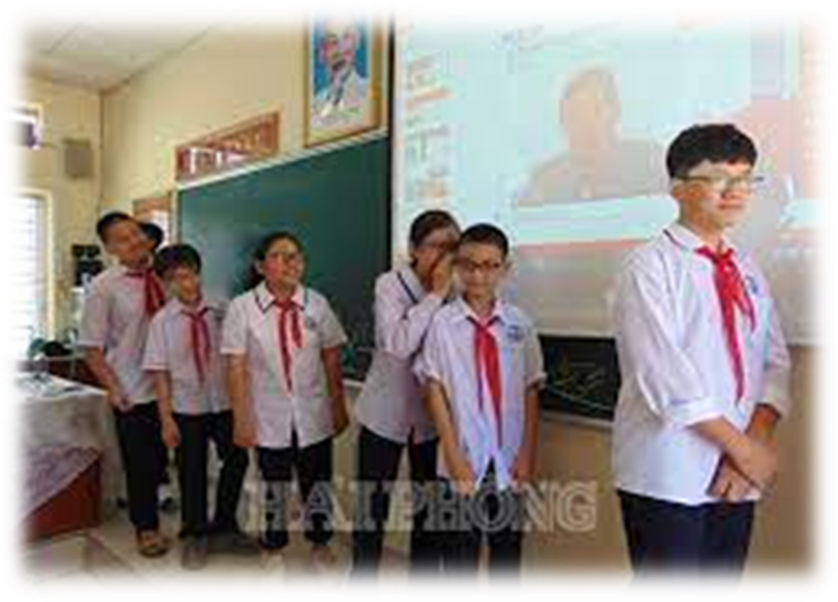
Activity 2: Presentation (10’)
Pre teach vocabulary
* Aim: To introduce the vocabulary appearing in the text.
* Content: Learn some vocabularies related to the topic.
* Products: Students read and understand the meaning of vocab.
Students know how to play the game “what and where”
* Organization of implementation
Teacher’s and Ss’ activities | Content
T-Ss  * T asks Ss to look at the photos and answer the question  ** Ss say the words.  ***Teacher shows and says the words aloud and asks Ss to repeat them.  * *** Teacher asks Ss to translate the word into Vietnamese.  Concept check: Slap the board | * Vocabulary  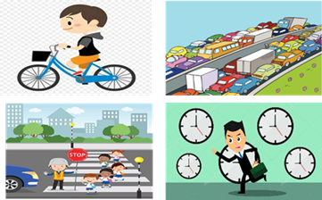  - cycle (v) /ˈsaɪkl/: đạp xe  - traffic jam (n.phr.) /ˈtræfɪk dʒæm/: tắc đường  - cross the road (v.phr.) /krɒs ðə rəʊd/: băng qua đường  - rush hour (n.phr.) /ˈrʌʃ aʊə(r)/: giờ cao điểm  * Checking vocab: < Slap the board >
Activity 3: Practice (20’)
Lead-in/ pre-read and listen
Task 1+Task 2
* Aims: - To get students interested in the topic; To set the context
- To help Ss understand the main idea of the text
* Content: Listen and read the conversation, choose the correct answer A, B, or C.
* Products: Students read and understand content of the conversation.
Ss choose the answers correctly.
* Organization of implementation:
Teacher’s and Ss’ activities | Content
* Set the sentences:  T-Ss  Look at the picture and the dialogue  a) Who are they in the dialogue?  b) Where are they?  T-Ss, Ss-Ss, T-Ss  * Teacher asks Ss to look at the picture (p.73), answer the question:  ** Ss work out and answer questions in pairs.  *** Ss share their answers as a whole class.  **** T asks them to read and listen to the conversation to check their answers. T encourages students to explain where they have found the answers from the conversation. | * Answer the questions:    a) They are Lan and Mark  b) They are at the schoolyard.  Task 1: Listen and read  Task 2: Read the conversation again and choose the correct answer:  1. How does Lan often go to school?  A. By bicycle.  B. By motorbike.  C. On foot.  2. It normally takes Lan ___ to get to school.  A. two minutes  B. ten minutes  C. twenty minutes  3. Lan and Mark agree to go cycling ______.  A. tomorrow  B. every day  MRS THU BA  C. at the weekend
Controlled practice
Task 3
* Aims: - To practice reading and listening for specific information, To practice scanning
- To develop Ss' knowledge of vocabulary
* Content: Write one word from the conversation to complete each sentence.
* Products: Students write correct words on the board. (work independently)
* Organization of implementation:
Teacher’s and Ss’ activities | Content
T-Ss, Ss-Ss, T-Ss  * Teacher asks Ss to work individually to read and listen to the conversation and find the words and phrases and then share their answers with their partners who sit next to them. (peer check)  ** Ss do exercise 3 individually  *** Ss share and discuss with their partners to write all words/ phrases down on the notebooks.  **** Teacher corrects their answers as a class | Task 3: Write one word from the conversation to complete each sentence.  1. Last Sunday afternoon, Lan ______ round the lake near her home.  2. Mark says to Lan: “You ______ be careful, especially when you cross  the road.  3. Traffic ______ are a problem in big cities.  4. – ______ does your mum go shopping?  – She often walks.  5. This road is very ______ during the rush hours.  * Answers  1. cycled 2. should 3. jams  4. How 5. crowded
Task 4
* Aims: To help Ss revise and develop the vocabulary about means of transport.
* Content: Look at the pictures and write a word under each.
* Products: Ss read each word correctly.
* Organization of implementation:
Teacher’s and Ss’ activities | Content
T – Ss  *Teacher asks students to Look at the pictures and write a word under each.  ** Have Ss work in pairs and write the means of transport under the right pictures.  *** Then T lets Ss read each word correctly.  **** Check and correct their pronunciation. | Task 4: Look at the pictures and write a word under each.  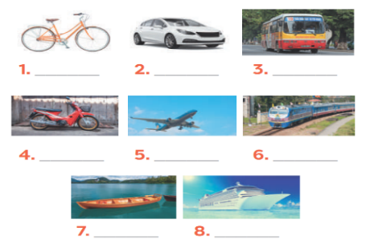  * Suggested answers:  1. bicycle 2. car 3. bus  4. motorbike 5. plane/air-plane  6. train 7. boat 8. Ship
Activity 4: Production (Less controlled practice) (5’)
Task 5
* Aims: To help Ss practicing talking about how they go to school, To practice team working
- To give students authentic practice in using target language
* Content: Find someone who … Write your friends’ names in the blanks. Then report to the class.
* Products: Students write correct the adjectives words on the board.
* Organization of implementation:
Teacher’s and Ss’ activities | Content
T-Ss, Ss-Ss  * Teacher gives Ss clear instructions in order to make sure Ss can do the survey effectively.  - ask students to look at the survey and think of the needed structures to ask their friends.  + Students goes around the class and ask at least 20 classmates and ask them  - observer Ss while they are role playing, note their language errors  ** Ss do as instructed  **** Teacher gives Ss feedback.  - choose some useful or excellent words/ phrases/ expressions/ word choices Ss have used to suggest other students use them  - choose some typical errors and correct as a whole class without nominating the students’ names | Task 5: Find someone who … Write your friends’ names in the blanks. Then report to the class  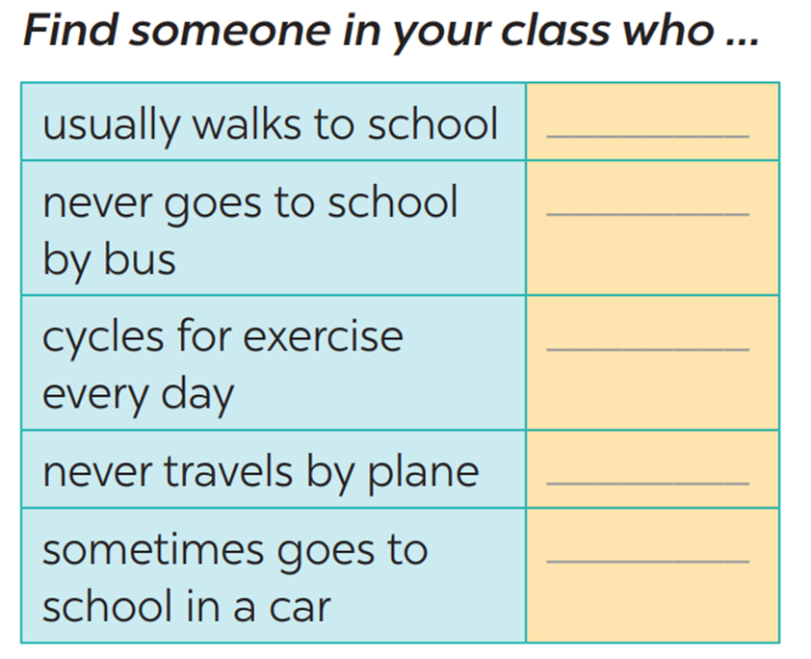  Eg: Do you usually walk to school?  Have you ever gone to school by bus/…?  Do you ride a bike to school?  Do you ever travel by plane?  →Yes, I do.  → No, never/not yet.
Activity 5: Consolidation (3’)
* Aim: To consolidate what students have learnt in the lesson.
* Content: Vocabulary of traffic and means of transport; read and understand content of the conversation
* Products: Say aloud some words they remember from the lesson.
* Organization of implementation:
Teacher’s and Ss’ activities | Content
- Teacher asks students to talk about what they have learnt in the lesson.  - Ss work independently | - Vocabulary of traffic and means of transport.  - Reading for specific information and details  - Scanning
* Homework (2’)
* Aim: To revise the lesson and prepare for the next lesson.
* Content: Review the lesson and prepare for the next lesson and do exercise in the workbook
* Products: Students’ textbook and workbook
* Organization of implementation
Teacher’s and Ss’ activities | Content
- T reminds Ss to do homework and prepare the new lesson. | - Learn all the new words by heart.  - talk about the traffic in your neighborhood  - Prepare lesson 2 ( A closer look 1).
Complement.
……………………………………………………………………………………………………………………………………………………………………………………………………...............

