Date of planning:…………..  Date of teaching: ………..…  WEEK: …. | Period .. : UNIT 10 : PLANET EARTH  Lesson 2 : A CLOSER LOOK 2
I. OBJECTIVES: * By the end of this lesson, Ss will be able to gain the following items:
1. Knowledge:
- To teach grammar notes: Non-defining relative clauses.; Relative clause (review)
+ Integrated skills: Listening, speaking, reading, writing.
* Vocabulary:
- Use the words and phrases related to planet Earth, habitats, and flora and fauna;
+ Talk about threats to flora and fauna and how to protect them;
* Grammar: Relative clause (2)
- Use non-defining relative clauses:
( Add extra information ; Have a comma when using non-defining relative clauses; Relative pronouns cannot be omitted in non-defining relative clauses.……
Eg: Earth , which is the third planet from the Sun, depends much on the Sun for its energy )
2. Competence:
- Access and consolidate information from a variety of sources
- Develop communication skills
- Be co-operative and supportive in pair work and teamwork.
3. Personal qualities:
- Actively participate in class and school activities.
- Develop self-study skills.
II. TEACHING AIDS:
- Teacher: Grade 9 text book; Projector / TV.....
- Students : Text books, workbook…
- Computer connected to the Internet.
- Hoclieu.vn
III. PROCEDURE:
* Remember!
- We use non-defining relative clauses to add extra information.
(Chúng ta sử dụng mệnh đề quan hệ không xác định để bổ sung thêm thông tin.)
Example: Earth, which is the third planet from the Sun, depends much on the Sun for its energy. (Trái Đất, hành tinh thứ ba tính từ Mặt trời, phụ thuộc nhiều vào Mặt trời về năng lượng.)
- If we remove the non-defining relative clause, the sentence still makes sense.
(Nếu bỏ mệnh đề quan hệ không xác định thì câu vẫn có nghĩa.)
Example: Earth depends much on the Sun for its energy. (Trái Đất phụ thuộc nhiều vào Mặt trời về năng lượng.)
+ We use comma (s) with non-defining relative clauses.
(Chúng ta sử dụng dấu phẩy (, ) với mệnh đề quan hệ không xác định.)
+ Relative pronouns cannot be omitted in non-defining relative clauses.
(Đại từ quan hệ không được lược bỏ trong mệnh đề quan hệ không xác định.)

III. PROCEDURE:

1. WARM UP & INTRODUCTION ( 3’- 5’)
* Objectives:
- To create an active atmosphere in the class before the lesson;
- To lead into the new lesson.
* Content:
To have some warm-up activities to create a friendly and relaxed atmosphere to inspire Ss to warm up to the subject and new lesson.
* Expected outcomes:
Having a chance to speak English.
* Organisation : Teacher’s instructions …

Teacher’s & Student’s activities | Content
+ Greeting  + QUIZ  - Divide the class into two big groups.  - Show the questions on the board.  - The questions can be MCQ questions, and the two groups just say A, B, C, or D.  - The one with most correct answers wins.  - Declare the winner and lead into the new lesson.  - Ask Ss to look at A CLOSER LOOK 2 on page 107  + Tell them that today they are going to learn non-defining relative clauses.  + Introduce the objectives of the lesson. Write the objectives in the left corner of the board.  NON-DEFINING RELATIVE CLAUSES. | + Greeting  + QUIZ  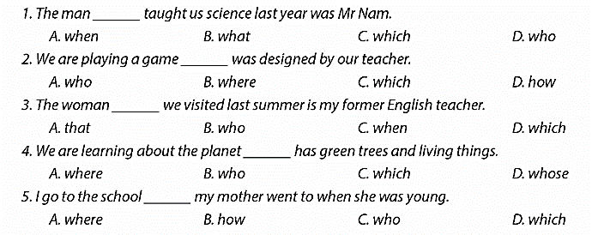  Key: 1. D 2. C 3. B 4. C 5. D  - Open the book and write the tittle of the lesson.
ACTIVITY 1. PRESENTATION/ NEW LESSON ( 12’- 15’)
* Objectives:
+ To help Ss have some idea of what a non-defining relative clause is.
* Content:
- Grammar Explanation
- Task 1: Complete the sentences with correct relative pronouns.
* Expected outcomes:
- Students know how to use the non-defining relative clause.
* Organisation : Teacher’s instructions.

Teacher’s & Student’s activities | Content
TASK 1: Complete the sentences with correct relative pronouns.
- Ask Ss to work individually to read the Remember box/ Page107  - Write examples of a sentence with a non-defining relative clause and one with a defining relative clause on the board.  - Ask some Ss to underline the relative clauses in the two examples. Ask them to point out the differences between pairs of relative clauses.  * Explain the differences in (1) sentence punctuation (,), (2) the position of the clause, (3) use/ function of each type of relative clause, and (4) whether they can be omitted or not, (5) whether the relative pronouns can be omitted or replaced with that.  ** Have Ss do the exercise individually.  - Check the answers as a class.  + T can also ask if these pronouns can be replaced with that or not.  + Ask several Ss to read aloud the full sentences.  - Correct their pronunciation if necessary. | 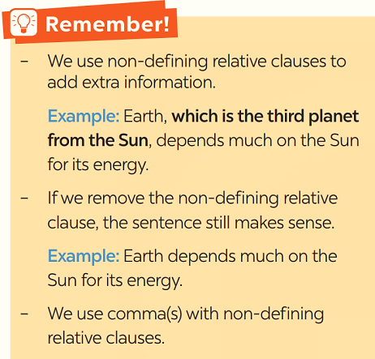* Examples:  + She gave me the cupcake that was red velvet flavoured.  + She gave me a cupcake, which was red velvet flavoured.  * Answer key:  1. which 2. who  3. whose. 4. which  5. which
ACTIVITY 2. PRACTICE ( 15’)
* Objectives:
+ To help Ss learn to recognise non-defining relative clauses in sentences;
- To help Ss become aware that non-defining relative clauses can be omitted from sentences.
+ To help Ss be aware of the position, the meaning of non-defining relative clauses, and the appropriate relative pronouns.
* Content:
- Task 2: Underline the relative clauses. Tick (√) if the relative clause can be omitted.
- Task 3: Complete each sentence with a non-defining relative clause (A-E).
* Expected outcomes: Students know how to use the non-defining relative clause.
* Organisation :
Teacher’s & Student’s activities | Content
TASK 2: Underline the relative clauses. Tick (✓) if the relative clause can be omitted.

+ Remind Ss that a non-defining relative clause can be omitted from a sentence. They are used to give extra information about the noun in front of it.  - Have Ss work in pairs to underline the relative clauses and tick if the relative clauses can be omitted.  - Write sentences 2 and 3 on the board and ask one student to go to the board and do the task.  - Check the student's answers. Correct any mistakes and re-explain the rule if necessary.  - Check the other sentences as a class.  - Have Ss read out loud sentences again and correct pronunciation if necessary. | - T_Ss  * Answer key:  1. ✓______ The second planet from the Sun is Venus, which is sometimes called Earth’s sister.  2. ✓______ The Ocean, which is the body of salt water, contains 97% of Earth’s water.  3. ______ Landforms make up the areas which include mountains, hills, plains and plateau.  4. ✓______ One of the world’s most famous earth scientists is James Hutton, who was a British geologist.  5. ✓______Artic sea ice and water make up a habitat for polar bears, whose main food is seals.
TASK 3 : Complete each sentence (1-5) with a non-defining relative clause (A-E).
+ Have Ss work individually to complete the sentences using nondefining relative clauses.  - Remind them of which relative pronouns (which, who, or whose) are used for which kinds of nouns that come before them.  - Also remind them of the meaning of the full sentence after they have completed them.  + Ask some Ss to read out their completed sentences.  - Correct their pronunciation if necessary.  - Check the answers as a class. | - T_ Ss  * Answer key:  - B 2. C 3. A  4. E 5. D
TASK 4: Combine the two sentences into one, using a non-defining relative clause.

- Have Ss work individually for five minutes to write their combined sentences.  - Remind students of the position of the non-defining relative clause in a sentence.  - Then ask them to work in pairs to swap their answers.  - Ask some Ss to write their combined sentences on the board.  - Check the answers as a class.  - Have the class read out their sentences. Correct pronunciation when necessary.  . | - T_ Ss.  * Answer key:  - The Moon, whose surface is dark, is Earth's only natural satellite.  2. Moonquakes, which can last up to half an hour, are much weaker than Earthquakes.  3. Like Earth, Mars is a rocky planet, which has mountains and canyons on its surface.  4. Venus, which has similar size and structure with Earth, is considered twin sister of Earth.  5. We should protect rivers and lakes, which provide humans with their main sources of fresh water.
* EXTRA ACTIVITIES:
- Teacher can also ask Ss to do an extra activity below.
- Each of the following sentences has ONE mistake. Find the mistakes in the sentences and correct them.
1. Earth Day is the day where people celebrate the wonder of Earth.
2. Polar habitats, what include the North and the South Poles, are extremely cold.
3. The Pacific Ocean, that is the largest and deepest one on Earth, is being polluted.
4. Earth planet, where has a solid and active surface, has various habitat types.
5. Climate change has caused the changes in the colour of the Oceans, what is so worrying.

KEY: 1. where => when ; 2. what => which ; 3. that => which
4. where => which 5. what => which
ACTIVITY 3. PRODUCTION/ FURTHER PRACTICE ( 8’)
* Objectives:
+ To enable Ss to practise using non-defining relative clauses;
- To create an atmosphere of playing and learning.
* Content:
- Task 5: Work in two groups. Take turns to say aloud one the places in the table. The other group explains or gives more information about it. The team that has the most corrected sentences wins.
* Expected : Students can add more information by using non-defining relative clauses.

* Organisation :

Teacher’s & Student’s activities | Content
TASK 5: Work in two groups. Take turns to say aloud one the places in the table. The other group explains or gives more information about it. The team that has the most corrected sentences wins.
- Divide the class into groups.  - Instruct Ss to take turns to say aloud one of the places (the Nile, Pacific Ocean, Viet Nam, the Sahara, Mount Fansipan) and the other explains or gives more information about the places.  - Give groups two minutes to prepare. Tell them that groups can write down their group’s sentences.  - Invite one group to say one name from the list, then the other reads out or says their sentence using a non-defining relative clause.  - Remind them that the group that has the correct sentence with a non-defining relative clause has the right to read out next name on the list for the other group to make a sentence with a non-defining relative clause.  - Correct any grammar and pronunciation mistakes if necessary.  - The group with the most correct sentence wins  * Teacher gives corrections and feedbacks. | * Example:  * Examples:  The Nile, which is the longest river, flows into the Mediterranean Sea.
5. WRAP-UP & HOME WORK (2’)

+ Ask Ss to summarise what they have learnt in the lesson.
- Have them say out loud what they should remember about non-defining relative clauses.
- Ask Ss to say make some sentences with words and phrases they remember from the lesson.
* HOME WORK:
- Do more exercises in workbook.
- Prepare new lesson: Lesson : COMMUNICATION.

==============================================

