Date of planning:…………..  Date of teaching: ………..…  WEEK: … | Period …. : UNIT 10 : PLANET EARTH  Lesson 2 : A CLOSER LOOK 1
I. OBJECTIVES: * By the end of this lesson, Ss will be able to gain the following items:
1. Knowledge:
- Use the lexical items related to the topic “ Planet Earth”.
- Have the right rhythm in sentences;
+ Integrated skills: Listening, speaking, reading, writing.
* Vocabulary:
- Use the words and phrases related to planet Earth, habitats, and flora and fauna;
+ Say sentences with correct rhythm;
+ Talk about threats to flora and fauna and how to protect them;
* Grammar: Relative clause (2)
- Use non-defining relative clauses;
2. Competence:
- Access and consolidate information from a variety of sources
- Develop communication skills
- Be co-operative and supportive in pair work and teamwork.
3. Personal qualities:
- Actively participate in class and school activities.
- Develop self-study skills.
II. TEACHING AIDS:
- Teacher: Grade 9 text book; Projector / TV.....
- Students : Text books, workbook…
- Computer connected to the Internet.
- Hoclieu.vn
III. PROCEDURE:

1. WARM UP & INTRODUCTION ( 3’- 5’)
* Objectives:
- To create an active atmosphere in the class before the lesson;
- To lead into the new lesson.
* Content:
- To have some warm-up activities to create a friendly and relaxed atmosphere to inspire Ss to warm up to the subject and new lesson.
* Expected outcomes:
- Students get some vocabulary from the lesson and be ready for the lesson.
* Organisation : Teacher’s instructions …

Teacher’s and Student’s activities | Content
+ Greeting  ** Brainstorming  - Give Ss a few minutes to play a game. Have Ss form two groups.  - Give Ss pictures of things and strips of paper with words / phrases including Solar System, outer space, landforms, water bodies, flora and fauna, liquid water, glacier  - Ask the groups to stick the words / phrases to the right pictures.  - The group with most correct answers wins.  - Ask Ss to open their books to page 106.  * Share with Ss the objectives of the lesson and have them open their books and start the lesson. | + Greeting  + Brainstorming  Words/phrases:  Solar System, outer space, landforms, water bodies, flora and fauna, liquid water, glacier  - Open the book and write the tittle of the lesson.
2. PRESENTATION/ NEW LESSON ( 12’- 15’)
A. ACTIVITY 1: VOCABULARY
* Objectives:
+ To introduce new words and phrases that are related to Earth.
* Content: - Teach vocabulary.
- Task 1: Write a word or phrase from the box under each picture.
* Expected outcomes: Students can identify some vocabulary about the planet Earth.
* Organisation : Teacher’s instructions.
Teacher’s & Student’s activities | Content
TASK 1: Write a word or phrase from the box under each picture.

* Teach vocabulary:  + Teacher uses different techniques to teach vocab (situation, realia, translation.)  * Teacher introduces the vocabulary by:  - providing the pictures  - eliciting the definition of the words  ** T may focus on presenting the words.  + To present each word, follow the steps:  + Show the picture and elicit the word.  + Read aloud the word several times and ask Ss to repeat.  + Invite some Ss to read the word aloud.  + Write the word on the board and highlight its phonological features (e.g. show the location of the main stress).  + Teacher does the checking technique.  * Have Ss read aloud the words and phrases in the box.  + Ask Ss to work in pairs to look at the pictures and describe them.  - Ss may choose to write habitats under Picture 1. Remind them that the word habitats is in plural, so it is not the right answer in 1 here. For the word poles, T may remind them that we have the North Pole and South Pole, thus Ss can guess the meaning of the word and match this word with the correct picture.  - Ss may also have difficulty with food chain and nature reserves.  - T can explain difficult words for Ss to guess the meaning of phrases: a chain means "a series of many things that connect together".  + reserve is a place to protect rare plants and animals.  + T can also use Vietnamese to explain the meanings of the new words.  - Have pairs write the correct words and phrases under the pictures.  - Invite Ss to take turns to read out their answers.  - Correct their pronunciation if needed. | - T_Ss  *Vocabulary  1. nature reserve (n)/ˈneɪtʃə rɪzɜːv/ khu bảo tồn thiên nhiên  2. food chain (n) /ˈfuːd tʃeɪn/  chuỗi thức ăn  3. pole (n) /pəʊl/ cực (Bắc/Nam)  4. ecological balance /ˌiːkəˈlɒdʒɪkl ˈbæləns/ cân bằng sinh thái  5. climate change (n) /ˈklaɪmət tʃeɪndʒ/ biến đổi khí hậu  * Answer key:  - flora and fauna  - habitats  3. poles  4. grassland  5. nature reserves  6. food chain
3. PRACTICE ( 15’)
* Objectives:
+ To help Ss to use words and phrases in 1 in context.
+ To help Ss to use more words and phrases related to Earth, Earth's problems, and Earth's protection in context.
* Content:
- Task 2: Complete each sentence with a word or phrase from 1.
- Task 3: Choose the correct answer A, B, C, or D
- Students can identify some vocabulary about the planet Earth and use them in different contexts
* Expected outcomes:
- Students can identify some vocabulary about the planet Earth and use them in different contexts
* Organisation :

Teacher’s Student’s activities | Content
TASK 2: Complete each sentence with a word or phrase from 1.

+ Ask Ss to work individually to complete the sentences.  - Ask some Ss to read aloud their sentences.  - Check the answers as a class.  - Correct Ss' pronunciation if necessary | + T_Ss  * Answer key:  - food chain  2. grassland  3. nature reserves  4. poles  5. habitats
TASK 3: Choose the correct answer A, B, C, or D
+ Ask Ss to work in pairs to choose the correct answer for each sentence.  - T can also ask some Ss to read out their answers or write them on the board.  - Check the answers as a class. Then have Ss read the sentences aloud as a class.  - Correct Ss' pronunciation if necessary.  EXTRA ACTIVITY  - Have Ss play a word game. Have Ss work in two groups.  - Show a picture with initial letter (s) of the word/ phrase describing the things in the pictures.  - Call on groups to read out the words and phrases.  - The group with more correct answers wins.  * Answer key:  1. habitat loss 2. nature reserve 3. ecological balan  4. polluted 5. global warming 6. climate change | * Answer key:  1. C 2. B  3. C 4. A  5. B  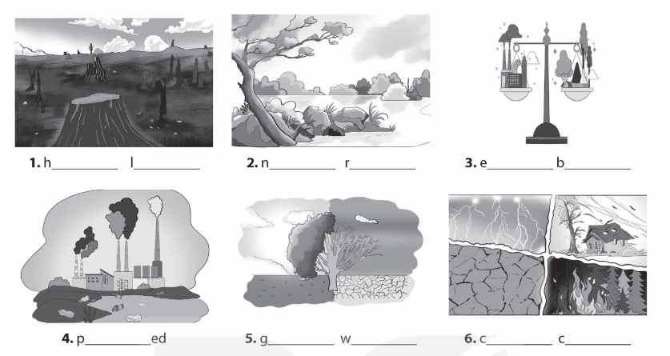  * Answer key:  1. habitat loss 2. nature reserve  3. ecological balance 4. polluted  5. global warming 6. climate change
B. ACTIVITY 2: PRONUNCIATION: ( 8’-12’ )

Rhym in sentences
* Objectives:
+ To help Ss be aware of the stressed words in a sentence;
+ To help Ss be aware of the stressed syllables in words in sentences;
- To help Ss recognise the stressed syllables that help create rhythm in sentences.
* Content:
- Task 4: Listen to the sentences and pay attention to the bold syllables. Does the speaker place stress on them?
- Task 5: Circle the stressed syllables in the sentences. Listen, check, and repeat.
* Expected outcomes:
* Organisation :
Teacher’s Student’s activities | Content
TASK 4: Listen to the sentences and pay attention to the bold syllables. Does the speaker place stress on them?
+ Have Ss read the Remember! box first. Remind them of the sentence stress in Unit 11 of Tieng Anh 7 and Tieng Anh 8.  - Ask Ss to listen to the recording once.  - Then play the recording again and have Ss repeat after each sentence as a class, then as individuals. Ask them to pay attention to the stressed words.  + Play the recording as many times as necessary. Then ask Ss to read out the sentences.  - Correct Ss' pronunciation if needed | 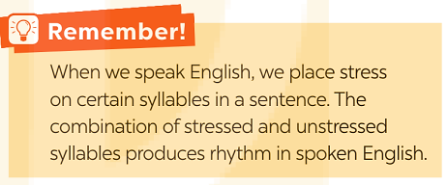  - T_ Ss.  * Key:  * Audio Script:  - Earth is the third planet from the Sun.  - Oceans, seas, rivers, and lakes are water bodies.  - The North and South poles are extremely cold and icy.  - Do moonquakes last up to half an hour?  Preserving natural resources is very important.
TASK 5: Circle the stressed syllables in the sentences. Listen, check, and repeat.

- Have Ss read the sentences and circle the stressed syllables In the sentences.  - Ask them to share their answers with their partners. Play the recording for Ss to check. Show them the correct answers.  + Play the recording again for Ss to listen and repeat each sentence after the recording.  + Correct Ss'pronunciation if necessary.  + Call on some Ss to read the sentences. Play the recording again if necessary. | * Answer key + Audio script.  - We’re doing a study on climate change.  - What is the distance from Earth to Mars?  - They’ll have a discussion on natural habitats.  - Plants provide us with food, oxygen, and energy.  - Our school organised various activities on Earth Day.  + How many stressed syllables are there in each sentence?  - 4 2. 4 3. 4 4. 5 5. 6
5. WRAP-UP & HOME WORK (2’)
- Ask Ss summarise ưhat they have learnt in the lesson.
- Ask them them to list some other learnt words/ phrases related to Earth .
* HOME WORK:
- Do more exercises in workbook.
- Prepare new lesson: Lesson 2: A CLOSER LOOK 2 .

===========================================

