Date of preparing:
Date of teaching:
REVIEW 2
Period 50: Lesson 2: SKILLS
I. OBJECTIVES:
By the end of this review, students will be able to revise the skills they have practiced in Units 4-5-6.
1. Knowledge:
- Practice reading for specific information about one’s favorite kind of music;
- Practice talking about a visit to a lower secondary school;
- Practice listening for specific information about a meal at a restaurant;
- Practice writing a paragraph about a meal at a restaurant.
2. Competences:
The ability of using some skills to practice some exercises in the textbook
Develop communication skills and cultural awareness
Be collaborative and supportive in pair work and teamwork
Actively join in class activities
3. Educational aims:
Know the importance of revision and need to study harder; Having the serious attitude toward studying and the good relationship with friends
II. TEACHING AIDS:
- Grade 7 textbook, Review (skills).
- Projector/ pictures and cards
- sachmem.vn
III. PROCEDURES:
* Activity1: Warm-up (5’)
* Aims: To increase students’ interest and lead them into the lesson.
* Content: Ask some questions about famous place.
* Products: Students’correct answers
* Organization of implementation:
Teacher’s and Ss’ activities |  |  | Content
T -Ss  * Teacher lets ss listen to some pieces of music and asks students to discuss what types of music they are.  ** Students raise hands to answer.  *** Teacher and students discuss the answers.  **** Teacher checks the answers as a class |  |  | * Warm up (Team work)  * What kind of music?  1. Country music  2. Classical music  4. Rock music  5. Hip hop music  6. Pop music
Practice (35’)
* Activity 2: READING
Task 1
* Aims: To help students practice reading for general information.
* Content: Choose the appropriate option (A, B or C) to fill in each gap of the paragraph
* Products: The correct answers from Ss.
* Organization of implementation:
Teacher’s and Ss’ activities | Content
T –Ss :  * Teacher has ss read the paragraph carefully and decide which option goes with which gap.  ** Students read the text fully and choose the correct answers.  *** Teacher asks students how can they choose the option.  **** Teacher confirms the answers as a class. | Task 1: Choose the appropriate option (A, B or C) to fill in each gap of the paragraph (p.70).  * Answer key:  1. C  2. A  3. B  4. C  5. A
* Activity 2: SPEAKING
Task 2
* Aims: To help students practice asking and answering about a visit to a lower secondary school.
* Content: Imagine you have just visited a lower secondary school. Ask and answer the questions
* Products: Some pairs report their answers for the class.
* Organization of implementation:
Teacher’s and Ss’ activities |  | Content
T –Ss; Ss – Ss  * Teacher asks students imagine that they have just visited a lower secondary school so that they can form their own ideas of where the school is, how many teachers and students there are, what school facilities are, what school outdoor activities students do.  Let ss read the questions to focus on the information they are going to answer.  ** Students work in pairs, asking and answering the provided questions.  *** Teacher calls on some pairs to report their answers for the class. Each pair may answer just one question to allow room for more pairs.  **** Teacher checks the answers and add more information if necessary. |  | Task2: Work in pairs. Imagine you have just visited a lower secondary school. Ask and answer the questions, using the suggestions (p.70).  1. Where the school is.  2. How many teachers and students there are.  3. What school facilities are.  4. What school outdoor activities students do.
* Activity 3: LISTENING
Task 3
* Aims: To help students practice listening for specific information.
* Content: Listen to a man talking about his meal at a restaurant and tick the adjs you hear
* Products: Some students read the words/adjectives they have ticked.
* Organization of implementation:
Teacher’s and Ss’ activities |  | Content
T - Ss, Ss – Ss  * Teacher allows ss some time to read the words/adjectives. Check if the words/adjectives are new or not. Check comprehension, if necessary.  Play the recording once.  ** Students listen and do the task.  *** Teacher allows students to share answers before discussing as a class.  **** Teacher invites one student to read the words/adjectives they have ticked. |  | Task 3: Listen to a man talking about his meal at a restaurant and tick the adjectives you hear (p. 70).  * Answer key:  1. ✓  2. ✓  3.  4. ✓  5.
Task 4.
* Aims: To help students review listening for specific information.
* Content: Listen again and fill in each gap with ONE word.
* Products: students’ correct answers.
* Organization of implementation:
Teacher’s and Ss’ activities |  | Content
T - Ss, Ss – Ss  * Teacher has ss read the table. Draw their attention to the meanings of the words: starter, main dish, dessert, drink.  Play the recording once or twice for the ss to complete the table.  ** Students listen and do the task.  *** Teacher allows students to share answers with their partners before discussing as a class.  **** Teacher invites one student to read the words/adjectives they have ticked |  | Task 4: Listen again and fill in each gap with ONE word (p.70).  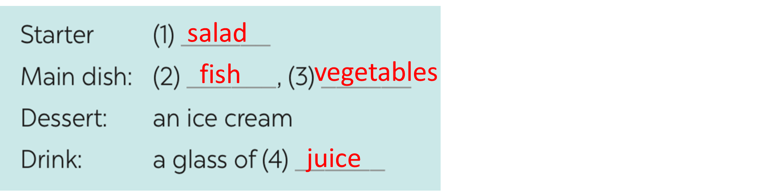  * Audio script  Last weekend, I went to a restaurant near my sister’s home. For a starter, I had a fresh salad. My main dish was fish. I really enjoyed the spices in it. The vegetables were good – very fresh and tasty. For dessert, I had an ice cream. It’s usually delicious but this time it wasn’t very sweet. So, I didn’t eat much. Then I had a glass of juice. I think the meal was OK.
* Activity 4: WRITING
Task 5
* Aims: To help students practice writing a paragraph about a meal in a restaurant.
* Content: Write a paragraph of about 60 words about a meal you had at a restaurant.
* Products: Students’ perfect writing.
* Organization of implementation:
Teacher’s and Ss’ activities |  | Content
T - Ss, Ss – Ss  * Teacher asks students to read the instruction and allow them some time to read the first sentence of the paragraph to think about the information they need to write.  ** Students do the task individually.  *** Teacher goes around and check if they are doing the task correctly and offer help if needed.  **** Teacher calls one or two volunteers to read aloud the paragraphs. Call for others’ comments. |  | Task 5: Write a paragraph of about 60 words about a meal you had at a restaurant.  * Suggested paragraph:  Last weekend, my parents and I had a meal at a small restaurant in the centre of town. For a starter, I had a salad. It was fresh. My main dish included rice, beef, and vegetables. The beef was tasty, and the vegetables were fresh. For dessert, I had a big ice cream. Then I drank a glass of orange juice with ice. The meal was great.
* Activity 5: Consolidation (3’)
* Aims: To consolidate what students have learnt in the lesson.
* Content: Summarize the content of the lesson.
* Products: A student says the lesson’s content aloud.
* Organization of implementation:
Teacher’s and Ss’ activities |  | Content
- Teacher asks students to talk about what they have learnt in the lesson. |  | - 4 skills
* Homework (2’)
* Aims: To revise the knowledge that students have gained in the lesson and to prepare for the next lesson
* Content: Review the lesson and prepare for the next lesson and do exercise in the workbook
* Products: Students’ textbook and workbook.
* Organization of implementation:
Teacher’s and Ss’ activities |  | Content
Teacher asks students to revise old lesson and to do exercise in workbook.  - Teacher asks students to complete the project and prepare the new lesson. |  | - revise the old lesson.  - Do exercise in workbook.  - Prepare for the next lesson: REVISION
- Complement: …………………………………………………………………………………………………………………………………………………………………………………………………….

