Date of preparing:
Date of teaching:
Period 49: REVIEW 2 (Unit 4,5, 6)
Lesson 1: LANGUAGE
I. OBJECTIVES:
By the end of this review, students will be able to revise the language they have learnt and the skills they have practiced in Units 4,5,6.
1. Knowledge:
* Vocabulary: - revise words related to music and arts; food and drinks; to school facilities and school activities;
* Pronunciation: - revise pronouncing the sounds /ʃ/, /ʒ/, /ɒ/, /ɔ:/, /tʃ/ and /dʒ/ correctly;
* Grammar: - revise the use of comparisons (like, different from, as…as); quantity (some, a lot of / lots of); prepositions of time and place (at/in/on).
2. Competence: Ss revise the language they have learnt and some skills they have practiced in Units 4 – 6; Doing exercises on pronunciation, vocabulary, grammar and everyday English
3. Educational aims:
Know the importance of revision and need to study harder; Having the serious attitude toward studying and the good relationship with friends.
II. TEACHING AIDS:
1. Teacher: - Grade 7 textbook, Planning Review 2)
- Smart TV/Pictures, sets of word cards
- sachmem.vn
2. Students: Text books, notebooks, posters, ….
III. PROCEDURES:
Activity1: WARM -UP (5’)
* Aim: To review the words related the unit 4-6
* Content: Game: FINDING KEYWORDS
* Products: Students find a keyword for each set of pictures.
* Organization of implementation:
Teacher’s and Ss’ activities |  | Content
* Warm up (Team work)  T –Ss  * Teacher shows 3 sets of pictures (taken from lessons of Units 4-5-6) and asks students to find a keyword for each set of pictures.  What are these pictures talking about?  ** Students raise hands to answer.  *** Teacher and students discuss the answers.  **** Teacher checks the answers. |  | * Game: FINDING KEYWORDS    Set 1: MUSIC & ARTS    Set 2: FOOD & DRINKS  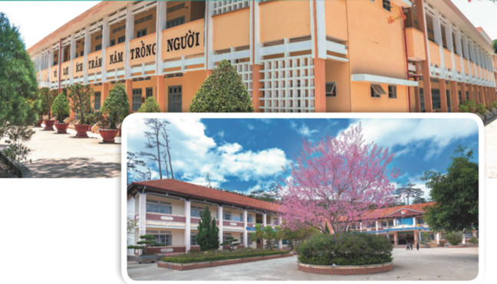  Set 3: SCHOOL FACILITIES
Activity 2: Practice (5’)
PRONUNCIATION
Task 1
* Aim: To help students review the pronunciation of the sounds learnt in Units 4 - 6.
* Content: Choose the word whose underlined part is pronounced diﬀerently
* Products: Students say the correct answer key.
* Organization of implementation:
Teacher’s and Ss’ activities | Content
- T –Ss:  * Teacher writes the sounds /ʃ/ and /ʒ/, /ɒ/ and /ɔ:/, /tʃ/ and /dʒ/on the board.  - Teacher writes one word containing the sound below each of them.  - Teacher asks students to read the words aloud.  ** Students do the task by reading aloud each group and circling the odd one out.  *** Teacher can invite some pairs of students to read aloud.  **** Teacher check students’ pronunciation ad give feedback. | Task 1: Circle the word in which the underlined part is pronounced differently. Then listen, check and repeat. (p. 70)  * Answer key:  1. D  2. B  3. C  4. B  5. C
Activity 3: VOCABULARY (15’)
Task 2.

* Aims: To help students review the phrases taught in Unit 4-6 and use them in different contexts.
* Content: Match a word in A with a word/phrase in B. Then complete the sentences with the appropriate phrases
* Products: Students say the sentences aloud and pronounce the words and phrases correctly
* Organization of implementation:
Teacher’s and Ss’ activities |  | Content
T - Ss, Ss – Ss  * Teacher asks ss to read the verbs in A and match them with the nouns in B. Remind ss that they have learnt these phrases in the previous three units. Make sure they remember their meanings.  ** Students do this exercise individually.  *** Teacher allows students to share their answers before discussing as a class.  **** Teacher checks the answers as a class and gives feedback.  T - Ss, Ss – Ss  * Teacher asks students to work individually to choose the correct words and complete the sentences.  ** Students work individually to complete the task.  *** Teacher allows students to share answers before discussing as a class.  **** Teacher asks students to say the sentences aloud and makes sure they pronounce the words and phrases correctly. Teacher can ask for translation to check their understanding. |  | Task 2: Match a word in A with a word/phrase in B. Then complete the sentences with the appropriate phrases (p.70)  * Answer key:  1. e  2. d  3. a  4. b  5. c  1. play the guitar  2. need some apples  3. perform a classical concert  4. drink juice  5. pass an entrance exam  Task 3: Underline the correct word to complete the sentences (p.70)  * Answer key:  1. composers  2. apples  3. concert  4. gifted  5. outdoor activities
Activity 4: GRAMMAR (15’)
Task 4 + 5
* Aims: To help students review grammar elements taught in Unit 5: How much, How many, some, a lot of;
more … than, different from, not as … as, the same as.
* Content: Complete the passages about camping. Use the words and phrases from the box (p.70).
- Complete the second sentence, using the words in brackets
* Products: Students say the correct answer key.
* Organization of implementation:
Teacher’s and Ss’ activities |  | Content
T - Ss, Ss – Ss  * Teacher asks students to work independently to fill in the blanks with the correct words from the box.  ** Students work individually to complete the task.  *** Teacher allows students to share answers before discussing as a class.  **** Teacher asks students to say the sentences aloud and makes sure they pronounce the words and phrases correctly. Teacher can ask for translation to check their understanding.  T - Ss, Ss – Ss  * Teacher gives a brief revision of more … than, different from, not as … as, the same as then asks students to do the task individually.  ** Students do the task individually.  *** Teacher allows students to share answers before discussing as a class.  **** Teacher asks students to say the sentences aloud and makes sure they pronounce the words and phrases correctly. Teacher can ask for translation to check their understanding |  | Task 4: Complete the passages about camping. Use the words and phrases from the box (p.70).  * Answer key:  1. How much  2. How many  3. a lot of.  4. much  5. some  6. many  Task 5: Complete the second sentence, using the words in brackets (p.70).  * Answer key:  1. I think rock and roll is more exciting than classical music.  2. The poster in the gallery is not different from the one in my house.  3. The ticket to the theatre is not as expensive as I expected.  4. The painting in the museum like the one in the gallery.
Activity 4: Consolidation (3’)
* Aim: To consolidate what students have learnt in the lesson.
* Content: summarize the content of the lesson.
* Products: A student says the lesson’s content aloud.
* Organization of implementation:
Teacher’s and Ss’ activities |  | Content
- Teacher asks students to talk about what they have learnt in the lesson. |  | - vocabulary and grammar in the lesson
* Homework (2’)
* Aim: To revise the knowledge that students have gained in the lesson and to prepare for the next lesson
* Content: Review the lesson and prepare for the next lesson and do exercise in the workbook
* Products: Students’ textbook and workbook.
* Organization of implementation:
Teacher’s and Ss’ activities |  | Content
- Teacher asks students to revise old lesson and to do exercise in workbook.  - Teacher asks students to complete the project and prepare the new lesson. |  | Do exercise in workbook.  - Prepare for the next lesson: Review (SKILLS).
* Complement: …………………………………………………………………………………………………………………………………………………………………………………………………….

