Date of planning:…………..  Date of teaching: ………..…  WEEK: ….. | Period 68: UNIT 8: TOURISM  Lesson 7: LOOKING BACK & PROJECT
I. OBJECTIVES: * By the end of this lesson, Ss will be able to gain the following items:
1. Knowledge:
- Review the vocabulary and grammar of Unit 8; Practice doing exercises.
- Use vocabulary items in new context
- Correctly use relative pronouns which, who, or whose in sentences.
- Apply what they have learnt (vocabulary and grammar) into practice through a project.
+ Integrated skills: Listening, speaking, reading, writing.
* Vocabulary:
+ Use the words and phrases related to tourism;
* Grammar:
+ Learn how to use relative pronouns correctly;
2. Competence:
- Develop communication skills and creativity
- Be co-operative and supportive in pair work and teamwork.
- Develop presentation skill
3. Personal qualities:
- Develop communication skills and creativity
- Actively join in class activities
II. TEACHING AIDS:
- Teacher: Grade 9 text book; Projector / TV.....
- Students : Text books, workbook…
- Computer connected to the Internet.
- Hoclieu.vn
III. PROCEDURE:

I. WARM UP & INTRODUCTION ( 3’- 5’)
* Objectives:
- To create an active atmosphere in the class before the lesson;
- To lead into the new lesson.
* Content: “Kim’s game”
+ To have some warm-up activities to create a friendly and relaxed atmosphere to inspire Ss to warm up to the subject and new lesson.
* Expected outcomes: Students can use the knowledge they have learnt in this unit to complete the tasks successfully.
- Having a chance to speak English.
* Organisation : Teacher’s instructions …

Teacher’s Student’s activities | Content
+ Greeting  + Kim’s game  - T asks Ss to work in groups of three or four Ss  - T gets them look at the pictures related to tourism on the screen.  - T tells Ss that the pictures will disappear after 2 seconds, so they should try to remember all the pictures without writing them down.  - After all the pictures disappear, ss have 1 minute to write them down (2 points for each correct answer)  - T gets ss to swap the posters among groups and give corrections after T shows the answers.  - Ss give marks to their friends’ answers.  - T leads in the lesson. | + Greeting ; T_Ss.  + Kim’s game  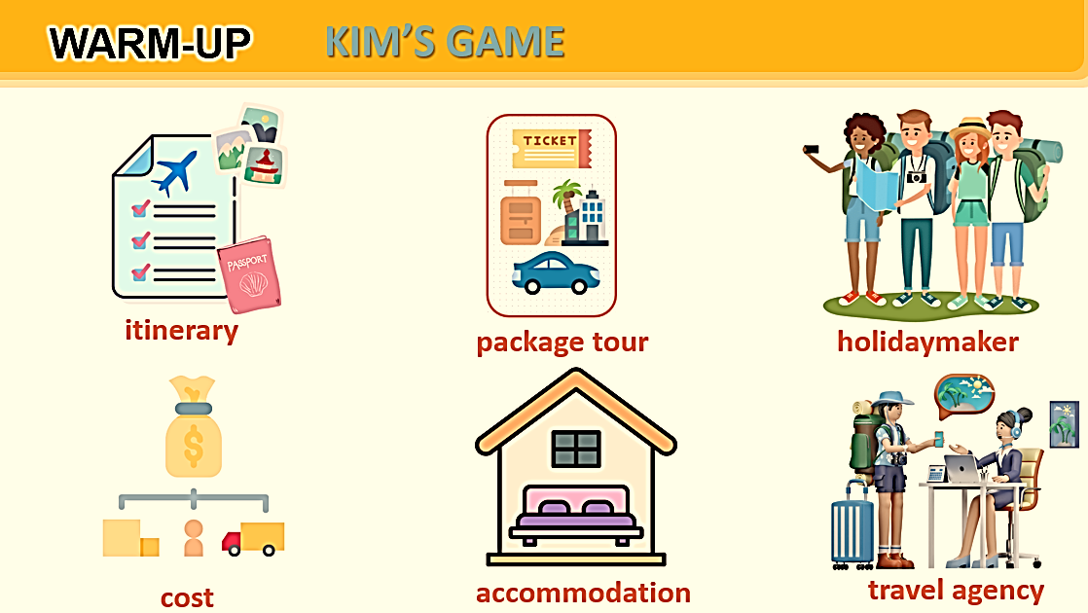  - Open the book and write the tittle of the lesson.
II. PRESENTATION/ NEW LESSON ( 12’- 15’)

ACTIVITY 1. VOCABULARY
* Objectives:
+ To help Ss revise the vocabulary items they have learnt in the unit.
+ To give Ss further practice in using the vocabulary items in new context.
* Content:
- Task 1: Choose the correct answer A, B, C, or D to complete each sentence.
- Task 2: Fill in each blank with a suitable word or phrase. The first letter has been given.
* Expected outcomes:
* Organisation : Teacher’s instructions.

Teacher’s Student’s activities | Content
TASK 1: Choose the correct answer A, B, C, or D to complete each sentence.

+ Have Ss do this activity individually.  - Ask Ss to read each sentence carefully, then refer to the four options and choose the correct answer.  - Allow Ss to compare their answers with their partners.  - Call on some Ss to share their answers with the class.  - Confirm the correct answers as a class. Explain if needed. | - T_Ss  *Key:  1. B  2. C  3. C  4. D  5. A
TASK 2: Fill in each blank with a suitable word or phrase. The first letter has been given.

+ Have Ss do this activity individually.  + Ask Ss to read each sentence carefully and decide what word is needed to complete the sentence.  - Note that the first letter has already been provided. Alternatively, encourage Ss to look for the word without looking at the suggested initial letter . Then they can look at the letter and see if they have found the correct answer.  + Ask Ss to compare their answers with their partners.  - Call on some Ss to share their answers with the class.  + Confirm the correct answers as a class. Explain if needed. | - T_Ss  - Work individually.  *Answer key:  1. domestic  2. fixed  3. apps  4. self-guided  5. natural
ACTIVITY 2: GRAMMAR

* Objectives:
+ To help Ss correctly use relative pronouns which, who, or whose in sentences.
+ To provide Ss with a more demanding task, using relative pronouns to combine two sentences into one.
* Content:
- Task 3: Use a relative pronoun which, who, or whose to complete each sentence.
- Task 4: Combine each pair of sentences, using a suitable relative pronoun which, who, or whose.
* Expected outcomes:
+ Recall the uses of relative pronouns in sentences
* Organasation: Teacher’s instructions.

Teacher’s Student’s activities | Content
TASK 3: Use a relative pronoun which, who, or whose to complete each sentence.

+ Have Ss do this activity individually.  - Ask Ss to read the sentences carefully and decide which relative pronoun is correct for each sentence.  * Tips: ask Ss to look at the word before the blank to see if it is a person {who) or a thing (which); then look at the word after it to see if it is a verb (who and which) or a noun (whose).  + Call on some Ss to share their answers with the class.  + Confirm the correct answers as a class. Explain if needed. | - T_ Ss  * Answer key:  1. which  2. who  3. which  4. whose  5. whose
TASK 4: Combine each pair of sentences, using a suitable relative pronoun which, who, or whose.
+ Have Ss work individually or in pairs.  - Ask Ss to read each pair of sentences carefully and decide what relative pronoun is needed to combine them, and how to form the new sentence (what to keep, what to omit).  - Allow Ss some time to write the sentences. Go round and offer help if needed.  - Call on some Ss to read their answers to the class.  - Confirm the correct answers as a class. Explain if needed. | - T_ Ss.  * Key:  1. My family spent four days in India, whose culture is unique.  2. Organising self-guided tours helps develop personal skills which are important for everybody.  3. Rusel stayed in a hotel in Bui Vien Street, which is one of the best streets for foreign tourists.  4. After the Muay Thai Show, my sons talked to the artists whose performance they admired so much.  5. We participated in a lot of activities with the local people, who were friendly and helpful.
ACTIVITY 3. PRODUCTION/ PROJECT ( 8’)

* Objectives: Making a plan for a two-day trip
- To give Ss an opportunity to plan their own trip.
* Content:
+ Making a plan for a two-day trip.
+ Ss’ presentations.
* Expected outcomes: Students’ speaking.

* Organization:
Teacher’s Student’s activities | Content
** Since Ss have had time to prepare for the project throughout the unit, the focus of this lesson should be on the final product, which is a plan for a two-day trip.  + Have Ss work in groups. Give them a few minutes to prepare for their presentations.  - Give Ss checklists for self and peer assessment. + Explain that they will have to check appropriate items while listening to their classmates' presentations and write comments if they have any. + The presenters should complete their self-assessment checklists in the same way after completing their presentations.  + Invite two or three groups to present their plans. + Encourage the rest of the class to ask questions at the end.  + Give feedback after each presentation.  + T can also give marks as part of Ss'continuous assessment.  + FEEDBACK FORM FOR TRIP PLAN PRESENTATION  (SEE TEACHER’S BOOK ) | + Ss’ presentations.
5. WRAP-UP & HOME WORK (2’)

* Ask one or two Ss to tell the class what they have learnt.
- Ask Ss to say make some sentences with words and phrases they remember from the lesson
* HOME WORK:
- Do more exercises in workbook.
- Prepare new lesson: Unit 9 : WORLD ENGLISHES.

==============================================

