Date of preparing:
Date of teaching:
UNIT 6: A VISIT TO A SCHOOL
Period 45: Lesson 4: COMMUNICATION
I. OBJECTIVES:
By the end of this lesson, Ss will be able to:
1. Knowledge:
- Vocabulary: revise vocabulary related to topic A visit to a school
- Grammar: structures to ask for details
2. Competence:
- Talk about one’s school
- Develop communication skills and creativity
- Be collaborative and supportive in pair work and teamwork
- Actively join in class activities
3. Educational aims:
- Students must love their school and be proud of their school.
II. TEACHING AIDS:
1. Teacher: - Grade 7 textbook, Planning (Unit 6, communication)
- Smart TV/Pictures, sets of word cards
- sachmem.vn
2. Students: Text books, notebooks, posters, ….
3. Method: Ask and answer; group works; individual ……
III. PROCEDURES: (STAGES)
Activity 1: Warm-up (5’)
* Aim: To introduce the topic.
* Content: Game: Matching (flags and the names of the countries).
* Products: Ss match flags and know the names of the countries correctly
* Organization of implementation:
Teacher’s and Ss’activities |  |  | Content
* Warm up: T – Ss  * Teacher shows the picture and asks students questions:  ** Students raise hands to answer the questions.  *** Teacher and students discuss the questions.  **** Teacher gives feedbacks and leads in the new lesson. |  |  | * Game: chatting  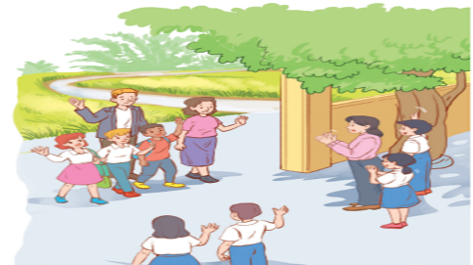  1. Who are they in the pictures  2. What are they doing?  → They are teachers and students from 2 different schools  → They are welcoming students and teachers from another school to visit their school.
Activity 2: Presentation (20’)
* EVERYDAY ENGLISH
* Pre- teach Vocab.

* Aim: To teach some vocab related the lesson.
* Content: Some vocab related to the lesson.
* Products: Read and understand the meaning of words.
* Organization of implementation:
Teacher’s and Ss’activities | Content
- T - Ss  * Teacher introduces the vocabulary.  ** Teacher introduces the vocabulary by:  providing the pictures  providing the definition of the words.  *** Teacher asks students to repeat.  **** Teacher rubs out and checks. | * Vocabulary:  - sport hall: hội trường thể thao  - learning resources: tài liệu học tập  - extra subjects: những môn học phụ  - get involved in: tham gia vào  - Laboratory: phòng thí nghiệm
Task 1
* Aims: To introduce ways to ask for details.
* Content: Listen and read the conversation. Pay attention to the highlighted sentence.
* Products: Students discuss the form of ways to ask for details.
* Organization of implementation:
Teacher’s and Ss’activities |  | Content
T –Ss: Ss- Ss  * Teacher lets students listen to the examples in Ex 1 in the book.  ** Teacher draws their attention to the form of ways to ask for details.  *** Teacher and students discuss the form of ways to ask for details.  **** Teacher confirms the answers and gives feedback. |  | Task 1: Listen and read the conversation. Pay attention to the highlighted sentence.  Mi: Are you doing anything this Sunday?  Phong: Not really.  Mi: Would you like to go with us to Binh Minh Lower Secondary School?  Phong: Sounds great! Can you tell me more?  Mi: We'll leave at 7 a.m. My friends David and Nick are coming too
Task 2
* Aims: To help students get to know the ways to ask for details.
* Content: Ask and answer questions about your visit to a famous school
* Products: Students role play in front of the class.
* Organization of implementation:
Teacher’s and Ss’activities |  | Content
T – Ss  * Teacher has students read the instructions to understand what they are going to do.  ** Students work in pairs to ask and answer questions about their visit to a famous school.  *** Teacher then asks students to exchange their answer among class.  **** Teacher gives feedback. |  | Task 2: Work in pairs. Ask and answer questions about your visit to a famous school.  * Example:  A: Are you doing anything this weekend?  B: Not really.  A: Would you like to go with us to the Supermarket?  B: Sounds great! Can you tell me more?  A: We'll leave at 8 a.m. My friends Linh and Nhi are coming to
Activity 3: Practice
WELCOME TO OUR SCHOOL! (15’)
Task 3
* Aims: To let students brainstorm ideas about things they want to show their friends at school.
* Content: Make a list of what you want to show your overseas friends about your school.
* Product: Students discuss in groups to exchange ideas.
* Organization of implementation:
Teacher’s and Ss’activities |  | Content
Task 3: T – Ss.  * Teacher has students read the instructions to understand what they are going to do.  ** Students work as individuals.  *** Students discuss in groups to exchange ideas.  **** Teacher goes around and offers help, if necessary |  | Task 3: Make a list of what you want to show your overseas friends about your school.  - the school library  - computer rooms  - playground  - school garden  - soccer field  - science Lab
Task 4
* Aims: To give students chances to practice asking and answering questions about their plans.
* Content: Ask and answer questions about your plan.
* Products: Students ask and answer questions about your plan in front of the class.
* Organization of implementation:
Teacher’s and Ss’activities |  | Content
Task 4: T - Ss, Ss – Ss  * Teacher gives instructions and asks students to read the example to understand how to start and end the conversation.  ** Students work in pairs, ask and answer questions about their plans.  *** Teacher allows students to share their answers with other pairs.  **** Teacher calls some pairs to act out the conversations in front of the class. Teacher and other Ss comment. |  | Task 4: Ask and answer questions about your plan.  * Example:  A: I'm going to show them the school library.  B: Sounds good. Can you tell me why?  A: I want them to see our learning resources. I think they're very modern.
Activity 4: Further practice
Task 5
* Aims: To let students practice talking about their school.
* Content: Read the passage and complete the table about a high school in the UK. Then discuss and fill in the information about your school.
* Products: Ss tell about Wilson School and their school in front of the class.
* Organization of implementation:
Teacher’s and Ss’activities |  | Content
* Teacher has read the instructions to understand what they are going to do. Remind them that they have to read the passage and fill the information from the passage in the column of Wilson High School.  Ask Ss to look at the table to understand what information they need to find in the passage (e.g. number of students and teachers, the subjects they study and the facilities the school has).  ** Ss read the passage individually and fill in the column of Wilson High School.  *** Teacher asks Ss to work in pairs and compare.  **** Teacher calls on one or two Ss to tell about Wilson School in front of the class.  *** Ss work in groups, discuss and fill in the table information about their school.  **** Teacher goes around and listen, make suggestions and corrections if needed |  | Task 5: Read the passage and complete the table about a high school in the UK. Then discuss and fill in the information about your school.  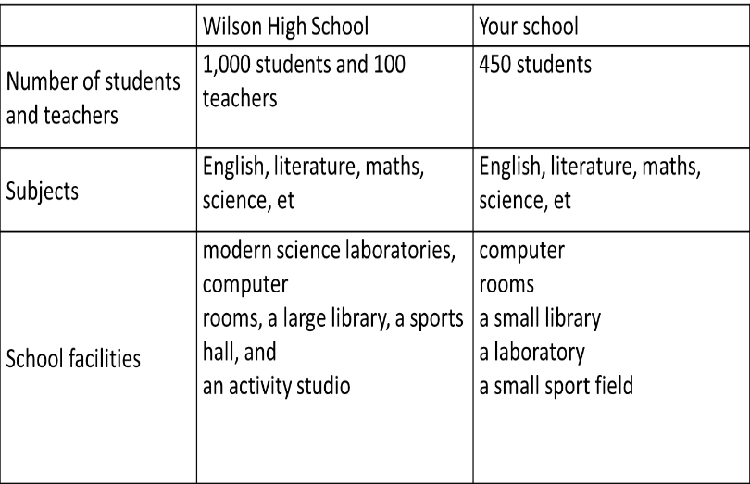
Activity 5: Consolidation (3’)
* Aims: To consolidate what students have learnt in the lesson.
* Content: Summarize the content of the lesson
* Products: Ss say aloud what they have learnt
* Organization of implementation:
Teacher’s and Ss’activities |  | Content
Teacher asks students to talk about what they have learnt in the lesson. |  | - vocabulary related to school  - structures to ask for details  - Talk about one’s school
* Homework (2’)
* Aim: To revise the knowledge that students have gained in this lesson. And prepare for the next lesson: Skills 1.
* Content: Revise the lesson and prepare for the next lesson and do exercise in the workbook
* Products: Students’ textbook and workbook
* Organization of implementation:
Teacher’s and Ss’ activities |  | Content
- T reminds Ss to do homework and prepare the new lesson. |  | - Revise some Tasks in the textbook  - Do some Exercises in the workbook  - To prepare for the next lesson: Unit 6 Skills 1.
Complement.
………………………………………………………………………………………………………………………………………………………………………………………………………..

