Date of planning: 17.02.2025  Date of teaching: 18.02.2025  WEEK: … | Period 67: UNIT 8: TOURISM  Lesson 5: SKILLS 2/ Listening and writing
I. OBJECTIVES: * By the end of this lesson, Ss will be able to gain the following items:
1. Knowledge:
+ To practice listening and writing.
- Listen for specific and general information about a one-day trip to the home of the Brontes.
- Write a paragraph introducing a half day tour in Hue.
+ Integrated skills: Listening, speaking, reading, writing.
* Vocabulary:
+ Use the words and phrases related to tourism;
+ Use stress in words ending in -ic and -ious correctly;
* Grammar:
+ Learn how to use relative pronouns correctly;
2. Competence:
- Develop communication skills and creativity
- Be co-operative and supportive in pair work and teamwork.
- Develop presentation skill
3. Personal qualities:
- Develop communication skills and creativity
- Actively join in class activities
II. TEACHING AIDS:
- Teacher: Grade 9 text book; Projector / TV.....
- Students: Text books, workbook…
- Computer connected to the Internet.
- Hoclieu.vn
III. PROCEDURE:
1. WARM UP & INTRODUCTION ( 3’- 5’)
* Objectives:
- To create an active atmosphere in the class before the lesson;
- To lead into the new lesson.
* Content: Game: Matching
+ To have some warm-up activities to create a friendly and relaxed atmosphere to inspire Ss to warm up to the subject and new lesson.
* Expected outcomes: Students can revise some words learnt in previous lessons.
Having a chance to speak English.
* Organisation : Teacher’s instructions …

Teacher’s Student’s activities | Content
+ Greeting  + Game: Matching the words with the right pictures  - T divides the class into 4 teams.  - T asks Ss to match the words with the pictures  - The group having more correct answers is the winner.  ** Introduce the objectives of the lesson: Listening to the schedule of a visit to the famous Brontes' village, and Writing about a schedule of a half day tour in Hue.  + Ask Ss what information they think the schedule of a visit offers.  + Share with Ss the lesson objectives. Write the objectives in a corner of the board and leave them there till the end of the lesson, or put them on a slide to show Ss. | + Greeting; T_Ss.  + Game:  Answer key:  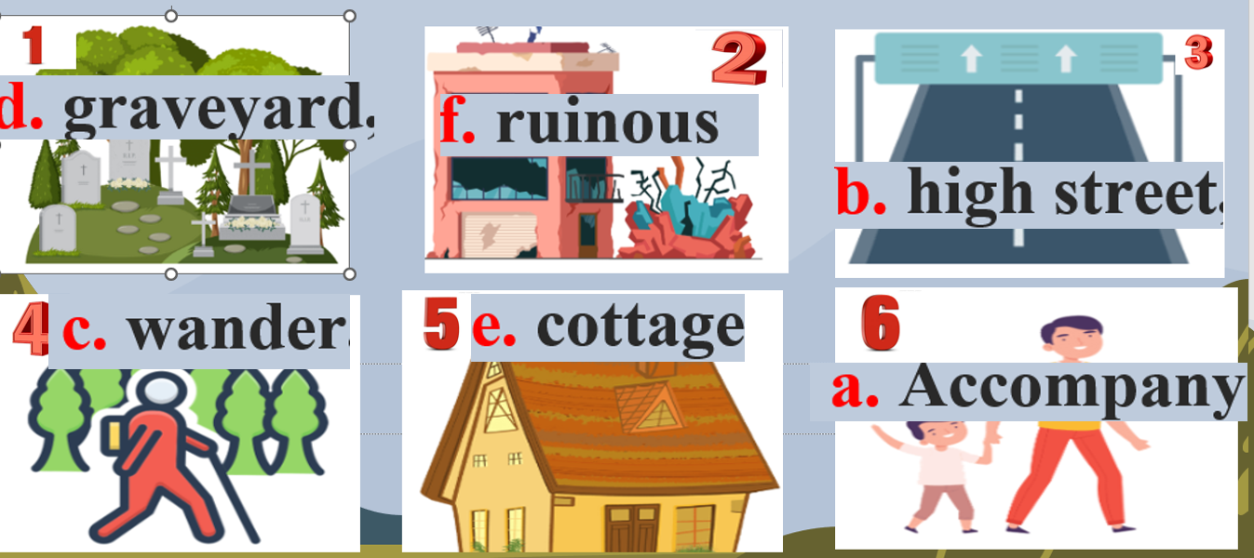  - Open the book and write the tittle of the lesson.
ACTIVITY 1. PRESENTATION/ NEW LESSON ( 12’- 15’)

A. LISTENING
* Pre-listening
* Objectives: To help Ss get some information / ideas about the Brontes.

* Content: Task 1: Work in pairs. Discuss the following question.
* Expected outcomes:Ss can listen for specific information to do the learning tasks.
* Organisation : Teacher’s instructions.
Teacher’s Student’s activities | Content
TASK 1: Work in pairs. Discuss the following question.

* Teach vocabulary:  + Teacher uses different techniques to teach vocab (situation, realia, translation.) if have .  - Have Ss work in pairs.  - Ask Ss to read the statements and discuss if they are true.  - Call on some pairs to share their answers. | - T_Ss  + Students’ own answers  1. T 3. T
* WHILE LISTENING ( 15’)
* Objectives:

2+3 : To help Ss develop their skill of listening for specific information through a filling-in-the blank task.
+ To help Ss relate the information from the listening to pictures.
* Content: Task 2: You will hear Trang, Phong, and Tom talking about how to manage their time effectively. For each student (1 – 3), choose the opinion (A – C) each of them expresses.
- Task 3: Listen again and choose the correct answer A, B, or C.
* Expected outcomes: Ss can listen for specific information to do the learning tasks.
* Organisation :
Teacher’s Student’s activities | Content
TASK 2: A tour guide is announcing the schedule for a one-day trip to the home of the Brontes. Listen and complete the missing information,
+ Have Ss work individually. Have Ss read the table carefully first so that they can have some ideas of what information they need to fill in the blanks.  - Play the recording for Ss to listen and do 2.  - Invite some Ss to share their answers with the class.  - Confirm the correct answers as a class.  - Play the recording again if needed. Pause at places where Ss have difficulties and show them how to find the answers. | - T_Ss  * Answer key:  1. 9/nine 2. world-famous  3. graveyard 4. entrance  5. 150 6. change
TASK 3: Look at the pictures, listen again and tick (✓) the two which illustrate the ideas of listening passage.

+ Have Ss do the task individually.  - Have Ss look at the pictures first and see what they illustrate.  - Play the recording again for Ss to listen and do the activity.  - Invite some Ss to share their answers with the class.  - Confirm the correct answers as a class.  - Play the recording again if needed. Pause at places where Ss have difficulties and show them how to find the answers.  Notes:  + Some proper names appearing in the listening are:  Clapham /klaepam/  Wycoller /wai'k Dla(r)/  Haworth / 'hauaB /  Bronte / 'brontei /  + T may write these names on the board and guide Ss how to pronounce them to make it easier for Ss to follow the listening. | - T_ Ss  * Answer key: 1 and 2  Explanation: the listening mentions 'ruinous cottage' (the building in Jane Eyre book) and 'two-storey house' (The Brontes' original home). It doesn't mention any bridge.
Transition from Listening to Writing
+ Tell Ss that in the upcoming writing tasks, they are going to write the same thing as in the listening: schedule of a visit.
Ask Ss to refer to the listening (Activities 1,2,3) for any vocabulary, ideas, or structures they may need.

ACTIVITY 2: WRITING
* Objectives:

+ To help Ss reflect on the listening and focus on the main points of an itinerary points of an itinerary.
- To help Ss write an introduction to a tour from given clues.
* Content:
Task 4: Work in pairs. Discuss and tick () the thing(s) that the tour guide in the listening passage mentions in her announcement at the beginning of the tour.
Task 5: Write a paragraph (100- 120 words) introducing this half day tour in Hue. Use the clues below.
* Expected outcomes: Ss can write an e-mail.
* Organisation :
Teacher’s Student’s activities | Content
TASK 4: Work in pairs . Discuss and tick () the thing(s) that the tour guide in the listening passage mentions in her announcement at the beginning of the tour.

+ Have Ss work in pairs. Ask Ss to read the list and tick the thing(s) that the tour guide mentions in the tour schedule.  - Invite some Ss to share their answers with the class.  - Check the correct answers as a class. | - T_ Ss.  + Key: 1, 3, 4
TASK 5 : Write a paragraph (100- 120 words) introducing this half day tour in Hue. Use the clues below.

+ Have Ss work individually. Allow them to discuss in pairs  if needed.  - Ask Ss to read the clues about the tour in Hue.  - Allow them some time to arrange the ideas and write the paragraph. Go around and offer help if needed.  + Call on some Ss to read aloud their passage to the class. Comment on them. | * T_ Ss.  * Suggested answer:  Hi, my name is Nam and I'm going to be with you on a five-hour tour of Hue City. Our first visit is Thien Mu Pagoda. It's the oldest pagoda in central and south Viet Nam and was built in 1602.Then we drive on to the Citadel, where we can see the palace ruins, learn about the history of the Nguyen Dynasty, and visit the altars of the Kings. The last visit is to Dong Ba Market. It's the biggest market in the city, where you'll see local products and chat with the locals. You can have lunch in or around the market before the tour end.
EXTRA ACTIVITY:
Make complete sentences from the clues given to write a complete text.
1. One day / I / visit / Mount Fuji, / which / Japan's / most iconic natural wonder.
2. It / famous / place / scenic beauty / historic site.
3. It / rise / 3,776 metres tall / reflects beautifully / five lakes / around / it.
4. Ancient samurai / use / base / mountain / remote training area.
5. Today, / Mount Fuji / international destination / tourism / mountain climbers.
Key :
1. One day, I will visit Mount Fuji, which is Japan's most iconic natural wonder.
2. It Is a famous place for its scenic beauty and historic site.
3. It rises 3,776 metres tall and reflects beautifully on the five lakes around it.
4. Ancient samurai used the base of the mountain as a remote training area.
5. Today, Mount Fuji is an international destination for tourism and mountain climbers.

4. WRAP-UP & HOME WORK (2’)

- Ask ss to summarise what they have learnt in the lesson.
- Have ss look at the objectives written on the board at the beginning of the lesson and tick the objectives they have learnt.
* HOME WORK:
- Do more exercises in workbook.
- Prepare new lesson: Lesson 7: LOOKING BACK.

Giáo viên dạy

Nguyễn Thị Ngọc

=================================================================

