Date of preparing:
Date of teaching:
UNIT 6: A VISIT TO A SCHOOL
Period 44: Lesson 3: A CLOSER LOOK 2

I. OBJECTIVES:
By the end of this lesson, Ss will be able to:
1. Knowledge:
- Use the prepositions of time and place
2. Competence:
- Know how to use the prepositions of time and place
- Develop communication skills and creativity
- Be collaborative and supportive in pair work and teamwork
- Actively join in class activities
3. Educational aims:
- the love for their country, know to preserve and be proud of their school.
- Develop self-study skills
II. TEACHING AIDS:
1. Teacher: - Grade 7 textbook, Planning (Unit 6, A closer look 2)
- Smart TV/Pictures, sets of word cards
- sachmem.vn
2. Students: Text books, notebooks, posters, ….
3. Method: Ask and answer; group works; individual ……
III. PROCEDURES:
Activity 1: Warm-up (5’)
* Aim: To activate students’ prior knowledge
To introduce the targeted grammar: prepositions of place and prepositions of time.
* Content: Game: Pelmanism (words and the meaning of words.)
* Products: Students’correct choice. (team work)
* Organization of implementation:
Teacher’s and Ss’activities |  |  | Content
* Warm up (group work)  - T – Ss, Ss- Ss  * Teacher divides the class into 2 teams.  ** Teacher puts 12 sets of numbers, one includes word and the meaning of words.  ***Members from two teams choose the pair of number  ****The group with the most correct word will be the winner  - Lead in:  These are the prepositions of time and place  Today we are going to learn about how to use the prepositions of time and place. |  |  | * Game: Pelmanism  Ex. In the morning → Vào buổi sáng  On Monday → Vào thứ 2  At 5 o’clock → Vào lúc 5 h đúng  At home → ở nhà  On the table→ ở trên cái bàn  -
Activity 2: Presentation (10’)
Prepositions of time and place
* Aim: To have students get to know about the prepositions of time and place: in, on, at.
* Content: Present and explain how to use the prepositions of time and place: in, on, at.
* Products: Understand and know how to use the prepositions of time and place: in, on, at
* Organization of implementation:
Teacher’s and Ss’activities | Content
T – Ss, Ss- Ss  *Teacher asks students to study the Grammar box.  - Teacher draws students’ attention to the meaning and use of at, in, on.  ** Teacher then asks some more able students to give some more examples.  *** Students find out the form and the usage of prepositions of time and place  **** Teacher gives comments and writes on the board the form and the usage.  -T can have Ss some more examples about how to use the prepositions of time and place: in, on, at in other cases. | * Grammar  * Prepositions of time and place  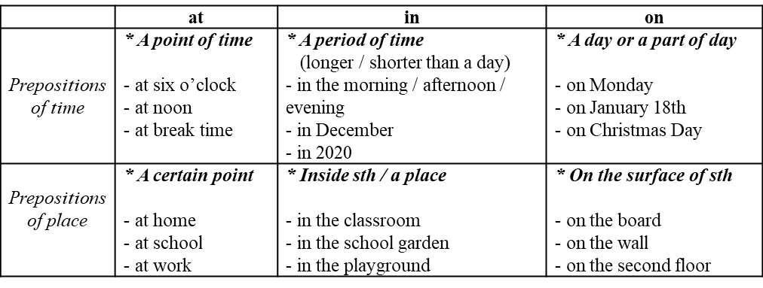
Activity 3: Practice (20’)
Task 1
* Aims: To check students’ understanding of the prepositions of time
* Content: Complete the sentences, using suitable prepositions of time.
* Products: Students say the correct answers aloud.
* Organization of implementation:
Teacher’s and Ss’activities |  | Content
T – Ss, Ss- Ss  * Teacher has students work individually.  ** Students work individually to complete the sentences.  *** Teacher lets students work in pairs and exchange the answers before checking with the whole class (explain each sentence if necessary).  **** Teacher confirms the answers and gives feedback. |  | Task 1: Complete the sentences, using suitable prepositions of time.  * Answer key:  1. at, at  2. in  3. in  4. on  5. at
Task 2
* Aims: To check students’ understanding of the prepositions of time.
* Content: Ask and answer the questions about your school.
* Products: Ask and answer the questions in front of the class fluently
* Organization of implementation:
Teacher’s and Ss’activities |  | Content
T –Ss  * Teacher has students read the questions individually. Remind them that the questions with when are used to ask about time and the prepositions of time (in, on, at) are used in the answers.  ** Students work in pairs to ask and answer the questions.  *** Teacher calls some pairs to ask and answer the questions in front of the class.  **** Teacher confirms the answers and gives feedback. |  | Task 2: Work in pairs. Ask and answer the questions about your school.  1. When does your school year start?  2. When do you have English lessons?  3. When do you usually celebrate Teachers’ Day?  4. When are you going to finish the school year?  * Suggested answer:  1. My school year starts in September.  2. I have English lessons on Monday and Friday.  3. I usually celebrate Teacher's Day on November 20th.  4. I am going to finish the school year in May.
Task 3
* Aims: To check students’ understanding of the prepositions of place.
* Content: Complete the sentences with at, in or on.
* Products: Ss write the correct answers on the board.
* Organization of implementation:
Teacher’s and Ss’activities |  | Content
T –Ss; Ss- Ss  * Teacher asks students to read the instructions to understand how to do the activity.  ** Teacher asks students to do the exercise individually, draws their attention to the type of words after the gaps so that they can choose the appropriate prepositions (e.g. he … third floor shows the surface, so they write on in the gap).  *** Teacher then has them work in pairs, comparing their answers. Teacher can go around helping students.  **** If there is time, have some Ss write the answers on the board. T and other Ss comment. |  | Task 3: Complete the sentences with at, in or on.  * Answer keys:  1. on 2. At 3. In 4. At 5. on - in
Task 4
* Aims: To check students’ understanding of the prepositions of place.
* Content: Look at the pictures and answer the questions.
* Products: Some pairs to ask and answer the questions in front of the class correctly.
* Organization of implementation:
Teacher’s and Ss’activities |  | Content
T –Ss; Ss- Ss  * Teacher has students read the instructions of the activity to understand what they are going to do. Remind them that questions with where are used to ask about places and prepositions of place (at, on, in) are used in the answers. Check comprehension.  ** Teacher asks students to do the exercise in pairs.  *** Then call on some pairs to ask and answer the questions in front of the class.  **** Teacher confirms the answers and gives feedback |  | Task 4: Work in pairs. Look at the pictures and answer the questions.  * Suggested answers:  1. At a school / lower secondary school  2. In the school garden  3. On the board  4. On the stage (of the school, in the meeting room)
Activity 4: Production (5’)
Task 5
* Aims: To help Ss distinguish the use of prepositions of place and prepositions of time.
* Content: Complete the passage with at, on, or in. Then discuss in groups.
* Products: Students’correct answers and explain them exactly.
* Organization of implementation:
Teacher’s and Ss’activities |  | Content
* Teacher has one or two Ss say how the prepositions of time and place are used. Then ask them to read the instructions of the activity to understand what they are going to do.  ** Students do the task individually.  *** Teacher lets Ss discuss in groups and decide which prepositions express time and which one express place. T goes around and corrects mistakes or gives help when necessary.  **** Teacher calls on some Ss to share their answers in front of the class. If time allows, select one or two Ss to read the complete passage in front of the class. T and other Ss comment. |  | Task 5: Complete the passage with at, on, or in. Then discuss in groups.  * Answer key:  1. in  2. in  3. at  4. at  5. on  6. on
Activity 5: Consolidation (3’):
* Aim: To consolidate what students have learnt in the lesson.
* Content: summarize the main content in the lesson.
* Products: Ss say what students have learnt in the lesson.
* Organization of implementation:
Teacher’s and Ss’activities |  | Content
Teacher asks students to talk about what they have learnt in the lesson. |  | * Grammar: How to use the prepositions of time and place
* Homework (2’)
* Aim: To revise the knowledge that students have gained in this lesson and prepare the new lesson
* Content: Review the lesson and prepare for the next lesson and do exersie in the workbbook
* Products: Students’ textbook and workbook
* Organization of implementation:
Teacher’s and Ss’ activities |  | Content
- T reminds Ss to do homework and prepare the new lesson. |  | - Do exercises in the workbook.  - Prepare lesson 4 (communication)
Complement.
………………………………………………………………………………………………………………………………………………………………………………………………………………..

