Date of planning:.../…/ 2024  Date of teaching: ……….  WEEK: 19 | Period 55: UNIT 7: NATURAL WONDERS  OF THE WORLD  Lesson 1: GETTING STARTED  Meeting on the corridor
I. OBJECTIVES: By the end of this lesson, Ss will be able to gain the following items:
1. Knowledge:
- Use the words related to natural wonders of the world;
- Gain vocabulary to talk about natural wonders of the world
- To practice listening and reading skills.
+ Integrated skills: Listening, speaking, reading, writing.
* Vocabulary:
- Use the words related to natural wonders of the world;
- Pronounce the sounds /sl / and /sn/ correctly in words and sentences;
* New words
* Grammar:
- Use the reported Yes/No questions;
* ask for permission and respond;
+ Talk about the Great Barrier Reef;
2. Competence:
- Students will be able to practice listening, speaking, reading and writing skills.
- Develop communication skills and cultural awareness.
- Be co-operative and supportive in pair work and teamwork.
3. Personal qualities:
- Actively participate in class activities.
- Develop self-study skills.
II. TEACHING AIDS:
- Teacher: Grade 9 text book; Projector / TV.....
- Students: Text books, workbook…
- Computer connected to the Internet.
- Hoclieu.vn
III. PROCEDURE:

1. WARM UP & INTRODUCTION ( 3’- 5’)
* Objectives: - To create an active atmosphere in the class before the lesson;
- To lead into the new lesson.
* Content: Think! ;
+ To have some warm-up activities to create a friendly and relaxed atmosphere to inspire Ss to warm up to the subject and new lesson.
* Expected outcomes: Students can answer some questions of the teacher about some cities. Having a chance to speak English.
* Organization : Teacher’s instructions …
Teacher’s activities | Student’s activities + Content
+ Greeting  * Option 1: Think!  - Begin the lesson by talking about the beauty around us. Ask students to identify/ talk about the most beautiful places in their own community.  - T introduces the topic natural wonders of the world. Show Ss some photos of famous natural wonders, such as Ha Long Bay, Sahara Desert, Great Barrier Reef, ...  - Ask Ss to open their books.  - Draw their attention to the box and introduce what they are going to learn in this unit  * T may introduce some warm-up activities to create a friendly and relaxed atmosphere to inspire Ss to warm up to the subject and new class…  - T encourages Ss to talk in English as much as possible  ** Write the unit title on the board. Ask Ss to open their books and start the lesson.  + Share with Ss the objectives of the lesson by displaying them on a projector. Alternatively, write the objectives in a corner of the board and leave them there and tick the objective off when the class finishes with them. | + Greeting  - T_Ss.  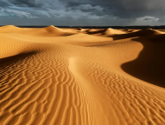  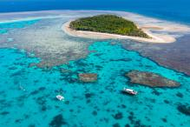  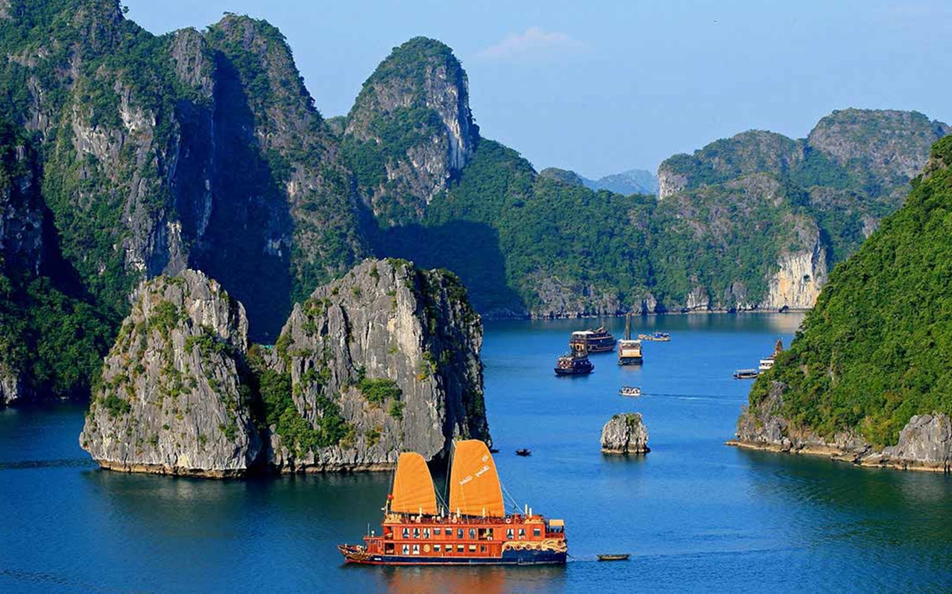  - Open the book and write the tittle of the lesson.
ACTIVITY 1. PRESENTATION/ NEW LESSON ( 12’- 15’)

* Objectives:
+ To create an active atmosphere in the class before the lesson;
+ To lead Ss into the new unit.
* Content: Learn some new words. Read the conversation and find out new words. Focus on topic of the lesson, grammar points…
* Expected outcomes: Knowing more new words. Understanding the conversation; topic of the lesson, grammar points.
- Students know the topic of the unit and be ready for the conversation.
+ Students can have some ideas about Natural Wonders.
* Organisation : Teacher’s instructions.
Teacher’s and Student’s activities | Content
1. Listen and read :/ Page 72
* Teach vocabulary:  + Teacher uses different techniques to teach vocab (situation, realia, translation.)  + Teacher introduces the vocabulary by:  - providing the pictures  - eliciting the definition of the words  + Teacher do the “Rub out and remember” checking technique.  + To begin with, ask Ss some questions: Have you ever been to Ha Long Bay? Do you know that it is a famous natural wonder? Have you heard of/read about other wonders: Mount Everest, the Dead Sea?, etc.  + Set the context for the listening and reading by asking Ss to look at the picture.  + Then ask Ss to look at the title and guess what the conversation between Lan and Tom is about.  - Play the recording for Ss to listen and read along. - Then have some Ss read the conversation aloud.  + Ask Ss some questions about the conversation.  + Confirm the correct answer. (They are talking about famous natural wonders.)  + Have Ss say the words in the text that they think are related to the topic of the unit.  + Have them pronounce the words containing the sounds /sl/ and /sn/. | - T_Ss  *Vocabulary:  1. crazy (adj) about sb/sth /ˈkreɪzi/ thích mê  2. coral (n,adj) /ˈkɒrəl/ san hô  3. landscape (n)/ˈlænd.skeɪp/ phong cảnh  4. peak (n) /piːk/ đỉnh, đỉnh núi  5. charming (adj) /ˈtʃɑː.mɪŋ/ đẹp  6. sustainable (adj) /səˈsteɪnəbl/ bền vững  7. location (n) /ləʊˈkeɪʃn/ địa điểm, nơi chốn  8. possess (v) /pəˈzes/ có, sở hữu  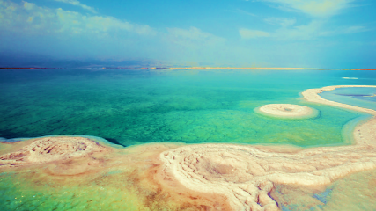
ACTIVITY 2. PRACTICE ( 15’)

* Objectives:
+ To help Ss understand the text.
+ To help Ss learn the new vocabulary of the unit.

+ To help Ss revise and learn the vocabulary related to the topic of the unit

* Content:
- Task 2: Read the conversation again and tick (√) T (True) of F (False) for each sentence.
- Task 3: Complete each sentence with a word or a phrase from the box
- Task 4: Underline the correct answer to complete each sentence.
* Expected outcomes: Students understand the conversation and topic of the lesson and can complete the tasks successfully
* Organisation : Teacher’s instructions.
Teacher’s Student’s activities | Content
TASK 2: Read the conversation again and tick (√) T (True) of F (False) for each sentence.

+ Have Ss work individually.Tell them to read the statements and decide whether they are true (T) or false (F) without reading the conversation again.  - If Ss find the task difficult, ask them to read the conversation again and find the information in it.  + Check their answers and explain if necessary. | - T_Ss  * Answer key:  1. T.  2. F  3. T  4. F
TASK 3: Complete each sentence with a word or a phrase from the box.
+ Ask Ss to read the sentences and find the words from the box to fill in the gaps.  + Have Ss share answers before discussing it as a class.  + Have some Ss write the correct answers on the board. If there's time, call on some Ss to read the sentences. | - T_ Ss  * Answer key:  1. landscape  2. couldn’t help  3. explore  4. support  5. development
TASK 4: Underline the correct answer to complete each sentence.
+ Have Ss work independently. Ask them to read the sentences, paying attention to the words given in brackets and their collocations.  + Tell Ss that most of these words appear in the conversation, so they can look back and find the words.  - Have Ss share answers before discussing it as a class.  - For more able Ss, have them make up sentences with these words. | - T_ Ss.  * Answer key:  1. crazy  2. landscape  3. explore  4. suggest  5. contributes
ACTIVITY 3 : PRODUCTION/ FURTHER PRACTICE ( 8’)

* Objectives: To help Ss learn about some famous natural wonders of the world.
* Content: Task 5: GAME.Natural Wonders Knowledge.
* Expected outcomes: Ss can know more about Natural Wonders

* Organisation :

Teacher’s Student’s activities | Content
TASK 5: GAME: Natural Wonders Knowledge
+ Ss work in groups of three or four. Explain to them what they are going to do.  - Give Ss some time (3-4 minutes) to do the task.  + T may call on some groups to write their answers on the board.  + The group that has the most correct answers wins. | + Suggested answers:  - The Grand Canyon, USA  - The Great Barrier Reef, Australia  - Ha Long Bay, Vietnam  - Northern Lights, Arctic and Antartic.  * Key:
B. PROJECT PREPARATION
- The project is at the end of the unit, but it is recommended that T assigns tasks, and instructs Ss to start preparing for it in the first lesson. The aim of this activity is to inform Ss about the final product of the project and how they can prepare for it.
- Ask Ss to open their book to the last page of the unit, the Project section, look at the pictures and say what the topic of the project is (Natural wonders of the world).
- Explain the project requirements: In groups, Ss will have to design a poster of a natural wonder of the world, and then give an oral presentation of their posters in the last lesson of the unit. Explain that poster presentations are a way to communicate ideas, research, or understand a topic in a visual way. Their posters should be clear and engaging, with a mixture of text and pictures or tables / graphs. Ss will display their posters around the classroom in advance. One representative from each group will stand next to the poster. The rest will walk round the classroom, study the posters, and talk to group representatives if they want to learn more about the natural wonders. Then the class will sit down and vote for the best poster.
- Put Ss into groups and have them choose their group leader. Then ask the group leaders to assign tasks to each group member, making sure that all group members contribute to the project work.
- T may suggest some steps for Ss to follow:
+ Step 1. Collecting information and pictures (searching the Internet, reading books / magazines, brainstorming ideas, etc. about a natural wonder: its location, its special features / attractions, threats to its existence, and ways / plans to preserve it)
+ Step 2. Organising ideas and visuals, and designing the posters
+ Step 3. Practising explaining their posters and answering questions about the content
- Help Ss set a deadline for each task and support them throughout the process.
- In each of the next lessons, spend a few minutes checking Ss' progress, helping them with
any topic-related or functional language they need, and solving any other problems that may arise with their projects.
(SEE TEACHER’S BOOK )
5. WRAP-UP & HOME WORK (2’)

- Ask one or two Ss to tell the class what they have learnt.
- Ask Ss to say aloud some words / phrases and the grammar points they remember from the lesson. Tell Ss that they will learn these language points in the upcoming lessons.
Notes:
Mount Everest: the highest mountain in the world (8,849m), located on the border between China and Nepal
* HOME WORK:
- Do more exercises in workbook.
- Prepare new lesson: Lesson 2: A CLOSER LOOK 1 .

==========================================

