Date of preparing:
Date of teaching:
UNIT 5: FOOD AND DRINK
Period 41: Lesson 7: LOOKING BACK and PROJECT

I. OBJECTIVES:
By the end of this lesson, Ss will be able to:
1. Knowledge
- Review the vocabulary and grammar of Unit 5
- Apply what they have learnt (vocabulary and grammar) into practice through a project
2. Core competence
- Develop communication skills and creativity
- Develop presentation skill
- Develop critical thinking skill
- Be collaborative and supportive in pair work and team work
- Actively join in class activities
3. Educational aim:
- Be more creative when doing the project
- Develop self-study skills
II. MATERIALS
1. Teacher: - Grade 7 textbook, Planning (Unit 5 - Looking back and project)
- Smart TV/Pictures, sets of word cards
- Sachmem.vn
2. Students: Text books, notebooks, posters, ….
3. Method: Ask and answer; group works; individual ……
II. PROCEDURES:
Activity 1: Warm -up (5’)
* Aim: To create an active atmosphere in the class before the lesson.
* Content: Making some food or drink, using the ingredients provided
* Products: Students work group and write the correct answers on the board.
* Organization of implementation:
Teacher’s and Ss’ activities | Content
* Warm up (Team work)  * Teacher puts Ss in small groups, shows some ingredients on the screen and gives some instructions.  ** Ss work in their teams to decide what food they can cook, using the ingredients provided.  *** Students then share their ideas with other groups.  **** Teacher corrects students’ answers if they make any mistakes and suggests some food they can make using the given ingredients. | Game: What can you make?  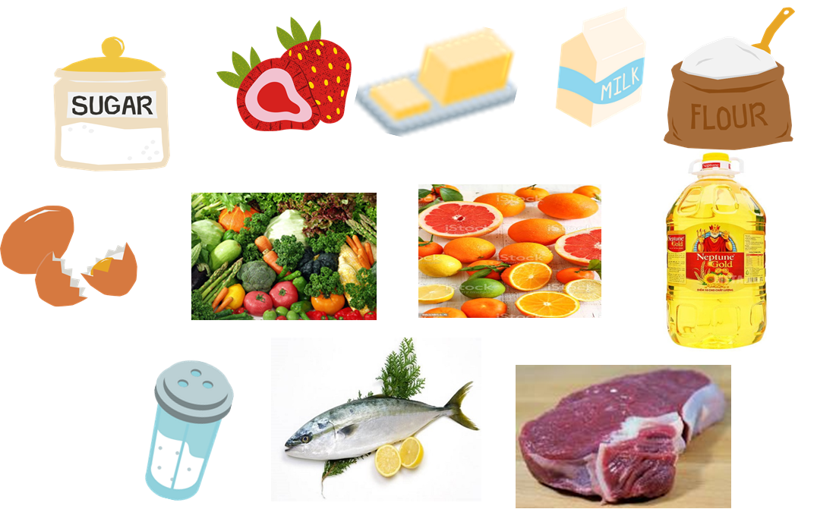
Activity 2: VOCABULARY (12’)
Task 1,2
* Aim: To help students revise the vocabulary items they have learnt in the unit.
* Content: - Add the words and phrases in the correct columns.
* Products: Ss write the correct words / sentences on the board.
* Organization of implementation:
Teacher’s and Ss’ activities | Content
Task 1:  - T –Ss:  * Teacher encourages students to find as many words or phrases as possible to add to the columns individually.  ** Students do the task individually.  *** Ss compare with their partners to find out who has more words and add any words they haven’t had into their tables.  **** Teacher gives feedback as a class discussion.  Task 2:  - T –Ss:  * Teacher has Ss do this activity individually.  ** Ss read the recipe and write about 7 sentences.  *** Ss then compare their answers with their partners. Some strong ones are nominated to read out their answers in front of the class.  **** Teacher gives feedback as a class discussion.  We need 1 teaspoon of pepper. | Task 1: Add the words and phrases in the correct columns.  Task 2: Read the recipe and write sentences.  * Suggested answers:  -We need 5 eggs. We need 2 tomatoes.  -We need 2 tablespoons of cold water.  -We need 40 grams of butter.  -We need 5 grams of onion.  - We need 1 teaspoon of salt.
  Dishes | Ingredients | Units of measurement
  pancakes  beef noodles  Rice  Beefsteak  Omelette  Roasted  chicken | flour  Rice  Rice noodle  Beef  Meat  salt | Gram  Litre  Tablespool  Teaspoon  kilo
Activity 3: GRAMMAR (13’)
Task 3+ Task 4

* Aims: To help Ss revise the use of some, any, much and a lot of / lots of/ How much/ How many
* Content: - Complete the sentences. Write some, any, much, or a lot of/ lots of.
- Make questions with How many/ How much for the underlined words
* Products: Students give the answers correctly.
* Organization of implementation:
Teacher’s and Ss’ activities | Content
Task 3: T –Ss; Ss – Ss  * Teacher gives instructions.  ** Ss do the exercise individually first.  *** Then they can swap and check their answers with a partner before discussing the answers as a class.  **** Teacher gives feedback as a class discussion.  Task4:  T - Ss, Ss – Ss  * Teacher gives instructions and asks SS do the task by playing game “The big wheel game”  *** Teacher divides the class into 2 teams; each team choose the question in order from 1 to 6;  ** Ss from each group spin and then make the question. If team A makes the Q correctly, they will get the points that they have just spined.  *** If team A makes the Q incorrectly, team B has the right to answer the question and spin the number to get points.  **** The teacher adds the total score and gives comments. The team which has more points will be the winner. | Task 3: Complete the sentences. Write some, any, much, or a lot of/ lots of.  * Key:  1. any 2. some 3. a lot of/ lots of 4. a lot of/ lots of 5. any, some  Task 4: Make questions with How many/ How much for the underlined words in the following sentences.  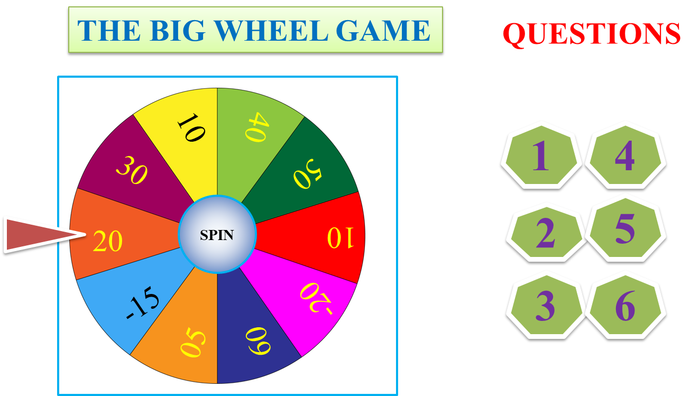  * Answer key:  1. How many bottles of juice are there in the fridge?  2. How much butter do you need for your pancakes?  3. How many bottles of fish sauce do you / we have?  4. How many chairs do you / we need (for the party)?  5. How much sugar did she put in her lemonade?  6. How many bananas does he eat every day?
Activity 4: Project (10’)
* Aims: To allow students to apply what they have learnt (vocabulary and grammar) into practice through a project.
* Content: Display and present the posters about eating habits around the world.
* Products: Students present their project in front of fluently.
* Organization of implementation:
Teacher’s and Ss’ activities | Content
- T - Ss, Ss – Ss  * Teacher has students display all or some of the posters on the wall or notice board and ask each group to present their poster to the whole class. When all groups have presented their posters, T may have the whole class vote for the best poster.  + Choose eating habits in Quang Ngai or in another area or country and design a poster for it, including:  Organize an exhibition.  Vote for the best poster.  ** Students do the project in groups before and present during lesson 7  *** Students listen to the others, vote for the best poster and finally complete the self-assessment by completing the statement Now I can … so that they can identify any difficulties and weak areas and provide further practice as the whole groups and individuals.  **** Teacher gives feedback. | * Posters exhibition: Eating habits around the world  - what typical food they eat for the meals  - what ingredients they need to cook  - how they cook  - how they serve the meals  - pictures or photos for illustration  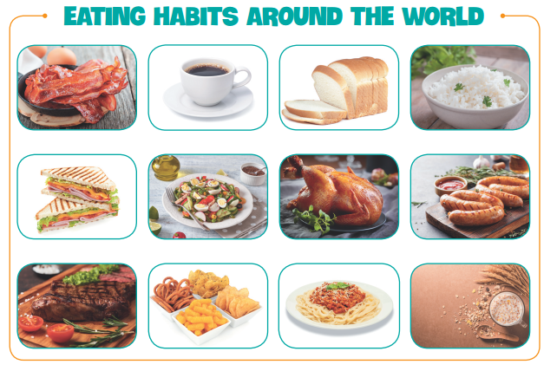  * Example:  Today, I am going to present my poster about eating habits in our country – Viet Nam. In our country, we have 3 main meals a day, including breakfast, lunch, and dinner. At around 6.30 a.m., they usually have a light breakfast with a bowl of pho, bread or sticky rice. Some people eat a bowl of instant noodles and drink a cup of coffee before going to work. Lunch usually starts around 11.30 a.m. They usually have some dishes like: rice, fish, meat and vegetables and drink juice for lunch. Dinner usually starts at 18:00 with rice, lots of vegetables, some meat and fish. Then they usually have some fruit and some tea.
Activity 5: Consolidation (3’)
* Aim: To consolidate what students have learnt in the lesson.
* Content: Summarize the content of the lesson.
* Products: A student says aloud the lesson’s content
* Organization of implementation:
Teacher’s and Ss’ activities | Content
- Teacher asks students to talk about what they have learnt in the lesson. | - revise vocabulary and grammar in unit 5  - Redo Project.
* Homework (2’)
* Aim: To revise the knowledge that students have gained in Unit 5 and to prepare for the next lesson
* Content: Review the lesson and prepare for the next lesson and do exercise in the workbook
* Products: Students’ textbook and workbook.
* Organization of implementation:
Teacher’s and Ss’ activities | Content
- Teacher asks students to revise old lesson and to do exercise in workbook.  - Teacher asks students to complete the project and prepare the new lesson. | - Complete the project perfectly  - Prepare for the next lesson: Unit 6 (Getting started)
Complement.
…………………………………………………………………………………………………………………………………………………………………………………………………….

